create table maman (
cinMama NUMBER(10) primary key,
nomMama VARCHAR2(15) not NULL,
prenMama VARCHAR2(15) not NULL,
dateMaman date
);
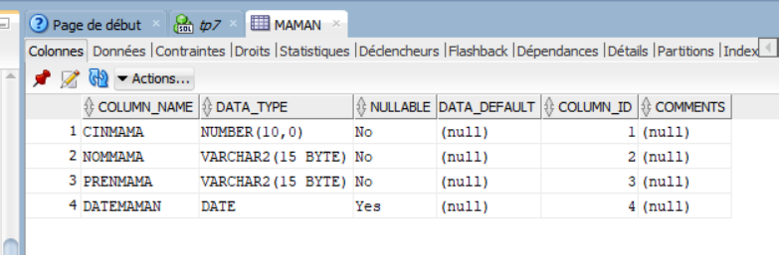
create table enfant(
NumEnf NUMBER(7),
CinMama NUMBER(10),
PrenEnf VARCHAR2(15),
NomEnf VARCHAR2(15),
dateEnf date,
Poids number(5,2),
taille NUMBER(10),
constraint Fk_1 FOREIGN KEY(CinMama)REFERENCES maman(cinMama),
CONSTRAINT PK_1 PRIMARY KEY(NumEnf,CinMama),
CONSTRAINT UN_1 UNIQUE(PrenEnf,NomEnf)
);

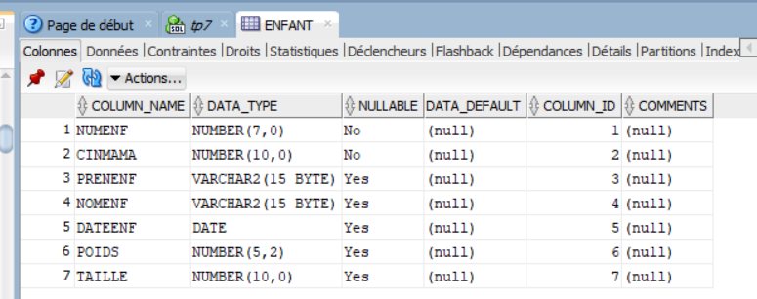

create table vaccin(
CodeVacc VARCHAR2(15) primary key ,
LibVacc VARCHAR2(40) UNIQUE,
AgeVacc NUMBER(4),
uniteAge varchar2(1) CHECK(uniteAge in('J','M','A'))
);

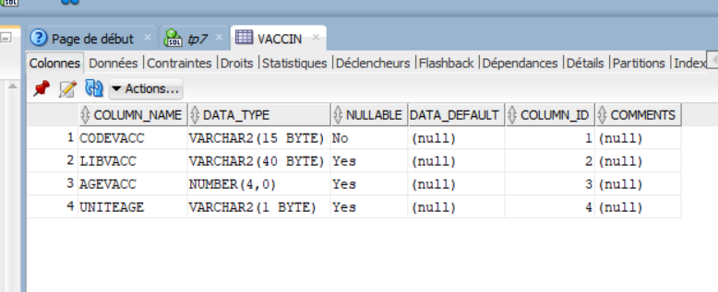

CREATE table effectuerVaccin(
NumEnf NUMBER(7),
CinMama NUMBER(10),
CodeVacc varchar2(15) REFERENCES vaccin(CodeVacc),
dateRealVacc date,
CONSTRAINT FK_2 FOREIGN key(NumEnf,CinMama)REFERENCES enfant(NumEnf,CinMama),
CONSTRAINT Pk_2 PRIMARY key(NumEnf,CinMama,CodeVacc)
);

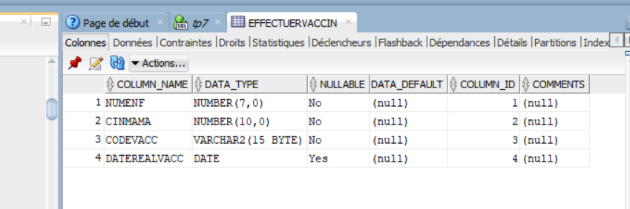

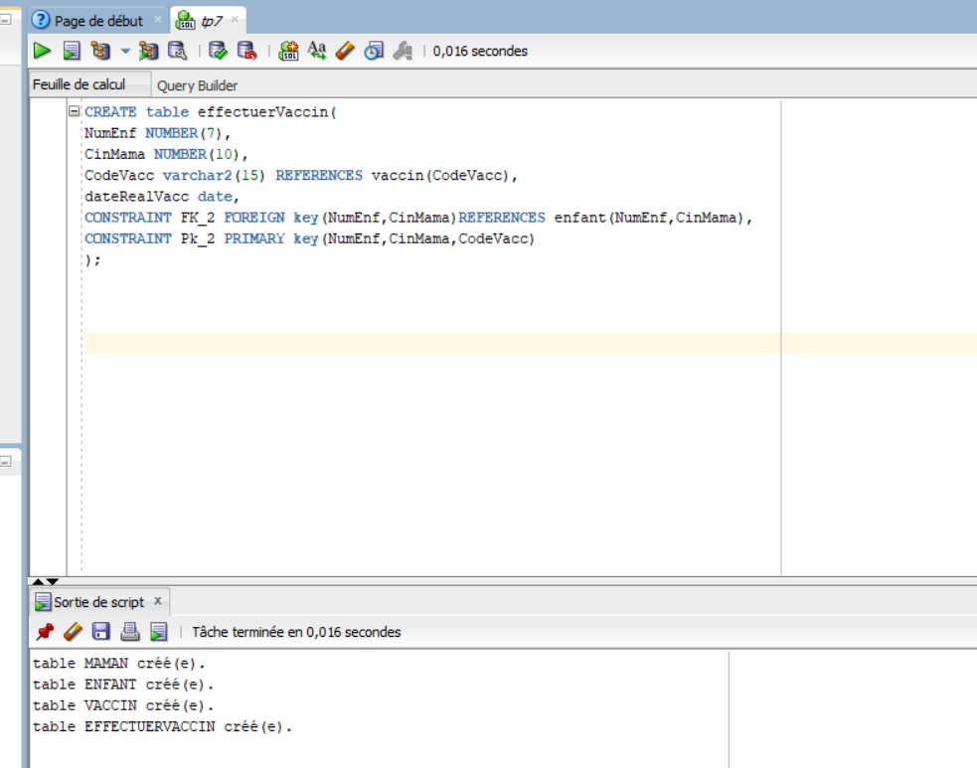

2-

insert into MAMAN VALUES(05020203,'Tounsi','Alia','05/04/1990');
insert into ENFANT VALUES(1,5020203,'Ali','Derbel','10/10/2017',3.5,53);
insert into VACCIN VALUES('VHB-0','Vaccin de lhepatite B',1,'J');
insert into EFFECTUERVACCIN VALUES(1,5020203,'VHB-0','11/10/2017');

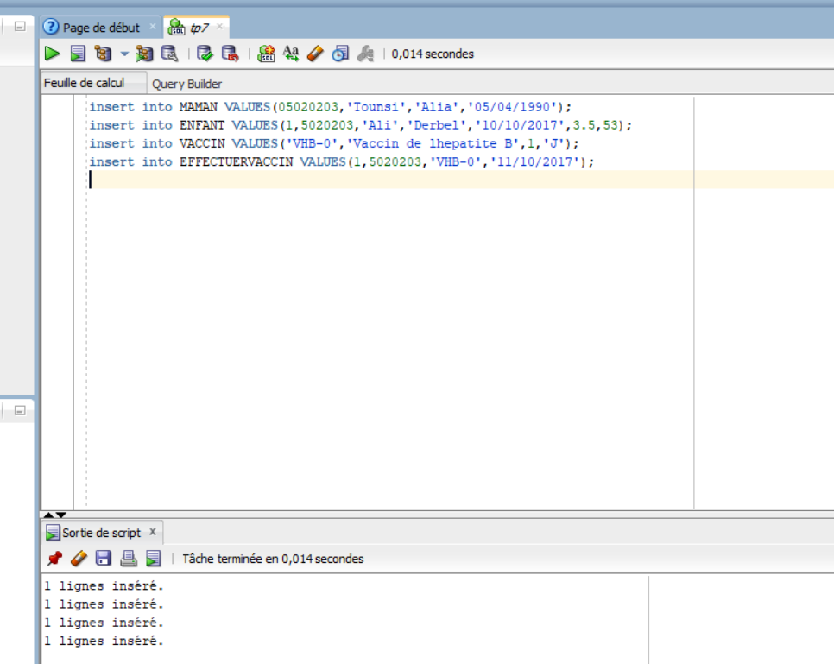
3)
-select* from VACCIN where (upper(uniteAge )='J' and AgeVacc <365)or (upper(uniteAge )='M' and AgeVacc <12);
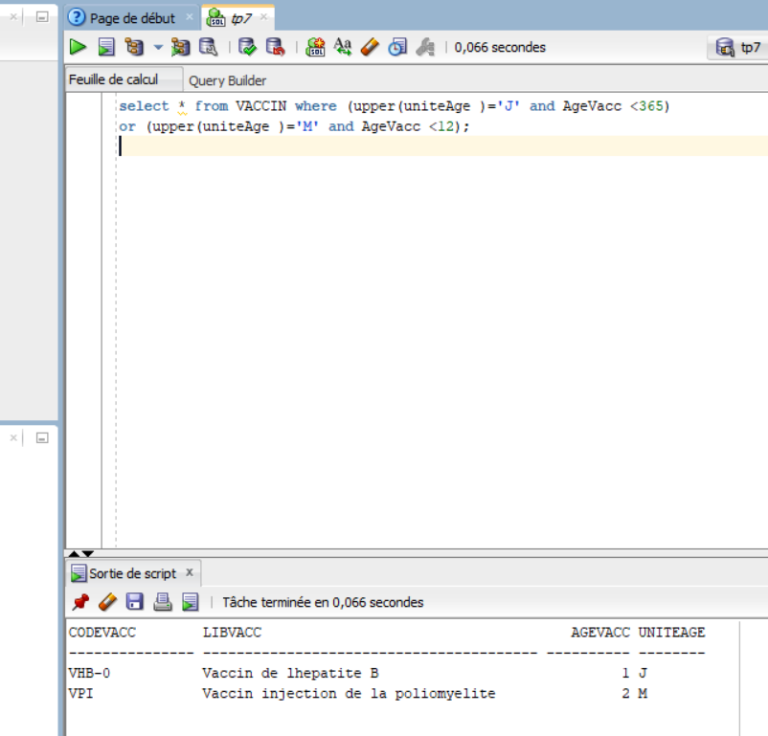
-select e.*,floor(months_between(e.dateEnf,m.dateMaman)/12)"Age" from ENFANT e,maman m where e.cinMama =m.cinMama ;
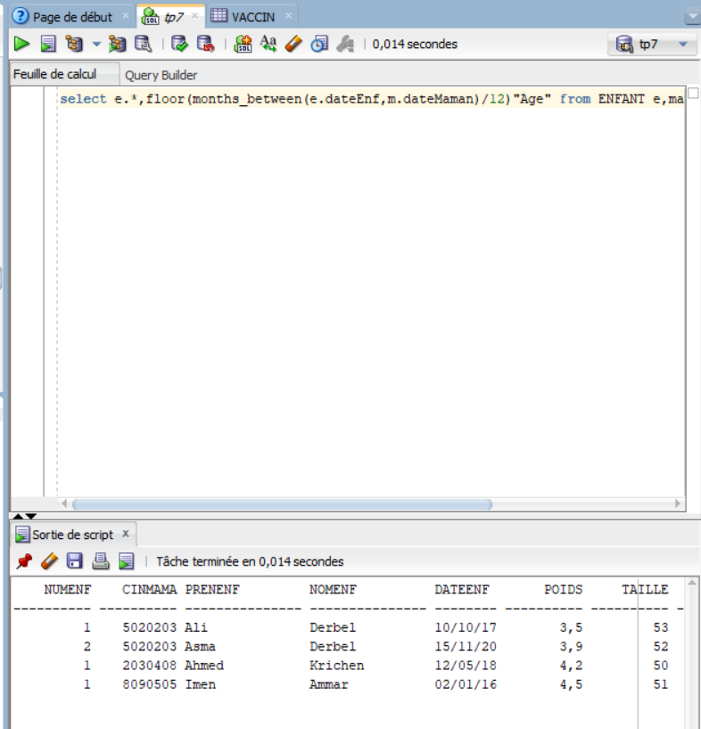
-select V.* FROM VACCIN V, EFFECTUERVACCIN E,ENFANT T where E.CODEVACC=V.CODEVACC and E.NUMENF=T.NUMENF and upper(T.PRENENF)='ALI' and upper(T.NOMENF)='DERBEL';
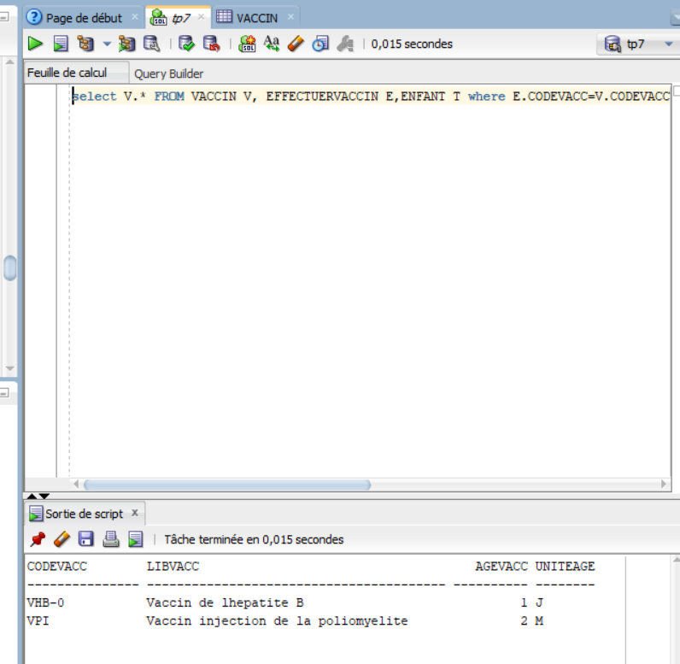
-SELECT * FROM VACCIN ORDER BY AGEVACC ;
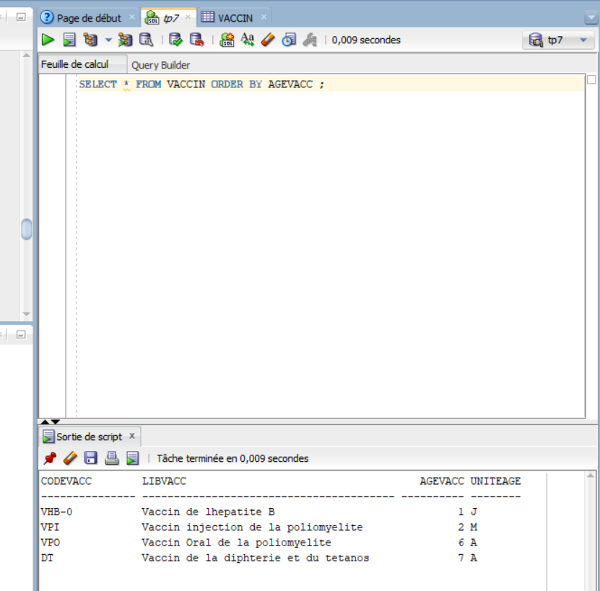
-SELECT M.cinMama,count(E.NumEnf) from MAMAN M,ENFANT E WHERE M.CINMAMA=E.CINMAMA GROUP BY M.CINMAMA;

-select M.* from MAMAN M,ENFANT E where E.CINMAMA=M.CINMAMA and E.DATEENF=(select MIN(E.DATEENF) from ENFANT);
OU
select CinMama ,e.PrenEnf ,e.NomEnf from enfant e
where e.dateEnf =(select max(dateEnf ) from enfant e1 where e.CinMama =e1.CinMama );

-select F.CinMama , PrenEnf , NomEnf from enfant e, EFFECTUERVACCIN F where e.CinMama = F.CinMama and e.NumEnf = F.NumEnf group by(F.CinMama , PrenEnf , NomEnf ) having(count(*)=(select count(*)from ENFANT))
-select e.* from enfant e,vaccin where upper(CodeVacc) = 'VPI' and decode(upper(uniteAge),'J',dateEnf+AgeVacc,'M',add_months(dateEnf,AgeVac),'A' , add_months(dateEnf,AgeVacc*12))=sysdate + 1;

-select m.*from maman m,ENFANT e where months_between(e.dateEnf,dateMaman)>40*12 and m.cinmama=e.CINMAMA;

-select e.CinMama,PrenEnf, NomEnf from ENFANT e,vaccin v,effectuerVaccin ev where e.CINMAMA=ev.CINMAMA and ev.CodeVacc=v.CodeVacc and count(ev.NumEnf)=4 group by e.CinMama,PrenEnf, NomEnf;

-select dateRealVacc, codevacc, count(*)"Nbre vaccins effectue"
from effectuerVaccin where TO_CHAR(dateRealVacc,'MM/RR')=TO_CHAR(sysdate,'MM/RR')
group by dateRealVacc,CodeVacc;

-select E.CinMama,E.PrenEnf,E.NomEnf from enfant E,effectuerVaccin ev
where E.NumEnf=ev.NumEnf ev.CodeVacc in (select CodeVacc from VACCIN
where months_between(E.dateEnf,sysdate)/12<AgeVacc);

