Library Management System
Software Requirements Specification & Design Documentation
Prepared by Nour Elsayed
Sadat Academy for Management Sciences (SAMS) — Computer Science and Information Systems
C++ Object-Oriented Implementation — Analysis, Design & Architecture

1. Introduction

1.1 Purpose
This document specifies the functional and non-functional requirements of the Library Management System. The system is designed to manage books, members, librarians, and book loans while enforcing data validation and loan-related business rules.
The current implementation is developed as a C++ object-oriented application and is designed to support future integration with persistent storage, a backend, and a user interface.

1.2 Scope
The Library Management System provides functionality for:
- Managing books
- Managing members
- Managing librarians
- Searching for books and loans
- Borrowing books
- Returning books
- Managing loan records
- Validating system data
- Preventing invalid and conflicting operations
The current system stores data in memory using C++ data structures. Database persistence, authentication, and frontend interfaces are considered future extensions.

1.3 Definitions
Term | Definition
Book | A library item that can be borrowed.
Member | A user who can borrow books.
Librarian | A user responsible for library management operations.
Loan | A record representing the borrowing of a book by a member.
Active Loan | A loan that has not yet been returned.
Returned Loan | A loan whose status has been changed to Returned.
Book ID | Unique identifier assigned to a book.
Member ID | Unique identifier assigned to a member.
Loan ID | Unique identifier assigned to a loan.
Facade | A design pattern providing a simplified interface to internal subsystems.
Factory | A design pattern responsible for object creation.

2. Overall Description

2.1 Product Perspective
The system follows an object-oriented architecture. The main public entry point is the Library class, which acts as a Facade over several internal subsystems:
Client
|
v
+---------------+
| Library |
| <<Facade>> |
+-------+-------+
|
+-----------+-----------+
| | |
v v v
BookCatalog MemberRegistry LoanManager
|
v
LoanFactory
|
v
Loan

2.2 User Classes

Member
A Member represents a user who can interact with borrowing operations. A member has a Name, Member ID, Email, and Phone number. A member can search for books, borrow books, return books, and view active loans.

Librarian
A Librarian represents a user responsible for library management. A librarian has a Name and ID, and can add books, remove books, add members, add librarians, search books, and view loans.

3. Actors and Use Case Diagram
The system has two primary actors: Member and Librarian. Search Book is shared between both roles.
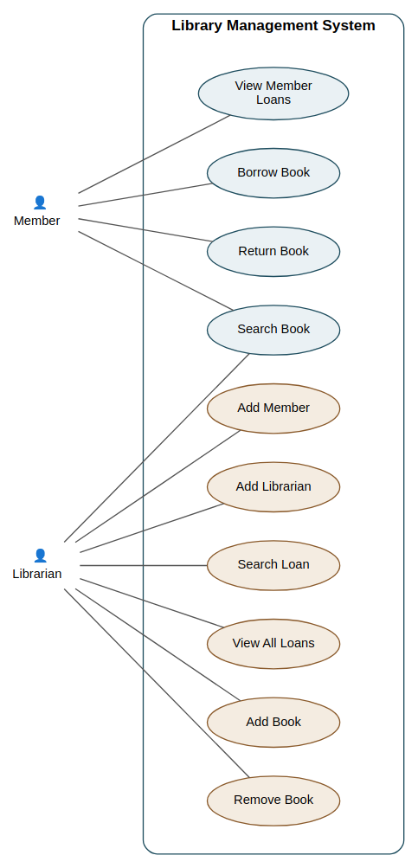
Figure 1 — Use Case Diagram: Member and Librarian interactions with the Library Management System
Note: only user-facing operations are modeled as use cases. Business rules such as date validation, ID uniqueness, and data validation (FR-11 through FR-14) are constraints enforced within these use cases rather than independent use cases.

3.1 Use Case: Borrow Book (UC-02)
Field | Description
Primary Actor | Member
Goal | Allow a member to borrow an available book.
Preconditions:
- The member exists in the system.
- The book exists in the library.
- The book is not currently borrowed.
- The borrow and return dates are valid, and the return date is not before the borrow date.
Main Flow:
- 1. The member requests to borrow a book (Member ID, Book ID).
- 2. The system verifies the book exists.
- 3. The system verifies the member exists.
- 4. The system checks whether the book is currently borrowed.
- 5. The system validates the loan dates.
- 6. The system requests LoanFactory to create a new Loan with a unique Loan ID.
- 7. The system stores the loan and confirms success.
Alternative Flows:
- A1 — Member Not Found: operation stops, "Member not found" is displayed.
- A2 — Book Not Found: operation stops, "Book not found" is displayed.
- A3 — Book Already Borrowed: operation stops, "Book is already borrowed!" is displayed.
- A4 — Invalid Dates: operation stops, an invalid date message is displayed.
Postconditions: on success, a new Active loan exists with a unique Loan ID and the book is considered borrowed. On failure, no loan is created and system data is unchanged.

3.2 Use Case: Return Book (UC-03)
Field | Description
Primary Actor | Member
Goal | Return a borrowed book.
Preconditions: the Loan ID exists and the loan is currently active.
Main Flow: the member requests to return a book by Loan ID; the system searches for the loan, verifies it exists and has not already been returned, marks it as returned, and confirms success.
Alternative Flows: A1 — Loan Not Found ("Loan not found!"); A2 — Loan Already Returned ("Book is already returned!").
Postconditions: the loan status changes from Active to Returned and remains stored as historical data.

3.3 Use Case: Add Book (UC-05)
Field | Description
Primary Actor | Librarian
Goal | Add a new book to the library catalog.
Preconditions: the book data is valid, the Book ID is positive, and no existing book has the same Book ID.
Main Flow: the librarian provides book information; the system validates the data, checks for a duplicate Book ID, adds the book to the catalog, and confirms success.
Alternative Flow: A1 — Duplicate Book ID ("Book ID already exists!").
Postconditions: the new book is stored in BookCatalog.

3.4 Use Case: Remove Book (UC-06)
Field | Description
Primary Actor | Librarian
Goal | Remove an available book from the catalog.
Preconditions: the Book ID is valid, the book exists, and the book is not currently borrowed.
Main Flow: the librarian provides a Book ID; the system checks whether the book is borrowed, searches for it, removes it, and confirms success.
Alternative Flows: A1 — Book Is Borrowed ("Book cannot be removed because it is currently borrowed!"); A2 — Book Not Found ("Book not found!").

4. Functional Requirements

FR-01: Add Book
The system shall allow a librarian to add a book. The system shall reject duplicate Book IDs.

FR-02: Remove Book
The system shall allow a librarian to remove an available book. The system shall prevent removal of a currently borrowed book.

FR-03: Search Book
The system shall allow a book to be searched using its Book ID.

FR-04: Add Member
The system shall allow a new member to be registered. Duplicate Member IDs shall be rejected.

FR-05: Add Librarian
The system shall allow a librarian to be registered. Duplicate Librarian IDs shall be rejected.

FR-06: Borrow Book
The system shall allow a valid member to borrow an available book, verifying member validity, book validity, availability, and date validity before creating a loan with a unique Loan ID.

FR-07: Return Book
The system shall allow a member to return a borrowed book using its Loan ID. A returned loan shall be marked Returned and cannot be returned again.

FR-08: Search Loan
The system shall allow a loan to be searched using its Loan ID.

FR-09: Display Loans
The system shall display loan information including Loan ID, Book ID, Member ID, Borrow Date, Return Date, and Status.

FR-10: Display Member Loans
The system shall display the active loans associated with a member, or report that none exist.

FR-11: Validate Book Data
The system shall reject empty titles, empty author names, negative prices, and invalid Book IDs.

FR-12: Validate User Data
The system shall reject empty names, invalid user IDs, empty member emails, and invalid member phone numbers.

FR-13: Validate Dates
The system shall reject invalid calendar dates and a return date occurring before the borrow date.

FR-14: Unique Identifiers
The system shall maintain and enforce unique identifiers for Books, Members, Librarians, and Loans.

FR-15: Book Count
The system shall provide the current number of books stored in the library catalog.

5. Non-Functional Requirements

NFR-01 Maintainability
The system shall be structured into classes with clearly defined responsibilities (BookCatalog, MemberRegistry, LoanManager, LoanFactory).

NFR-02 Modularity
The system shall use independent components with clearly defined responsibilities; changes to book management should not require unnecessary modifications to loan management.

NFR-03 Encapsulation
Internal class data shall be protected using appropriate access modifiers, exposing controlled public operations.

NFR-04 Reliability
The system shall validate input data and prevent invalid objects from being created; invalid operations shall not corrupt system state.

NFR-05 Extensibility
The architecture should allow future features (database integration, web/mobile frontend, fine calculation, reservations, notifications, authentication) without major changes to core domain classes.

NFR-06 Usability
The system shall provide clear messages for successful and invalid operations (e.g. "Book borrowed successfully!", "Book not found").

NFR-07 Testability
System components should be independently testable, covering valid operations, invalid operations, duplicate data, missing data, invalid dates, loan state changes, and search operations.

6. Business Rules
ID | Rule
BR-01 | Two books cannot have the same Book ID.
BR-02 | Two members cannot have the same Member ID.
BR-03 | Two librarians cannot have the same ID.
BR-04 | Every newly created loan receives a unique Loan ID.
BR-05 | A book cannot have more than one active loan at the same time.
BR-06 | The return date cannot occur before the borrow date.
BR-07 | A book with an active loan cannot be removed from the catalog.
BR-08 | Returned loans remain stored in the system and their status changes to Returned.

7. Design Patterns and Refactoring
Before refactoring, the Library class was responsible for managing books, members, librarians, loans, searching, borrowing, returning, and validation — a single class with too many responsibilities:
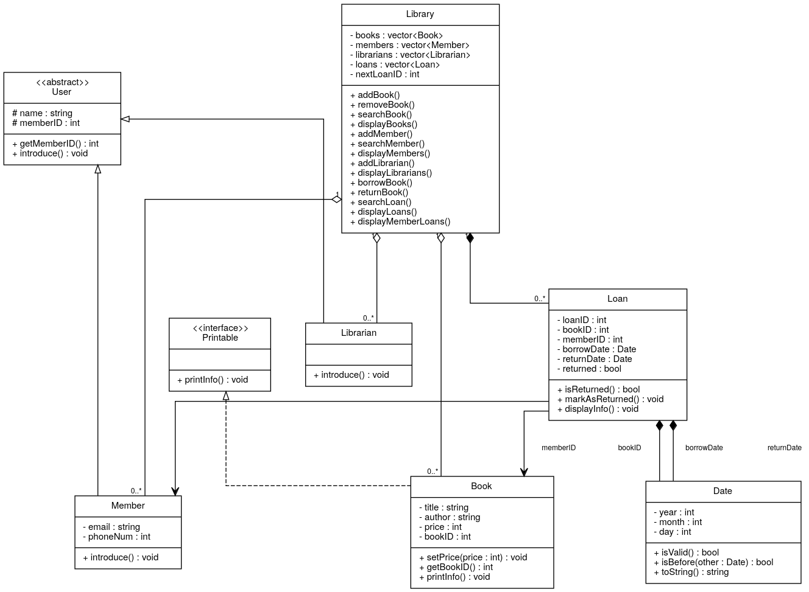
Figure 2 — Class diagram before refactoring: a single monolithic Library class

7.1 Facade Pattern
Field | Value
Applied Class | Library
Problem | The original Library class had too many responsibilities, making the system harder to maintain.
Solution | Responsibilities were separated into three subsystems — BookCatalog, MemberRegistry, and LoanManager — with Library acting as a Facade providing a simple unified interface.
Example:
library.borrowBook(
memberID,
bookID,
borrowDate,
returnDate
);
The client does not need to directly interact with LoanManager, BookCatalog, or MemberRegistry.
Benefits:
- Reduces coupling between the client and internal subsystems.
- Hides implementation details and simplifies the public API.
- Supports the Single Responsibility Principle.
- Makes future changes to internal subsystems easier.

7.2 Factory Pattern
Field | Value
Applied Class | LoanFactory
Problem | LoanManager was responsible for both managing loans and creating Loan objects, including generating loan IDs.
Solution | Loan creation moved to LoanFactory, which generates Loan IDs and constructs Loan objects; LoanManager focuses solely on managing created loans.
Example:
Loan newLoan = loanFactory.createLoan(
bookID,
memberID,
borrowDate,
returnDate
);
Benefits:
- Separates object creation from loan management.
- Centralizes and isolates Loan ID generation logic, reducing risk of duplication.
- Keeps LoanManager focused on loan operations.
- Makes future changes to Loan creation easier.

7.3 Pattern Summary
Pattern | Class | Main Responsibility
Facade | Library | Provides a simple interface to system subsystems
Factory | LoanFactory | Creates Loan objects and generates Loan IDs
Strategy and Observer patterns were deliberately not introduced: there is currently no more than one loan policy that would warrant a Strategy pattern, and no event/subscriber mechanism (such as notifications or logging) that would warrant an Observer pattern. Adding them now would be pattern-for-pattern's-sake rather than solving a real design problem.

7.4 Final Class Diagram (After Facade + Factory)
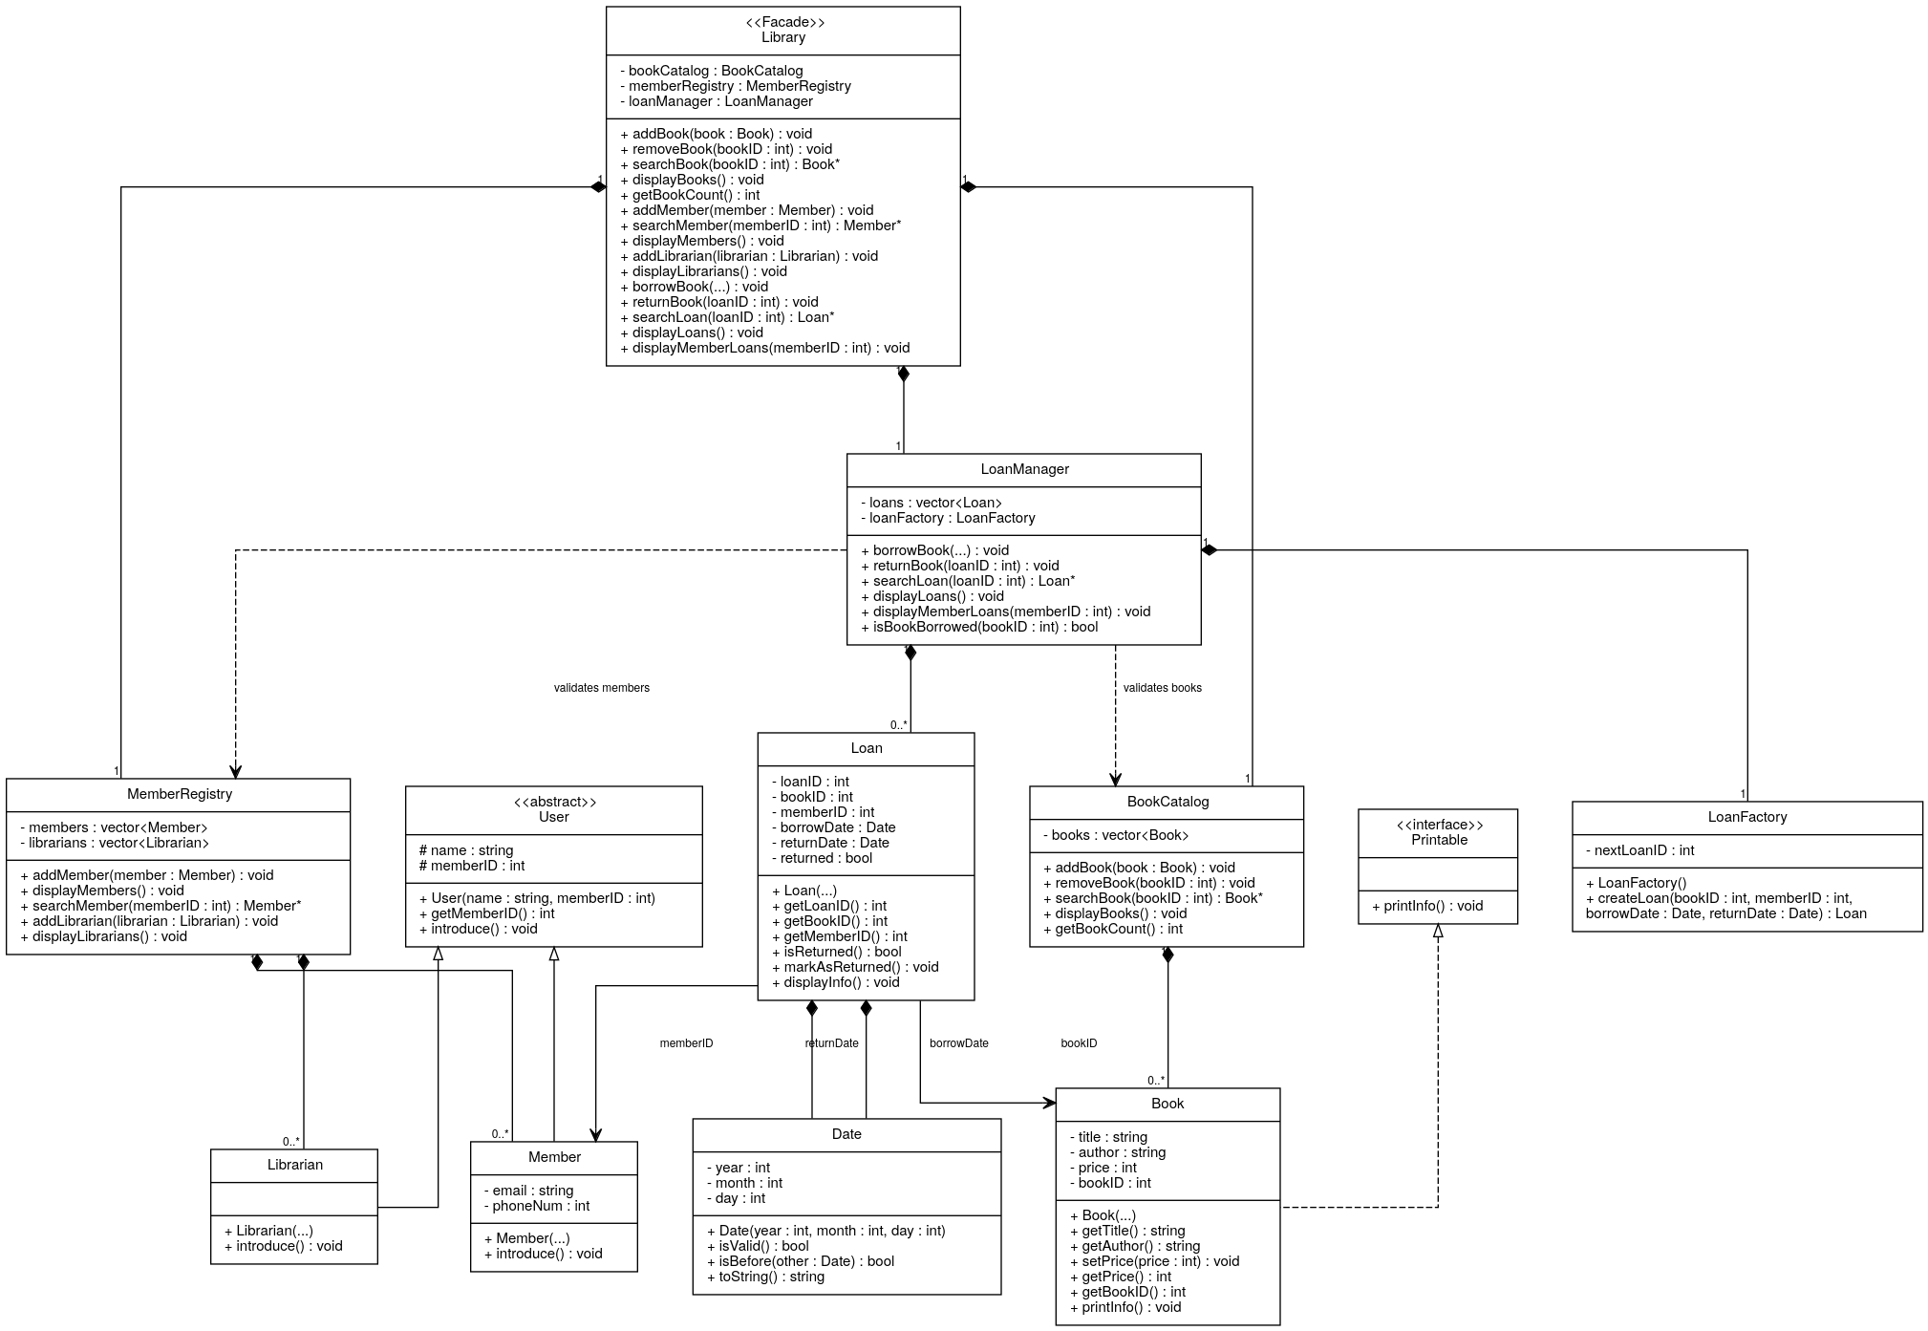
Figure 3 — Final class diagram: Library (Facade) delegating to BookCatalog, MemberRegistry, and LoanManager, with LoanFactory (Factory) responsible for Loan creation

8. Sequence Diagrams
Sequence diagrams show how the classes collaborate at runtime to fulfill each use case, complementing the static class diagram.

8.1 Borrow Book
This flow shows the full architecture: Library delegates to LoanManager, which validates the book (BookCatalog) and member (MemberRegistry), checks availability, then hands off to LoanFactory to construct the Loan.
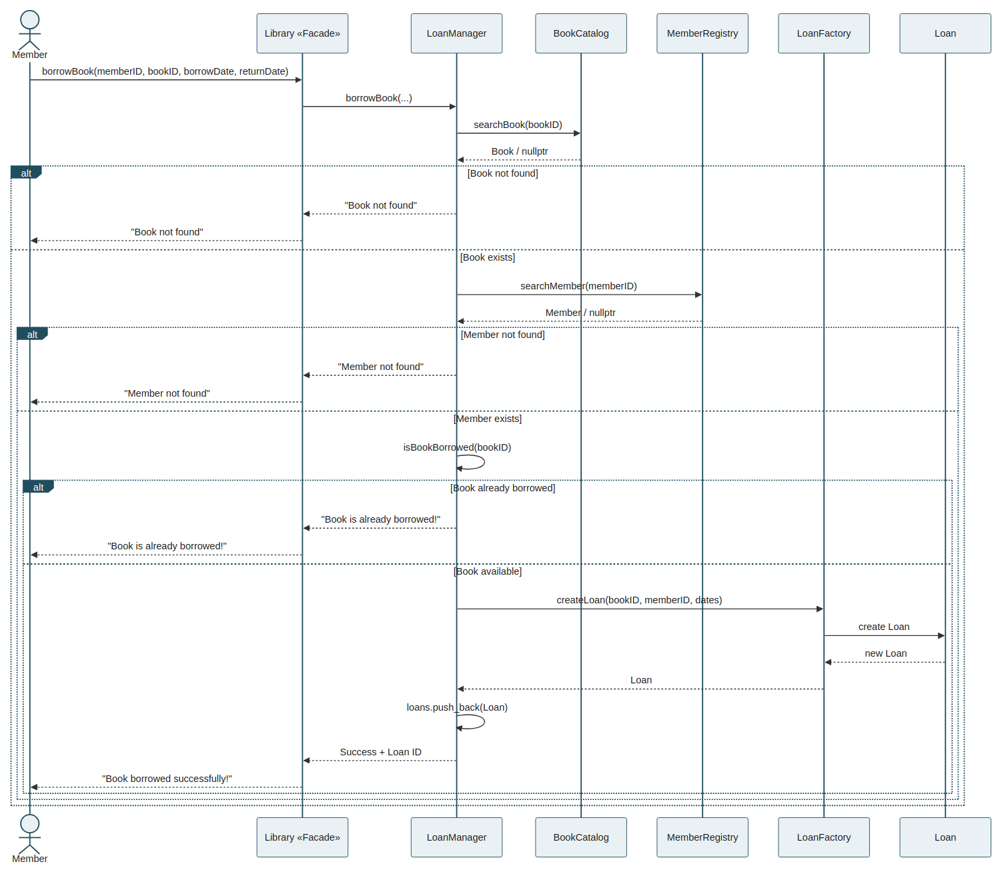
Figure 4 — Sequence diagram: Borrow Book

8.2 Return Book
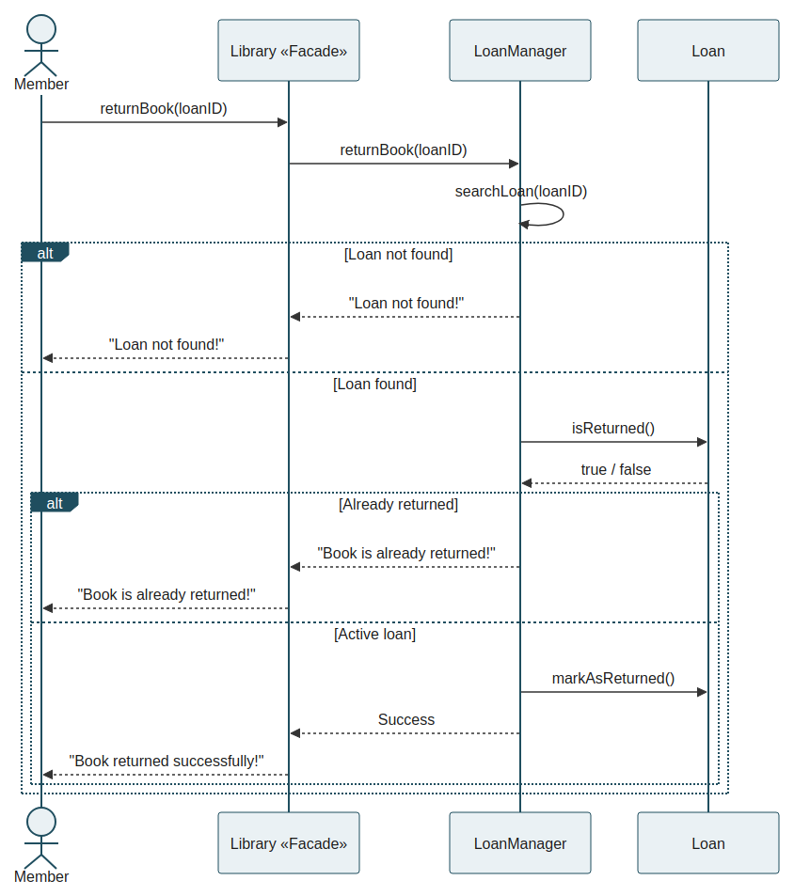
Figure 5 — Sequence diagram: Return Book

8.3 Add Book
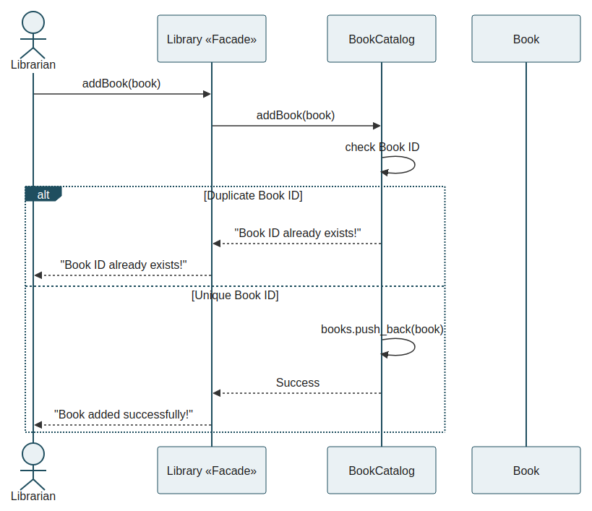
Figure 6 — Sequence diagram: Add Book

9. Database Design
The database schema is derived from the domain model (Book, Member, Librarian, Loan), not the other way around. User is an abstract class in C++ with no independent table; Member and Librarian remain separate tables since they are distinct entities in the current system scope.
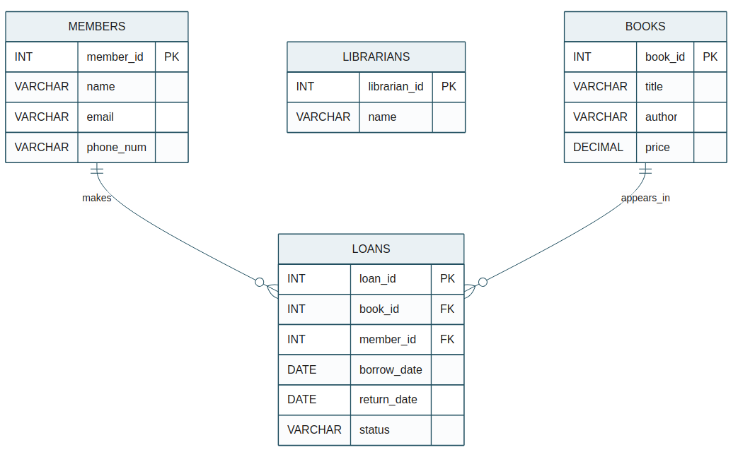
Figure 7 — Entity-Relationship Diagram

9.1 SQL Schema
CREATE TABLE members (
member_id INT PRIMARY KEY,
name VARCHAR(100) NOT NULL,
email VARCHAR(150) NOT NULL,
phone_num VARCHAR(20) NOT NULL
);
CREATE TABLE librarians (
librarian_id INT PRIMARY KEY,
name VARCHAR(100) NOT NULL
);
CREATE TABLE books (
book_id INT PRIMARY KEY,
title VARCHAR(200) NOT NULL,
author VARCHAR(150) NOT NULL,
price DECIMAL(10, 2) NOT NULL,
CHECK (price >= 0)
);
CREATE TABLE loans (
loan_id INT PRIMARY KEY,
book_id INT NOT NULL,
member_id INT NOT NULL,
borrow_date DATE NOT NULL,
return_date DATE NOT NULL,
status VARCHAR(20) NOT NULL,
FOREIGN KEY (book_id) REFERENCES books(book_id),
FOREIGN KEY (member_id) REFERENCES members(member_id),
CHECK (return_date >= borrow_date),
CHECK (status IN ('ACTIVE', 'RETURNED'))
);

9.2 Enforcing "One Active Loan Per Book" (BR-05)
A foreign key alone cannot express that a book has at most one active loan at a time. On DBMSs that support partial/filtered unique indexes (e.g. PostgreSQL, SQL Server), this is enforced directly at the database level:
-- PostgreSQL example
CREATE UNIQUE INDEX one_active_loan_per_book
ON loans (book_id)
WHERE status = 'ACTIVE';
On DBMSs without partial indexes, the same rule is enforced in the application/service layer before insert (as LoanManager already does via isBookBorrowed()), or via a trigger.

10. Architecture and Backend Mapping
The current C++ implementation is treated as the domain/application prototype that the future backend will build on — not something to discard.
┌──────────────────┐
│ Frontend │
│ Web / Mobile UI │
└────────┬──────────┘
│ HTTP/REST
▼
┌──────────────────┐
│ Backend │
│ Controllers │
│ Services │
│ Repositories │
└────────┬──────────┘
▼
┌──────────────────┐
│ Database │
│ Books, Members, │
│ Librarians, Loans│
└──────────────────┘
C++ (current) | Backend (future)
Book | Book model / entity
Member | Member model / entity
Librarian | Librarian model / entity
Loan | Loan model / entity
BookCatalog | Book repository / service
MemberRegistry | Member repository / service
LoanManager | Loan service
LoanFactory | Loan creation logic
Library Facade | API / service boundary
This mapping means the business rules already validated by the 30 tests carry over to the backend instead of the system being reinvented from scratch.

10.1 Candidate REST Endpoints (Future Scope)
GET /books
POST /books
GET /books/{id}
DELETE /books/{id}
GET /members
POST /members
POST /loans (borrow)
POST /loans/{id}/return
GET /loans/{id}
GET /members/{id}/loans
Authentication and role-based access (Member vs Librarian) are intentionally out of scope until the backend phase begins, to avoid designing security around a system that does not yet persist data.

11. Requirements Traceability
The current test suite (30 scenarios) is mapped to functional requirements, providing evidence that documented behavior is actually verified in code.
Requirement | Existing Test
Add Book | Test 20
Remove borrowed book | Test 2
Return Book | Test 3
Return already returned loan | Test 5
Borrow again | Test 6
Already borrowed | Test 8
Member not found | Test 9
Book not found | Test 10
Invalid dates | Test 11
Remove available book | Test 12
Search Book | Tests 14, 15
Display Member Loans | Tests 16, 17
Invalid Price | Test 18
Book Count | Test 19
Duplicate Book ID | Test 20
Duplicate Member ID | Test 21
Duplicate Librarian ID | Test 22
Invalid Date | Test 23
Invalid Book ID | Test 24
Invalid Member ID | Test 25
Invalid Librarian ID | Test 26
Invalid Loan ID | Test 27
Search Loan | Tests 28, 29
Invalid Search ID | Test 30

12. Error Handling
The system uses validation and C++ exceptions to prevent invalid object creation, for example:
Invalid price
Invalid date
Invalid book ID
Invalid member ID
Invalid loan ID
Operations that depend on existing entities provide controlled error messages:
Book not found
Member not found
Loan not found
Book is already borrowed!

13. Future Enhancements
The following features are intentionally outside the current implementation and may be introduced in future development phases:
- Persistence — replace in-memory vectors with database-backed storage.
- Authentication and Authorization — login and role-based permissions for members and librarians.
- Reservations — allow members to reserve unavailable books.
- Fines — calculate fines for overdue books.
- Notifications — notify members about due dates and overdue loans.
- Frontend — a graphical or web-based user interface.
- Backend API — expose library operations through a backend service.

14. Current Project Status
The current C++ implementation has completed:
- Object-Oriented Design (Encapsulation, Inheritance, Polymorphism, Abstraction, Composition)
- Input Validation and Exception Handling
- Unit-style Functional Testing (30 scenarios, all passing)
- Responsibility Refactoring (Single Responsibility Principle)
- Facade Pattern (Library)
- Factory Pattern (LoanFactory)
- UML Modeling (Class, Use Case, Sequence diagrams)
- Requirements Analysis (Functional + Non-Functional)
- Use Case Modeling and detailed Use Case descriptions
- Database Design (ERD + SQL schema)
The next development phase focuses on choosing a backend stack and database engine, then implementing the first backend endpoints while carrying over the validated business rules.

