Miscarriage

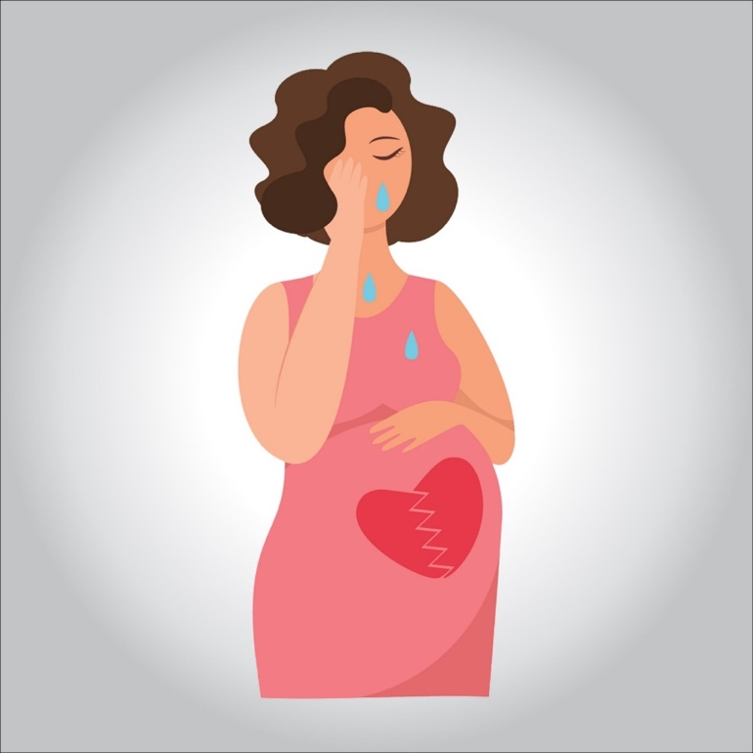

**Miscarriage is the spontaneous loss of a pregnancy before the 20th week. About 10 to 20 percent of known pregnancies end in miscarriage. But the actual number is likely higher because many miscarriages occur so early in pregnancy that a woman doesn’t realize she’s pregnant.**

**Miscarriage is a somewhat loaded term — possibly suggesting that something was amiss in the carrying of the pregnancy. This is rarely true. Most miscarriages occur because the fetus isn’t developing normally.**

**Miscarriage is a relatively common experience — but that doesn’t make it any easier. Take a step toward emotional healing by understanding what can cause a miscarriage, what increases the risk and what medical care might be needed.**

**What are the most common symptoms?**

**Most miscarriages occur before the 12th week of pregnancy.**

**Signs and symptoms of a miscarriage might include:**

* **Vaginal spotting or bleeding**
* **Pain or cramping in your abdomen or lower back**
* **Fluid or tissue passing from your vagina**

**If you have passed fetal tissue from your vagina, place it in a clean container and bring it to your health care provider’s office or the hospital for analysis.**

**Keep in mind that most women who experience vaginal spotting or bleeding in the first trimester go on to have successful pregnancies.**



**Causes**

**Abnormal genes or chromosomes**

**Most miscarriages occur because the fetus isn’t developing normally. About 50 percent of miscarriages are associated with extra or missing chromosomes. Most often, chromosome problems result from errors that occur by chance as the embryo divides and grows — not problems inherited from the parents.**

**Chromosomal abnormalities might lead to:**

* **Blighted ovum.Blighted ovum occurs when no embryo forms.**
* **Intrauterine fetal demise.In this situation, an embryo forms but stops developing and dies before any symptoms of pregnancy loss occur.**
* **Molar pregnancy and partial molar pregnancy.With a molar pregnancy, both sets of chromosomes come from the father. A molar pregnancy is associated with abnormal growth of the placenta; there is usually no fetal development.**

**A partial molar pregnancy occurs when the mother’s chromosomes remain, but the father provides two sets of chromosomes. A partial molar pregnancy is usually associated with abnormalities of the placenta, and an abnormal fetus.**

**Molar and partial molar pregnancies are not viable pregnancies. Molar and partial molar pregnancies can sometimes be associated with cancerous changes of the placenta.**

**Maternal health conditions**

**In a few cases, a mother’s health condition might lead to miscarriage. Examples include:**

* **Uncontrolled diabetes**
* **Infections**
* **Hormonal problems**
* **Uterus or cervix problems**
* **Thyroid disease**

**What does NOT cause miscarriage?**

**Routine activities such as these don’t provoke a miscarriage:**

* **Exercise, including high-intensity activities such as jogging and cycling.**
* **Sexual intercourse.**
* **Working, provided you’re not exposed to harmful chemicals or radiation. Talk with your doctor if you are concerned about work-related risks.**

**Risk factors**

**Various factors increase the risk of miscarriage, including:**

* **Women older than age 35 have a higher risk of miscarriage than do younger women. At age 35, you have about a 20 percent risk. At age 40, the risk is about 40 percent. And at age 45, it’s about 80 percent.**
* **Previous miscarriages.Women who have had two or more consecutive miscarriages are at higher risk of miscarriage.**
* **Chronic conditions.Women who have a chronic condition, such as uncontrolled diabetes, have a higher risk of miscarriage.**
* **Uterine or cervical problems.Certain uterine abnormalities or weak cervical tissues (incompetent cervix) might increase the risk of miscarriage.**
* **Smoking, alcohol and illicit drugs.Women who smoke during pregnancy have a greater risk of miscarriage than do nonsmokers. Heavy alcohol use and illicit drug use also increase the risk of miscarriage.**
* **Being underweight or being overweight has been linked with an increased risk of miscarriage.**
* **Invasive prenatal tests.Some invasive prenatal genetic tests, such as chorionic villus sampling and amniocentesis, carry a slight risk of miscarriage.**

**Complications**

**Some women who miscarry develop a uterine infection, also called a septic miscarriage. Signs and symptoms of this infection include:**

* **Fever**
* **Chills**
* **Lower abdominal tenderness**
* **Foul-smelling vaginal discharge**

**Prevention**

**Often, there’s nothing you can do to prevent a miscarriage. Simply focus on taking good care of yourself and your baby:**

* **Seek regular prenatal care.**
* **Avoid known miscarriage risk factors — such as smoking, drinking alcohol and illicit drug use.**
* **Take a daily multivitamin.**
* **Limit your caffeine intake. A recent study found that drinking more than two caffeinated beverages a day appeared to be associated with a higher risk of miscarriage.**

**If you have a chronic condition, work with your health care team to keep it under control**

**Diagnosis**

**Your health care provider might do a variety of tests:**

* **Pelvic exam. Your health care provider might check to see if your cervix has begun to dilate.**
* **Ultrasound. During an ultrasound, your health care provider will check for a fetal heartbeat and determine if the embryo is developing normally. If a diagnosis can’t be made, you might need to have another ultrasound in about a week.**
* **Blood tests. Your health care provider might check the level of the pregnancy hormone, human chorionic gonadotropin (HCG), in your blood and compare it to previous measurements. If the pattern of changes in your HCG level is abnormal, it could indicate a problem. Your health care provider might check to see if you’re anemic — which could happen if you’ve experienced significant bleeding — and may also check your blood type.**
* **Tissue tests. If you have passed tissue, it can be sent to a lab to confirm that a miscarriage has occurred — and that your symptoms aren’t related to another cause.**
* **Chromosomal tests. If you’ve had two or more previous miscarriages, your health care provider may order blood tests for both you and your partner to determine if your chromosomes are a factor.**

**Possible diagnoses include:**

* **Threatened miscarriage. If you’re bleeding but your cervix hasn’t begun to dilate, there is a threat of miscarriage. Such pregnancies often proceed without any further problems.**
* **Inevitable miscarriage. If you’re bleeding, cramping and your cervix is dilated, a miscarriage is considered inevitable.**
* **Incomplete miscarriage. If you pass fetal or placental material but some remains in your uterus, it’s considered an incomplete miscarriage.**
* **Missed miscarriage. In a missed miscarriage, the placental and embryonic tissues remain in the uterus, but the embryo has died or was never formed.**
* **Complete miscarriage. If you have passed all the pregnancy tissues, it’s considered a complete miscarriage. This is common for miscarriages occurring before 12 weeks.**
* **Septic miscarriage. If you develop an infection in your uterus, it’s known as a septic miscarriage. This can be a severe infection and demands immediate care.**

**Treatment**

**Threatened miscarriage**

**For a threatened miscarriage, your health care provider might recommend resting until the bleeding or pain subsides. Bed rest hasn’t been proved to prevent miscarriage, but it’s sometimes prescribed as a safeguard. You might be asked to avoid exercise and sex, too. Although these steps haven’t been proved to reduce the risk of miscarriage, they might improve your comfort.**

**In some cases, it’s also a good idea to postpone traveling — especially to areas where it would be difficult to receive prompt medical care. Ask your doctor if it would be wise to delay any upcoming trips you’ve planned.**

**Miscarriage**

**With ultrasound, it’s now much easier to determine whether an embryo has died or was never formed. Either finding means that a miscarriage will definitely occur. In this situation, you might have several choices:**

* **Expectant management. If you have no signs of infection, you might choose to let the miscarriage progress naturally. Usually this happens within a couple of weeks of determining that the embryo has died. Unfortunately, it might take up to three or four weeks. This can be an emotionally difficult time. If expulsion doesn’t happen on its own, medical or surgical treatment will be needed.**
* **Medical treatment. If, after a diagnosis of certain pregnancy loss, you’d prefer to speed the process, medication can cause your body to expel the pregnancy tissue and placenta. The medication can be taken by mouth or by insertion in the vagina. Your health care provider might recommend inserting the medication vaginally to increase its effectiveness and minimize side effects such as nausea and diarrhea. For about 70 to 90 percent of women, this treatment works within 24 hours.**
* **Surgical treatment. Another option is a minor surgical procedure called suction dilation and curettage (D&C). During this procedure, your health care provider dilates your cervix and removes tissue from the inside of your uterus. Complications are rare, but they might include damage to the connective tissue of your cervix or the uterine wall. Surgical treatment is needed if you have a miscarriage accompanied by heavy bleeding or signs of an infection.**

**Physical recovery**

**In most cases, physical recovery from miscarriage takes only a few hours to a couple of days. In the meantime, call your health care provider if you experience heavy bleeding, fever or abdominal pain.**

**You may ovulate as soon as two weeks after a miscarriage. Expect your period to return within four to six weeks. You can start using any type of contraception immediately after a miscarriage. However, avoid having sex or putting anything in your vagina — such as a tampon — for two weeks after a miscarriage**

**Future pregnancies**

**It’s possible to become pregnant during the menstrual cycle immediately after a miscarriage. But if you and your partner decide to attempt another pregnancy, make sure you’re physically and emotionally ready. Ask your health care provider for guidance about when you might try to conceive.**

**Keep in mind that miscarriage is usually a one-time occurrence. Most women who miscarry go on to have a healthy pregnancy after miscarriage. Less than 5 percent of women have two consecutive miscarriages, and only 1 percent have three or more consecutive miscarriages.**

**If you experience multiple miscarriages, generally two or three in a row, consider testing to identify any underlying causes — such as uterine abnormalities, coagulation problems or chromosomal abnormalities. If the cause of your miscarriages can’t be identified, don’t lose hope. About 60 to 80 percent of women with unexplained repeated miscarriages go on to have healthy pregnancies.**