Top of Form

Bottom of Form

Perimenopause

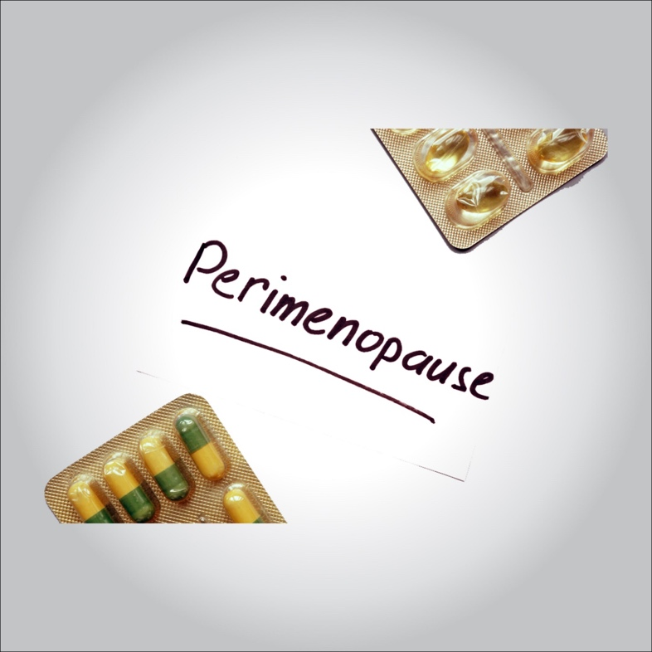

**Perimenopause means “around menopause” and refers to the time during which your body makes the natural transition to menopause, marking the end of the reproductive years. Perimenopause is also called the menopausal transition.**

**Women start perimenopause at different ages. You may notice signs of progression toward menopause, such as menstrual irregularity, sometime in your 40s. But some women notice changes as early as their mid-30s.**

**The level of estrogen — the main female hormone — in your body rises and falls unevenly during perimenopause. Your menstrual cycles may lengthen or shorten, and you may begin having menstrual cycles in which your ovaries don’t release an egg (ovulate). You may also experience menopause-like symptoms, such as hot flashes, sleep problems and vaginal dryness. Treatments are available to help ease these symptoms.**

**Once you’ve gone through 12 consecutive months without a menstrual period, you’ve officially reached menopause, and the perimenopause period is over.**

**Symptoms**

**Throughout the menopausal transition, some subtle — and some not-so-subtle — changes in your body may take place. You might experience:**

* **Irregular periods. As ovulation becomes more unpredictable, the length of time between periods may be longer or shorter, your flow may be light to heavy, and you may skip some periods. If you have a persistent change of seven days or more in the length of your menstrual cycle, you may be in early perimenopause. If you have a space of 60 days or more between periods, you’re likely in late perimenopause.**
* **Hot flashes and sleep problems. Hot flashes are common during perimenopause. The intensity, length and frequency vary. Sleep problems are often due to hot flashes or night sweats, but sometimes sleep becomes unpredictable even without them.**
* **Mood changes. Mood swings, irritability or increased risk of depression may happen during perimenopause. The cause of these symptoms may be sleep disruption associated with hot flashes. Mood changes may also be caused by factors not related to the hormonal changes of perimenopause.**
* **Vaginal and bladder problems. When estrogen levels diminish, your vaginal tissues may lose lubrication and elasticity, making intercourse painful. Low estrogen may also leave you more vulnerable to urinary or vaginal infections. Loss of tissue tone may contribute to urinary incontinence.**
* **Decreasing fertility. As ovulation becomes irregular, your ability to conceive decreases. However, as long as you’re having periods, pregnancy is still possible. If you wish to avoid pregnancy, use birth control until you’ve had no periods for 12 months.**
* **Changes in sexual function. During perimenopause, sexual arousal and desire may change. But if you had satisfactory sexual intimacy before menopause, this will likely continue through perimenopause and beyond.**
* **Loss of bone. With declining estrogen levels, you start to lose bone more quickly than you replace it, increasing your risk of osteoporosis — a disease that causes fragile bones.**
* **Changing cholesterol levels. Declining estrogen levels may lead to unfavorable changes in your blood cholesterol levels, including an increase in low-density lipoprotein (LDL) cholesterol — the “bad” cholesterol — which contributes to an increased risk of heart disease. At the same time, high-density lipoprotein (HDL) cholesterol — the “good” cholesterol — decreases in many women as they age, which also increases the risk of heart disease.**

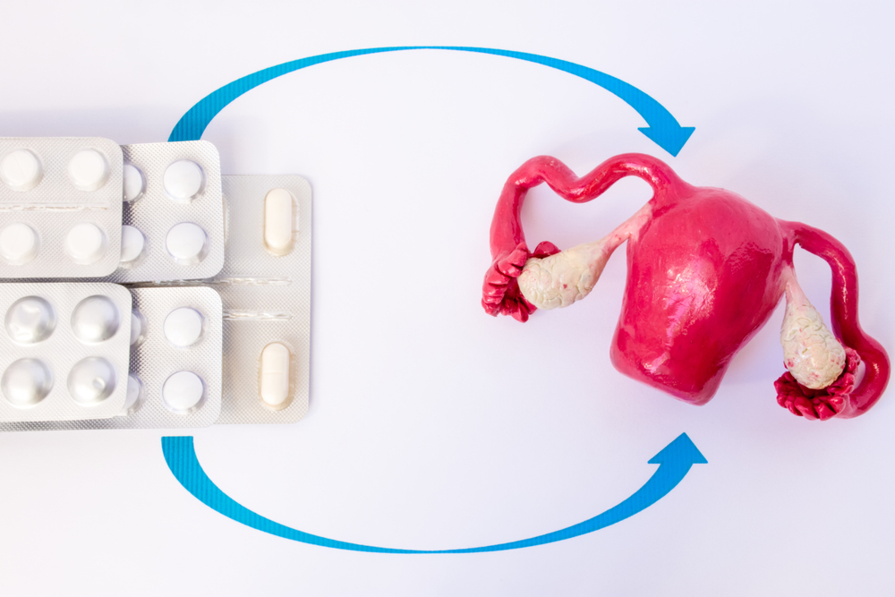

**Causes**

**As you go through the menopausal transition, your body’s production of estrogen and progesterone rises and falls. Many of the changes you experience during perimenopause are a result of decreasing estrogen.**

**Risk factors**

**Menopause is a normal phase in life. But it may occur earlier in some women than in others. Although not always conclusive, some evidence suggests that certain factors may make it more likely that you start perimenopause at an earlier age, including:**

* **Smoking. The onset of menopause occurs one to two years earlier in women who smoke than in women who don’t smoke.**
* **Family history. Women with a family history of early menopause may experience early menopause themselves.**
* **Cancer treatment. Treatment for cancer with chemotherapy or pelvic radiation therapy has been linked to early menopause.**
* **Hysterectomy. A hysterectomy that removes your uterus, but not your ovaries, usually doesn’t cause menopause. Although you no longer have periods, your ovaries still produce estrogen. But such surgery may cause menopause to occur earlier than average. Also, if you have one ovary removed, the remaining ovary might stop working sooner than expected.**

**Complications**

**Irregular periods are a hallmark of perimenopause. Most of the time this is normal and nothing to be concerned about. However, see your doctor if:**

* **Bleeding is extremely heavy — you’re changing tampons or pads every hour or two for two or more hours**
* **Bleeding lasts longer than seven days**
* **Bleeding occurs between periods**
* **Periods regularly occur less than 21 days apart**

**Signs such as these may mean there’s a problem with your reproductive system that requires diagnosis and treatment.**

**Diagnosis**

**Perimenopause is a process — a gradual transition. No one test or sign is enough to determine if you’ve entered perimenopause. Your doctor takes many things into consideration, including your age, menstrual history, and what symptoms or body changes you’re experiencing.**

**Some doctors may order tests to check your hormone levels. But other than checking thyroid function, which can affect hormone levels, hormone testing is rarely necessary or useful to evaluate perimenopause.**

**Treatment**

**Drug therapy is often used to treat perimenopausal symptoms.**

* **Hormone therapy. Systemic estrogen therapy — which comes in pill, skin patch, gel or cream form — remains the most effective treatment option for relieving perimenopausal and menopausal hot flashes and night sweats. Depending on your personal and family medical history, your doctor may recommend estrogen in the lowest dose needed to provide symptom relief for you. If you still have your uterus, you’ll need progestin in addition to estrogen. Systemic estrogen can help prevent bone loss.**
* **Vaginal estrogen. To relieve vaginal dryness, estrogen can be administered directly to the vagina using a vaginal tablet, ring or cream. This treatment releases just a small amount of estrogen, which is absorbed by the vaginal tissue. It can help relieve vaginal dryness, discomfort with intercourse and some urinary symptoms.**
* **Antidepressants. Certain antidepressants related to the class of drugs called selective serotonin reuptake inhibitors (SSRIs) may reduce menopausal hot flashes. An antidepressant for management of hot flashes may be useful for women who can’t take estrogen for health reasons or for women who need an antidepressant for a mood disorder.**
* **Gabapentin (Neurontin). Gabapentin is approved to treat seizures, but it has also been shown to help reduce hot flashes. This drug is useful in women who can’t use estrogen therapy for health reasons and in those who also have migraines.**

**Before deciding on any form of treatment, talk with your doctor about your options and the risks and benefits involved with each. Review your options yearly, as your needs and treatment options may change.**

**Lifestyle and home remedies**

**Making these healthy lifestyle choices may help ease some symptoms of perimenopause and promote good health as you age:**

* **Ease vaginal discomfort. Use over-the-counter, water-based vaginal lubricants (Astroglide, K-Y jelly, others) or moisturizers (Replens, Vagisil, others). Choose products that don’t contain glycerin, which can cause burning or irritation in women who are sensitive to that chemical. Staying sexually active also helps by increasing blood flow to the vagina.**
* **Eat healthy. Because your risk of osteoporosis and heart disease increases at this time, a healthy diet is more important than ever. Adopt a low-fat, high-fiber diet that’s rich in fruits, vegetables and whole grains. Add calcium-rich foods. Ask your doctor if you should also take a calcium supplement and if so, what type and how much — also ask if you need more vitamin D, which helps your body absorb calcium. Avoid alcohol and caffeine if they seem to trigger hot flashes.**
* **Be active. Regular exercise and physical activity helps prevent weight gain, improves your sleep and elevates your mood. Try to exercise for 30 minutes or more on most days of the week, although not right before bedtime. Regular exercise has been shown to reduce hip fracture risk in older women and to strengthen bone density.**
* **Get enough sleep. Try to keep a consistent sleep schedule. Avoid caffeine, which can make it hard to get to sleep, and avoid drinking too much alcohol, which can interrupt sleep.**
* **Practice stress reduction techniques. Practiced regularly, stress-reduction techniques, such as meditation or yoga, can promote relaxation and good health throughout your lifetime, but they may be particularly helpful during the menopausal transition.**