VAGINITIS

**Vaginitis is an inflammation of the vagina that can result in discharge, itching and pain. The cause is usually a change in the normal balance of vaginal bacteria or an infection. Reduced estrogen levels after menopause and some skin disorders can also cause vaginitis.**

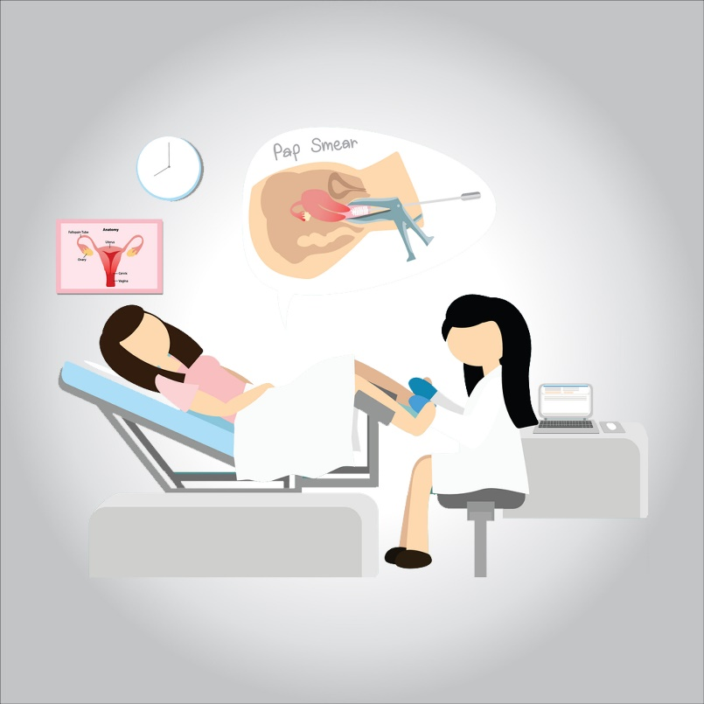

**The most common types of vaginitis are:**

* **Bacterial vaginosis, which results from a change of the normal bacteria found in your vagina to overgrowth of other organisms**
* **Yeast infections, which are usually caused by a naturally occurring fungus called Candida albicans**
* **Trichomoniasis, which is caused by a parasite and is commonly transmitted by sexual intercourse**

**Treatment depends on the type of vaginitis you have.**

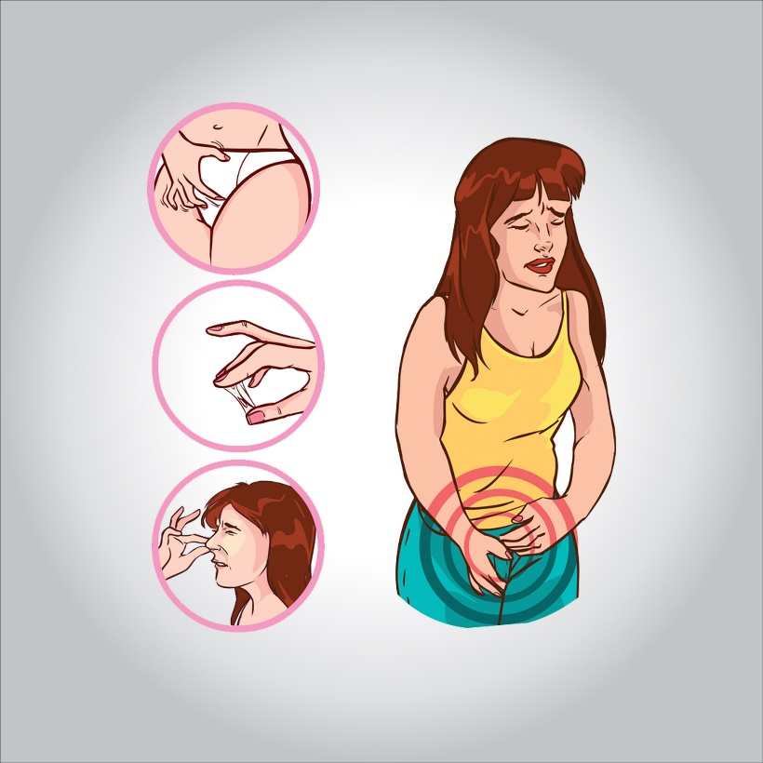

**Symptoms**

**Vaginitis signs and symptoms can include:**

* **Change in color, odor or amount of discharge from your vagina**
* **Vaginal itching or irritation**
* **Pain during intercourse**
* **Painful urination**
* **Light vaginal bleeding or spotting**

**If you have vaginal discharge, which many women don’t, the characteristics of the discharge might indicate the type of vaginitis you have. Examples include:**

* **Bacterial vaginosis. You might develop a grayish-white, foul-smelling discharge. The odor, often described as a fishy odor, might be more obvious after sexual intercourse.**
* **Yeast infection. The main symptom is itching, but you might have a white, thick discharge that resembles cottage cheese.**
* **Trichomoniasis. An infection called trichomoniasis (trik-o-moe-NIE-uh-sis) can cause a greenish-yellow, sometimes frothy discharge.**

**When to see a doctor**

**See your doctor if you develop unusual vaginal discomfort, especially if:**

* **You have a particularly unpleasant vaginal odor, discharge or itching.**
* **You’ve never had a vaginal infection. Seeing your doctor can establish the cause and help you learn to identify the signs and symptoms.**
* **You’ve had vaginal infections before.**
* **You’ve had multiple sex partners or a recent new partner. You could have a sexually transmitted infection. Some sexually transmitted infections have signs and symptoms similar to those of a yeast infection or bacterial vaginosis.**
* **You’ve completed a course of over-the-counter anti-yeast medication and your symptoms persist.**
* **You have a fever, chills or pelvic pain.**

**Causes**

**The cause depends on what type of vaginitis you have:**

* **Bacterial vaginosis. This most common cause of vaginitis results from a change of the normal bacteria found in your vagina, to overgrowth of one of several other organisms. Usually, bacteria normally found in the vagina (lactobacilli) are outnumbered by other bacteria (anaerobes) in your vagina. If anaerobic bacteria become too numerous, they upset the balance, causing bacterial vaginosis.**

**This type of vaginitis seems to be linked to sexual intercourse — especially if you have multiple sex partners or a new sex partner — but it also occurs in women who aren’t sexually active.**

* **Yeast infections. These occur when there’s an overgrowth of a fungal organism — usually C. albicans — in your vagina. C. albicans also causes infections in other moist areas of your body, such as in your mouth (thrush), skin folds and nail beds. The fungus can also cause diaper rash.**
* **Trichomoniasis. This common sexually transmitted infection is caused by a microscopic, one-celled parasite called Trichomonas vaginalis. This organism spreads during sexual intercourse with someone who has the infection.**

**In men, the organism usually infects the urinary tract, but often it causes no symptoms. In women, trichomoniasis typically infects the vagina, and might cause symptoms. It also increases a women’s risk of getting other sexually transmitted infections.**

* **Noninfectious vaginitis. Vaginal sprays, douches, perfumed soaps, scented detergents and spermicidal products may cause an allergic reaction or irritate vulvar and vaginal tissues. Foreign objects, such as tissue paper or forgotten tampons, in the vagina can also irritate vaginal tissues.**
* **Genitourinary syndrome of menopause (vaginal atrophy). Reduced estrogen levels after menopause or surgical removal of your ovaries can cause the vaginal lining to thin, sometimes resulting in vaginal irritation, burning and dryness.**

**Risk factors**

**Factors that increase your risk of developing vaginitis include:**

* **Hormonal changes, such as those associated with pregnancy, birth control pills or menopause**
* **Sexual activity**
* **Having a sexually transmitted infection**
* **Medications, such as antibiotics and steroids**
* **Use of spermicides for birth control**
* **Uncontrolled diabetes**
* **Use of hygiene products such as bubble bath, vaginal spray or vaginal deodorant**
* **Douching**
* **Wearing damp or tightfitting clothing**
* **Using an intrauterine device (IUD) for birth control**

**Complications**

**Women with trichomoniasis or bacterial vaginosis are at a greater risk of acquiring sexually transmitted infections because of the inflammation caused by these disorders. In pregnant women, symptomatic bacterial vaginosis and trichomoniasis have been associated with premature deliveries and low birth weight babies.**

**Prevention**

**Good hygiene may prevent some types of vaginitis from recurring and may relieve some symptoms:**

* **Avoid baths, hot tubs and whirlpool spas.**
* **Avoid irritants. These include scented tampons, pads, douches and scented soaps. Rinse soap from your outer genital area after a shower, and dry the area well to prevent irritation. Don’t use harsh soaps, such as those with deodorant or antibacterial action, or bubble bath.**
* **Wipe from front to back after using the toilet. Doing so avoids spreading fecal bacteria to your vagina.**

**Other things you can do that may help prevent vaginitis include:**

* **Don’t douche. Your vagina doesn’t require cleansing other than normal bathing. Repetitive douching disrupts the normal organisms that reside in the vagina and can actually increase your risk of vaginal infection. Douching won’t clear up a vaginal infection.**
* **Use a latex condom. Both male and female latex condoms may help you avoid infections spread by sexual contact.**
* **Wear cotton underwear. Also wear pantyhose with a cotton crotch. If you feel comfortable without it, skip wearing underwear to bed. Yeast thrives in moist environments.**

**Diagnosis**

**To diagnose vaginitis, your doctor is likely to:**

* **Review your medical history. This includes your history of vaginal or sexually transmitted infections.**
* **Perform a pelvic exam. During the pelvic exam, your doctor may use an instrument (speculum) to look inside your vagina for inflammation and abnormal discharge.**
* **Collect a sample for lab testing. Your doctor might collect a sample of cervical or vaginal discharge for lab testing to confirm what kind of vaginitis you have.**
* **Perform pH testing. Your doctor might test your vaginal pH by applying apH test stick or pH paper to the wall of your vagina. An elevated pH can indicate either bacterial vaginosis or trichomoniasis. However, pH testing alone is not a reliable diagnostic test.**

**Treatment**

**A variety of organisms and conditions can cause vaginitis, so treatment targets the specific cause:**

* **Bacterial vaginosis. For this type of vaginitis, your doctor may prescribe metronidazole (Flagyl) tablets that you take by mouth or metronidazole (MetroGel) gel or clindamycin (Cleocin) cream that you apply to your vagina. You’ll need to get tested and be given a prescription for these medications.**
* **Yeast infections. Yeast infections usually are treated with an over-the-counter antifungal cream or suppository, such as miconazole (Monistat 1), clotrimazole, butoconazole or tioconazole (Vagistat-1). Yeast infections may also be treated with a prescription oral antifungal medication, such as fluconazole (Diflucan). The advantages of over-the-counter treatment are convenience, cost and not waiting to see your doctor. However, you might have something other than a yeast infection. Using the wrong medicine may delay an accurate diagnosis and proper treatment.**
* **Trichomoniasis. Your doctor may prescribe metronidazole (Flagyl) or tinidazole (Tindamax) tablets.**
* **Genitourinary syndrome of menopause (vaginal atrophy). Estrogen — in the form of vaginal creams, tablets or rings — can effectively treat this condition. This treatment is available by prescription from your doctor, after other risk factors and possible complications are reviewed.**
* **Noninfectious vaginitis. To treat this type of vaginitis, you need to pinpoint the source of the irritation and avoid it. Possible sources include new soap, laundry detergent, sanitary napkins or tampons.**