Cavities



**Dental cavities are holes in teeth that form when acid in the mouth erodes tooth enamel. Untreated cavities can lead to toothaches, infection, and tooth extractions. People of all ages get cavities. Good dental care — including brushing, flossing, and regular dental checkups — can prevent tooth decay. Cavities are also called dental caries.**

**A cavity is a hole in a tooth that develops from tooth decay. Cavities form when acids in the mouth wear down or erode, a tooth’s hard outer layer (enamel). Anyone can get a cavity. Proper brushing, flossing, and dental cleanings can prevent cavities (sometimes called dental caries).**

**Cavities are one of the most common chronic diseases that affect all ages.**

**tooth decay can happen at any age, although cavities are more common in children. They may not brush properly and consume more sugary foods and drinks.**

**Adults also get cavities. Sometimes, new decay develops around the edges of cavities treated in childhood. Adults also are more likely to have receding gums. This condition exposes the lower parts of teeth to cavity-causing plaque.**

**Tooth decay can affect all layers of a tooth. It can take three years for a cavity to form in the strong outer layer of tooth enamel. Decay progresses more quickly through the dentin (middle layer) to pulp (innermost layer). Pulp contains a tooth’s nerve endings and blood supply.**

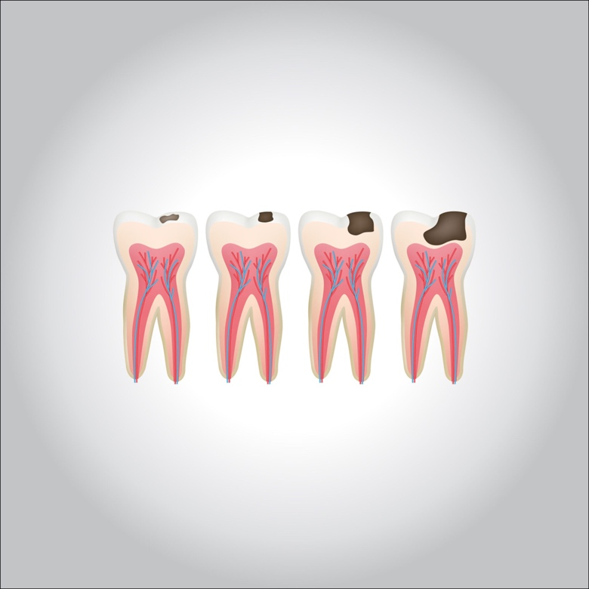

**Many factors play a role in the development of cavities. These steps typically occur:**

* **Bacteria in the mouth feed on sugary, starchy foods and drinks (fruit, candy, bread, cereal, sodas, juice, and milk). The bacteria convert these carbohydrates into acids.**
* **Bacteria, acid, food, and saliva mix to form plaque. This sticky substance coats the teeth.**
* **Without proper brushing and flossing, acids in plaque dissolve tooth enamel, creating cavities, or holes.**

**Certain factors increase your risk of cavities:**

* **Conditions like**[**Sjogren’s syndrome**](https://my.clevelandclinic.org/health/diseases/4929-sj%C3%B6grens-syndrome)**, or medications like**[**antidepressants**](https://my.clevelandclinic.org/health/treatments/9301-depression-medicines)**, cause dry mouth.**
* **Consuming sugary, starchy foods or drinks and snacking between meals.**
* **Family history of cavities.**
* **Previous**[**radiation therapy to treat head and neck cancer**](https://my.clevelandclinic.org/health/treatments/16192-head-and-neck-cancer-radiation-therapy)**.**
* **Receding gums.**

**Tooth decay on the outer enamel surface doesn’t usually cause pain or symptoms. You’re more likely to experience symptoms as decay progresses into the dentin and root. Signs of cavities include:**

* [**Bad breath**](https://my.clevelandclinic.org/health/symptoms/17771-bad-breath-halitosis)**or a bad taste in the mouth.**
* **Bleeding gums or other signs of**[**gum disease**](https://my.clevelandclinic.org/health/diseases/10950-gingivitis-and-periodontal-disease-gum-disease)**.**
* **Facial swelling.**
* [**Toothache**](https://my.clevelandclinic.org/health/diseases/10957-toothache)**or mouth pain.**
* [**Tooth sensitivity**](https://my.clevelandclinic.org/health/symptoms/10954-teeth-sensitivity)**to hot or cold foods or drinks.**
* **Redness around or inside the mouth.**

**Diagnosis**

**Twice-a-year**[**dental checkups**](https://my.clevelandclinic.org/health/treatments/11187-dental-check-up)**are the best way to catch cavities early when your dentist can save much of the tooth. Your dentist will use various instruments to examine your teeth. A tooth with a cavity will feel softer when your dentist probes it. You may also get**[**dental X-rays**](https://my.clevelandclinic.org/health/articles/11199-dental-x-rays)**. X-rays show cavities before the decay is visible.**

**Treatment**

**Treatment depends on the severity of tooth decay. Cavity treatments include:**

* **Fluoride: When decay is caught early,**[**fluoride**](https://my.clevelandclinic.org/health/drugs/11195-fluoride)**treatments can repair tooth enamel. This process is called remineralization. You may need prescription toothpaste and mouthwash, as well as fluoride treatments at the dental office.**
* **Fillings: Once a hole forms in the tooth, dentists drill out the decayed material and fill the hole.**[**Dental fillings**](https://my.clevelandclinic.org/health/treatments/17002-fillings)**are made of silver amalgam, composite resin, or gold.**
* **Root canal: A root canal treats pain from root decay.**[**Endodontists**](https://my.clevelandclinic.org/health/articles/16959-endodontics)**are dental specialists who treat problems that affect a tooth’s root. During a root canal, this healthcare provider removes the pulp that contains nerve endings that cause pain.**
* **Tooth extraction: If a root canal isn’t possible, your healthcare provider may extract (pull) the tooth. You may need a**[**dental implant**](https://my.clevelandclinic.org/health/treatments/10903-dental-implants)**to replace a pulled permanent tooth. Implants keep teeth from shifting and changing your appearance and bite.**

**Prevention**

**Proper**[**oral hygiene**](https://my.clevelandclinic.org/health/diseases/16914-oral-hygiene)**, including regular brushing and flossing, can get rid of plaque and acids that cause cavities. Good**[**teeth and gum care**](https://my.clevelandclinic.org/health/articles/11186-teeth--gum-care)**includes:**

* **Tooth-brushing with fluoride toothpaste at least twice a day, and preferably after every meal.**
* **Cutting back on sugary, starchy foods and drinks.**
* **Daily flossing to get rid of food and plaque stuck between teeth.**
* **Dental checkups at least twice a year.**
* [**Dental sealants**](https://my.clevelandclinic.org/health/treatments/10912-sealants)**to protect the top chewing surfaces of teeth.**