DISLOCATION



**Sinusitis is an inflammation or swelling of the tissue lining the sinuses. Healthy sinuses are filled with air. But when they become blocked and filled with fluid, germs can grow and cause an infection.**

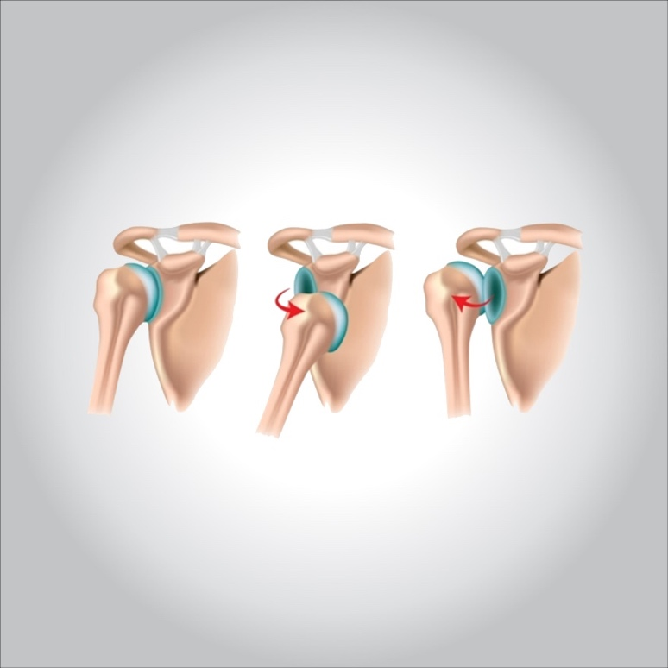

**What are the symptoms?**

**A dislocated joint can be:**

* **Visibly deformed or out of place**
* **Swollen or discolored**
* **Intensely painful**
* **Immovable**

**When to see a doctor**

**It can be difficult to tell a broken bone from a dislocated bone. For either type of injury, get medical help right away. If possible, ice the joint and keep it immobile while you’re waiting to be seen.**

**What are the causes?**

**Dislocations can occur in contact sports, such as football and hockey, and in sports in which falls are common, such as downhill skiing, gymnastics and volleyball. Basketball players and football players also commonly dislocate joints in their fingers and hands by accidentally striking the ball, the ground or another player.**

**A hard blow to a joint during a motor vehicle accident and landing on an outstretched arm during a fall are other common causes.**

**What are the risk factors?**

**Risk factors for a joint dislocation include:**

* **Susceptibility to falls.Falling increases your chances of a dislocated joint if you use your arms to brace for impact or if you land forcefully on a body part, such as your hip or shoulder.**
* **Some people are born with ligaments that are looser and more prone to injury than those of other people.**
* **Sports participation.Many dislocations occur during high-impact or contact sports, such as gymnastics, wrestling, basketball and football.**
* **Motor vehicle accidents.These are the most common cause of hip dislocations, especially for people not wearing a seat belt.**

**What are the complications?**

**Complications of a joint dislocation can include:**

* **Tearing of the muscles, ligaments and tendons that reinforce the injured joint**
* **Nerve or blood vessel damage in or around your joint**
* **Susceptibility to reinjury if you have a severe dislocation or repeated dislocations**
* **Development of arthritis in the affected joint as you age**

**Stretching or tearing of ligaments or tendons that support your injured joint or damage to nerves or blood vessels surrounding the joint might require surgery to repair these tissues.**

**What is the prevention?**

**To help prevent a dislocation:**

* **Take precautions to avoid falls.Get your eyes checked regularly. Ask your doctor or pharmacist if any of the drugs you take might make you dizzy. Be sure your home is well-lighted and that you remove any potential tripping hazards from the areas where you walk.**
* **Play safely.Wear the suggested protective gear when you play contact sports.**
* **Avoid recurrence.Once you’ve dislocated a joint, you might be more susceptible to future dislocations. To avoid recurrence, do strength and stability exercises as recommended by your doctor or physical therapist to improve joint support.**

**Treatment:**

**The dislocated joint must be fixed with a pillow so that the joint bones do not collide, and it is allowed to move with the least possible pain, taking into account that the dislocation is returned to its place by specialized personnel.**