Gum



**The gums are part of the soft tissue lining of the mouth. They surround the teeth and provide a seal around them. Unlike the soft tissue linings of the lips and cheeks, most of the gums are tightly bound to the underlying bone which helps resist the friction of food passing over them. Thus when healthy, it presents an effective barrier to the barrage of periodontal insults to deeper tissue. Healthy gums are usually coral pink in light skinned people, and may be naturally darker with melanin pigmentation.**

**Changes in color, particularly increased redness, together with swelling and an increased tendency to bleed, suggest an inflammation that is possibly due to the accumulation of bacterial plaque. Overall, the clinical appearance of the tissue reflects the underlying histology, both in health and disease. When gum tissue is not healthy, it can provide a gateway for periodontal disease to advance into the deeper tissue of the periodontium, leading to a poorer prognosis for long-term retention of the teeth. Both the type of periodontal therapy and homecare instructions given to patients by dental professionals and restorative care are based on the clinical conditions of the tissue.**

**The gums are divided anatomically into marginal, attached and interdental areas**

**Characteristics of healthy gums**

**According to color:**

**Healthy gums usually have a color that has been described as “coral pink”. Other colours like red, white, and blue can signify inflammation (gingivitis) or pathology. Smoking or drug use can cause discoloring as well (such as “meth mouth”). Although described as the colour coral pink, variation in colour is possible. This can be the result of factors such as: thickness and degree of keratinization of the epithelium, blood flow to the gums, natural pigmentation of the skin, disease, and medications.**

**Since the colour of the gums can vary, uniformity of colour is more important than the underlying color itself. Excess deposits of melanin can cause dark spots or patches on the gums (melanin gingival hyperpigmentation), especially at the base of the interdental papillae. Gum depigmentation (aka gum bleaching) is a procedure used in cosmetic dentistry to remove these discolorations.**

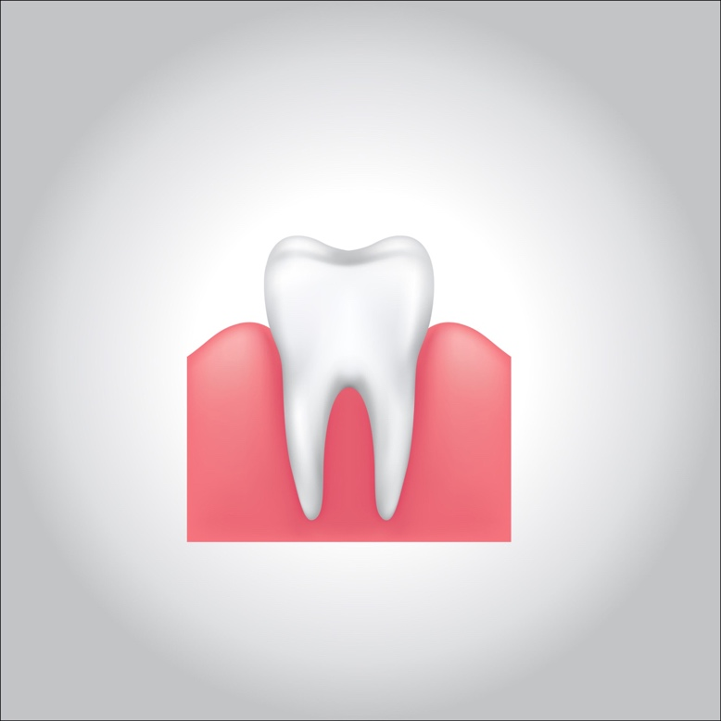

**Contour:**

**Healthy gums have a smooth curved or scalloped appearance around each tooth. Healthy gums fill and fit each space between the teeth, unlike the swollen gum papilla seen in gingivitis or the empty interdental embrasure seen in periodontal disease. Healthy gums hold tight to each tooth in that the gum surface narrows to “knife-edge” thin at the free gingival margin. On the other hand, inflamed gums have a “puffy” or “rolled” margin.**

**Texture:**

**Healthy gums have a firm texture that is resistant to movement, and the surface texture often exhibits surface stippling. Unhealthy gums, on the other hand, is often swollen and less firm. Healthy gums have an orange-peel like texture to it due to the stippling.**

**Reaction to disturbance:**

**Healthy gums usually have no reaction to normal disturbance such as brushing or periodontal probing. Unhealthy gums, conversely, will show bleeding on probing (BOP) and/or purulent exudate.**

**Clinical significance**

**The gingival cavity microecosystem, fueled by food residues and saliva, can support the growth of many microorganisms, of which some can be injurious to health. Improper or insufficient oral hygiene can thus lead to many gum and periodontal disorders, including gingivitis or periodontitis, which are major causes for tooth failure. Recent studies have also shown that anabolic steroids are also closely associated with gingival enlargement requiring a gingivectomy for many cases. Gingival recession is when there is an apical movement of the gum margin away from the biting (occlusal) surface. It may indicate an underlying inflammation such as periodontitis or pyorrhea, a pocket formation, dry mouth or displacement of the marginal gums away from the tooth by mechanical (such as brushing), chemical, or surgical means. Gingival retraction, in turn, may expose the dental neck and leave it vulnerable to the action of external stimuli, and may cause *root sensitivity*.**

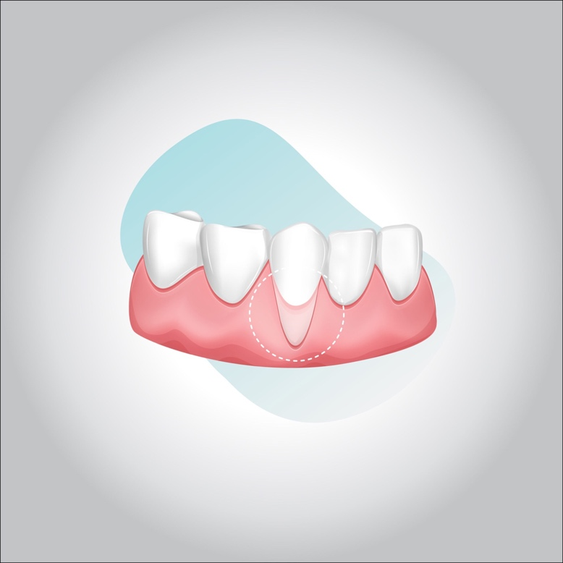

**What is periodontal disease?**

**Periodontal diseases are mainly the result of infections and inflammation of the gums and bone that surround and support the teeth. In its early stage, called gingivitis, the gums can become swollen and red, and they may bleed. In its more serious form, called periodontitis, the gums can pull away from the tooth, bone can be lost, and the teeth may loosen or even fall out. Periodontal disease is mostly seen in adults. Periodontal disease and tooth decay are the two biggest threats to dental health.**

**A recent CDC report1 provides the following data related to prevalence of periodontitis in the U.S.:**

* **47.2% of adults aged 30 years and older have some form of periodontal disease.**
* **Periodontal disease increases with age, 70.1% of adults 65 years and older have periodontal disease.**

**This condition is more common in men than women (56.4% vs 38.4%), those living below the federal poverty level (65.4%), those with less than a high school education (66.9%), and current smokers (64.2%)**

**Causes**

**Bacteria in the mouth infect tissue surrounding the tooth, causing inflammation around the tooth leading to periodontal disease. When bacteria stay on the teeth long enough, they form a film called plaque, which eventually hardens to tartar, also called calculus. Tartar build-up can spread below the gum line, which makes the teeth harder to clean. Then, only a dental health professional can remove the tartar and stop the periodontal disease process.**

**Warning signs**

**The following are warning signs of periodontal disease:**

* **Bad breath or bad taste that won’t go away**
* **Red or swollen gums**
* **Tender or bleeding gums**
* **Painful chewing**
* **Loose teeth**
* **Sensitive teeth**
* **Gums that have pulled away from your teeth**
* **Any change in the way your teeth fit together when you bite**
* **Any change in the fit of partial dentures**

**Risk factors**

**Certain factors increase the risk for periodontal disease:**

* **Smoking**
* **Diabetes**
* **Poor oral hygiene**
* **Stress**
* **Heredity**
* **Crooked teeth**
* **Underlying immuno-deficiencies—e.g., AIDS**
* **Fillings that have become defective**
* **Taking medications that cause dry mouth**
* **Bridges that no longer fit properly**
* **Female hormonal changes, such as with pregnancy or the use of oral contraceptives**

**Prevention and treatment**

**Gingivitis can be controlled and treated with good oral hygiene and regular professional cleaning. More severe forms of periodontal disease can also be treated successfully but may require more extensive treatment. Such treatment might include deep cleaning of the tooth root surfaces below the gums, medications prescribed to take by mouth or placed directly under the gums, and sometimes corrective surgery.**

**To help prevent or control periodontal diseases, it is important to:**

1. **Brush and floss every day to remove the bacteria that cause gum disease.**
2. **See a dentist at least once a year for checkups, or more frequently if you have any of the warning signs or risk factors mentioned above.**