Orthodontics

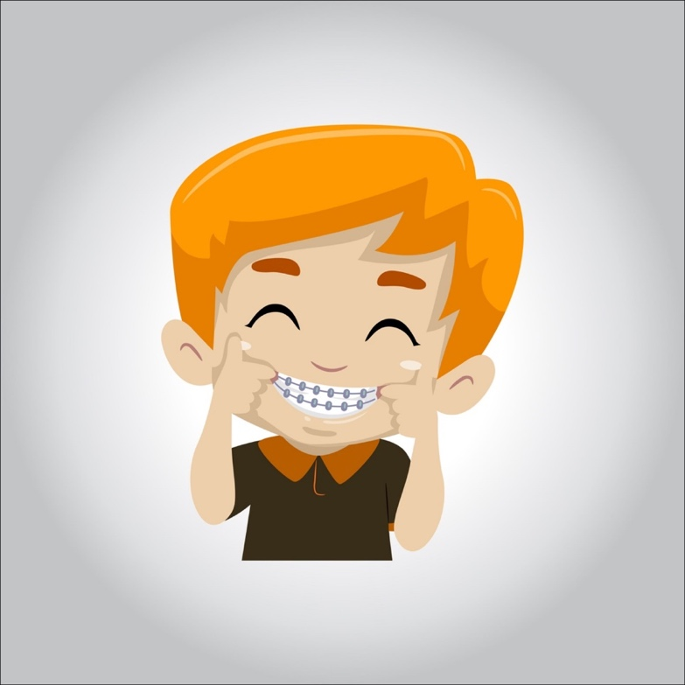

**Some people have straight teeth that line up together, but many of us have crooked teeth that don’t fit together correctly. Crooked teeth can affect your bite. The good news is you can easily straighten your teeth and correct your bite with the help of the right orthodontic treatment. Find out what orthodontics is and how it can help you.**

**Orthodontics is the dentistry branch that addresses the diagnosis, prevention, interception, guidance, and correction of bad bites or dental irregularities, including the use of braces.**

**A specialist known as an orthodontist is the right person to consult for your orthodontic treatment. These specialists attend two or more additional years of education after four years of dental school.**

**Fixed vs. Removable Appliances**

**Orthodontic treatments could involve fixed or removable appliances. Depending on how severe your situation is, your orthodontist will advise you on which approach is the right one for you.**

**Fixed appliances include:**

* [**Braces**](https://www.colgate.com/en-us/oral-health/early-orthodontics/getting-braces-what-you-need-to-know)**– You’ve most likely heard of braces – they’re the most common fixed appliance. They consist of bands, wires, and brackets. How do they work? The bands are the anchors held in place around your teeth. Brackets are attached to the front of your teeth. Arch wires connect the brackets to the bands. Tightening the archwires puts pressure on your teeth, slowly moving them towards their target position. Braces are usually adjusted monthly and are worn for a few months to a few years.**
* **Special fixed appliances – These should only be used as a last resort to control thumb sucking or tongue thrusting. Since they’re attached to the teeth by bands, they can feel quite uncomfortable while eating.**
* **Fixed space maintainers – Sometimes, young children lose their teeth prematurely. In such situations, an orthodontist might place a space maintainer in your child’s mouth to keep the space open until a permanent tooth appears.**
* **Removable appliances include:**
* **Aligners – These are increasingly becoming a popular alternative to traditional braces for adults. Aligners move teeth in the same way as braces, but they are virtually invisible and don’t involve metal wires and brackets. If you’re using them, you need to remove them while eating, brushing, and flossing.**
* **Removable space maintainers –These devices are used for the same reason as fixed space maintainers. They’re made up of plastic or wire branches and an acrylic base that fits over the jaw. They’re placed in open spaces between teeth to keep the teeth apart.**
* **Jaw repositioning appliances –These appliances are also known as splints. They’re placed either on the top or lower jaw and are used to treat TMJ disorders by training the jaw to close in a better position.**
* **Lip and cheek bumpers –Your lip and cheek muscles might exert pressure on your teeth. In such cases, you can use bumpers to keep your lips and cheeks away from the teeth.**
* **Palatal expander –This device is a plastic plate that fits over the roof of the mouth. It’s used when the arch of your upper jaw needs to be widened.**
* **Removable retainers –These devices, worn on the roof of the mouth, prevent your teeth from shifting back to their previous position.**
* **Headgear –These devices slow down the growth of the upper jaw. They also hold the back teeth in place while the front teeth are pulled back.**

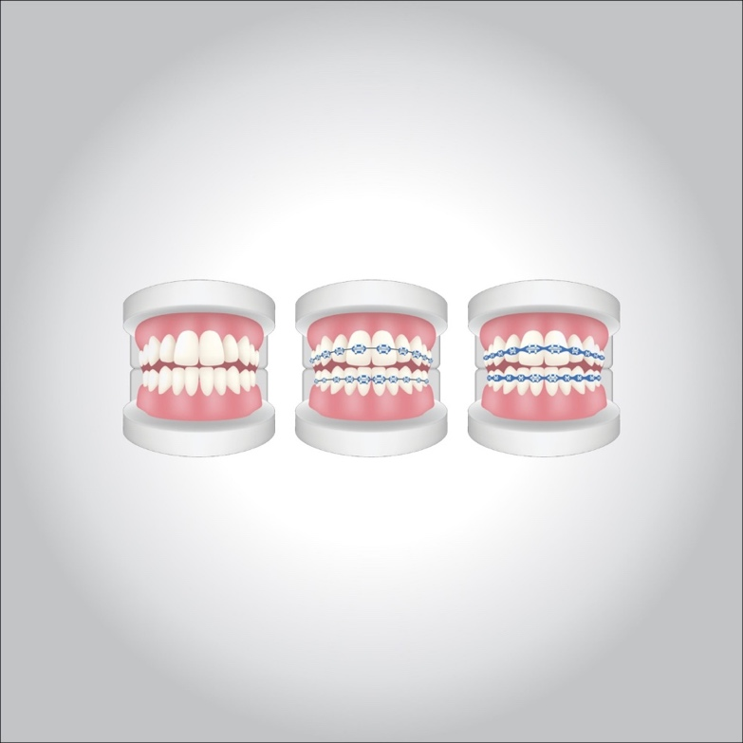

**Benefits**

**You might think that straightening your teeth only has aesthetic benefits, but that couldn’t be farther from the truth. Crooked teeth can be harder to clean, which can lead to tooth decay or**[**periodontal disease**](https://www.colgate.com/en-us/oral-health/gum-disease/periodontal-disease)**. Teeth that don’t fit correctly can make it harder to chew, leading to headaches, shoulder or back pain, and even temporomandibular joint (TMJ) disorders.**

**Orthodontic treatments involve different types of appliances used to retrain muscles, slowly move teeth, and affect your jaw’s growth by placing gentle pressure on your teeth and jaw.**

**How Do I Know if I Need Orthodontic Treatment?**

**Here are some problems with your teeth that may require orthodontics:**

* **Overbite – In this case, the upper front teeth appear to stick out over the lower teeth.**
* **Underbite – Here, the lower teeth may appear too far forward, while the upper teeth are set too far back.**
* **Crossbite –You know you have a crossbite when your upper teeth fit behind your lower teeth when your mouth is closed.**
* **Open bite – Some people have a vertical gap between the front lower and upper teeth when biting down. This is called an open bite.**
* **Misplaced midline — Here, the center of your upper and lower front teeth don’t line up.**
* **Spacing— In this case, your teeth don’t seem to fill up your mouth. There appear to be random gaps or spaces between teeth.**
* **Crowding –This is what happens when the dental ridge in your mouth doesn’t have room for all your teeth.**

**However, only your orthodontist can correctly determine which orthodontic treatment is right for you. Using diagnostic tools such as clinical exams, plastic models of your teeth, and X-rays, your orthodontist will develop a treatment plan that works for you and your teeth.**

**We know that there is a lot to consider while looking at possible orthodontic treatment plans. But now that you know more about what orthodontics is, why it’s important, and how it works, we hope you’re well on your way to experiencing its benefits for yourself!**

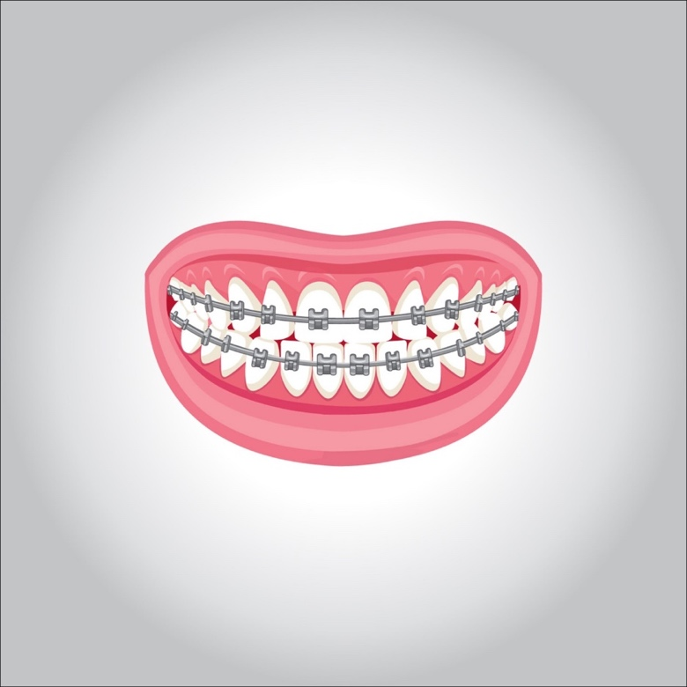

**5 smoking effects on the oral health**

**Most people are now aware that smoking is bad for their health. It can cause many different medical problems and, in some cases, fatal diseases. However, many people don’t realize the damage that smoking does to their mouth, gums, and teeth.**

**Smoking can lead to tooth staining,**[**gum disease**](https://www.dentalhealth.org/gum-disease)**, tooth loss, and in more severe cases**[**mouth cancer**](https://www.dentalhealth.org/mouth-cancer)**.**

**One of the effects of smoking is staining on the teeth due to the nicotine and tar in the tobacco. It can make your teeth yellow in a very short time, and heavy smokers often complain that their teeth are almost brown after years of smoking.**

**Smoking can also lead to gum disease. People who smoke are more likely to produce bacterial plaque, which leads to gum disease. The gums are affected because smoking causes a lack of oxygen in the bloodstream, so the infected gums don’t heal. Smoking causes people to have more dental plaque and causes gum disease to get worse more quickly than in non-smokers. Gum disease is still the most common cause of tooth loss in adults.**

**There is special toothpaste for people who smoke. They are sometimes a little more abrasive than ordinary toothpaste and you should use them with care. Your dental team may recommend that you use these toothpaste alternately with your usual toothpaste. There are several ‘whitening’ toothpaste on the market. Although they do not affect the natural color of your teeth, they may be effective at removing staining, and therefore may improve the overall appearance of your teeth.**

**People who smoke may find they are more likely to have**[**bad breath**](https://www.dentalhealth.org/bad-breath)**than non-smokers. Fresh-breath products such as mouthwashes may help to disguise the problem in the short term, but will not cure it**

**It is important that you visit your dental team regularly for a normal check-up and a full mouth examination so that any other conditions can be spotted early.**

**You should visit your dental team regularly, as often as they recommend. People who smoke are more likely to have stained teeth, and therefore may need appointments more often with the dental hygienist.**

**Your dentist will carry out a regular examination to make sure that your teeth and gums and whole mouth are healthy.**

**Your dental team will also examine your cheeks, tongue, and throat for any signs of other conditions that may need more investigation.**

**They may also be able to put you in touch with organizations and self-help groups that will have the latest information to help you stop smoking.**

**Your dentist may also refer you to a dental hygienist, for extra treatment, thorough cleaning, and to keep a closer check on the health of your mouth. Your dental hygienist will be able to advise you on how often you should visit them, although this should usually be every three to six months.**