Tonsillitis

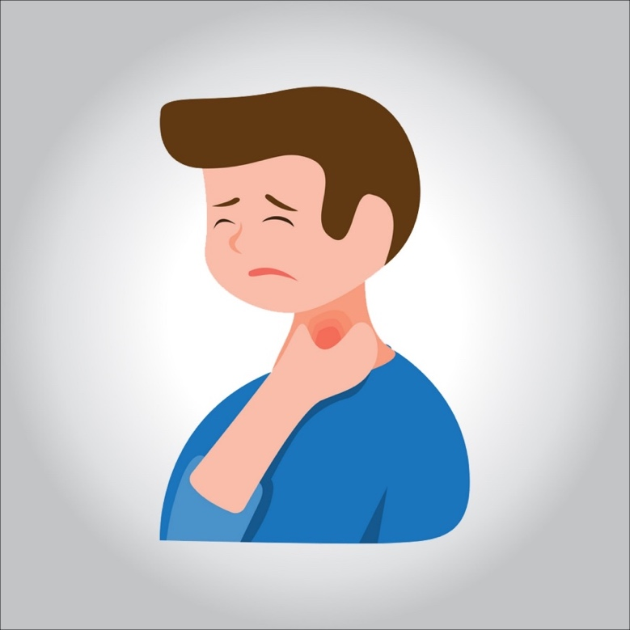

**Tonsillitis is an infection of the tonsils caused by viruses or by some types of bacteria.**

**Tonsils are lumps of tissue on both sides of the back of the throat that help the immune system protect the body from infection. But in some cases, the infections are more than the tonsils can handle and they become infected.**

**The infected tonsils become inflamed and red in color, and have a yellow or white lining. People with tonsillitis may have a sore throat, fever, swollen lymph nodes in the neck, and trouble swallowing.**

**What are the signs and symptoms of tonsillitis?**

**The inflamed tonsils appear swollen and red in color, and may be covered by spots or a yellow or whitish lining. A person with tonsillitis may have the following symptoms:**

* **sore throat**
* **white spots or pus on the tonsils**
* **swollen lymph nodes in the neck**
* **voice changes**
* **fever**
* **pain when swallowing**
* **stomach ache**
* **headache**

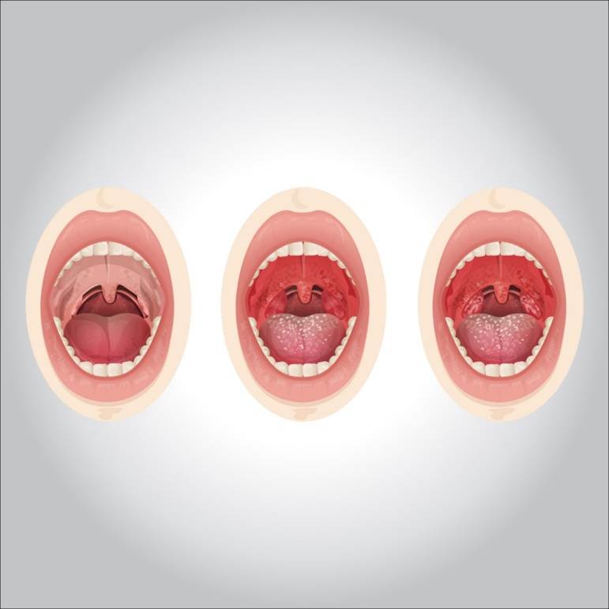

**What are the causes of tonsillitis?**

**Tonsillitis is usually caused by a virus like the following:**

* **adenoviruses**
* **the flu virus**
* **Epstein-Barr virus (mononucleosis)**

**Bacteria can also cause tonsillitis. The most frequent is group A streptococcus ( strep throat ). In very few cases, tonsillitis can be caused by something other than an infection.**

**How is tonsillitis diagnosed?**

**The doctor will ask about your symptoms and examine your throat and neck. The doctor may use a soft cotton swab to collect a sample from your tonsils and the back of your throat for testing.**

**It is important that your doctor knows if the infection is caused by bacteria. If you have strep throat, you will need antibiotic treatment to kill the bacteria. This will help you feel better and prevent other problems that may appear if strep throat is not treated.**

**How is tonsillitis treated?**

**If your doctor prescribes antibiotics, be sure to carefully follow their directions. Finish taking all the medicine, even if the symptoms disappear and you feel better. Otherwise, the infection may reappear.**

**If the strep test result is negative, the tonsillitis is probably due to a virus and antibiotics will not help. As with a cold (also caused by a virus), you will have to wait several days and let the virus cycle.**

**In rare cases, if a person has a lot of tonsillitis, a tonsillectomy may be recommended by the doctor or an otolaryngologist (a doctor who specializes in ear, nose, and throat problems). This is surgery to remove the tonsils. Tonsillectomy used to be a frequent procedure, but now experts recommend watching and waiting because large tonsils often shrink on their own over time.**

**How can I feel better?**

**Get plenty of rest and drink plenty of fluids. You can take acetaminophen or ibuprofen to relieve pain or discomfort. (But don’t take aspirin or other products that contain aspirin, because you could be at risk of developing Reye’s syndrome, a disease that can have serious complications.)**

**Avoid smoking or doing anything that can irritate your throat. You should drink a lot of liquid. Perhaps you prefer softer foods, such as applesauce, flavored gelatin, or ice cream. If you don’t feel like eating, try drinking liquids that contain calories, such as fruit juices, milkshakes, and soups or broths.**

**To protect yourself from tonsillitis or prevent the spread of another person:**

* **Wash your hands often and properly.**
* **If someone in your home or a friend has tonsillitis, don’t use that person’s glasses, cups, knives, toothbrushes, or other utensils. And if you have tonsillitis, keep your things separate and don’t share them with anyone.**
* **Do not kiss anyone until you have fully recovered.**
* **Buy a new toothbrush when you feel better and are no longer contagious.**