

Name:- Noura Ali Salem

Section:- 3

Memory Allocation Assignment

Contents

How to run the program:- 2

Note:- 2

Instructions:- 2

Aspects taken into consideration:- 5

Aspects that aren’t covered in the program: 5

# How to run the program:-

1-Open NetBeans

2-Click file -> open project

3-Double click on OS pro2 folder

4-Choose memory mapping

5-Run

# Note:-

* Whenever you want to see memory contents click on show memory button below the table even if you clicked it previously it will be refreshed with the newest contents
* Holes don’t interfere eg.

|  |  |  |
| --- | --- | --- |
|  | Starting address | Ending address |
| Hole 1 | 20 | 100 |
| Hole 2 | 90 | 150 |

Such cases are not handled

# Instructions:-

1-You enter the holes’ starting address and size.

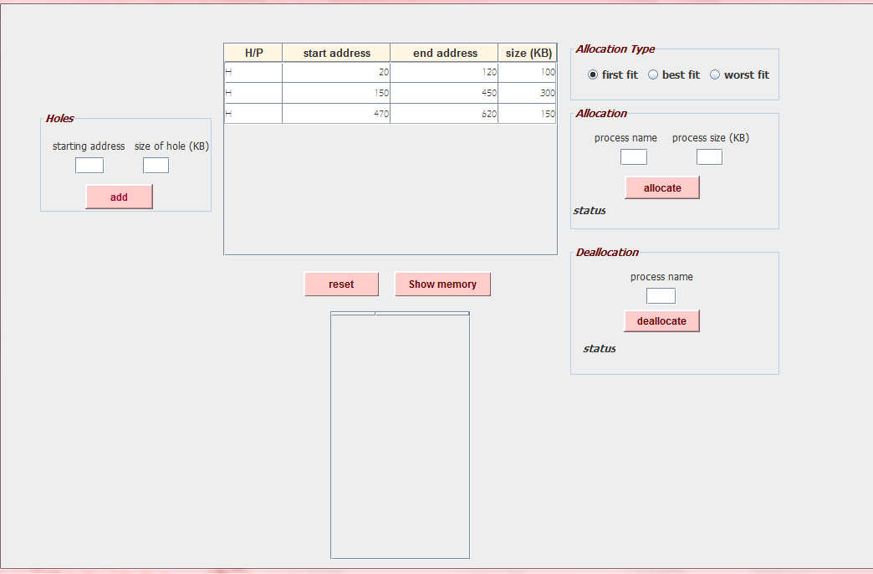

2-Then you choose what type of allocation.

3-Enter the process name and its size. As shown in the fig. below the memory contents after choosing first fit allocation allocating p1 whose size =120KB ,and p2 whose size =100KB

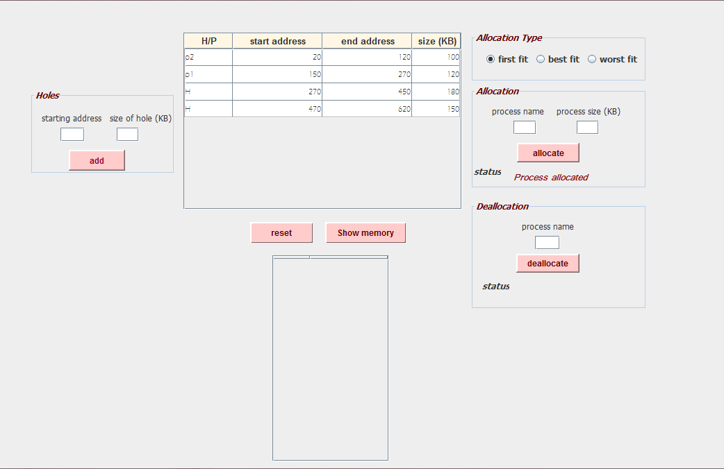

4-If the process is allocated then its status should be process allocated.

5-If the process didn’t find suitable hole size then its status should be waiting. As shown below after we tried to allocate p3 whose size=270KB

there isn’t enough space and the process status is waiting, so another process must be deallocated.

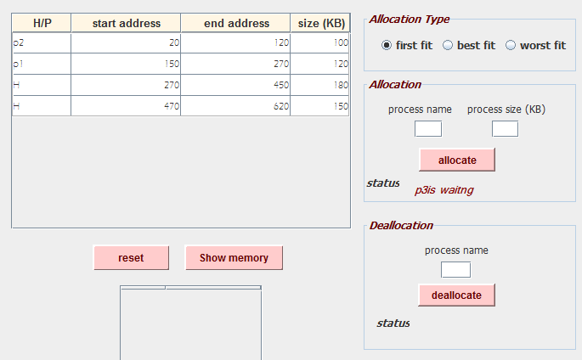

memory contents

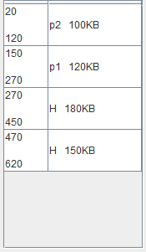Address size of hole/process

6-You should choose which process to deallocate in order to have the sufficient hole size that fits the waiting process. As shown below we chose

p1 to be deallocated and the memory contents changed accordingly

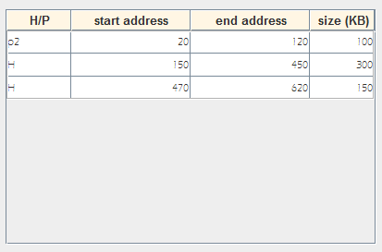

Memory contents after deallocating p1

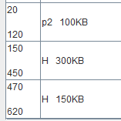

7-After deallocation, re-write the process name and size then click allocate .If the deallocated process left a suitable hole for the waiting process ,then the waiting process will be allocated else it is still waiting. As shown below is the memory contents after re-allocating p3

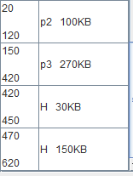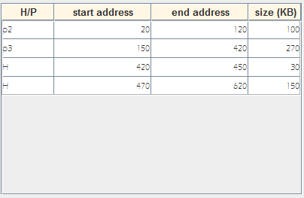

Concerning other two types of allocation (best fit and worst fit), kindly follow the same steps from 3 to 7.

# Aspects taken into consideration:-

1-When two holes are inserted if they are adjacent then they are merged together.

2-when the holes entered in any order, they are arranged in ascending order according to their starting addresses as long as holes don’t intefer

3-When a process is deallocated there are some cases handled

* If the process is sandwiched between two holes both are adjacent to the process, then when deallocating -> there is a large hole will be formed its size equals to 1st adjacent hole +process deallocated+ 2nd adjacent hole.
* If the process sandwiched between two processes, then a hole is formed of size equals to the deallocated process
* If the process to be deallocated is followed by an adjacent hole , then a hole will be formed its size equals process deallocated+ adjacent hole.
* If the process to be deallocated is preceded by an adjacent hole , then a hole will be formed and its size equals to adjacent hole +process deallocated.
* If none of the above are the cases then the process is replaced directly with a hole having the same size.

# Aspects that aren’t covered in the program:

1-checking whether the user entered hole addresses such that they don’t holes don’t interfere