# **What is the Problem statement?**

Ramallah city in is equipped with video surveillance cameras installed on different roads and highways. Traffic monitoring is done by human operators to visualize the congestion of a road or to measure the flow of the traffic. The video stream of this existing network of cameras is delivered unprocessed to the traffic management center. Thus, there are no video storage of accident scenes. In addition, there is no associated technology for a rapid emergency management.

Road accidents can cause serious injuries affecting mostly the head and the brain, leading to lifelong disabilities and even death.

They provide inefficient time management on road intersections. This forces vehicle commuters to wait unnecessarily, which in turn causes traffic jams, pollution, extra delays, etc.

Intelligence cannot be obtained and they are not adaptive. Currently, at intersections, each road is assigned a constant fraction of time to be green regardless of the number of vehicles or flow density

Traffic slow-downs can cause debilitating congestion and add to urban air pollution. Businesses suffer from delivery delays and lost productivity. Emergency vehicles are slowed down by bottlenecks, potentially putting lives at risk. And all of it diminishes the city's overall quality of life.

**What is the Project objectives?**  
Some of the key functionality cities achieve with these systems include the following:

* the measurement in real time of traffic parameters to insure a fluid traffic and avoid accidents.
* Congestion detection: With cameras and sensors constantly monitoring intersections, technicians can monitor the entire city from the city's traffic management center.
* Adaptive control: Congestion detection also enables adaptive control, which causes dynamic adjustments to systems including traffic lights, on-ramp signaling, and bus rapid transit lanes.
* Connected vehicle: This up-and-coming technology enables vehicles to communicate directly with intersections. The Smart Traffic Management can include a connected vehicle roadside unit for this purpose.

# **Product specification**

# Is a web page application that shows the current situation of the road junctions and detect accidents and traffic jam and save the time in a driver

# **What traffic parmeters extraction includes?**

- Vehicle counting (Traffic jam detection)

- An accident detection approach based on vehicle motion .

- Distinguishing the absence and the presence of vehicles on road to compute the traffic density on road .

# **Dataset description:**

The proposed data is a collection of labeled pictures of car crash and non-accidents, in various weather states.

Dataset collection: the data is collected from videos by dashboard-mounted cameras in Ramallah streets, videos are gathered in different cases (early morning, evening, rainy weather, fog weather).

1500 photos will be labeled as non accident)

Dataset features:

1- Photos: frames that are extracted from videos

2- Labels: photos will be labeled (accidents and non-accidents)

3- Time: at which time the frame has been extracted.

4-Location: the defined location (the name of the streets that the frames are extracted from)

# **Give The general steps of the video based accident detection techniques:**

The general steps of abnormal behavior detection in road are presented in Figure below. The first step is motion detection and tracking, then feature extraction ,abnormal behavior detection and finally saving data .

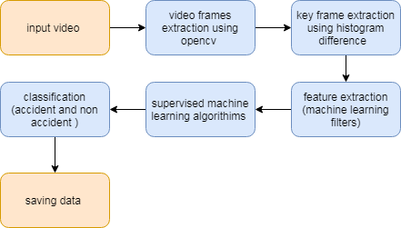

* To capture the video, we will be using the VideoCapture function of the opencv module and store the recorded video into a variable.
* The currentframe variable keeps the frame count. Then we will be using the imwrite function to write the frame at the path mentioned earlier.
* The amount of data in video processing is significantly reduced by using video segmentation and key-frame extraction. So, these two technologies have gradually become the focus of research. With the square histogram difference considered at block level for the video frames, a new method of extracting the keyframes based on shot type is presented.
* Feature extraction is a part of the dimensionality reduction process, in which, an initial set of the raw data is divided and reduced to more manageable groups,gabor filter that has a distinguishing value at the spatial location of that feature.
* Frames will be tested and inserted into a trained supervised model to be classified accident or non accident
* Data will be saved in database with time and location.

**Introduction to YOLO Algorithm for Object Detection**

YOLO is an algorithm that uses neural networks to provide real-time object detection. This algorithm is popular because of its speed and accuracy. It has been used in various applications to detect traffic signals, people, parking meters, and animals.

What is YOLO?

YOLO is an abbreviation for the term ‘You Only Look Once’. This is an algorithm that detects and recognizes various objects in a picture (in real-time). Object detection in YOLO is done as a regression problem and provides the class probabilities of the detected images.

YOLO algorithm employs convolutional neural networks (CNN) to detect objects in real-time.

YOLO algorithm is important because of the following reasons:

**Speed**: This algorithm improves the speed of detection because it can predict objects in real-time.

**High accuracy**: YOLO is a predictive technique that provides accurate results with minimal background errors.

**Learning capabilities:** The algorithm has excellent learning capabilities that enable it to learn the representations of objects and apply them in object detection.

**How the YOLO algorithm works:**

YOLO algorithm works using the following three techniques:

**Residual blocks**: the image is divided into various grids.

**Bounding box regression**: A bounding box is an outline that highlights an object in an image.

Every bounding box in the image consists of the following attributes:

Width (bw), Height (bh), Class (for example, person, car, traffic light, etc.)- This is represented by the letter c., Bounding box center (bx,by)

**Intersection Over Union (**IOU)

Intersection over union (IOU) is a phenomenon in object detection that describes how boxes overlap. YOLO uses IOU to provide an output box that surrounds the objects perfectly

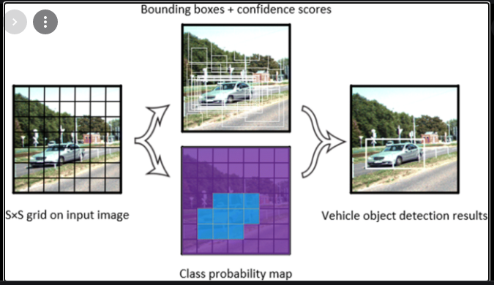

**What procedures will had for Ensuring information privacy and security in TMS**

Ensuring information privacy and security in Traffic management system is essential for all involved people, transit agencies, government,and so on. data may contain personal information and can track people and vehicles, several requirements need to be satisfied.

* Verification of data consistency checks the legality and consistency of messages to avoid messages with malicious data.
* Availability ensures continuous operation of the system even under attacks (e.g. DoS by jamming).
* Real-time constraints focus on maintaining communication and efficient computing even with the usage of security techniques. Authentication legitimizes messages.

Furthermore, the new trend of using cloud computing with TMS increases the complexity for providing

security to the system, because the inherent security problems in cloud computing are also added to TMS.