CUSTOMER TO CUSTOMER WEBSITE

- Introduction
The project is a Customer-to-Customer (C2C) E-commerce Website that allows users to buy and sell products directly through the platform. The system provides a marketplace where sellers can create advertisements for their products, while buyers can search, browse, and communicate with sellers through an integrated messaging system.
The platform is designed to simplify online trading between individuals by offering categorized product listings, user reviews, favorites management, and reporting features. In addition, administrators and moderators can monitor reports, manage inappropriate content, and maintain the security and reliability of the platform.
The project was developed using Microsoft SQL Server as the database management system. The database design focuses on maintaining data integrity, efficient relationships between entities, and optimized query performance using indexing and query optimization techniques.
2. Project Functionalities
1. User Management
- User registration and login.
- Different user roles:
  - User
  - Moderator
  - Admin
- Account status management.
2. Product Advertisement Management
- Add new product advertisements.
- Edit and delete advertisements.
- Upload multiple images for each advertisement.
- Store product details such as:
  - Title
  - Description
  - Price
  - Category
  - Location
3. Category Management
- Organize products into categories.
- Support parent-child categories for better classification.
4. Search Functionality
- Search products by:
  - Title
  - Category
  - Location
  - Price
- Filter advertisements based on user preferences.
5. Favorites System
- Users can save advertisements to favorites.
- Quick access to saved products.
6. Messaging System
- Direct communication between buyer and seller.
- Conversations linked to specific advertisements.
- Message history storage.
7. Review and Rating System
- Users can review sellers.
- Rating system for improving trust between users.

8. Reporting System
- Users can report advertisements or users.
- Moderators review reports and take actions such as:
  - Warning users
  - Deleting advertisements
  - Banning users
9. Reports and Analytics
- Generate reports based on:
  - Advertisement views
  - User activities
  - Product statistics

3. Queries Optimization
1. Index on Advertisement Title
-Used to improve search performance.
2. Index on Category ID
-Used for filtering advertisements by category
3. Index on Location ID
-Used for location-based searches.
4. Index on User ID
-Used to quickly retrieve advertisements created by a user
5. Composite Index for Search Optimization

Before and After Optimization
1. Index on Advertisement Title
Before Optimization:
Problem
- SQL Server performs a full table scan.
- Slow search performance when the Ad table becomes large.
After Optimization:
Improvement
- Faster search performance.
- Reduced query execution time.
- Better use of index searching instead of full table scanning.

2. Index on Category ID

Before Optimization:
Problem
- Full table scan on the Ad table.
- Slow filtering when handling many advertisements
After Optimization:
Improvement
- Faster category filtering.
- Reduced disk I/O operations.
- Improved response time for category pages.
3.Index on Location ID
Before Optimization:
Problem
- Slow location filtering due to table scanning.
- Performance decreases as data grows.
After Optimization:
Improvement
- Faster location-based search.
- Improved filtering performance.
- Better scalability for large datasets

4. Index on User ID
Before Optimization:
Problem
- Slow retrieval of advertisements created by users.
- Full table scan affects dashboard performance.
After Optimization
Improvement
- Faster retrieval of seller advertisements.
- Improved user dashboard performance.
- Reduced query execution cost

5. Composite Index for Search Optimization
Before Optimization:
Problem
- Multiple filtering conditions cause expensive table scans.
- Slow performance in advanced search operations.
After Optimization:
Improvement
- Faster multi-condition search queries.
- Optimized filtering and sorting.
- Reduced execution time for advanced search operations.

Stored Procedures

1. Add New Advertisement Procedure

2. Search Advertisements Procedure

3. Add Product to Favorites Procedure

4. Send Message Procedure

5. Generate Most Viewed Ads Report Procedure

Views

1. Active Advertisements View

2. User Advertisements View

3. Advertisement Details View

4. Reviews View

5. Reports View

Triggers

1. Automatically Set Advertisement Creation Date

2. Increase Views Count Trigger

3. Prevent Negative Prices Trigger

4. Log Deleted Advertisements Trigger

5. Automatically Resolve Report Date Trigger

(ERD Diagram)

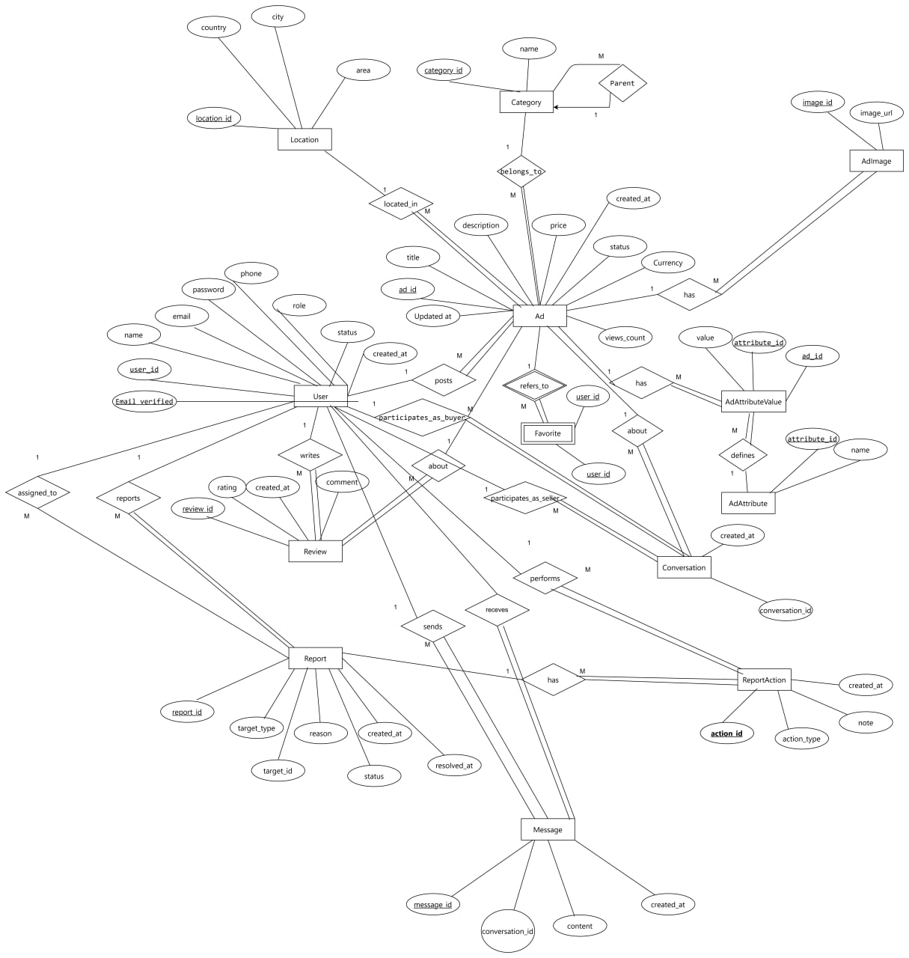

Schema

