Analyzing and Visualizing WeRateDogs

# Introduction

Have you heard about one of the most famous meme of 2016 *“they’re good dogs Brent”* and the twitter account WeRateDogs*?* Probably yes, but if not. Here I can tell you a bit about it and better than that I can show you some fun analysis of WeRateDogs tweets data.

First, WeRateDogs is a Twitter account that rates people's dogs with a humorous comment about the dog. These ratings almost always have a denominator of 10. The numerators however are almost always greater than 10 (11/10, 12/10, 13/10, etc.). In theory the rates should be 1 to 10. However, WeRateDogs disagree, they admit almost all dogs deserve a 10 and sometimes more than that.

WeRateDogs has over 6 million followers and has received international media coverage. One of those coverage were about the quote *“they’re good dogs Brent”,* this was an exchange in which WeRateDogs shut down a person having an issue with its rating system in humorous ways.

So what does this rating do? Which dog type (breed) is most common dog in the tweet dataset? What dog type has the highest average rating? These questions and more are answered in the following insights:

# Most common dog type

WeRateDogs has over 6000+ tweets. I was able to analyzed around 1500+ tweets. The most rated dog was golden retriever with more than 140 ratings.

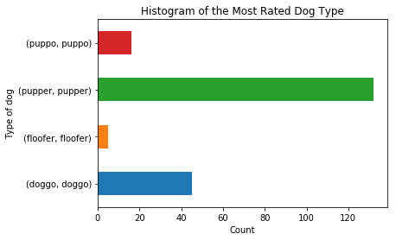

# Lowest average rating among dog types

Almost all dogs deserve ratings above 10. This is a notable exception (for the curious ones). This Japanese spaniel has the lowest average rating.



This is an example of the most rated dog type (Golden retriever). The average rating was also high (11.59). No wonder why! Cute!



**Most common dog category**

Most common category is pupper

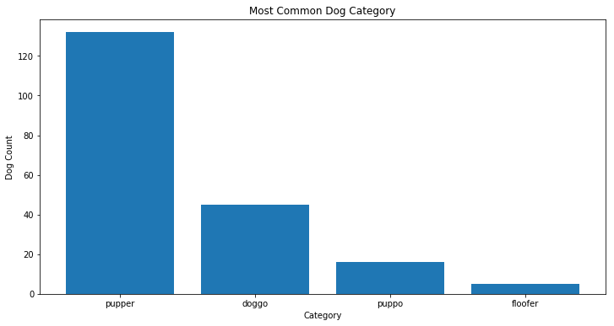

**Rate frequency**

**Rate that most used is in range 10:12**

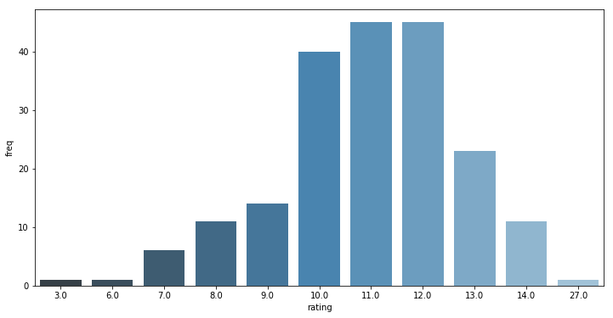

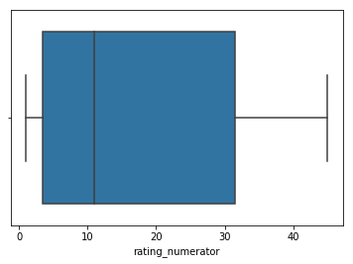

# Retweet counts

Amazingly many tweets have been retweeted more than 1000 times some more than even 40000 times. There is not a clear relationship between the ratings and the retweets.

