SOFTWARE DESIGN DESCRIPTION
Ahla — Local Guide Matching Platform
Architecture, data, class, interface and behaviour design
Field | Details
Document | Software Design Description (SDD), following the IEEE 1016 structure
Version | 1.0 — 4 October 2026
Course | Software Engineering — MUST University, academic year 2025–2026
Prepared by | Ahla project team (add team members' names)
Related document | Ahla SRS v1.0 — FR-xx, NFR-xx, UC-xx and BR-xx identifiers refer to it

1. Introduction

1.1 Purpose
This document describes how Ahla is designed: its architecture, modules, data model, classes, interfaces and the interactions behind its most important use cases. It turns the SRS into a design the team can implement and test, and records why each major decision was taken.

1.2 Scope
The design covers the whole of Ahla version 1.0: the mobile-first web app for tourists and hosts, the admin panel, the Laravel application, the MySQL database, the background job scheduler and the five external services (payment, translation, maps, email/SMS and video call).

1.3 Definitions
Business terms are defined in SRS §1.3. Design terms used here:
Term | Meaning
Module | A group of controllers, services, models and repositories for one feature (e.g. Booking).
Service | A class that holds the business rules of a module (e.g. BookingService).
Domain event | A message such as BookingAccepted that other modules react to.
Listener | A class that reacts to a domain event (e.g. NotificationListener).
Job | A task run in the background or on a schedule (e.g. ExpireRequests every 10 minutes).
State class | A class representing one status of a host or booking and the actions allowed in it.

1.4 References
- Ahla SRS v1.0.
- IEEE Std 1016-2009, Software Design Descriptions.
- Laravel 11 documentation (routing, Eloquent, queues, scheduling, events).

1.5 Overview
Section 2 explains the design approach, Section 3 the architecture, Section 4 the data design, Section 5 the classes and the state machines, Section 6 the interfaces, Section 7 the dynamic behaviour, Section 8 the design patterns, Section 9 the cross-cutting concerns and Section 10 the traceability to the SRS.

2. System Overview and Design Approach

2.1 System context
Tourists and hosts use a mobile-first web app; admins use an admin panel. Both call the Laravel application over HTTPS. Only the application accesses the database and the encrypted storage. The application calls the payment gateway, the translation API and the email/SMS provider; maps are loaded in the browser; verification calls happen through a video-call link.

2.2 Design methodology
Methodology | Pros for Ahla | Cons for Ahla | Chosen?
Object-Oriented Design + Agile (Scrum, 2-week sprints) | Rich domain objects with their own rules and states (Host, Booking, Payment). Sprints let us release search and booking first, then add translation, disputes and payouts. | Needs a clear domain model early, before the team starts coding features. | Yes
Structured design (top-down functional decomposition) | Simple to explain; fits small scripts. | Rules such as the 2-bookings-per-day limit, refunds and suspensions would be repeated in many procedures and easy to break. | No
Waterfall | Predictable plan and documents. | Tourism needs early feedback from real hosts and tourists (pricing, refund rules); waterfall delays that feedback until the end. | No

2.3 Architectural style
Architecture style | Pros for Ahla | Cons for Ahla | Chosen?
Layered modular monolith (MVC, Laravel) with internal events and a job queue | One codebase and one database: bookings, limits and payments stay consistent in one transaction. Modules (Booking, Matching, Verification…) keep responsibilities separate. Events + queue handle notifications, expiry and payouts without blocking users. | The whole app scales as one unit; a very slow module (e.g. translation) must be isolated with the queue. | Yes
Microservices | Booking, payments and messaging could scale and be deployed separately. | Too much infrastructure for a student team. The 2-per-day limit and payment capture would need distributed transactions across services. | No
Pure event-driven (message broker) | Natural for reactions: “host cancelled” → refund, suggestions, strike, notifications. | Needs a broker (e.g. RabbitMQ) and eventual consistency, which is risky for money and limits. We keep the idea as internal events inside the monolith. | No (idea reused)

Decision
Ahla is a transactional marketplace: its most important rules (two bookings per host per day, no double booking, authorise-then-charge payments, refunds) must be checked and saved together in one database transaction. A layered modular monolith built with object-oriented classes keeps these rules consistent and simple to test, while internal events and a background job queue handle the reactions (notifications, alternative-host suggestions, expiry, payouts) without slowing users down. Agile sprints let us validate the rules with real hosts and tourists early.

2.4 Design goals
- Never break the money and limit rules: daily limit, overlap, authorise-then-capture and refunds are checked in one locked transaction (NFR-02).
- Trust by design: only Active hosts are bookable; the host state machine enforces it in one place (BR-01).
- Fast for tourists: search under 2 s (NFR-01); slow work (emails, translation, suggestions) runs in the background.
- Replaceable providers: payment and translation behind interfaces (Adapter), so the provider can change.
- Testable rules: limits, refunds, matching and suspension are plain classes with unit tests (NFR-13).

3. Architectural Design

3.1 Architecture diagram
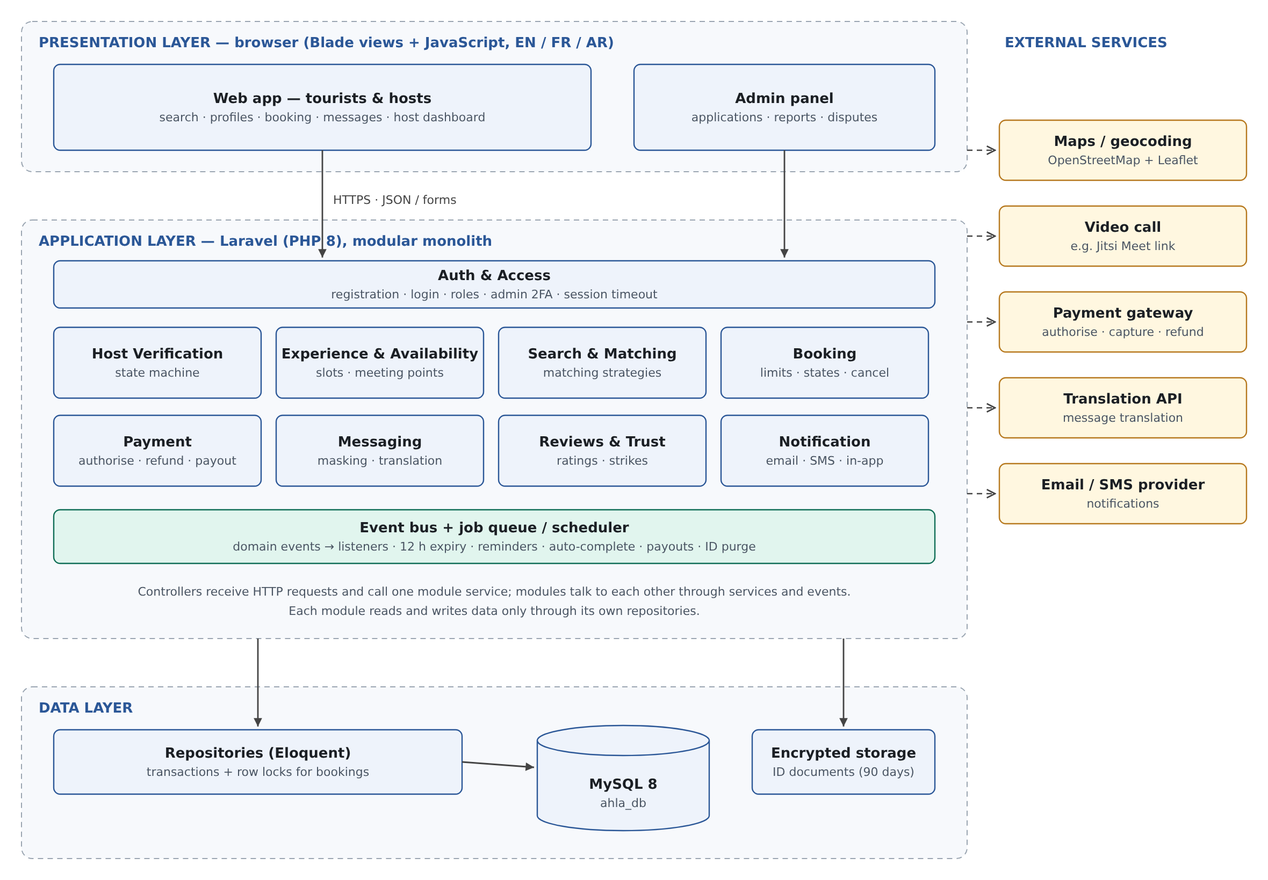
Figure 1 — Layered modular architecture of Ahla.
Requests flow downwards: presentation → application → data. Modules never call the database of another module directly; they use that module's service or react to its events.

3.2 Component responsibilities
Component | Responsibility | Talks to
Web app — tourist & host (Blade + JS) | Search, profiles, booking, messaging, host dashboard; responsive, in EN/FR/AR. | Controllers (HTTPS, JSON)
Admin panel | Host applications, video-call scheduling, reports, disputes, suspensions. | Verification module, Trust & Admin module
Auth & Access | Registration, login, roles, 2FA for admins, session timeout. | Users table, all controllers
Host Verification module | Applications, ID storage, video-call scheduling, host state machine (Applied → Verified → Active → Suspended). | Encrypted file storage, Notification, video-call service
Experience & Availability module | Experiences, weekly slots, blocked dates, meeting points. | Map service, Database
Search & Matching module | Filters and ranks hosts with matching strategies; finds alternative hosts. | Experience module, Database
Booking module | Requests, 2-per-day and overlap checks, accept/decline, cancellation, completion, booking state machine. | Payment module, Matching module, Event bus
Payment module | Authorise, capture, refund (refund policies), payouts minus 15% commission. | Payment gateway (Adapter), Database
Messaging module | Booking conversations, contact masking, translation. | Translation service (Adapter)
Reviews & Trust module | Reviews, ratings, reports, strike counter, automatic suspension, disputes. | Booking module, Verification module
Notification module | Email/SMS/in-app messages for every event and reminders. | Email/SMS provider, Event bus
Event bus + Job queue / scheduler | Dispatches domain events to listeners; runs timed jobs (expire requests after 12 h, reminders, auto-complete, payouts, ID deletion after 90 days). | All modules
Data layer (MySQL + encrypted storage) | Persistent data; ID documents in an encrypted private disk. | All modules through repositories
External: payment gateway | Card authorisation, capture, refund, payout transfers; payment webhooks. | Payment module
External: translation, map, email/SMS, video call | Message translation; geocoding and maps; notifications; verification calls. | Messaging, Experience, Notification, Verification

3.3 Scheduled and background jobs
Scheduled job | Frequency | What it does | Requirement
ExpireRequests | Every 10 min | Requests older than 12 h → Expired; release authorisation; notify tourist | FR-13
SendReminders | Every 10 min | Reminders 24 h and 2 h before each accepted booking | FR-19
AutoComplete | Every 30 min | Bookings ended 2 h ago with no dispute → Completed | FR-16
ReleasePayouts | Hourly | Completed > 24 h ago, no dispute → payout (amount − 15%) | FR-25
PublishReviews | Daily | Publish reviews older than 14 days | FR-20
PurgeIdDocuments | Daily | Delete ID files 90 days after the verification decision | NFR-04

3.4 Deployment view
Environment | Configuration
Development | Laravel Sail or XAMPP on each laptop; MySQL; payment gateway sandbox; fake SMS (logged).
Production | One Linux VPS: Nginx + PHP-FPM 8.3, MySQL 8, a queue worker (supervised), cron running the Laravel scheduler every minute, HTTPS certificate, daily encrypted backups.

3.5 Technology choices
Layer | Technology | Reason
Presentation | Laravel Blade, plain JavaScript, Leaflet maps, CSS with RTL support | Server-rendered pages load fast on phones; RTL for Arabic.
Application | PHP 8.3, Laravel 11 (routing, Eloquent ORM, events, queues, scheduler) | Mature framework the team knows; events and scheduler built in.
Data | MySQL 8 (InnoDB), Laravel encrypted private disk for ID files | Transactions and row locks for the booking rules; encryption for NFR-04.
Quality | PHPUnit, Laravel feature tests, k6 load tests, SonarCloud | Covers unit, integration, load and code-quality checks.

4. Data Design

4.1 Entity–relationship diagram
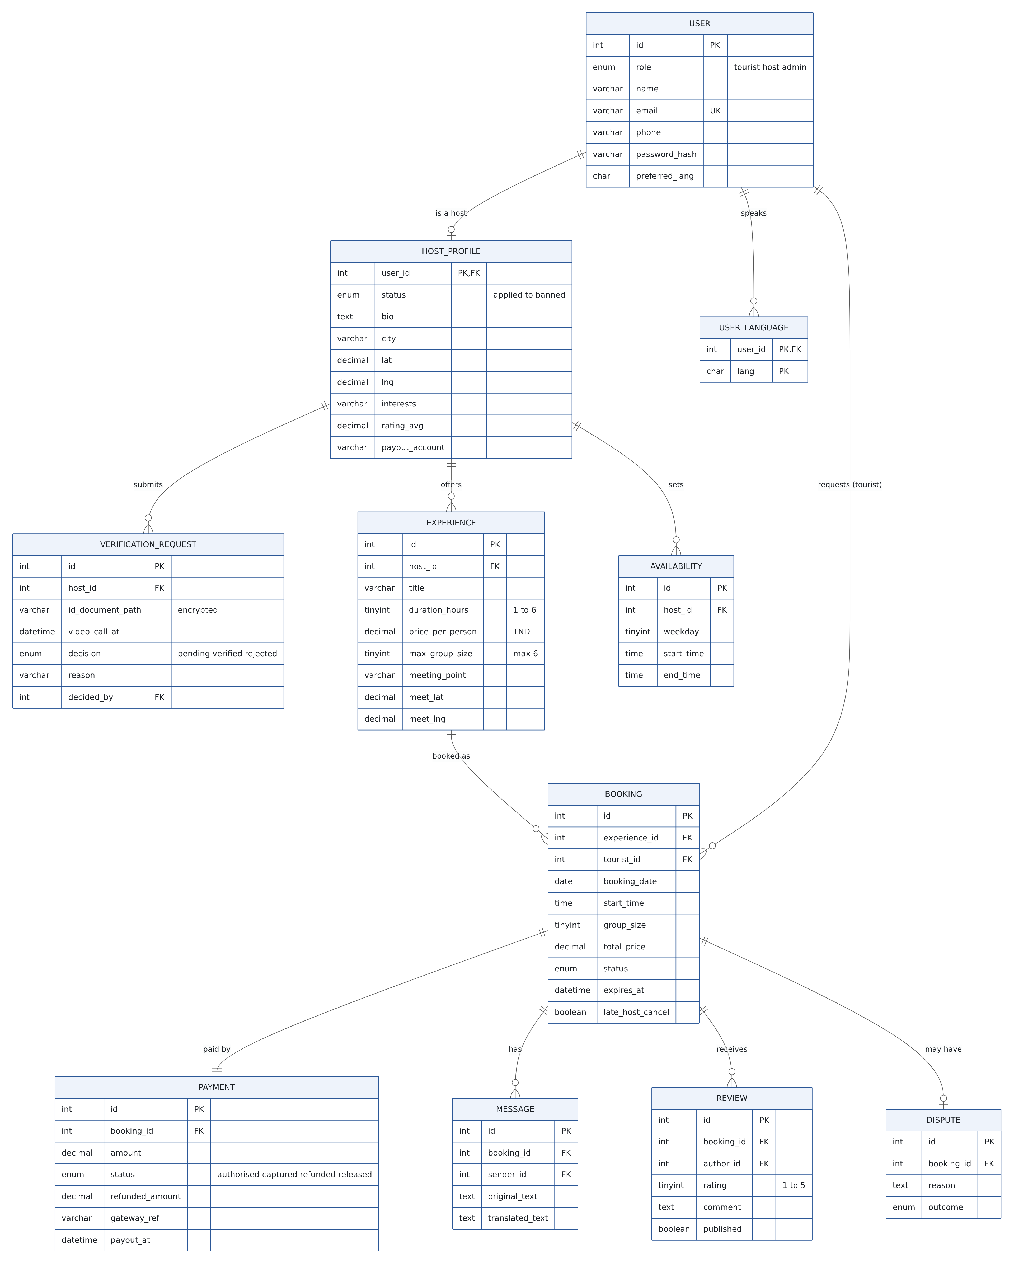
Figure 2 — Logical data model (ahla_db).

4.2 Data dictionary
Table | Key columns and rules
users | id PK; role ENUM(tourist, host, admin); email UNIQUE; phone; password_hash (bcrypt); preferred_lang; two_factor_secret (admins).
user_languages | (user_id, lang) PK — languages a user speaks (ISO codes).
host_profiles | user_id PK/FK; status ENUM(applied, verified, active, suspended, rejected, banned); bio; city; lat/lng; interests; rating_avg; payout_account.
verification_requests | id PK; host_id FK; id_document_path (encrypted disk); video_call_at; decision; reason; decided_by FK → users; decided_at.
experiences | id PK; host_id FK; title; duration_hours 1–6; price_per_person DECIMAL(10,3); max_group_size ≤ 6; meeting point + lat/lng; published.
availability | id PK; host_id FK; weekday; start_time; end_time — plus blocked_dates(host_id, date).
bookings | id PK; experience_id FK; tourist_id FK; booking_date; start_time; end_time; group_size; total_price DECIMAL(10,3); status; expires_at; late_host_cancel. INDEX(experience_id, booking_date), INDEX(status, expires_at).
payments | id PK; booking_id FK UNIQUE; amount; status; refunded_amount; gateway_ref; commission; payout_at.
messages | id PK; booking_id FK; sender_id FK; original_text; translated_text; created_at.
reviews | id PK; booking_id FK; author_id FK; rating 1–5; comment; published. UNIQUE(booking_id, author_id).
disputes · reports · audit_log | Disputes per booking; reports on users/experiences; audit_log(entity, entity_id, old_status, new_status, actor_id, reason, at) for NFR-12.

4.3 Integrity rules
- Money is stored as DECIMAL(10,3) (TND has 3 decimals), never as floating-point numbers.
- The daily limit is enforced by locking the host's bookings for that date (SELECT … FOR UPDATE) before counting, inside the same transaction that inserts or accepts the booking (NFR-02).
- A booking's payment row is created in the same transaction as the booking; a failed authorisation rolls everything back.
- ID documents are stored on an encrypted disk and deleted by the PurgeIdDocuments job 90 days after the decision (NFR-04).

5. Class Design

5.1 Domain model
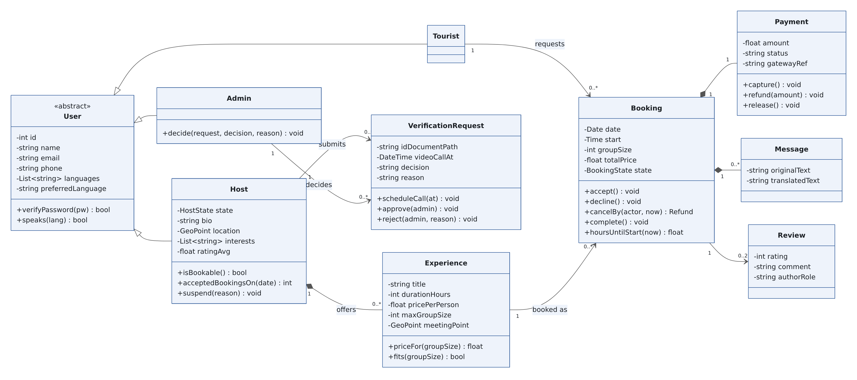
Figure 3 — Domain classes.

5.2 Services, strategies and adapters
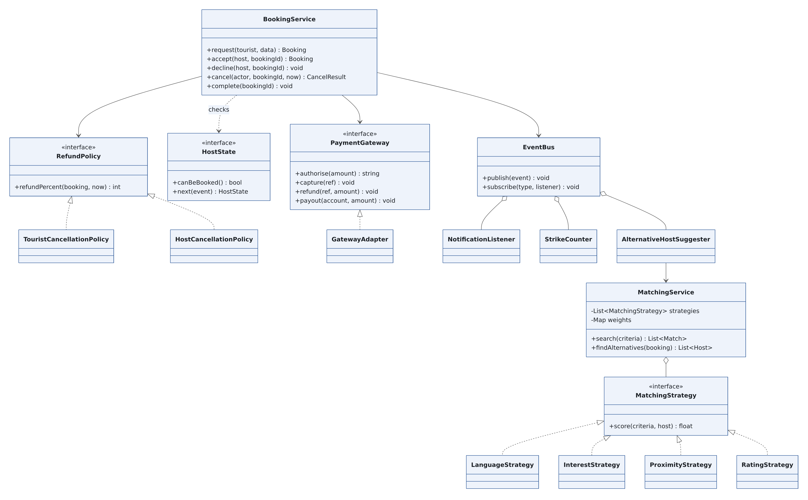
Figure 4 — Service, strategy, state, adapter and event classes.

5.3 Class design table
Class | Attributes | Operations | Related classes
User (abstract) | id, name, email, phone, passwordHash, languages, preferredLanguage | verifyPassword(), speaks(language) | Tourist, Host, Admin (inheritance)
Host | status: HostState, bio, city, location, interests, ratingAvg, payoutAccount | isBookable(), acceptedBookingsOn(date), suspend(reason) | Experience, Booking, VerificationRequest, Review
VerificationRequest | idDocumentPath, videoCallAt, decision, reason, decidedBy | scheduleCall(at), approve(admin), reject(admin, reason) | Host, Admin
Experience | title, description, interests, durationHours, pricePerPerson, maxGroupSize, meetingPoint | priceFor(groupSize), fits(groupSize) | Host, AvailabilitySlot, Booking
Booking | date, startTime, endTime, groupSize, totalPrice, status: BookingState, requestedAt | accept(), decline(), cancelBy(actor, now), complete(), hoursUntilStart(now) | Tourist, Experience, Payment, Message, Review
Payment | amount, status (authorised/captured/refunded), gatewayRef, refundedAmount | capture(), refund(amount), release() | Booking, PaymentGateway
Review | rating 1–5, comment, authorRole, createdAt | publish() | Booking, User
BookingService | bookings, payments, events | request(), accept(), decline(), cancel(), complete() | Booking, PaymentService, RefundPolicy, EventBus
MatchingService | strategies: List<MatchingStrategy>, weights | search(criteria), findAlternatives(booking) | MatchingStrategy (Strategy), Host
RefundPolicy (interface) | — | refundPercent(booking, now) | TouristCancellationPolicy, HostCancellationPolicy

5.4 State machines
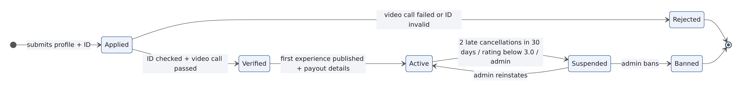
Figure 5 — Host verification states (State pattern: HostState).
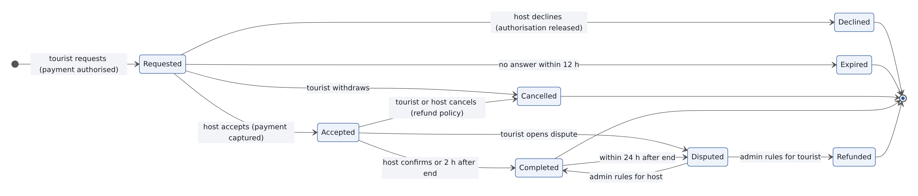
Figure 6 — Booking states (State pattern: BookingState).

5.5 Key algorithms
Match score (MatchingService.search)
- Filter: only Active hosts with a free slot on the date, a group size that fits, and at least one language shared with the tourist.
- Score = 0.4 × language + 0.3 × interests + 0.2 × proximity + 0.1 × rating, where language = 1 if the host speaks the tourist's preferred language (else 0.5), interests = shared ÷ tourist's interests, proximity = 1 − distance ÷ 15 km, rating = average ÷ 5 (new hosts count as 4.0 so they are not hidden).
- The two strongest criteria become the “why this host” tags (FR-09). Weights live in configuration so the team can tune them.
Refund amount (RefundPolicy)
- TouristCancellationPolicy: hours = start − now; ≥ 48 → 100%, ≥ 24 → 50%, otherwise 0%.
- HostCancellationPolicy: always 100%; if hours < 24, the booking is flagged late_host_cancel = true (strike).
Alternative hosts (MatchingService.findAlternatives)
- Same filter as search for the booking's date and start time, restricted to 10 km from the original meeting point and excluding the cancelling host; sorted by match score; top 3.

6. Interface Design

6.1 Application API
Pages call these JSON endpoints. All require a logged-in user except registration and login; each checks the user's role and that the booking or profile belongs to them.
Method + endpoint | Purpose | Main request fields | Success | Errors
POST /api/auth/register | Create tourist or host account | role, name, email, phone, password, languages | 201 {user} | 422 invalid, 409 email exists
POST /api/auth/login · /logout | Start / end session | email, password (+ 2FA code for admins) | 200 | 401
POST /api/host/application | Apply as host | bio, city, location, interests, idDocument (file) | 201 {status: applied} | 422, 403 already applied
PATCH /api/admin/applications/{id} | Schedule call / decide | videoCallAt or decision + reason | 200 {status} | 403, 409 wrong state
POST · PUT /api/experiences | Publish / edit experience | title, duration, pricePerPerson, maxGroupSize, meetingPoint… | 201 / 200 | 422, 403 not verified
PUT /api/availability | Weekly slots, blocked dates | slots[], blockedDates[] | 200 | 422
GET /api/search | Ranked hosts / experiences | city, date, language, interests, groupSize, lat, lng | 200 {results + whyMatched} | 422
POST /api/bookings | Request booking | experienceId, date, start, groupSize | 201 {booking: requested} | 409 host full / slot taken, 422, 402 payment refused
POST /api/bookings/{id}/accept · /decline | Host response | — | 200 {booking} | 409 limit reached or expired, 403
POST /api/bookings/{id}/cancel | Cancel (tourist or host) | reason | 200 {refund, alternatives[]} | 403, 409 already cancelled
POST /api/bookings/{id}/complete | Host confirms completion | — | 200 | 409 not yet ended
GET · POST /api/bookings/{id}/messages | Conversation | text | 200 / 201 {original, translated} | 403
POST /api/bookings/{id}/review | Review after completion | rating, comment | 201 | 409 not completed or > 14 days
POST /api/bookings/{id}/dispute | Open dispute | reason, photos | 201 | 409 > 24 h after end
POST /api/reports | Report user / experience | targetType, targetId, reason | 201 | 422
PATCH /api/admin/hosts/{id}/status | Suspend, reinstate, ban | status, reason | 200 | 403, 409
POST /api/webhooks/payment | Gateway callback | signed event | 200 | 400 bad signature

6.2 User interface principles
- Mobile-first, one main action per screen; the booking request fits in at most 5 screens (NFR-07).
- The refund policy is shown before the tourist pays, and again on the cancel screen.
- Hosts see a countdown for each request they must answer within 12 hours.
- Every status is shown with text and an icon, not colour alone (NFR-09); Arabic pages switch to right-to-left.

6.3 External interfaces
Service | Interface in Ahla | Failure behaviour
Payment gateway | PaymentGateway interface: authorise, capture, refund, payout; webhook endpoint with signature check | No booking without authorisation; refunds retried automatically; admin alerted
Translation API | Translator interface: translate(text, from, to) | Show original text with a “translation unavailable” note (NFR-11)
Email / SMS | Laravel notification channels | Queued and retried 3 times; in-app notification always stored
Map service | Leaflet in the browser; geocoding on save | Address text still shown if the map does not load
Video call | Admin pastes or generates a meeting link when scheduling | Admin can reschedule

7. Dynamic Behaviour

7.1 Request a booking and the host accepts (UC-06, UC-07)
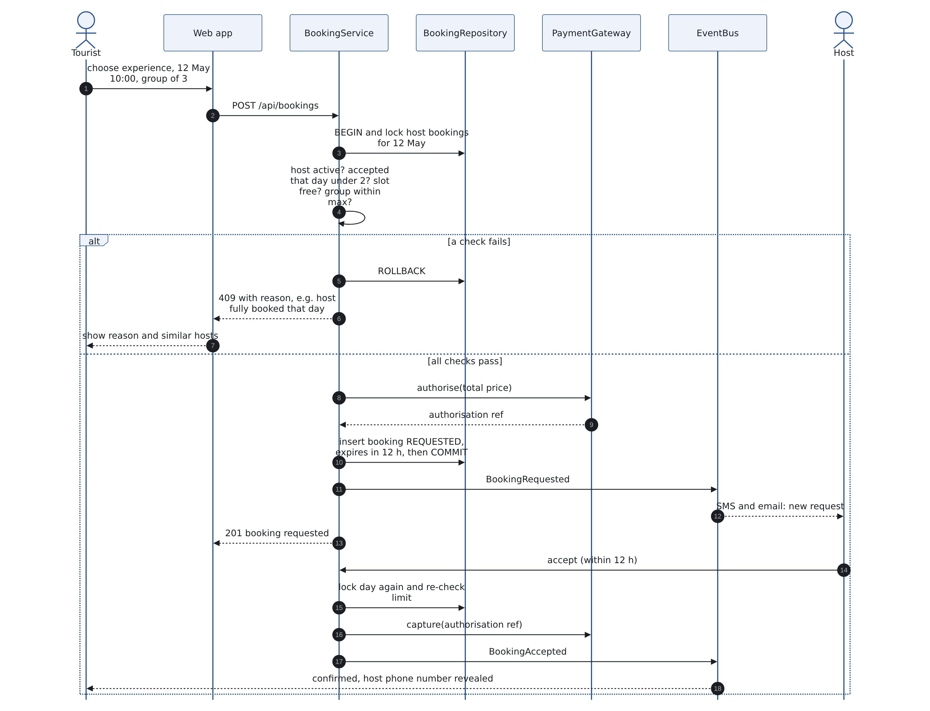
Figure 7 — Booking request with the daily-limit check, then acceptance.

7.2 Host cancels less than 24 hours before (UC-08)
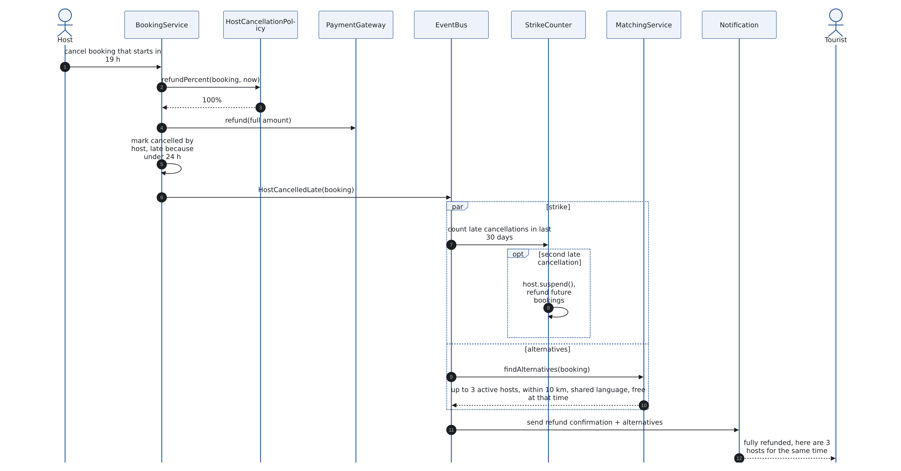
Figure 8 — Late host cancellation: refund, strike and alternative hosts.

8. Design Patterns
Pattern | Problem solved | Where applied
State | A host and a booking go through many statuses, and the allowed actions depend on the status (a suspended host cannot be booked; an expired request cannot be accepted). Long if/else chains on a status field break easily. | HostState (Applied, Verified, Active, Suspended, Rejected, Banned) and BookingState (Requested, Accepted, Declined, Expired, Cancelled, Completed, Disputed); each state class allows or refuses each action.
Strategy | Hosts must be ranked by several criteria that the team will tune, and refunds follow different rules depending on who cancels. | MatchingStrategy: LanguageStrategy, InterestStrategy, ProximityStrategy, RatingStrategy combined by MatchingService with weights. RefundPolicy: TouristCancellationPolicy (100/50/0%) and HostCancellationPolicy (100%).
Observer (domain events) | One action triggers many reactions (a late host cancellation → refund, strike, alternative hosts, emails). Putting them all in BookingService makes it huge and slow. | EventBus with listeners: NotificationListener, StrikeCounter, AlternativeHostSuggester, AuditLogger; slow listeners run on the job queue.
Adapter | External providers (payment gateway, translation API) have different APIs and may be replaced. | PaymentGateway interface with one adapter per provider; Translator interface with a provider adapter and a fallback that returns the original text.

9. Cross-Cutting Concerns

9.1 Security and privacy
- bcrypt passwords, HTTPS only, CSRF protection on forms, 30-minute idle timeout, mandatory 2FA for admins (NFR-03).
- Policies (Laravel Gates) check ownership on every booking, message and profile action.
- ID documents on an encrypted disk, readable only by admins, deleted after 90 days (NFR-04). Phone numbers revealed only after acceptance (FR-17).
- No card data in Ahla; only gateway references are stored (NFR-05).

9.2 Concurrency
- Request and accept both run in a database transaction that locks the host's bookings for the date and re-counts accepted bookings (NFR-02).

9.3 Error handling and logging
- Validation errors → 422 with field messages; rule violations (host full, expired) → 409 with a plain-language reason.
- Every status change of hosts, bookings and payments is written to audit_log (NFR-12).

9.4 Localisation and accessibility
- All texts in language files (en, fr, ar); RTL stylesheet for Arabic; WCAG 2.1 AA checks in the release checklist (NFR-08, NFR-09).

10. Requirements Traceability
Requirement | Component(s) | Class(es) | Endpoint / job
FR-01, FR-02 | Auth & Access | User, Tourist, Host, Admin | /api/auth/*
FR-03 – FR-05 | Host Verification | Host, HostState, VerificationRequest | /api/host/application, /api/admin/applications/{id}
FR-06, FR-07 | Experience & Availability | Experience, AvailabilitySlot | /api/experiences, /api/availability
FR-08 – FR-10 | Search & Matching | MatchingService, MatchingStrategy implementations | /api/search
FR-11 – FR-13 | Booking, Payment | BookingService, Booking, BookingState, Payment, PaymentGateway | /api/bookings, /accept, /decline · ExpireRequests
FR-14, FR-15 | Booking, Payment, Matching | RefundPolicy implementations, AlternativeHostSuggester | /api/bookings/{id}/cancel
FR-16 | Booking | Booking, BookingState | /complete · AutoComplete
FR-17 – FR-19 | Messaging, Notification | Message, Translator, NotificationListener | /messages · SendReminders
FR-20 – FR-24 | Reviews & Trust, Admin panel | Review, StrikeCounter, Report, Dispute | /review, /reports, /dispute, /api/admin/hosts/{id}/status
FR-25, FR-26 | Payment | Payout, PaymentGateway | ReleasePayouts
NFR-02 | Booking, Data layer | BookingService (locked transaction) | /api/bookings, /accept
NFR-03 – NFR-05, NFR-12 | Auth, Verification, Payment, Data layer | AuditLogger, encrypted storage | All endpoints
NFR-11 | Messaging, Payment | Translator fallback, PaymentGateway adapter | /messages, /api/bookings

11. Design Review and Open Issues

11.1 Self-check against the design quality checklist
Checklist item | Our check | Status / action
Each component has one clear responsibility | Booking does not send emails or compute matches; it publishes events and calls Matching and Payment. | OK
Low coupling to external providers | Payment and translation are behind Adapter interfaces; providers can be swapped. | OK
Business rules in one place | Daily limit and overlap checked only in BookingService; refunds only in RefundPolicy classes. | OK
Concurrency handled | Request and accept both lock the host's day and re-check the limit (NFR-02). | OK
Every Must requirement traced | Traceability table covers FR-01 – FR-26 and the main NFRs. | OK
Time-based rules have an owner | 12 h expiry, reminders, auto-complete, payouts and ID deletion are scheduled jobs. | OK
Open question | Payment provider not chosen; must support authorise/capture/refund and international cards. | To decide in sprint 1

11.2 Open issues
- Choose the payment provider (must support authorise/capture/refund, international cards and payouts in TND).
- Confirm the matching weights with real users after the first usability test.
- Decide whether a booking can span midnight (currently not allowed: experiences end the same day).

