MIU Campus Network Project
Parts 10 & 11 — Connectivity Verification & Documentation
Network Address: 172.16.0.0/16

Field | Details
Course | Computer Networks
Prepared by | Nour Adel Mohamed  Salma Adel Ahmed  Mawada Osama Sayed  Kenzy Mohamed Hagag  Rana Ahmed
Student ID | Nour 2024/03653  Salma 2024/05913  Mawada 2024/04924  Rana 2024/04720  Kenzy 2024/00649
Submission Date | 19/5/2026
Instructor | ____________Dr.Yassmine Al kady_______________

Part 10: Verify Connectivity
This section documents all connectivity verification steps performed in Cisco Packet Tracer, including ping tests, IP interface verification, and routing table inspection for every device in the network.

10.a — Ping Tests Between All Devices
The following ping tests were performed to verify end-to-end connectivity across all segments of the network topology.

Test 1: PC1 (Main) → PC2 (Main)
Source → Destination | PC1 (Main) → PC2 (Main)
Purpose | Same VLAN intra-building
Command | ping <destination-IP>
Expected Result | 5/5 packets received (0% loss)
Actual Result | _____________ packets received

[ Screenshot: Ping: PC1 (Main) → PC2 (Main) ]
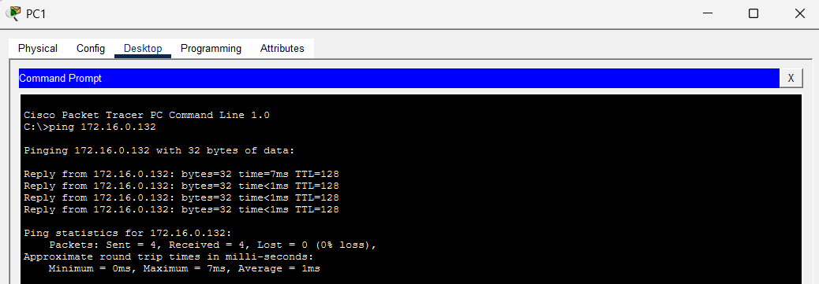
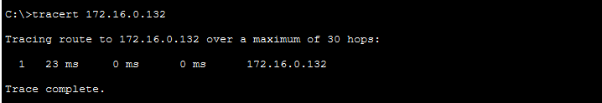

Test 2: PC1 (Main) → PC3 (Main)
Source → Destination | PC1 (Main) → PC3 (Main)
Purpose | Cross-VLAN intra-building
Command | ping <destination-IP>
Expected Result | 5/5 packets received (0% loss)
Actual Result | _____________ packets received

[ Screenshot: Ping: PC1 (Main) → PC3 (Main) ]

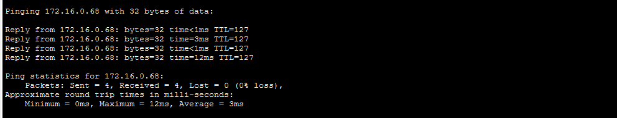

Test 3: PC1 (Main) → PC4 (S Building)
Source → Destination | PC1 (Main) → PC4 (S Building)
Purpose | Cross-building OSPF
Command | ping <destination-IP>
Expected Result | 5/5 packets received (0% loss)
Actual Result | _____________ packets received

[ Screenshot: Ping: PC1 (Main) → PC4 (S Building) ]

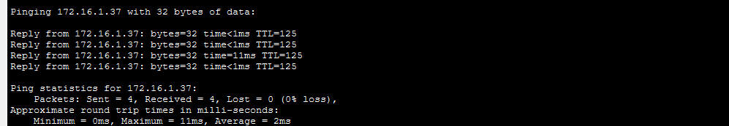

Test 4: PC1 (Main) → PC7 (N Building)
Source → Destination | PC1 (Main) → PC7 (N Building)
Purpose | OSPF ↔ EIGRP redistribution
Command | ping <destination-IP>
Expected Result | 5/5 packets received (0% loss)
Actual Result | _____________ packets received

[ Screenshot: Ping: PC1 (Main) → PC7 (N Building) ]

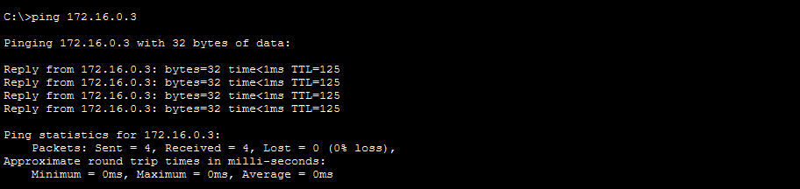

Test 5: PC4 (S Building) → PC9 (R Building)
Source → Destination | PC4 (S Building) → PC9 (R Building)
Purpose | Cross-building EIGRP
Command | ping <destination-IP>
Expected Result | 5/5 packets received (0% loss)
Actual Result | _____________ packets received

[ Screenshot: Ping: PC4 (S Building) → PC9 (R Building) ]
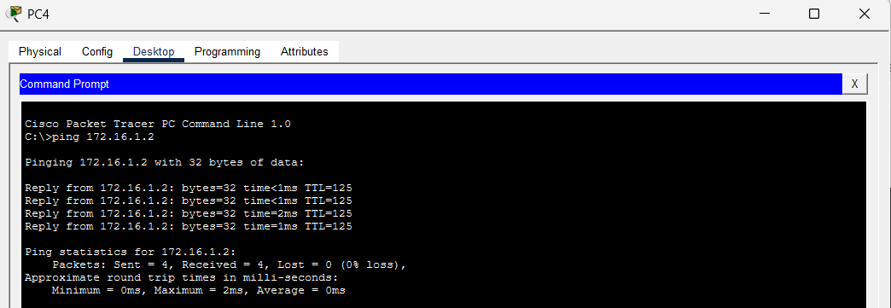

Test 6: PC1 (Main) → Web Server (172.16.1.54)
Source → Destination | PC1 (Main) → Web Server (172.x)
Purpose | Campus → Server Room
Command | ping <destination-IP>
Expected Result | 5/5 packets received (0% loss)
Actual Result | _____________ packets received

[ Screenshot: Ping: PC1 (Main) → Web Server (172.16.1.54) ]

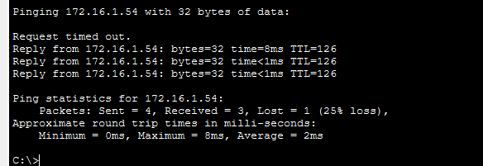

Test 7: PC1 (Main) → DNS Server (172.x)
Source → Destination | PC1 (Main) → DNS Server (172.x)
Purpose | Campus → DNS
Command | ping <destination-IP>
Expected Result | 5/5 packets received (0% loss)
Actual Result | _____________ packets received

[ Screenshot: Ping: PC1 (Main) → DNS Server (172.16.1.52) ]

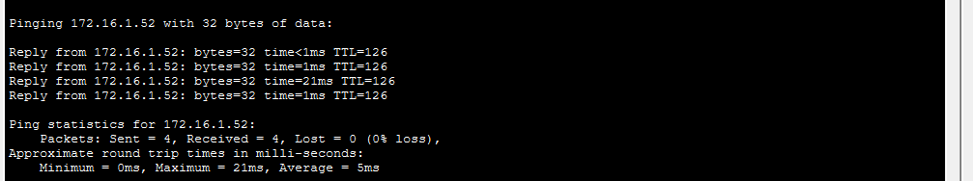

Test 8: PC1 (Main) → Branch PC11 (192.168.2.6)
Source → Destination | PC1 (Main) → Branch PC11 (192.168.2.6)
Purpose | HQ → Branch via VPN
Command | ping <destination-IP>
Expected Result | 5/5 packets received (0% loss)
Actual Result | _____________ packets received

[ Screenshot: Ping: PC1 (Main) → Branch PC11 (192.168.2.6) ]

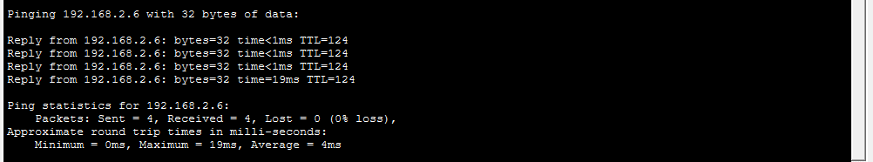

Test 9: PC1 (Main) → Branch PC12 (192.168.3.x)
Source → Destination | PC1 (Main) → Branch PC12 (192.168.3.x)
Purpose | HQ → Branch VLAN 3 via VPN
Command | ping <destination-IP>
Expected Result | 5/5 packets received (0% loss)
Actual Result | _____________ packets received

[ Screenshot: Ping: PC1 (Main) → Branch PC12 (192.168.3.6) ]

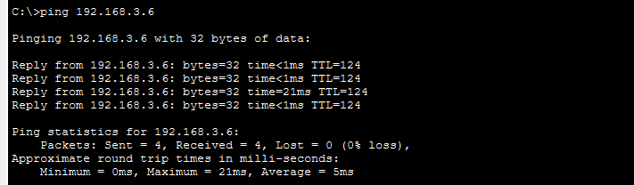

Test 10: Laptop (Home) → Web Server
Source → Destination | Laptop (Home) → Web Server (209.165.200.227)
Purpose | Home Network → HQ via Internet
Command | ping <destination-IP>
Expected Result | 5/5 packets received (0% loss)
Actual Result | _____________ packets received

[ Screenshot: Ping: Laptop (Home) → Web Server ]

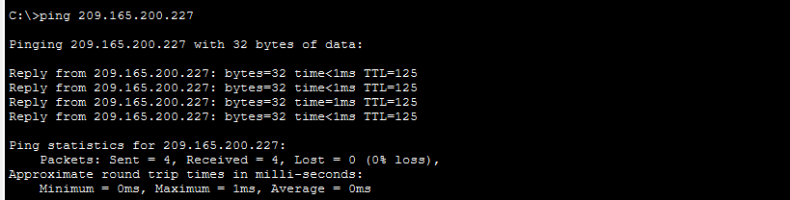
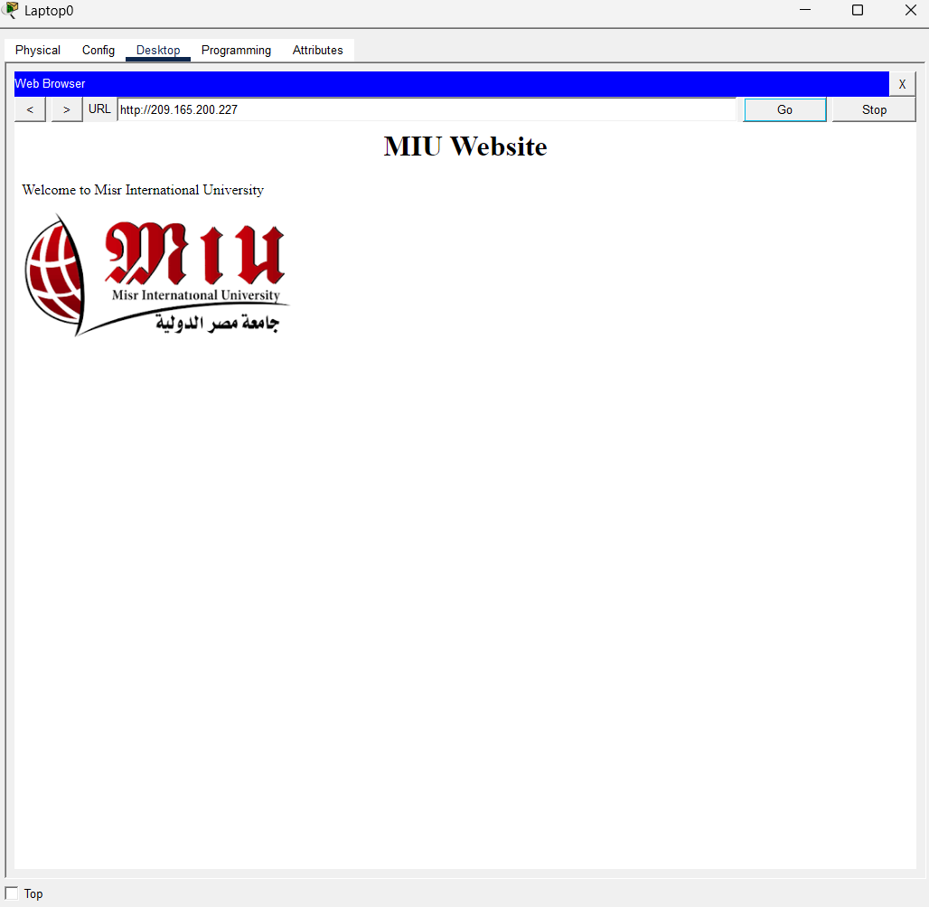

10.b — IP Interface Display (show ip interface brief)
The following tables and screenshots document the IP address assigned to each interface on each device in the network.

MIU-GW (2911)
Commands used:
- show ip route
- show ip interface brief
- show crypto isakmp sa
- show crypto ipsec sa

[ Screenshot: MIU_GW (2911) — show ip interface brief ]

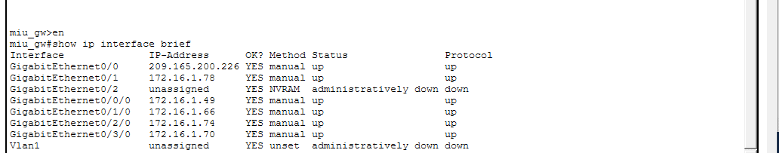
[ Screenshot: MIU_GW (2911) — show ip interface route ]

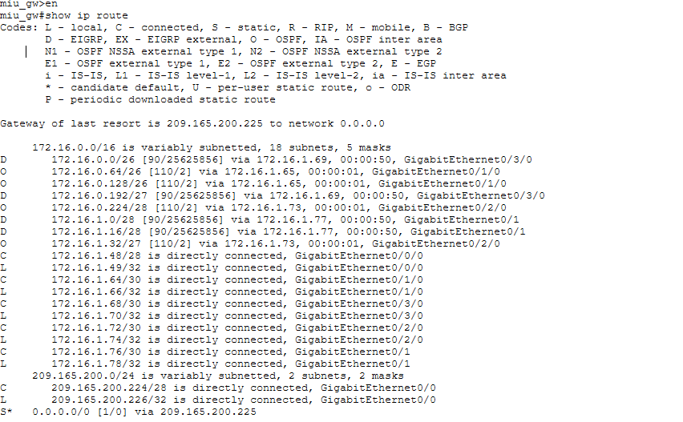
[ Screenshot: MIU_GW (2911) — show crypto isakmp sa ]

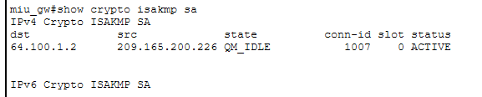

[ Screenshot: MIU_GW (2911) — show crypto ipsec sa]

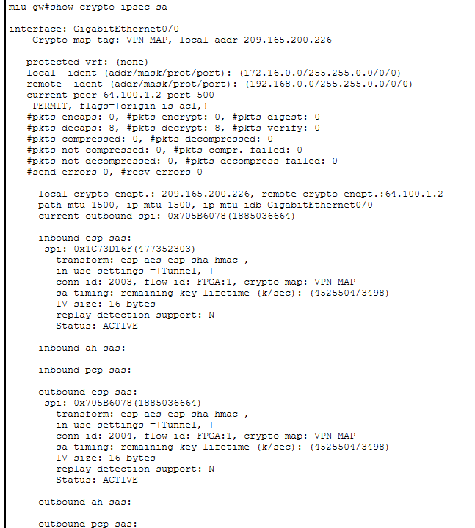

Branch_GW (2911)
Commands used:
- show ip route
- show ip interface brief
- show crypto isakmp sa

[ Screenshot: Branch_GW (2911) —show crypto isakmp sa]
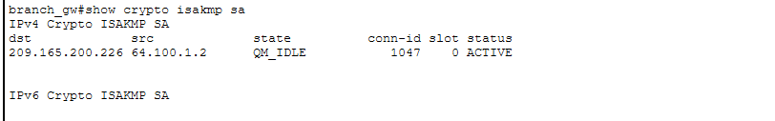
[ Screenshot: Branch_GW (2911) — show ip interface brief ]

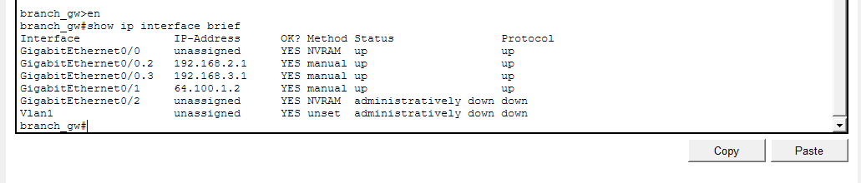
[ Screenshot: Branch_GW (2911) — show ip route ]

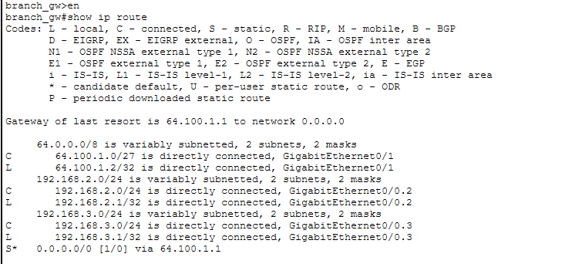

ISP Router
Commands used:
- show ip route
- show ip interface brief

[ Screenshot: ISP Router — show ip interface brief ]

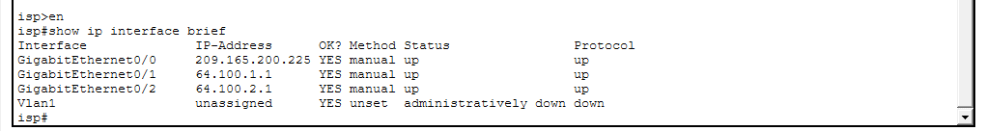
[ Screenshot: ISP Router — show ip route ]
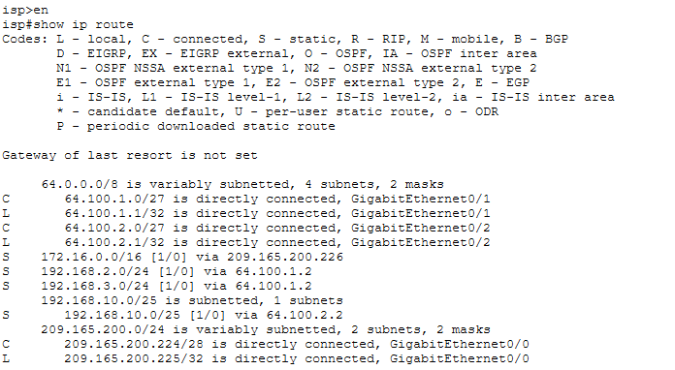

Main-MLS
Commands used:
- show ip route
- show ip interface brief
- show vlan brief

[ Screenshot: Main-MLS — show ip interface brief ]

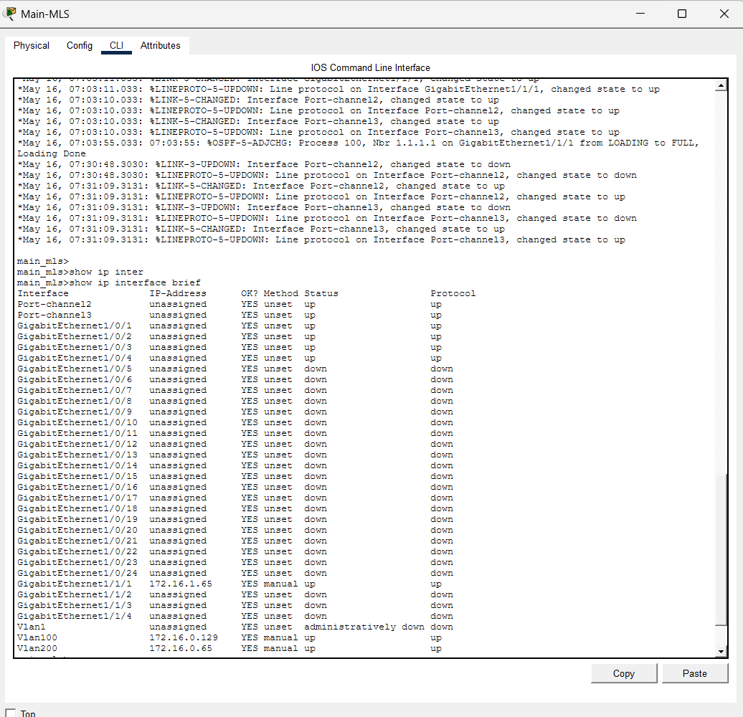

[ Screenshot: Main-MLS — show ip route ]

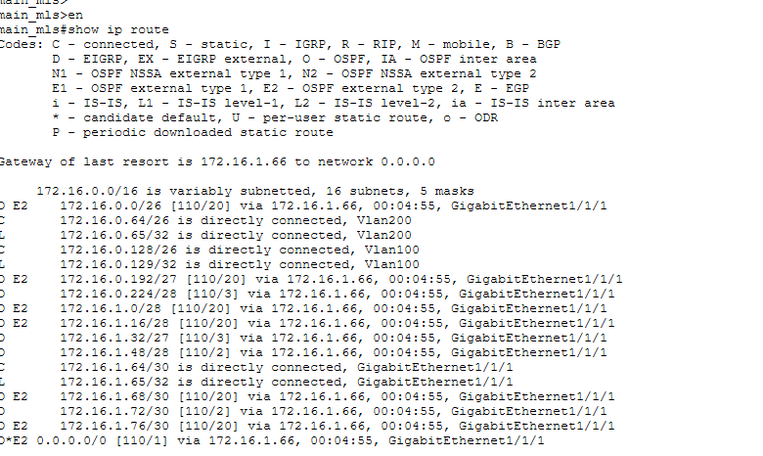

[ Screenshot: Main-MLS — show vlan brief ]

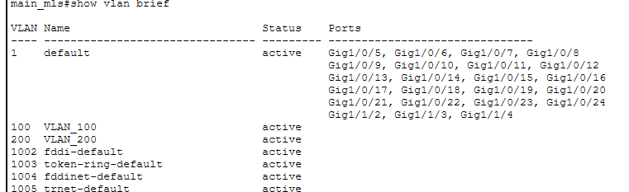

S-MLS
Commands used:
- show ip route
- show ip interface brief
- show vlan brief

[ Screenshot: S-MLS — show ip interface brief ]

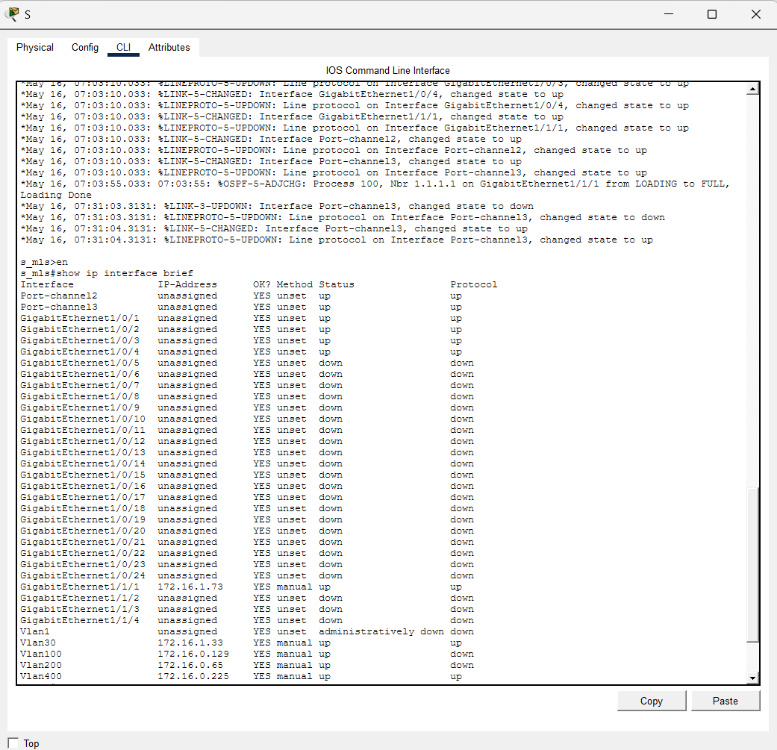

[ Screenshot: S-MLS — show ip route]

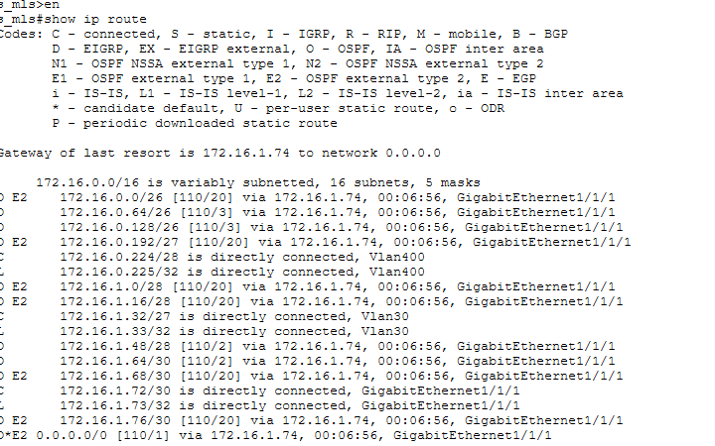

[ Screenshot: S-MLS — show vlan brief]

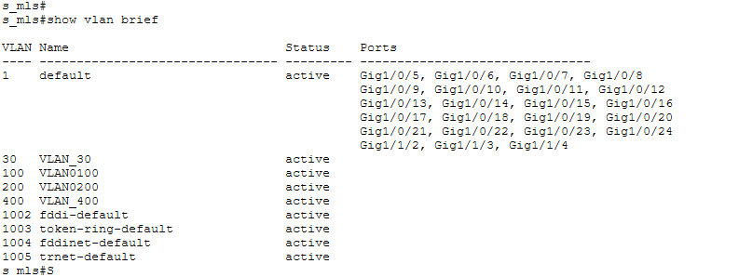

N-MLS
Commands used:
- show ip route
- show ip interface brief
- show vlan brief

[ Screenshot: N-MLS — show ip interface brief ]

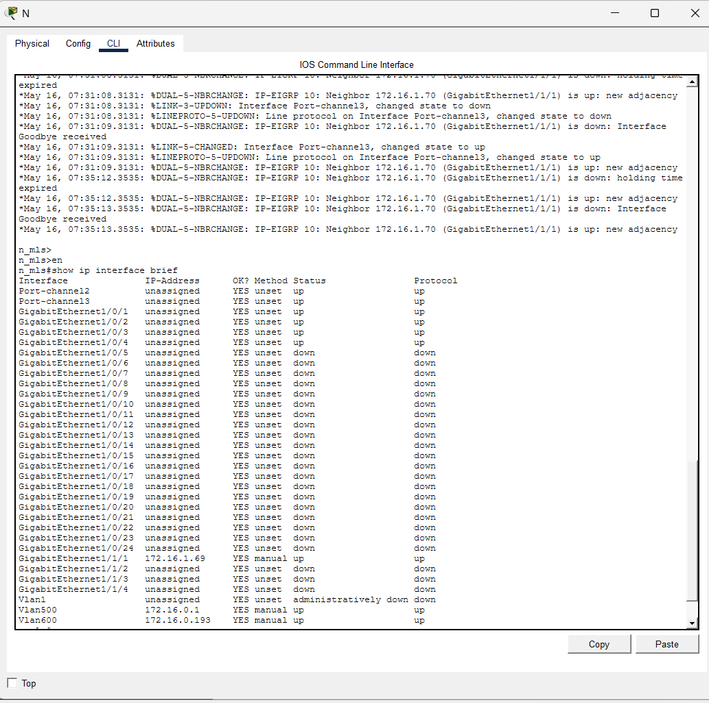

[ Screenshot: N-MLS — show ip route ]
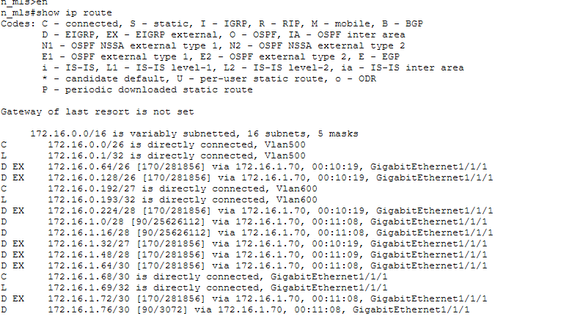

[ Screenshot: N-MLS — show vlan brief ]
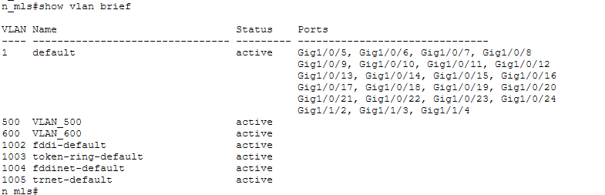

R-MLS
Commands used:
- show ip route
- show ip interface brief
- show vlan brief

[ Screenshot: R-MLS — show ip interface brief ]

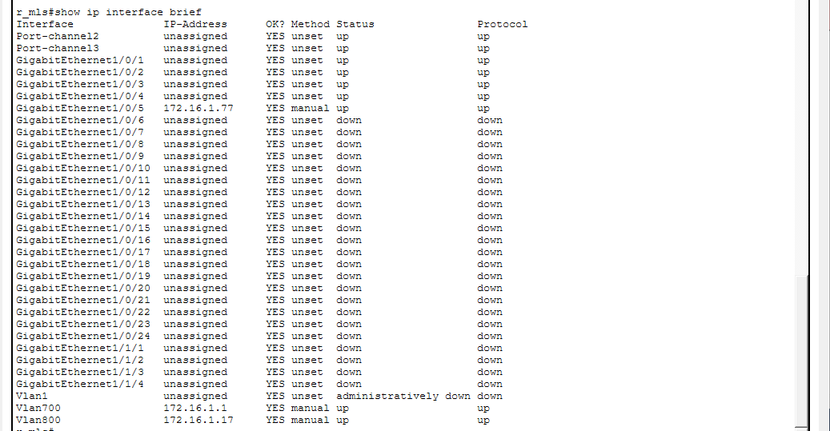

[ Screenshot: R-MLS — show ip route]

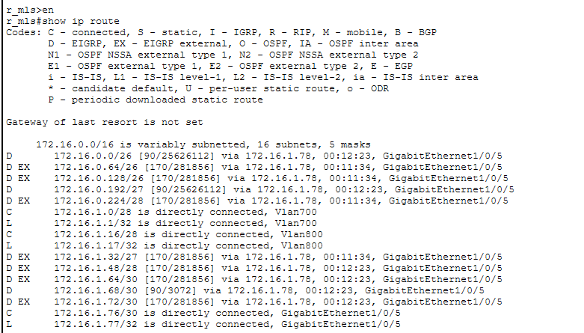

[ Screenshot: R-MLS — show vlan brief]

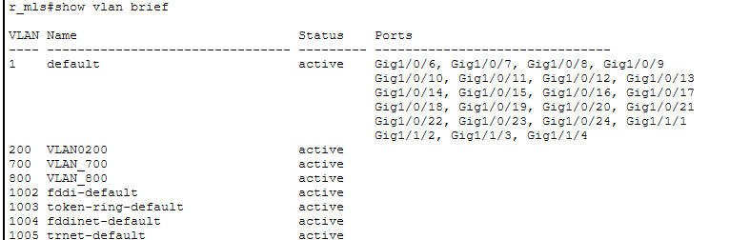

10.d — Routing Tables (show ip route)
Routing tables were captured for all routers after full convergence of OSPF and EIGRP protocols and after VPN tunnel establishment.

MIU-GW (2911) — Routing Table
[ Screenshot: MIU-GW (2911) — show ip route ]

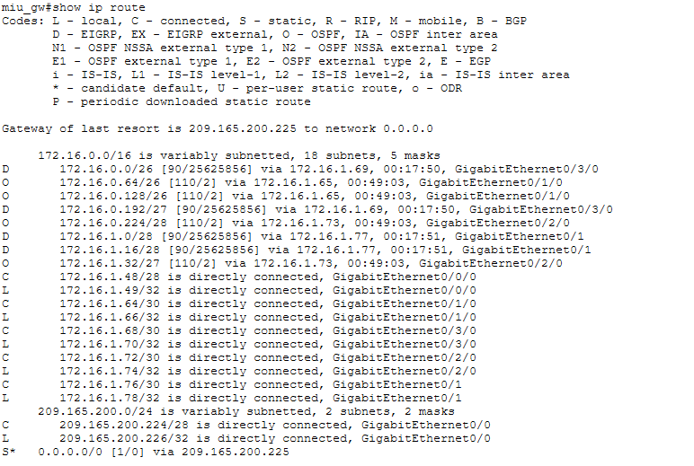

📌 Note: Verify OSPF routes show 'O', EIGRP routes show 'D', static/default routes show 'S'.

Branch_GW (2911) — Routing Table
[ Screenshot: Branch_GW (2911) — show ip route ]
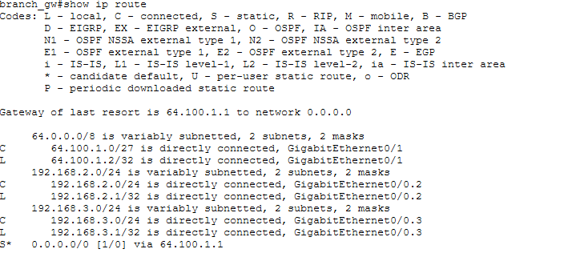

📌 Note: Verify OSPF routes show 'O', EIGRP routes show 'D', static/default routes show 'S'.

ISP Router — Routing Table
[ Screenshot: ISP Router — show ip route ]

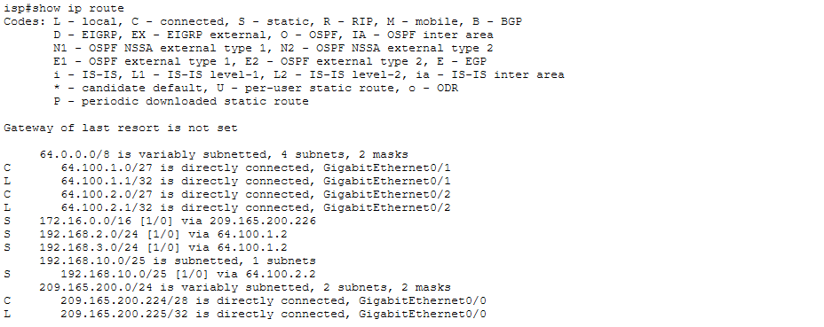

📌 Note: Verify OSPF routes show 'O', EIGRP routes show 'D', static/default routes show 'S'.

Main-MLS — Routing Table
[ Screenshot: Main-MLS — show ip route ]

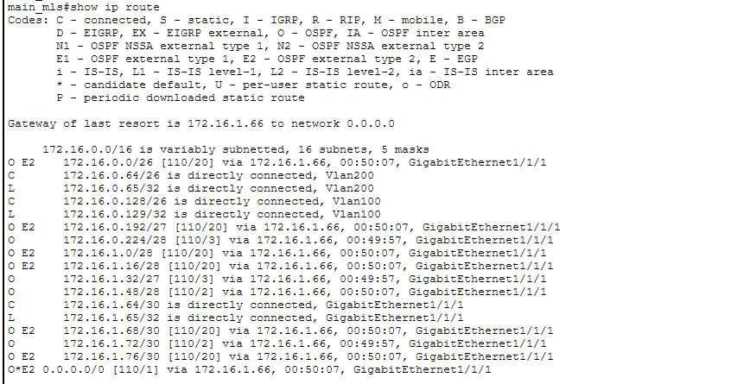

📌 Note: Verify OSPF routes show 'O', EIGRP routes show 'D', static/default routes show 'S'.

S-MLS — Routing Table
[ Screenshot: S-MLS — show ip route ]
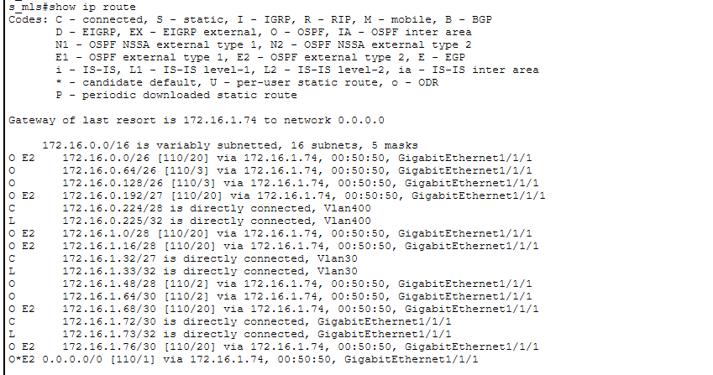

📌 Note: Verify OSPF routes show 'O', EIGRP routes show 'D', static/default routes show 'S'.

N-MLS — Routing Table
[ Screenshot: N-MLS — show ip route ]
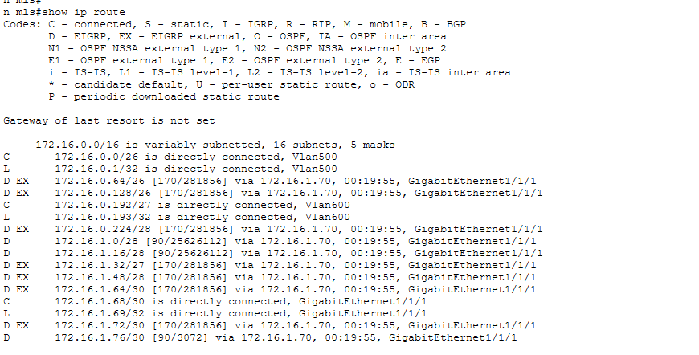

📌 Note: Verify OSPF routes show 'O', EIGRP routes show 'D', static/default routes show 'S'.

R-MLS — Routing Table
[ Screenshot: R-MLS — show ip route ]

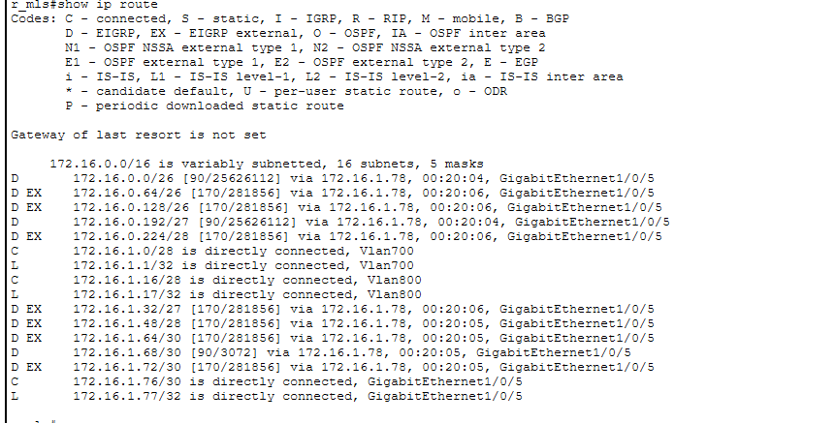

📌 Note: Verify OSPF routes show 'O', EIGRP routes show 'D', static/default routes show 'S'.

Part 11: Documentation and Handover
This section provides complete configuration documentation for all implemented parts of the MIU Campus Network project, including device configurations, routing protocols, VLANs, VPN, DHCP, and services.

11.1 — Network Overview
Parameter | Value
Network Address | 172.16.0.0/16
Routing Protocol (Main/S Buildings) | OSPF
Routing Protocol (N/R Buildings) | EIGRP
WAN Connectivity | ISP — 209.165.200.224/28 (Public)
VPN Type | Site-to-Site IPsec VPN
Branch Network | 192.168.2.0/24 (VLAN 2), 192.168.3.0/24 (VLAN 3)
Home Network | 192.168.10.0/25
Internet Access | NAT/PAT via MIU-GW

11.2 — Building Configurations

Main Building
Routing Protocol | OSPF
VLANs | VLAN 100 (31 hosts), VLAN 200 (40 hosts)
Devices | Main-MLS, Main-SW1, Main-SW2, PC1, PC2, PC3

MLS Switch Configuration (Inter-VLAN Routing):
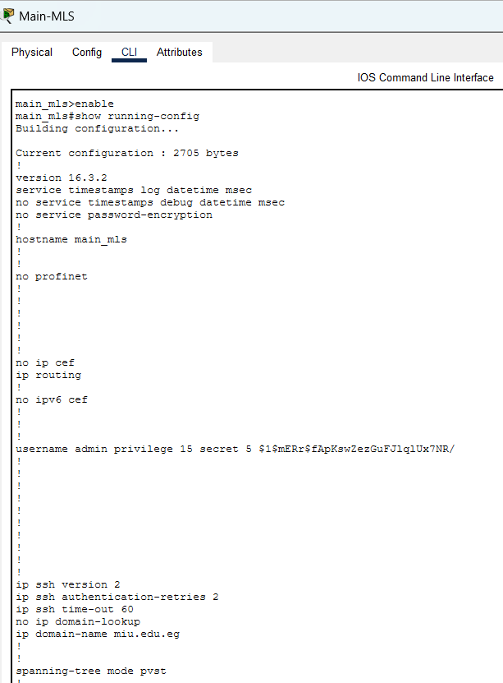
[ Screenshot: Main Building — MLS running-config ]

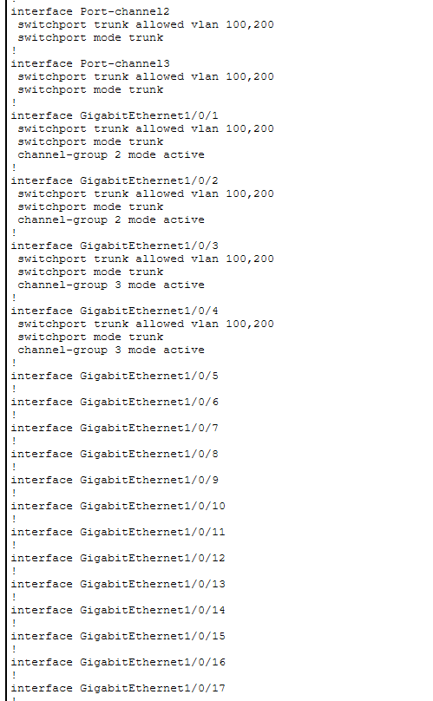

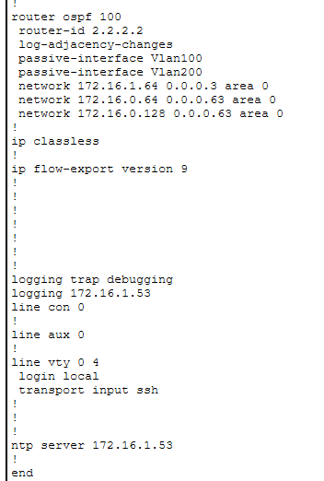
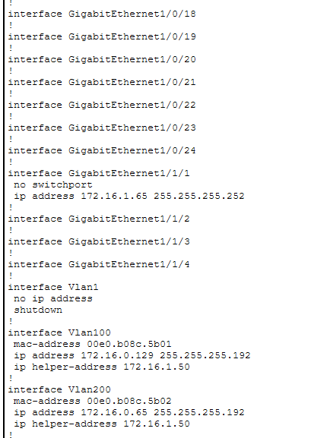

Access Switch Configuration (VLAN & Port Assignment):
[ Screenshot: Main Building — Access Switch running-config ]
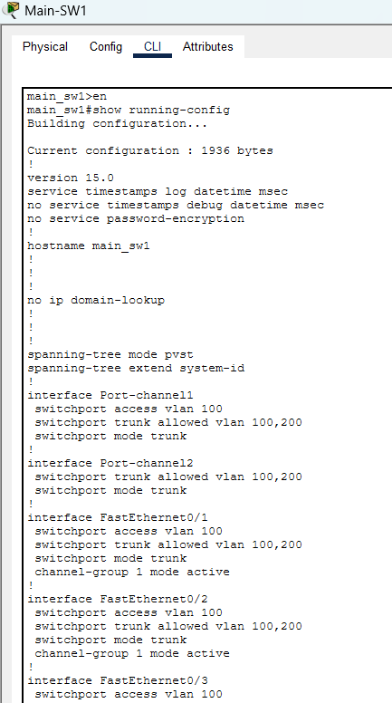
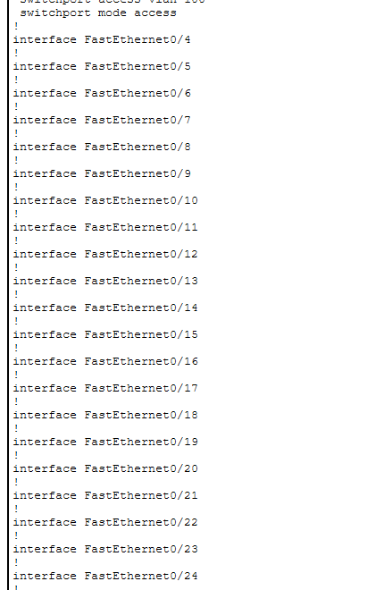
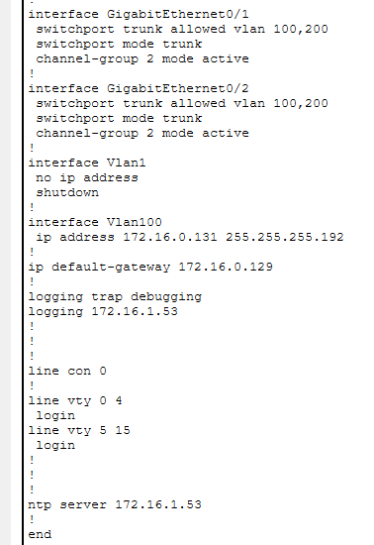

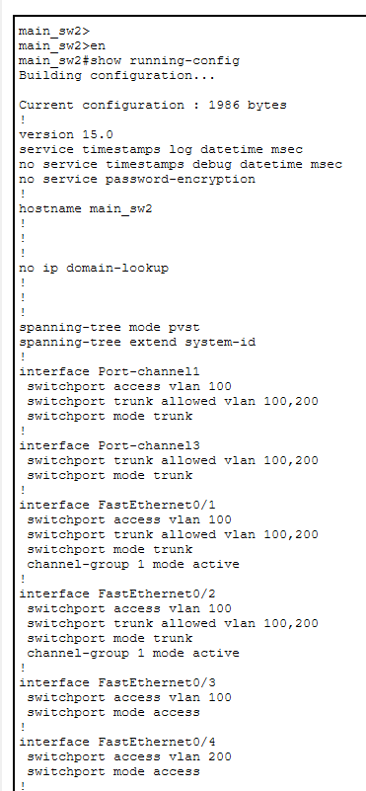
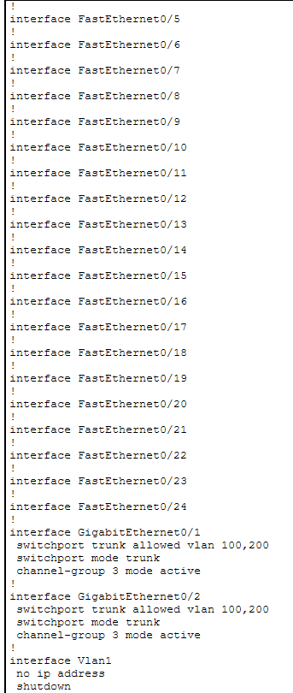

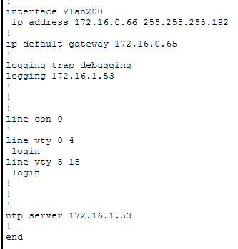

S Building
Routing Protocol | OSPF
VLANs | VLAN 30 (7 hosts), VLAN 30 (15 hosts)
Devices | S-MLS, S-SW1, S-SW2, PC4, PC5, PC6

MLS Switch Configuration (Inter-VLAN Routing):
[ Screenshot: S Building — MLS running-config ]
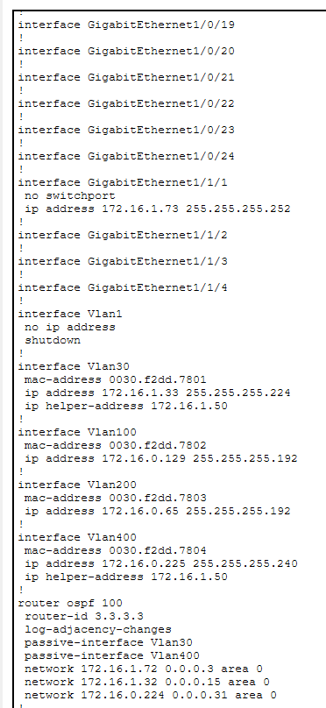
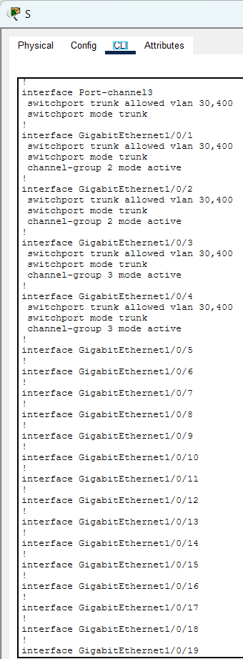
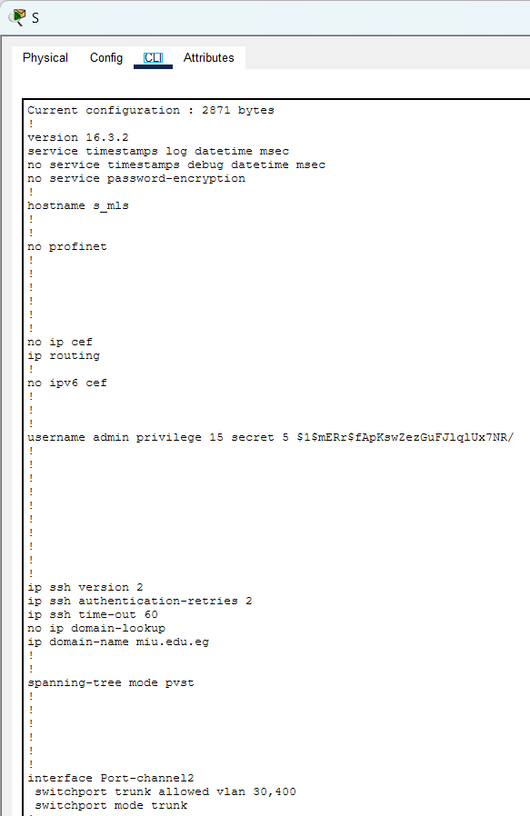

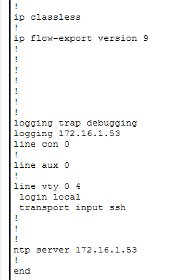

Access Switch Configuration (VLAN & Port Assignment):
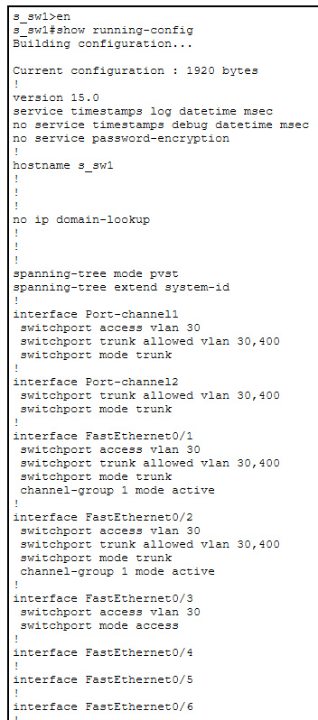
[ Screenshot: S Building — Access Switch running-config ]
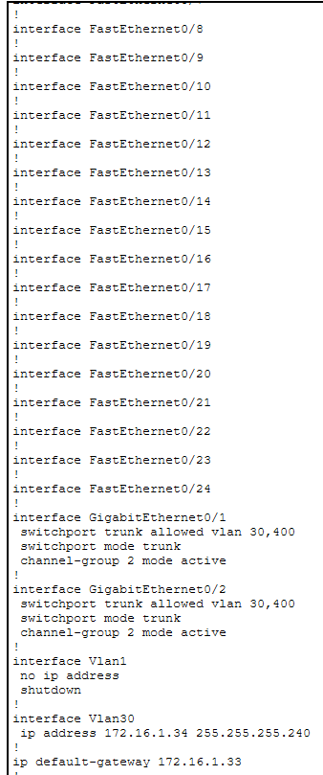

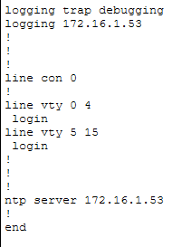

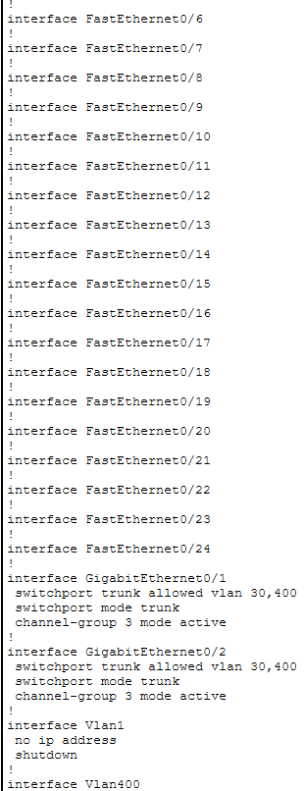
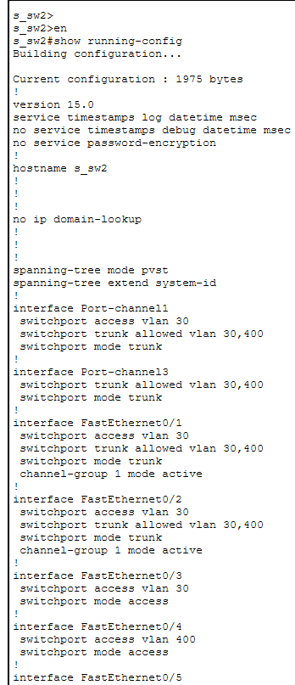

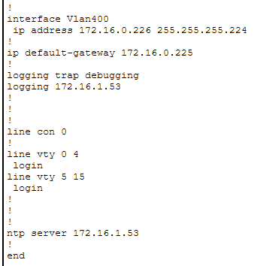

N Building
Routing Protocol | EIGRP
VLANs | VLAN 500 (61 hosts), VLAN 600 (25 hosts)
Devices | N-MLS, N-SW1, N-SW2, PC7, PC8

MLS Switch Configuration (Inter-VLAN Routing):
[ Screenshot: N Building — MLS running-config ]
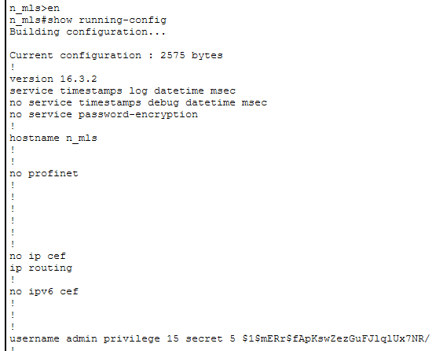
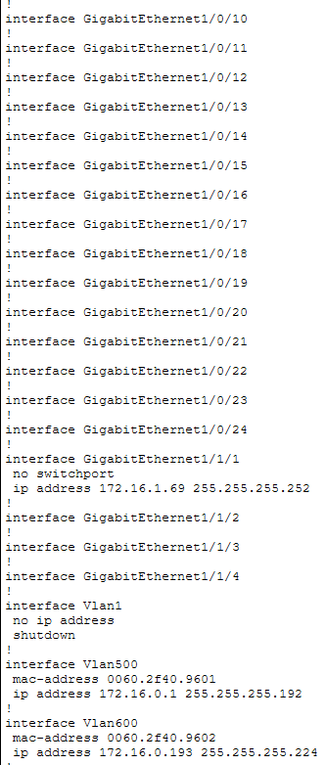
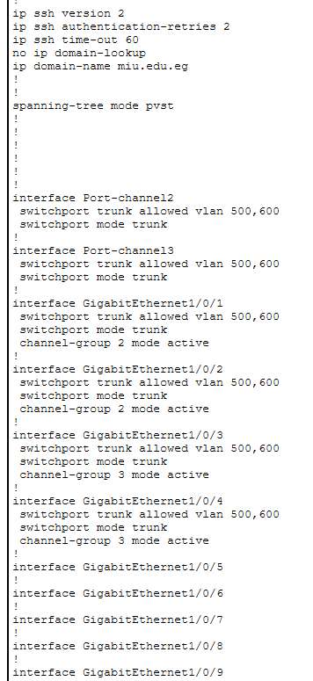

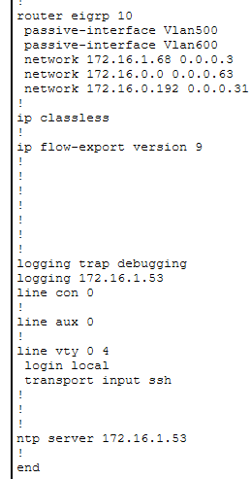

Access Switch Configuration (VLAN & Port Assignment):
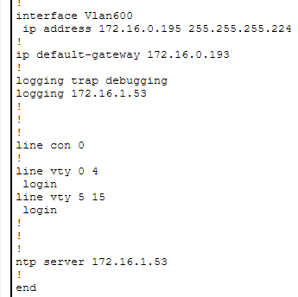
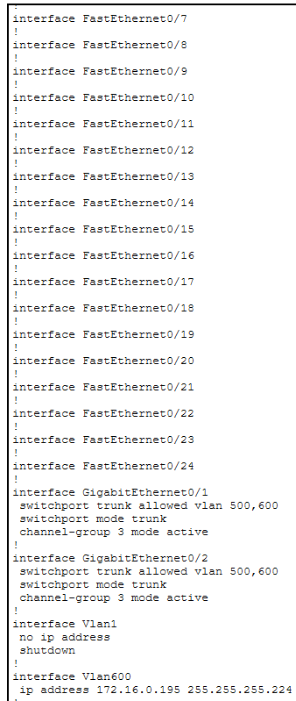
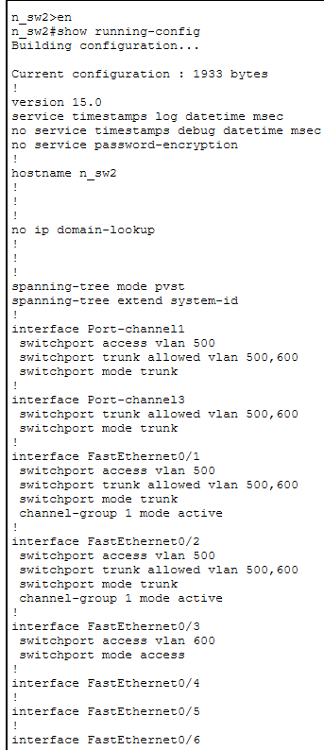
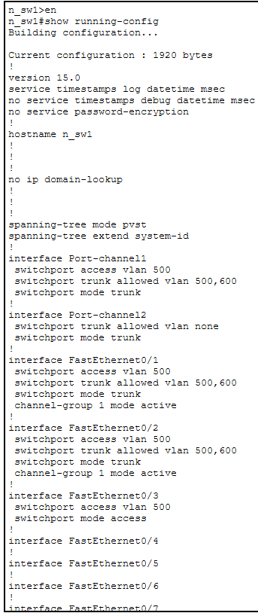
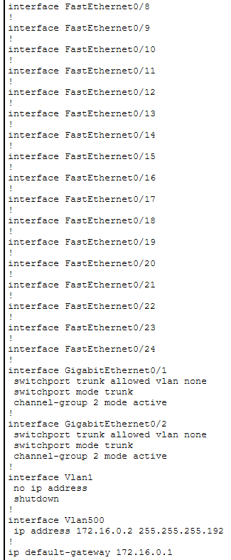
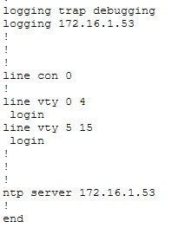
[ Screenshot: N Building — Access Switch running-config ]

R Building
Routing Protocol | EIGRP
VLANs | VLAN 700 (12 hosts), VLAN 800 (8 hosts)
Devices | R-MLS, R-SW1, R-SW2, PC9, PC10

MLS Switch Configuration (Inter-VLAN Routing):
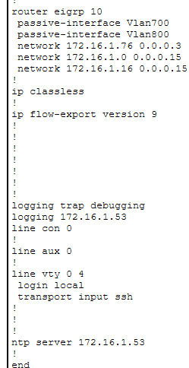
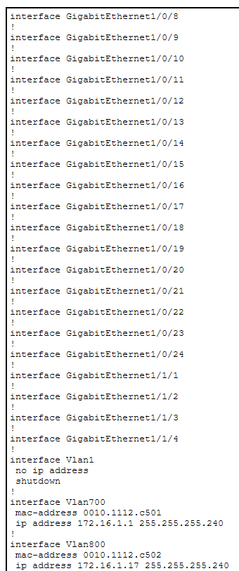
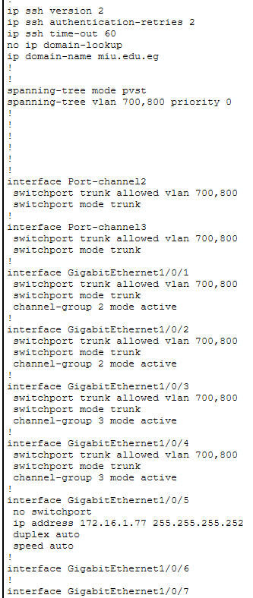
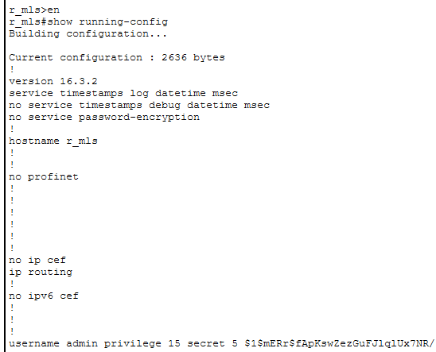
[ Screenshot: R Building — MLS running-config ]

Access Switch Configuration (VLAN & Port Assignment):
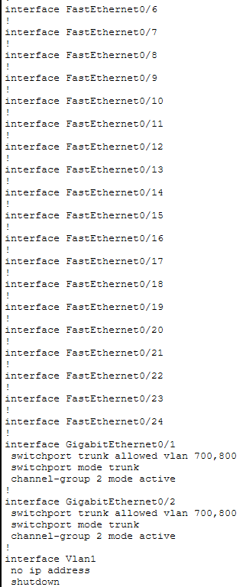
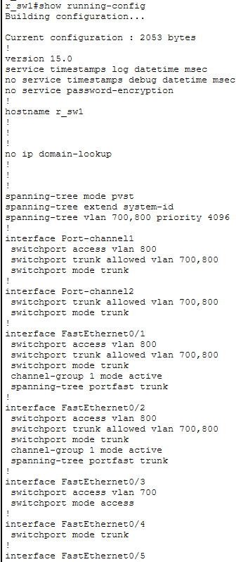
[ Screenshot: R Building — Access Switch running-config ]
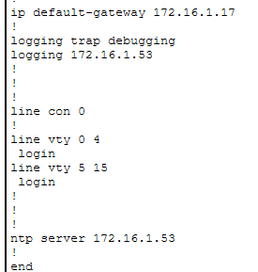
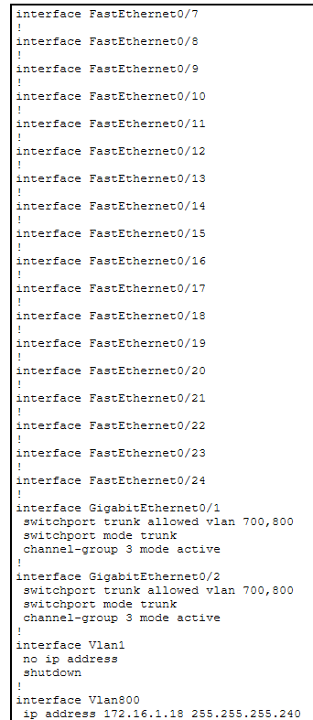
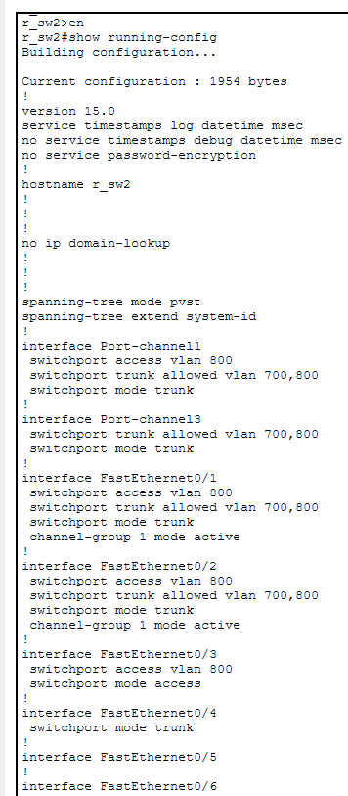
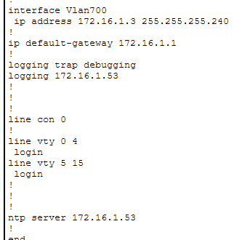

11.3 — Servers Room Configuration
Server | Service
DHCP Server | Dynamic IP for all VLANs
Email Server | mlu.edu.eg
Web Server | HTTP/HTTPS
DNS Server | DNS resolution
NTP Server | Time synchronization
Syslog Server | Centralized logging

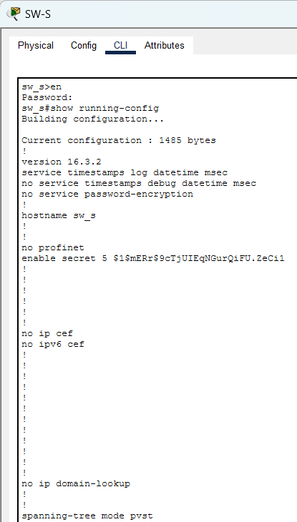
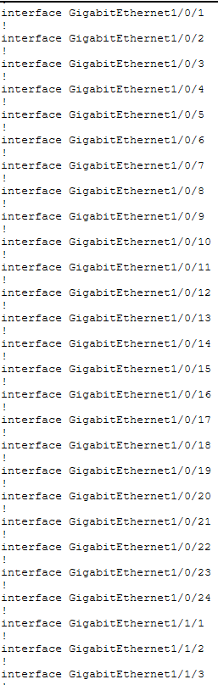
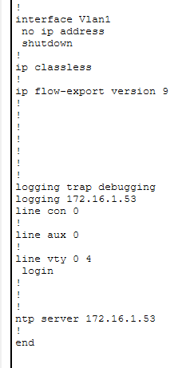
[ Screenshot: Server Room — SW-S Configuration ]

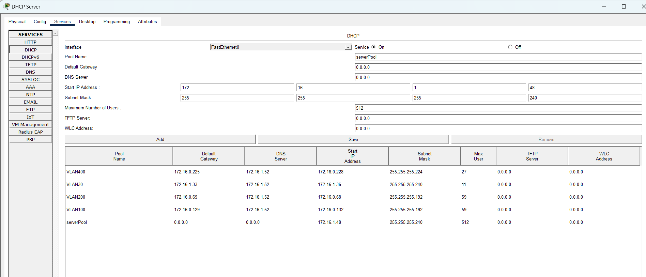
[ Screenshot: DHCP Server — Pool Configuration ]

[ Screenshot: DNS Server — A Records ]

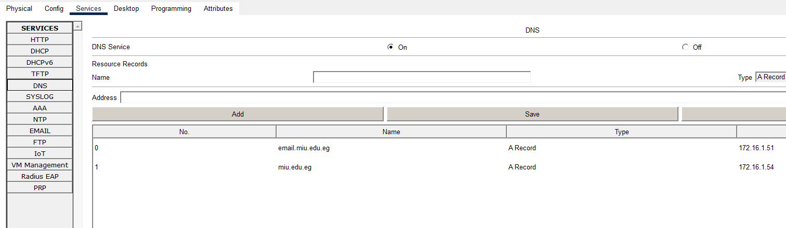

11.4 — Site-to-Site VPN Configuration
IPsec VPN tunnel established between MIU-GW and Branch_GW over the public internet.

Parameter | Value
VPN Type | Site-to-Site IPsec
HQ Public IP | 209.165.200.226/28
Branch Public IP | 64.100.1.2/27
Encryption | AES / 3DES
Hashing | SHA / MD5
IKE Phase 1 | ISAKMP Policy
IKE Phase 2 | IPsec Transform Set
Interesting Traffic | HQ subnets ↔ Branch subnets

[ Screenshot: MIU-GW — VPN Configuration (crypto map, isakmp) ]
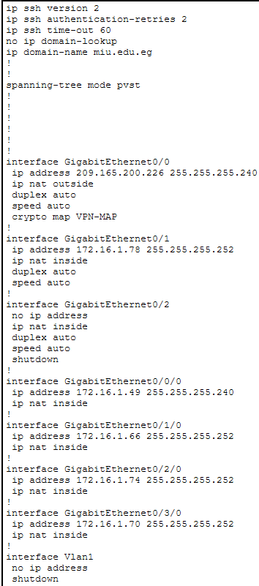
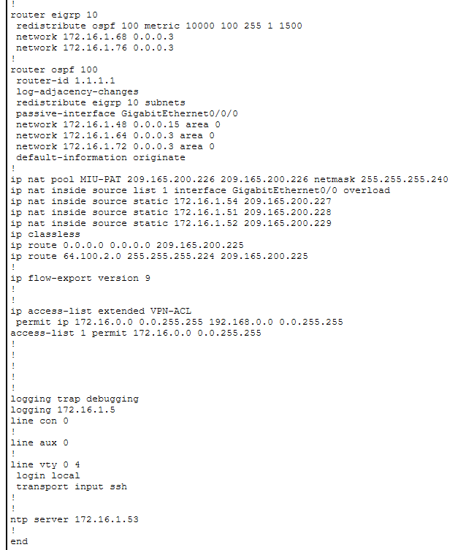
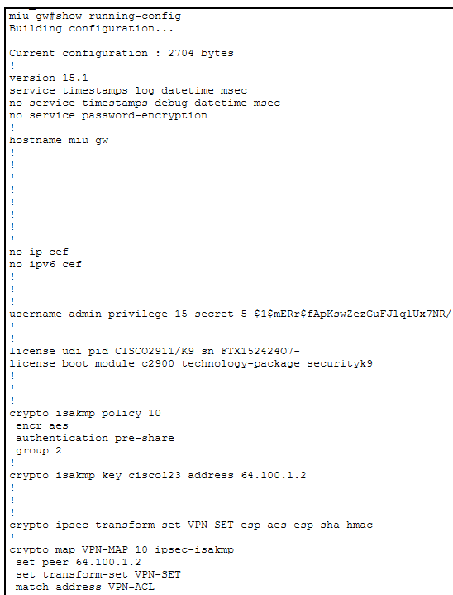

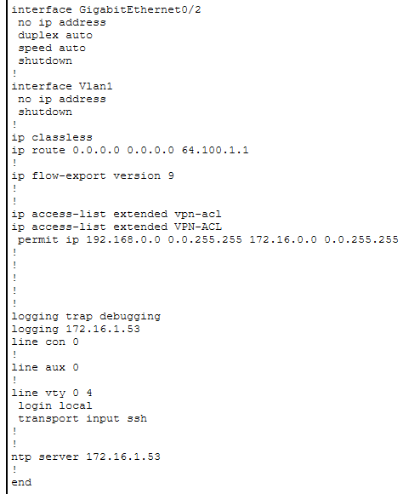
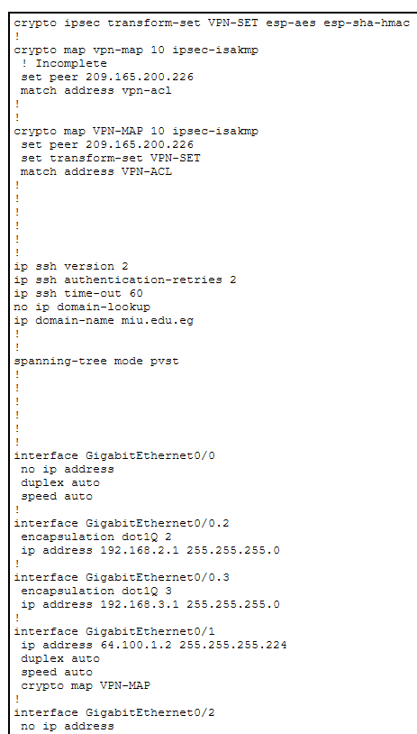
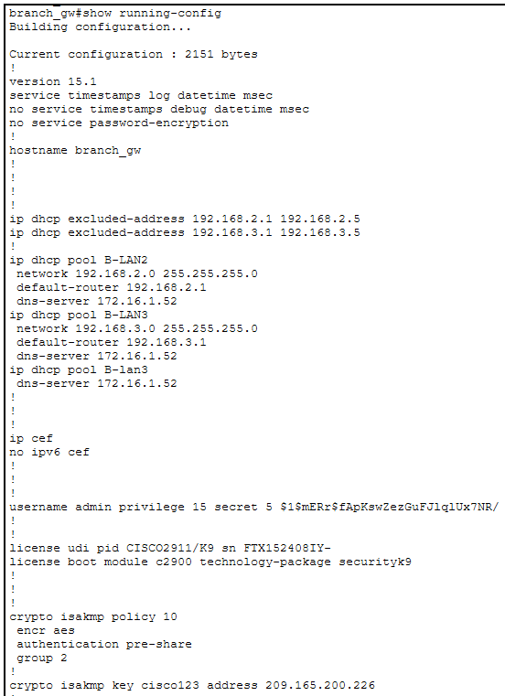
[ Screenshot: Branch_GW — VPN Configuration ]

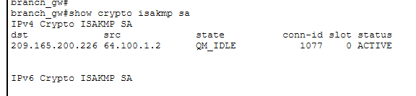
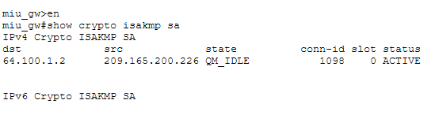
[ Screenshot: show crypto isakmp sa — Tunnel Established ]

11.5 — Home Network Configuration
Parameter | Value
Wireless Router WAN IP | 64.100.2.2/27
LAN Subnet | 192.168.10.0/25
DHCP | Enabled on wireless router
Devices | Laptop, Smartphone, Tablet, IoT PC

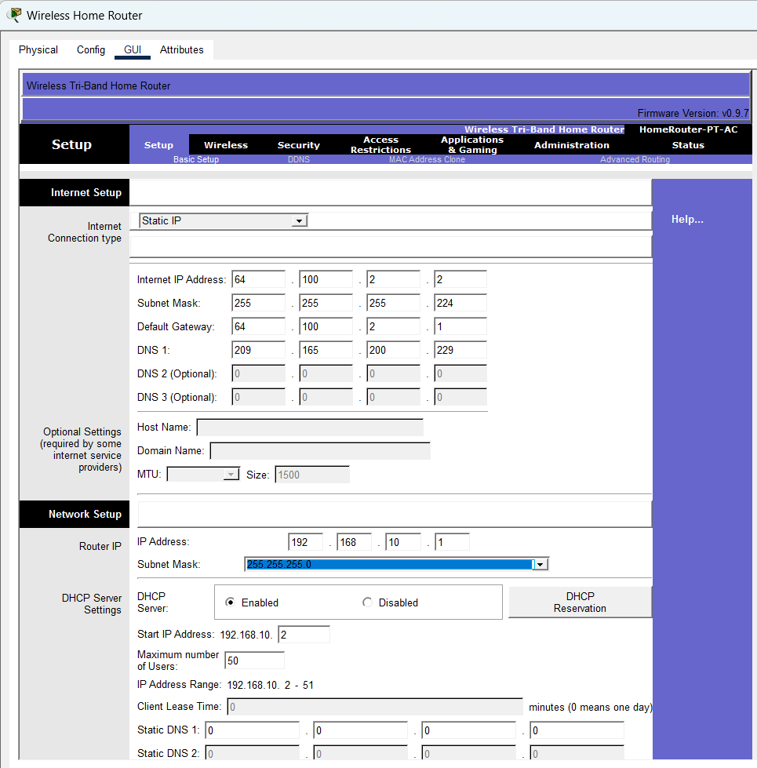
[ Screenshot: Wireless Home Router — Configuration ]

11.6 — Traceroute Tests
Traceroute was used to verify the path packets take across the network, confirming correct routing through OSPF, EIGRP, and the VPN tunnel.

Traceroute 1: PC1 → Web Server (via OSPF + Server Room)
[ Screenshot: traceroute: PC1 → Web Server (via OSPF + Server Room) ]
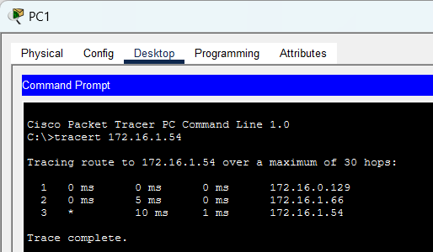

Traceroute 2: PC7 → PC9 (N Building → R Building via EIGRP)
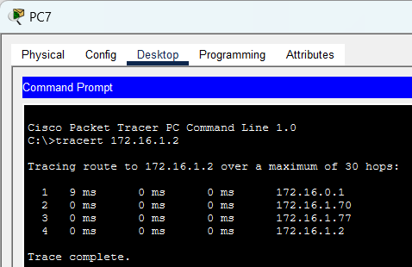
[ Screenshot: traceroute: PC7 → PC9 (N Building → R Building via EIGRP) ]

Traceroute 3: PC1 → Branch PC11 (via VPN tunnel)
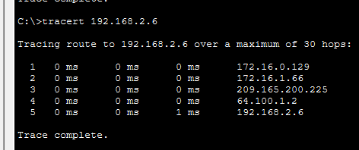
[ Screenshot: traceroute: PC1 → Branch PC11 (via VPN tunnel) ]

Traceroute 4: Laptop → Web Server (Home → ISP → HQ)
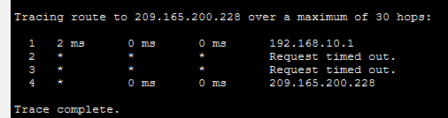
[ Screenshot: traceroute: Laptop → Web Server (Home → ISP → HQ) ]

— End of Document —

