As a conclusion, CAMshift and HAAR Cascade are two different methods used for detection ; the first one is used for tracking the specified object detected with the second method, so even if there is a permanent movement of the object that we want to detect ,with the collaboration of this two methods the detection will be succeeded .

1.3 Face recognition methods :

We have developed a near-real-time computer system that can locate and track a subject's head, and then recognize the person by comparing characteristics of the face to those of known individuals. The technology of face recognition has become mature within these few years. System, using the face recognition, has become true in real life. In this paper, we will have a comparative study of three most recently methods for face recognition. One of the approach is eigenface, fisherfaces and other one is the Local Binary Patterns Histograms (LBPH). After the implementation of the above three methods, we learn the advantages and Disadvantages of each approach and the difficulties for the implementation.

1.3.1 The Eigenfaces method :

Eigenfaces is the name given to a set of [eigenvectors](https://en.wikipedia.org/wiki/Eigenvector) when they are used in the [computer vision](https://en.wikipedia.org/wiki/Computer_vision) problem of human [face recognition](https://en.wikipedia.org/wiki/Facial_recognition_system). The approach of using eigenfaces for [recognition](https://en.wikipedia.org/wiki/Facial_recognition_system) was developed by Sirovich and Kirby (1987) and used by Matthew Turk and [Alex Pentland](https://en.wikipedia.org/wiki/Alex_Pentland) in face classification. The eigenvectors are derived from the [covariance matrix](https://en.wikipedia.org/wiki/Covariance_matrix) of the [probability distribution](https://en.wikipedia.org/wiki/Probability_distribution) over the high-[dimensional](https://en.wikipedia.org/wiki/Dimension) [vector space](https://en.wikipedia.org/wiki/Vector_space) of face images.

• Individual features  
– eyes, nose, mouth, head outline  
– position and size relationships  
• Disadvantages  
– multiple views  
– fragile and complex

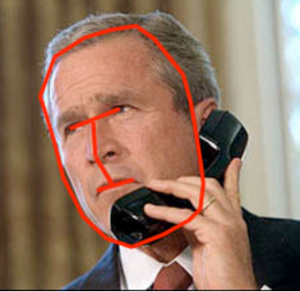

The eigenface approach  
– images are points in a vector space  
– use PCA to reduce dimensionality face space  
– compare projections into face space to recognize faces

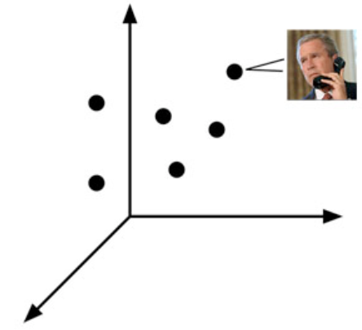

1.3.2 The Fisherfaces method:

Fisherface Concept-Differing from the Eigenface concept, the fisherface method tries to maximize the ratio of the between-class scatter versus the within-class scatter . The result of this shapes the projections so that the distances between the classes are at a maximum, while the distances between samples of the same class are at a minimum. A possible disadvantage is if the between-class scatter is large, then the within-class scatter might also still be of a relatively  
large value.

Conclusion :

Eigenfaces and Fisherfaces take a somewhat holistic approach to face recognition. You treat your data as a vector somewhere in a high-dimensional image space. We all know high-dimensionality is bad, so a lower-dimensional subspace is identified, where (probably) useful information is preserved. The Eigenfaces approach maximizes the total scatter, which can lead to problems if the variance is generated by an external source, because components with a maximum variance over all classes aren’t necessarily useful for classification. So to preserve some discriminative information we applied a Linear Discriminant Analysis and optimized as described in the Fisherfaces method. The Fisherfaces method worked great... at least for the constrained scenario we’ve assumed in our model.

Now real life isn’t perfect. You simply can’t guarantee perfect light settings in your images or 10 different images of a person. So what if there’s only one image for each person? Our covariance estimates for the subspace may be horribly wrong, so will the recognition. Remember the Eigenfaces method had a 96% recognition rate. How many images do we actually need to get such useful estimates?

[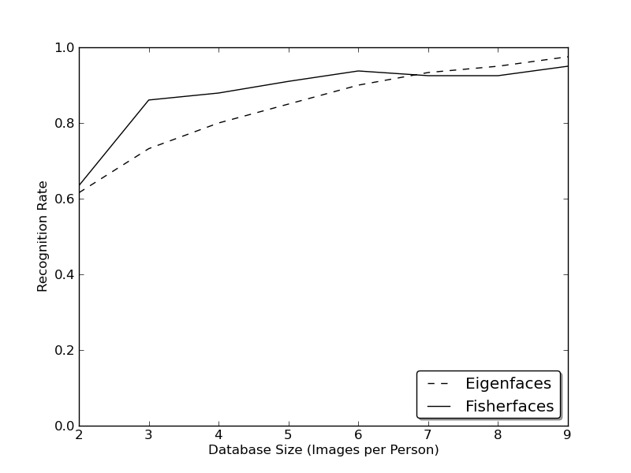](http://docs.opencv.org/2.4/_images/at_database_small_sample_size.png)

So in order to get good recognition rates you’ll need at least 8(+-1) images for each person and the Fisherfaces method doesn’t really help here. The above experiment is a 10-fold cross validated result carried.

So some research concentrated on extracting local features from images. The idea is to not look at the whole image as a high-dimensional vector, but describe only local features of an object. The features you extract this way will have a low-dimensionality implicitly. But you’ll soon observe the image representation we are given doesn’t only suffer from illumination variations. Think of things like scale, translation or rotation in images - your local description has to be at least a bit robust against those things. the Local Binary Patterns methodology has its roots in 2D texture analysis. The basic idea of Local Binary Patterns is to summarize the local structure in an image by comparing each pixel with its neighborhood. Take a pixel as center and threshold its neighbors against. If the intensity of the center pixel is greater-equal its neighbor, then denote it with 1 and 0 if not. You’ll end up with a binary number for each pixel, just like 11001111. So with 8 surrounding pixels you’ll end up with 2^8 possible combinations, called Local Binary Patterns or sometimes referred to as LBP codes. For example a LBP operator described in literature used a fixed 3 x 3 neighborhood just like this:

[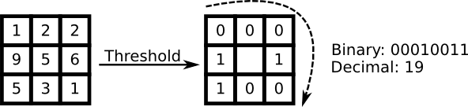](http://docs.opencv.org/2.4/_images/lbp.png)

1.3.3 Local Binary Patterns :

Local Binary Pattern used in face recognition was proposed by Ahonen . The method provide information about the shape and the texture. The original LBP operator labels the pixels of an image by thresholding the 3∗3-neighbourhood of each pixel with the center value and consider the results as a binary number, and we make a histogram to describe the image. Here we use the extension to original operator called uniform pattern. A LBP is called uniform if it contains at most two bitwise transitions from 0 to 1. With this criteria, the number of bins of different patterns reduced from 256 to 59, 58 bins for different uniform patterns, and one bin for nonuniform patterns. A image is divided by p ∗ p patches, each of them have a histogram of LBP. The histogram will be concatenated as a p ∗ p ∗ 59vector feature descriptor.  
The parameters are the divided number p, and the inputimages pixel d. In the experiment, we find out if p is bigger, the result always be better. The image size 64 ∗ 64 is most suitable for all cases. In the end, we decide d = 64 ∗ 64 and p = 8 for testing. Moreover, LBP reaches a highest accuracy.