CamShift is a tracking algorithm, which is based on MeanShift algorithm, what camShift do is nothing but do meanShift in every single frame of a video, and record the results we got by meanShift.
- CamShift algorithm includes these three parts:
- 1. Back Projection
- 2. MeanShift
- 3. Track
1. Back Projection.
Back projection is a method which use the histogram of an image to show up the probabilities of colors may appear in each pixel.
First we transform the picture space to HSV space (or any space which include a H channel that represent the hue of each pixel, of course, value of hue is between 0 to 180) Secondly, we split the H channel out, as a single grayscale image, and get its histogram, and normalize it. Thirdly, use “calcBackProject()” function to calculate the back projection of the image.
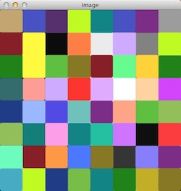
Example:
this is an example to explain how we get the back projection.

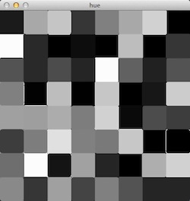
transform the picture into HSV space and here is the hue channel:

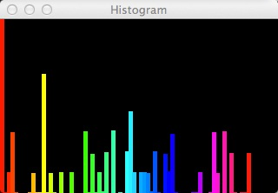
This is its histogram looks like:

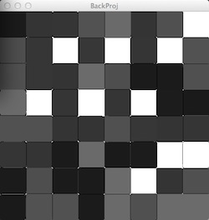
“calcBackProject()” function actually calculate the weight of each color in the whole picture using histogram, and change the value of each pixel to the weight of its color in whole picture.

2. MeanShift

MeanShift is an algorithm which finding modes in a set of data samples representing an underlying probability density function, so the whole algorithm is:
a. Initialize the sphere, including the center and radius.
b. Calculate the current mass center.
c. Move the sphere’s center to mass center
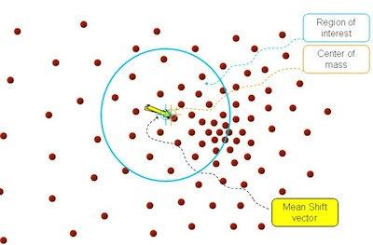
d. repeat step b and c, until converge, that is, current mass center after calculate, is the same point with center of sphere.
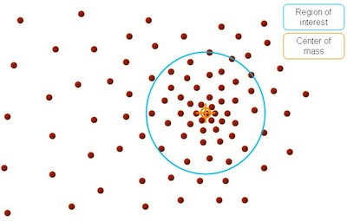

3. Track
The last step is tracking, if we have a video, or frames captured by our web camera, what we need to do is just use meanShift algorithm to every single frame, and the initial window of each frame is just the output window of the prior frame.
By using OpenCV camshift() function, we can get a RotatedRect, which is defined in OpenCV like:

class RotatedRect
{
public:
// constructors
RotatedRect();
RotatedRect(const Point2f& _center, const Size2f& _size, float _angle);
RotatedRect(const CvBox2D& box);
// returns minimal up-right rectangle that contains the rotated rectangle
Rect boundingRect() const;
// backward conversion to CvBox2D
operator CvBox2D() const;
// mass center of the rectangle
Point2f center;
// size
Size2f size;
// rotation angle in degrees
float angle;
};

lien
http://eric-yuan.me/continuously-adaptive-shift/

