**GitHub Username**: https://github.com/noureldeen-abouelkassem

LoveMeter

Description

Once you signed up in this app you can find your friends by name, email or phone number and ask him 10 true or false question about yourself, things you love and so on and let him answer the questions then the result will appear to both of you.

Intended User

For all people with all ages

Features

* Use Firebase storage to store account information like photo, mail, phone and name.
* You can choose your photo from the gallery or take a photo.
* Use Firebase notification to send notification when a friend sends you the question list.

User Interface Mocks

These can be created by hand (take a photo of your drawings and insert them in this flow), or using a program like Google Drawings, [www.ninjamock.com](http://www.ninjamock.com), Paper by 53, Photoshop or Balsamiq.

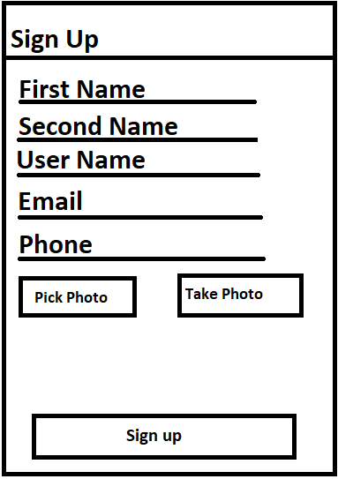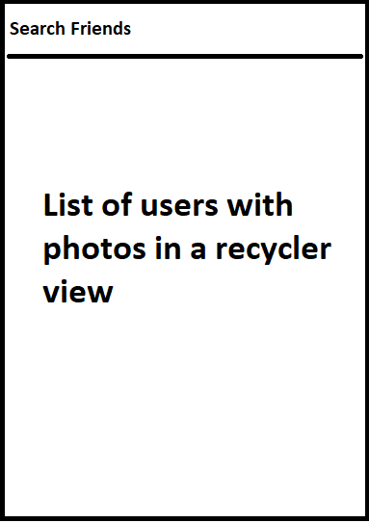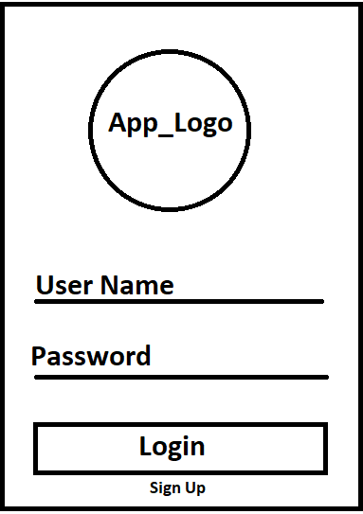**App Screens**

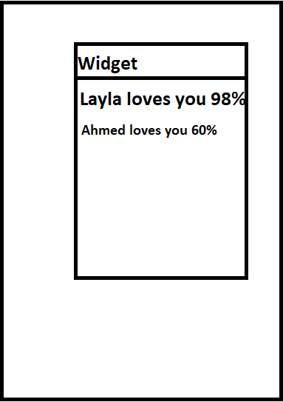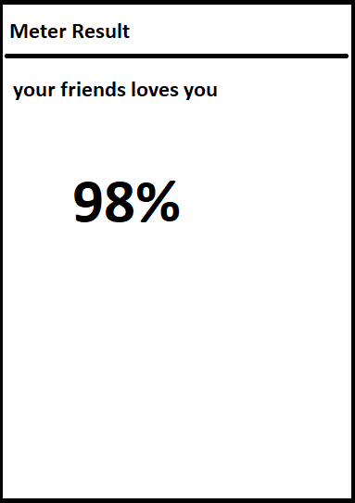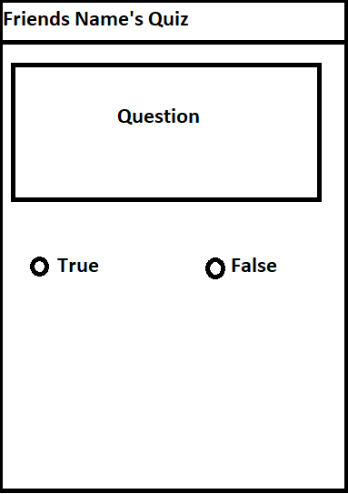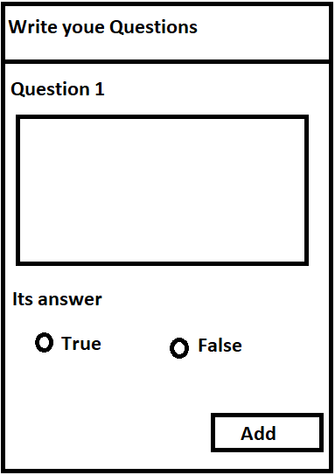

Key Considerations

**How will your app handle data persistence?**

The App will use Firebase Realtime database

**Describe any edge or corner cases in the UX.**

If the user want to return to the search screen (Home Screen) he press one back button.

**Describe any libraries you’ll be using and share your reasoning for including them.**

Glide for images, hdodenhof for circular image view and ButterKnife for View Injection.

**Describe how you will implement Google Play Services or other external services.**

will add this to gradle dependencies {  
        // ...  
        classpath 'com.google.gms:google-services:3.2.1' // google-services plugin  
    }

then dependencies {  
  // ...  
  compile 'com.google.firebase:firebase-core:15.0.0'  
    
  // Getting a "Could not find" error? Make sure you have  
  // added the Google maven respository to your root build.gradle  
}

apply plugin: 'com.google.gms.google-services'

to be able to use firebase.

Next Steps: Required Tasks

This is the section where you can take the main features of your app (declared above) and break them down into tangible technical tasks that you can complete one at a time until you have a finished app.

**Task 1: Project Setup**

* Configure libraries
* Build the structure of the app
* Build firebase classes

**Task 2: Implement UI for Each Activity and Fragment**

* Build UI for All Activities and Fragments

**Task 3: Create the Firebase RealTime database structure.**

* Start Building the structure of the database.
* Start testing sending and retrieving data from the database.

**Task 4: Start implementing the AsyncTask to update the results.**

* Start Implementing an AsyncTask to refresh the results.

**Task 5: Start implementing the whole project.**

* Start Implementing all the classes and activities.