

Uber

8 April 2023

# Introduction

Uber fulfills the need for an efficient, convenient, and reliable transportation service for people who don't have access to their own vehicle or don't want to use public transportation. It provides an alternative to traditional taxi services and allows passengers to quickly and easily request a ride using their smartphone. Additionally, Uber offers features such as real-time tracking, estimated arrival times, and cashless payments, making the experience more convenient for users. For drivers, Uber provides a flexible way to earn income on their own schedule. Overall, Uber has revolutionized the transportation industry by providing a fast, affordable, and convenient option for people to get around in many cities around the world.

1. **User Requirements** 
   * **User Registration:** The software should allow users to register an account with their personal details such as name, phone number, email address, and payment information.

* + **Login:** The software should have a secure login system that allows registered users to log in using their email address or phone number.

* + **Ride Request:** The software should allow users to request a ride by entering their pickup location and destination. Users should be able to view the estimated time of arrival and fare before confirming the ride.

* + **Payment Method:** The software should have a secure payment system that allows users to pay for their ride using a credit/debit card or cash.

* + **View Nearby Drivers:** The software should match the user with the nearest available driver who can accept the ride request. The driver should be able to view the user’s pickup location, destination, and estimated fare.

* + **Ride Cancellation:** The software should allow users and drivers to cancel a ride if necessary. The cancellation policy should be clear and fair to both parties.

* + **Rating System:** The software should allow users to rate the driver and provide feedback after the ride. The driver’s rating should be visible to other users to help them make an informed decision when selecting a driver.

1. **Functional Requirements**

**1. Request Ride :**

* + - * **Description/Action:** The user should be able to book a ride using the Uber application.
      * **Requirements/Inputs:** o Location o Destination o Type of ride
      * **Source of Inputs:** User input via the Uber application.
      * **Precondition:** The user has a registered Uber account and is logged into the Uber application.
      * **Post condition:** The ride request is sent to available drivers, and the user receives an estimated time of arrival.
      * **Output:** Confirmation of the ride booking, including the driver's name, car details, and estimated time of arrival.

1. **Accept Incoming Request :** 
   * **Description/Action:** The driver should be able to accept or decline a ride request.
   * **Requirements/Inputs:** o Ride request details, including pick-up location, destination, and type of ride. 
     + Driver availability and proximity to the pick-up location.
   * **Source of Inputs:** Driver input via the Uber driver application.
   * **Precondition:** The driver is logged into the Uber driver application and has the necessary documents and vehicle requirements.
   * **Post condition:** The driver either accepts or declines the ride request.
   * **Output:** Confirmation of the ride acceptance or decline.

1. **Cancel Ride :** 
   * **Description/Action:** The user or driver should be able to cancel a ride request or trip.
   * **Requirements/Inputs:** Ride request or trip details, including pickup location, destination, and type of ride.
   * **Source of Inputs:** User or driver input via the Uber application.
   * **Precondition:** o For user cancellation: The ride request has not been accepted by a driver.

o For driver cancellation: The driver has accepted the ride request and started the trip.

* + **Post condition:** The ride request or trip is cancelled, and the other party (user or driver) receives a notification.
  + **Output:** Notification of the ride cancellation.

1. **Rate Ride :** 
   * **Description/Action:** The user or driver should be able to rate and review the other party after completing a trip.
   * **Requirements/Inputs**:
     + Rating system (e.g. 1-5 stars).
     + Trip details, including the user's name and location.
   * **Source of Inputs:** User or driver input via the Uber application
   * **Precondition:** The trip has been completed, and the user or driver is ready to provide feedback.
   * **Post condition:** The other party (user or driver) receives a rating and review from the user or driver.
   * **Output:** Rating and review feedback submitted by the user or driver.

1. **View Nearby Drivers :** 
   * **Description/Action:** The Uber system should be able to recommend high-performing drivers to users based on their past trip experiences.
   * **Requirements/Inputs:** o Driver performance data (e.g. average rating, completion rate, cancellation rate).
     + User trip data, including past trips with drivers and feedback provided by users.
     + **Source of Inputs:** Uber system data.
     + **Precondition:** The Uber system has access to driver performance data and user trip data.
     + **Post condition:** The Uber system recommends high-performing drivers to users based on their past trip experiences.
     + **Output:** Recommended driver list provided to users based on their past trip experiences.

**4) Non-Functional Requirements**

* + - * + **Performance:** The Uber app must perform efficiently and respond to user actions quickly. The app should be able to handle a large number of concurrent users and requests.
        + **Usability:** The Uber app must be easy to use and navigate, even for non-technical users.
        + **Maintainability:** The Uber app must be easy to maintain and update over time. The app should be modular and welldocumented.
        + **Security:** The Uber app must be secure and protect the user's personal and financial data. The app should use encryption and other security measures to prevent data breaches.
        + **Scalability:** The Uber app must be scalable and able to handle a growing number of users and requests over time.
        + **Portability:** The Uber app must be portable and able to run on different platforms and environments.

**Use Case Diagram:**

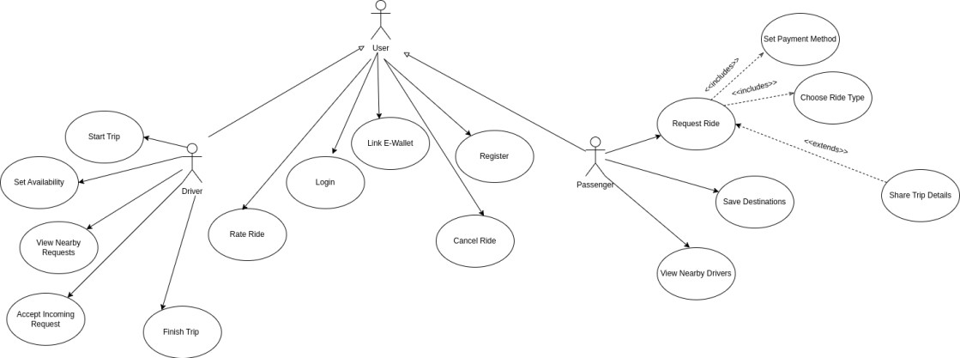

**Sequence Diagram:**

