3-8 Decoder

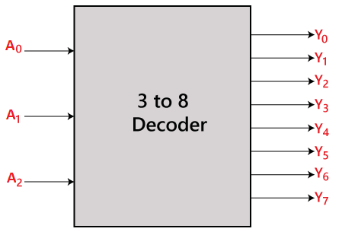

In digital systems, decoders are essential components that help to convert input signals into a specific output signal based on the input's value. In this report, we will explore three different methods for implementing a 3 to 8 decoder in Verilog.

1. **Using RTL-style case statement** to assign the appropriate output value based on the input signal. This approach is straightforward and easy to understand, especially when there are few possible input combinations. However, as the number of input combinations increases, the code becomes repetitive and harder to manage.

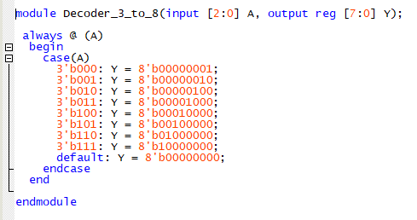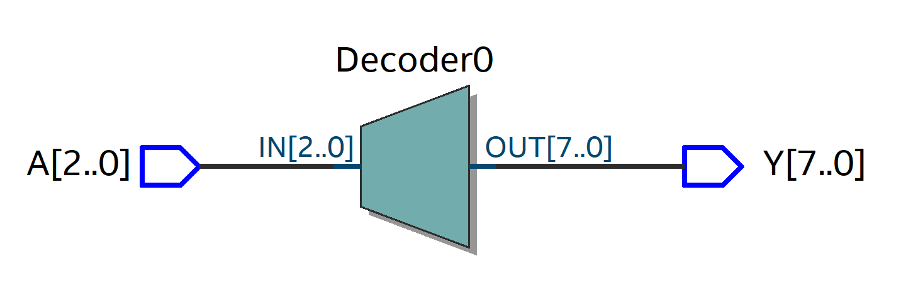

1. **Using structural approach with AND gates** to implement the 3 to 8 decoders. This approach is more scalable and easier to modify since we can add more gates and connections to accommodate more inputs and outputs. However, it requires more lines of code and can quickly become unwieldy.

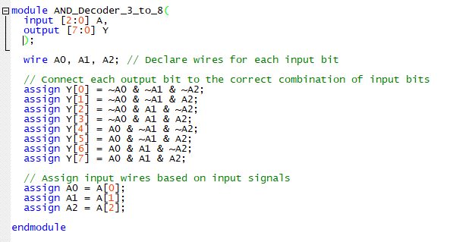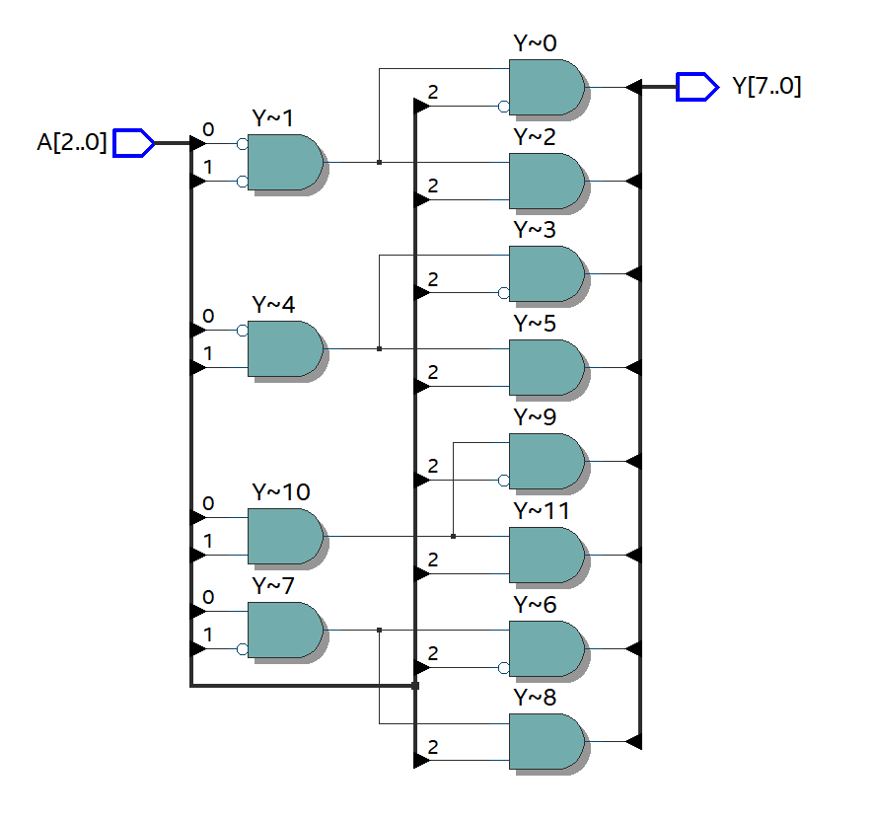

1. **Using behavioral approach with loops** to implement the 3 to 8 decoders. This approach is concise and easy to read, especially when there are many possible input combinations. It uses a for loop to iterate over all possible output values and sets the appropriate output bit to 1 if the input matches the output value. While this approach may not be as efficient as the other two methods, it provides more flexibility and ease of modification.

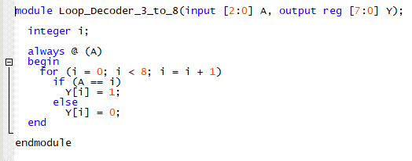

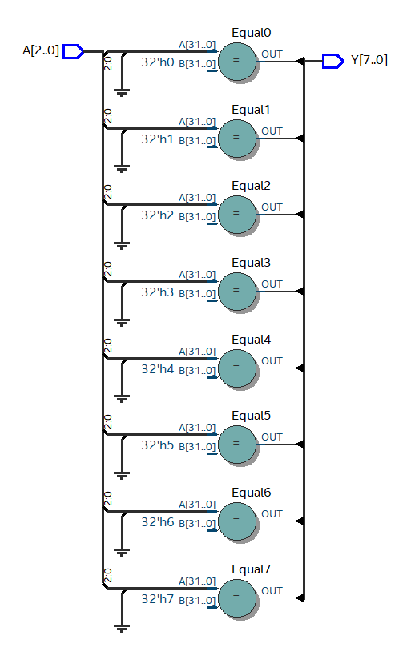

**Conclusion**

we have seen three different methods for implementing a 3 to 8 decoder in Verilog: using an RTL-style case statement, a structural approach with AND gates, and a behavioral approach with loops. Each method has its advantages and disadvantages, and the choice of implementation style depends on the specific requirements and constraints of the design. As such, it is critical to choose the method that best suits the design's functionality, scalability, and readability.