Sa

* Duckie Town is an educational platform that aims to teach fundamental concepts in robotics, machine learning, and computer science through the use of self-driving toy cars. The platform was developed by the Duckietown Foundation, a non-profit organization dedicated to promoting education and research in these fields.
* The Duckie Town platform consists of a miniature city with roads, traffic lights, and other infrastructure, as well as a fleet of small, self-driving toy cars called "duckies." The duckies are equipped with sensors and computers that allow them to navigate the city and follow traffic rules.
* Users can interact with the Duckie Town platform through a web-based interface, where they can program the duckies to perform various tasks and experiments. The platform includes a range of educational materials and challenges, which are designed to help users learn about topics such as machine learning, computer vision, and control systems.
* The goal of Duckie Town is to provide an engaging and interactive learning experience that helps students develop a deeper understanding of the underlying principles of robotics, machine learning, and computer science.

**Team hardware**

* **Ahmed ahmed**
* **Adham sakr**
* **Adam shawky**
* **Amr Ashraf**
* **Ahmed Nasser**
* **Eslam Mohamed**
* **Nada Samir**
* **Ahmed ElSayed**
* **Nour Morsy**

**Raspberry pi 4B:**

**Pins:**

1. **3.3V Power**
2. **5V Power**
3. **Ground**
4. **5v**
5. **General Purpose Input/Output (GPIO)**
6. **Ground**
7. **General Purpose Input/Output (GPIO)**
8. **UART**
9. **Ground**
10. **UART**
11. **General Purpose Input/Output (GPIO)**
12. **General Purpose Input/Output (GPIO)**
13. **General Purpose Input/Output (GPIO)**
14. **Ground**
15. **General Purpose Input/Output (GPIO)**
16. **General Purpose Input/Output (GPIO)**
17. **3.3V Power**
18. **General Purpose Input/Output (GPIO)**
19. **General Purpose Input/Output (GPIO)**
20. **Ground**
21. **General Purpose Input/Output (GPIO)**
22. **General Purpose Input/Output (GPIO)**
23. **General Purpose Input/Output (GPIO)**
24. **General Purpose Input/Output (GPIO)**
25. **Ground**
26. **General Purpose Input/Output (GPIO)**
27. **+5V Power**
28. **+5V Power**
29. **General Purpose Input/Output (GPIO)**
30. **Ground**
31. **General Purpose Input/Output (GPIO)**
32. **General Purpose Input/Output (GPIO)**
33. **General Purpose Input/Output (GPIO)**
34. **Ground**
35. **General Purpose Input/Output (GPIO)**
36. **General Purpose Input/Output (GPIO)**
37. **General Purpose Input/Output (GPIO)**
38. **General Purpose Input/Output (GPIO)**
39. **Ground**
40. **General Purpose Input/Output (GPIO)**

* **General Purpose Input/Output (GPIO)**: These pins can be used to send signals to and receive signals from external devices. They can be programmed to function as either inputs or outputs, and can be used to control a wide variety of devices, including LEDs, motors, and sensors.
* **UART**: The UART (Universal Asynchronous Receiver/Transmitter) pins (8 and 10) can be used for serial communication with external devices. They can be used to send and receive data in a format that is understood by both the Raspberry Pi and the external device.
* **3.3V Power**: This pin provides a 3.3V power supply. It can be used to power external devices that require a 3.3V power supply.
* **5V Power**: This pin provides a 5V power supply. It can be used to power external devices that require a 5V power supply.
* **Ground**: These pins are used to ground devices. When connecting multiple devices, it is important to connect the ground pins of each device to ensure that they all share the same reference voltage.
* **General Purpose Input/Output (GPIO) pins**: Some of the GPIO pins on the Raspberry Pi can be used for communication with external devices using a variety of protocols. For example, you can use the GPIO pins to send and receive data using the I2C or SPI protocols.
* **USB ports**: The Raspberry Pi 4 Model B has two USB ports that can be used to connect a variety of USB devices, including keyboards, mice, and external storage devices.
* **Ethernet port**: The Raspberry Pi 4 Model B has an Ethernet port that can be used to connect the device to a network.
* **HDMI port**: The Raspberry Pi 4 Model B has an HDMI port that can be used to connect the device to a display.
* **Audio output**: The Raspberry Pi 4 Model B has a 3.5mm audio output jack that can be used to connect the device to external speakers or headphones.

**RGB LEDS:**



* An RGB LED has 4 pins, one for each color (Red, Green, Blue) and a common cathode. It has three different color-emitting diodes that can be combined to create all sorts of color! Any color is possible depending on how bright each diode

**Circuit:**

**Reference:**[*https://www.ardumotive.com/how-to-use-rgb-led-en.html*](https://www.ardumotive.com/how-to-use-rgb-led-en.html)

**Motors:**

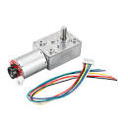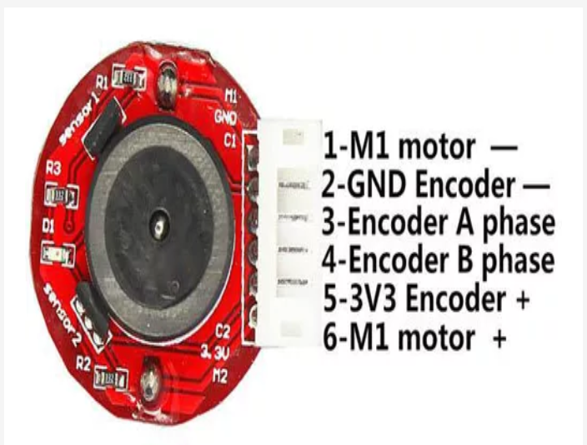

**Specification:**

* Material: Metal
* Voltage: DC 12.0V
* Encoder motor end 11 signals
* Input voltage(V) 12
* Retarder Reduction Ratio 1:70
* No Load Speed(RPM) 80
* No Load Current (mA) ≤60
* Rated torque(kg.cm) 3.3 Kg.cm
* Rated Speed(RPM) 60
* Rated Current(A) ≤0.4
* Max. Torque ≥ 10 Kg.cm
* Unload Current(A) ≤1.0
* Construction: Permanent Magnet
* Commutation: Brush
* DIY Dimension: 82*32*27 mm
* Shaft Diameter: 6 mm
* Net Weight:0.18 Kg
* Box Materials: Zinc alloy, zincification
* We will connect the motors with Arduino and use communication protocol to take readings and give it to **Raspberry pi 4B**

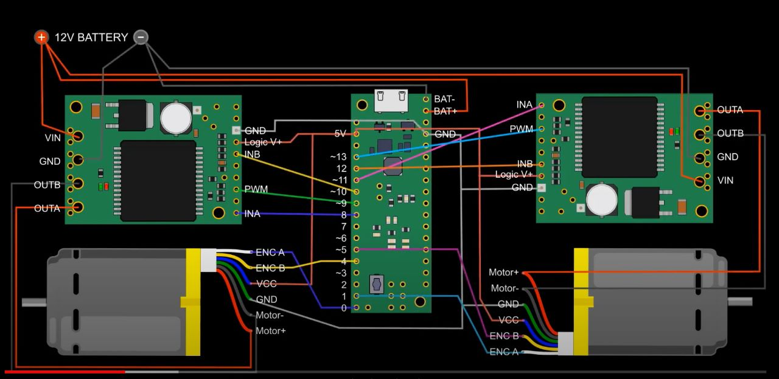

**Reference:** [**https://www.youtube.com/watch?v=dTGITLnYAY0**](https://www.youtube.com/watch?v=dTGITLnYAY0)

