ATTACHMENT II

ARAKAWA GRIDS

Arakawa grids were first described in Arakawa and Lamb (1977).[1] There are several different grids with unique staggers labelled as A, B, C, D and E. The following examples show how many of these grids can be defined in GRIB2 using grid definition template 3.1 along with bits 5 through 8 of Flag table 3.4. The relevant bit settings are noted where applicable.

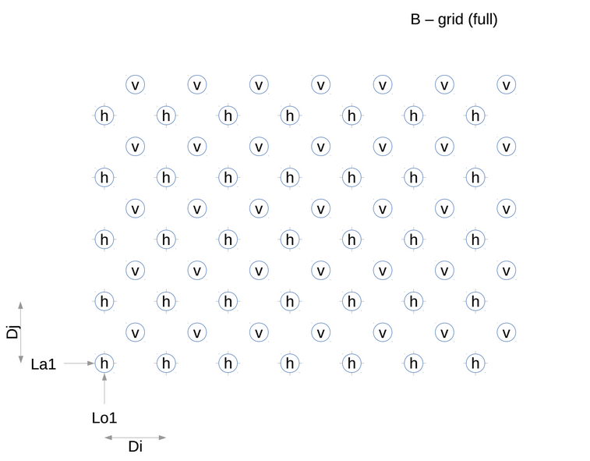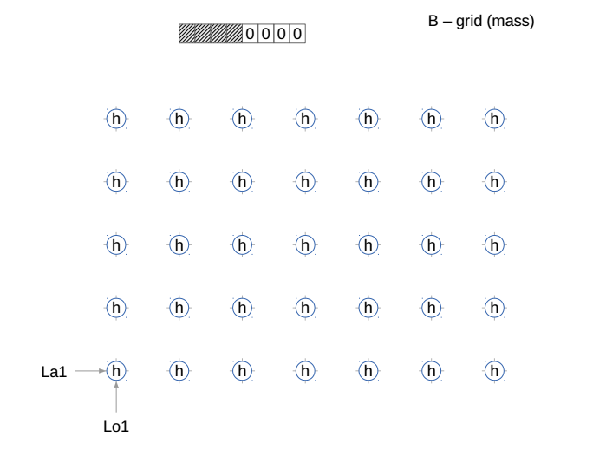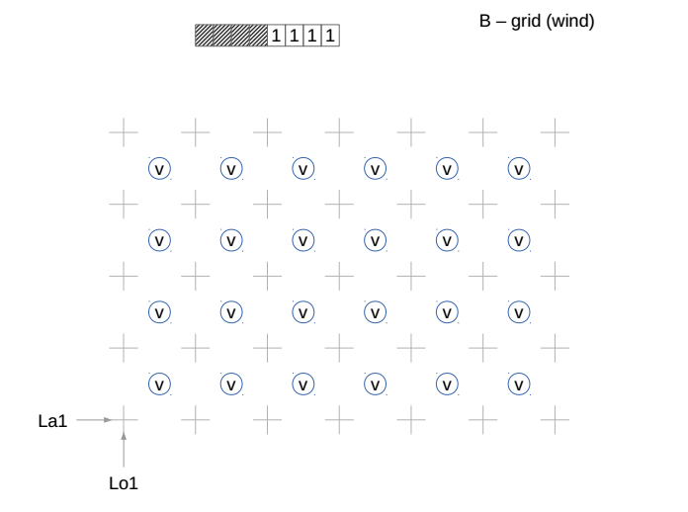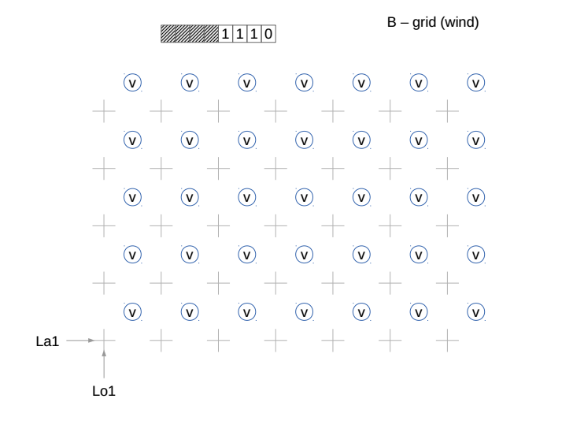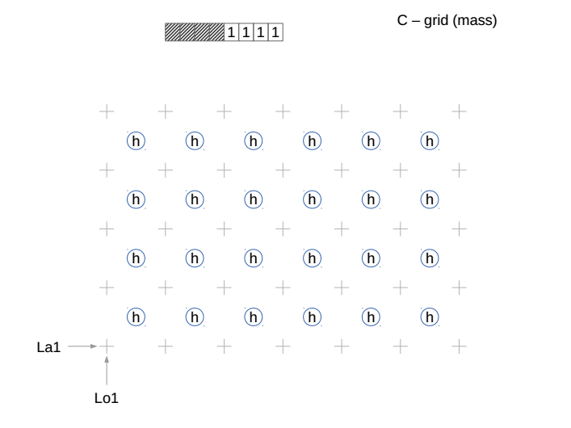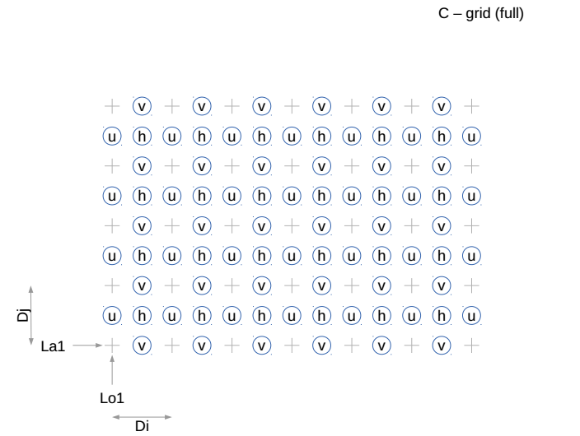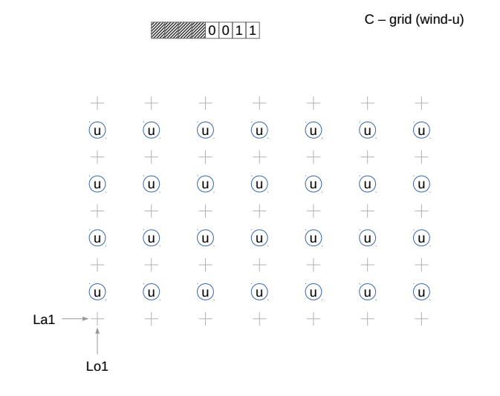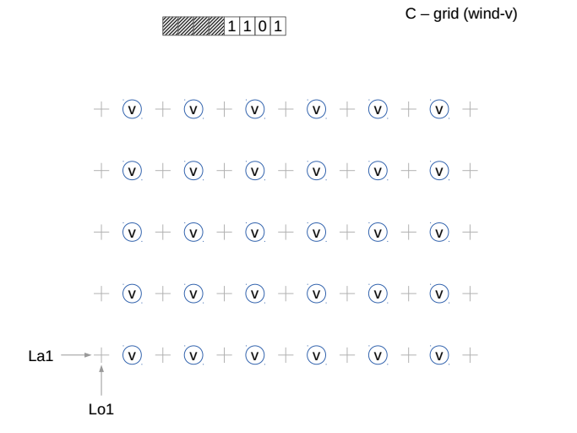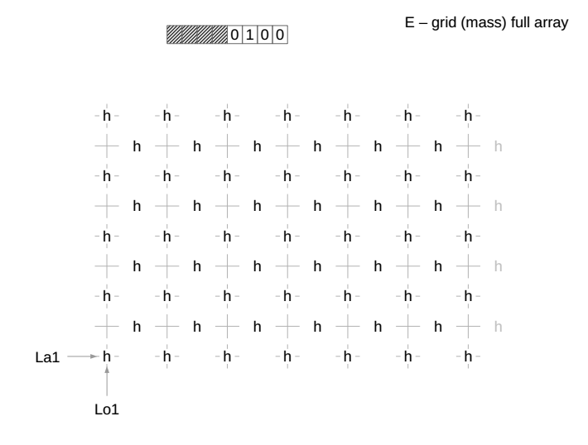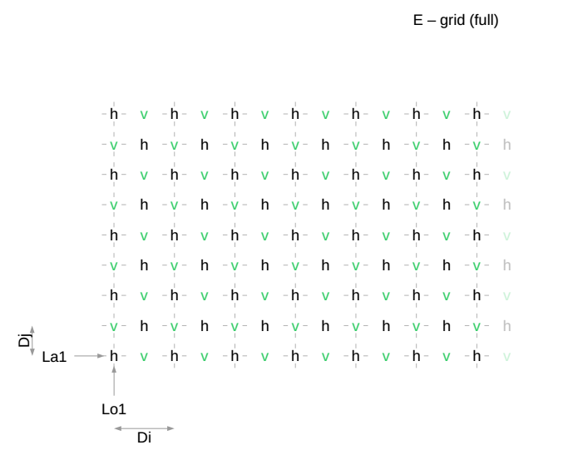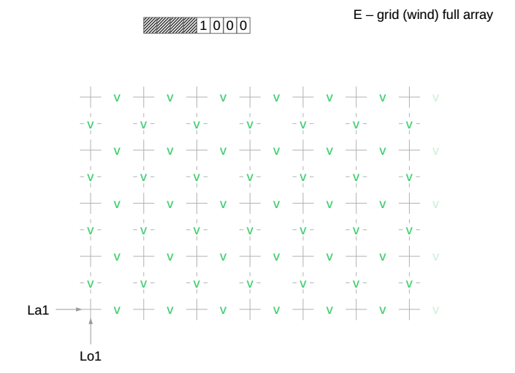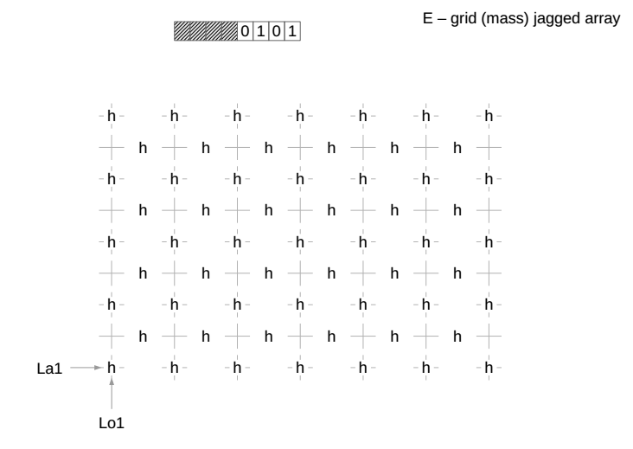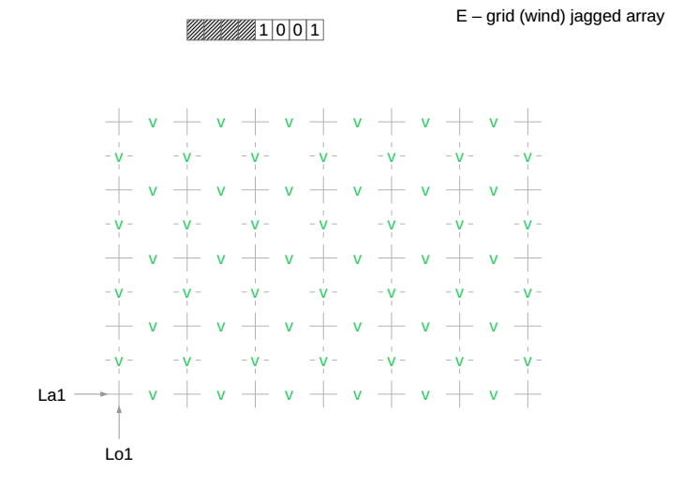

1. Arakawa, A. and V.R. Lamb, 1977:Computational design of the basic dynamical processes of the UCLA general circulation model. *Methods of Computational Physics* 17*,* New York: Academic Press, pp. 173–265.