Information Engineering and Technology Faculty

GermanUniversity in Cairo



Multi-Media Services   
Video Streaming

|  |  |
| --- | --- |
| Authors: | Youssef Tarek Abdelhady 40-2928  Nour El-din Samir 40-3993  Nadine El-Bialy 40-0379  Ahmed Ossama 40-2688 |
| Supervisor: | Dr. Mohamed Abdelwahab |

Abstract

In this work, the concept of multi-media streaming is applied by implementing an android application using Android Studio as the development tool and Firebase as the real-time database and storage provider. The application uses authentication techniques as it is divided into a Sign in Activity for users to enter their credentials, a Register activity, provided video names List Activity and finally a Video activity that streams the chosen video by the user in a real-time manner.

Contents

Background 4

- Web Services 4

- Multimedia Streaming 4

- Firebase 5

- Brief Overview 5

Methodology 6

- Sign In / Login Activity 6

- Register Activity 7

- List Activity 8

- Video Activity 9

References 10

**List of Figures**

Figure 1 6

Figure 2 7

Figure 3 8

Figure 4 9

# Background

## Web Services

Web services as stated by their name are services offered from one application/device to another using the World Wide Web (Internet) for interaction. They are XML-based systems that exchange information which includes programs, objects, documents, etc. To exchange such information, a set of protocols and standards are used [1].

## Multimedia Streaming

Multimedia streaming is a technology that enables providing the multimedia data between clients on different multimedia applications over the internet. This technology makes the client able to playback the digital media content without waiting for the whole data or media file to be downloaded, so it is received as real-time stream. Streamed data is sent by a server application which is received and presented by a real-time client application. Multimedia streaming has some demanding requirements on the network bandwidth, delay and loss. Streaming over the internet offers best-effort service and doesn’t guarantee on the quality of service for the transmission of multimedia data, as the nowadays internet is a packet-switched network which is not designed to handle asynchronous traffic like the videos and audios. Delivering the multimedia data over the internet is done by some streaming protocols. Choosing a streaming protocol depends on the goals you are trying to achieve, HTTP based protocols use TCP which is reliable, support packet lost and ordering and requires three-way handshake when delivering data. On the other hand, protocols like the SRT (Secure Reliable Transport) uses UDP which doesn’t support packet loss or ordering (no retransmissions), but is faster at transporting data. The most common used protocols in multimedia streaming are the traditional streaming protocols such as RTSP and RTMP which support low latency, works the best while targeting small audience from a dedicated media server. Traditional streaming protocols are not supported on all end devices (ex : IOS devices) . Moreover, there is the adaptive HTTP-based streaming protocols such as Apple HLS, Low-Latency HLS and MPEG-DASH. The HTTP-based streaming protocols provide the best videos quality no matter the software, device or the connection. Also, the new technologies protocols such as the SRT and webRTC help in delivering reliable streams and enable real-time communication [2][3].

## Firebase

It is a platform that was adopted and presented by Google in 2014 to developers for use in building their projects (e.g. mobile and web apps) [4]. Firebase is considered a **BaaS** (Back-end as a service) that consumers use in their development process. Moreover, in Firebase documents are stored as a set of **keys** along with their corresponding **values**. Some of the provided services by Firebase are; **Authentication**, **Real-time Database**, **Storage**, **Hosting** and a **Testing environment** [5].

## Brief Overview

An app was designed such that users can log into it and can choose from a list of videos stored on a database.Upon choosing the video, the video is streamedas a real time stream to be viewed by the user. The app was developed by Android Studio with the integration of Firebase Authentication, Realtime Database and Storage. The app contains four activities which are Main, Register, List and Video.

# 

# Methodology

## Sign In / Login Activity

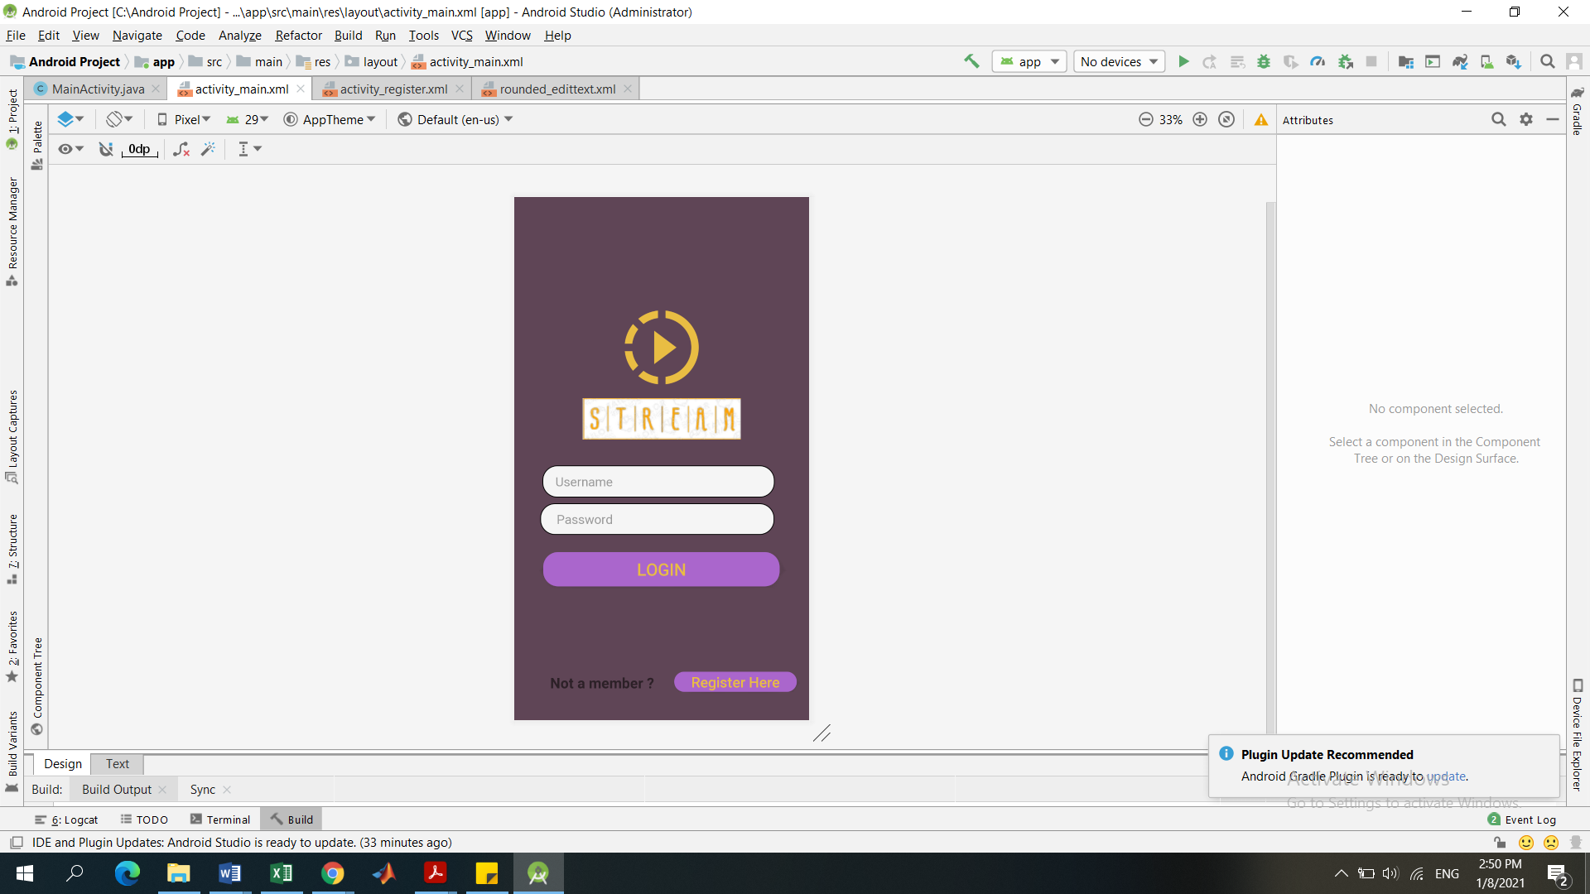

Figure 1

In this work, our android application’s main activity is the login or sign in activity shown in figure (1), which is the first screen that appears when the application runs. In this activity, initially, if the user or client does not have an account, they can press on the **Register Here** button, which leads to the ***Register Activity***. However, if the user already has an account, to login, the user enters his username/Email and password. These values are checked in our users’ database using **Firebase Authentication**, where these values are checked to be valid values of a present user. If the entered user values seem to be invalid. i.e. not present in the database, then the error message “Username is invalid”. If the values are valid, then the user will be signed in successfully.

Finally, after successfully signing in, the focus changes to the List Activity, where a list of all the available videos, are presented.

## Register Activity

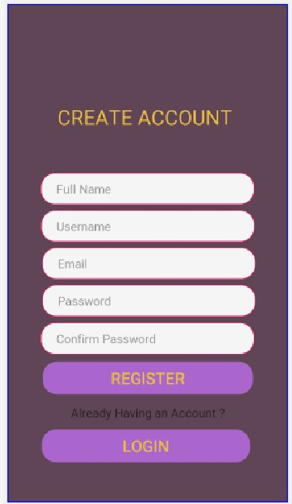

Figure 2

In this work our android application provides the ability of new users to register new accounts to the application. Upon clicking the **Register here** button in the **Sign in Activity**, it redirects the app to the **Register Activity** as shown in figure (2). This activity requires the user to enter multiple specified fields which are; user’s full name, E-mail, Password and Confirm Password. Upon receiving these fields from the user and making sure that the credentials specified follow the specific defined rules (e.g. password length, Username or E-mail already used). Furthermore, if all specified rules were satisfied, the user is successfully registered by using his/her entered signup credentials to create a new record in our app’s database using **Firebase**, where each user is identified by an id and a set of keys with their corresponding values that are stored in the Real-time Database provided by Firebase and also using the Firebase Authentication tool (Storing the E-mail and password).

Finally, after the user has successfully registered to the application, the app changes the focus **back to the Sign in Activity** where the user signs in again to the app as a predefined user.

## List Activity

After signing in from the Main Activity, the user is directed to the List Activity. The List Activity contains the videos that the user can stream from the database which is Firebase Storage. Each video can be identified from its name and photo present in the list as shown in figure (3).

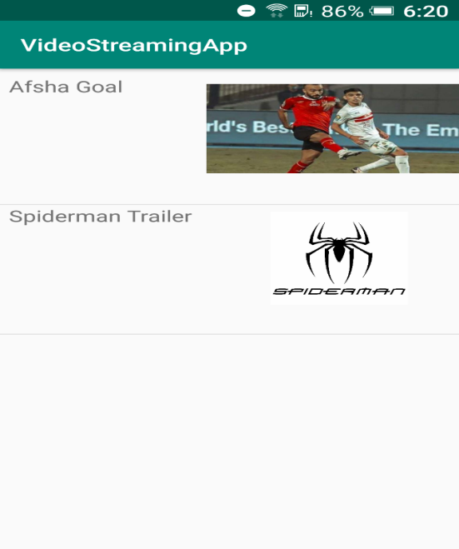

Figure 3

When any item in the list is clicked, The URL for the corresponding video in Firebase Storage is sent to the Video Activity in order to stream the video in real time for the user.

## Video Activity

After choosing the selected video from the list view activity we move to the video activity where the video is played and streamed online .The videos in the list view were uploaded on Firebase storage that we connected the application to it in android studio. The video URL is copied from firebase storage after uploading the video and is used to request streaming the video from firebase storage once we are directed to the video activity. Media controller is pre-defined tool in android studio was used to add some features to our video view such as the play/pause button, time duration and progress bar, as shown in figure(4).

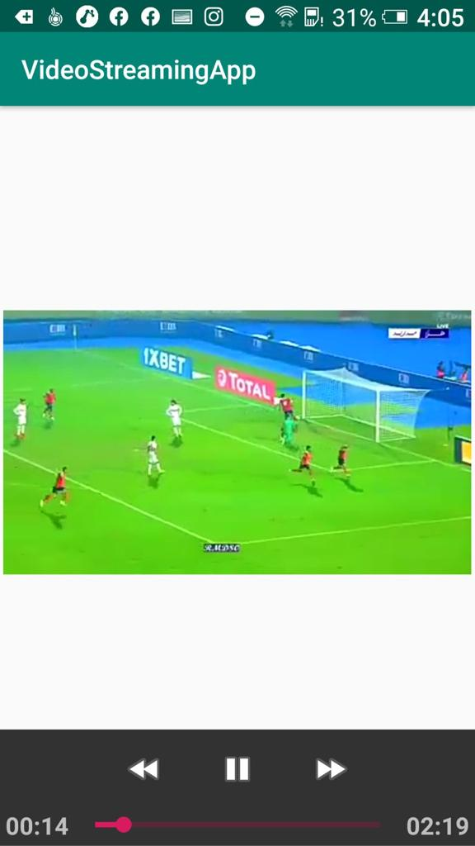

Figure 4

# References

[1] <https://www.tutorialspoint.com/webservices/what_are_web_services.htm>

[2] <https://www.wowza.com/blog/streaming-protocols>

[3] https://link.springer.com/referenceworkentry/10.1007%2F0-387-30038-4_166

[4] <https://en.wikipedia.org/wiki/Firebase>

[5] <https://www.educative.io/edpresso/what-is-firebase>