Data Set:

The data set used is Yacht Hydrodynamics. The response variable is the resistance and the predictors are all the other variables. The other variables are:

* Longitudinal position of the center of buoyancy, labeled as longitude
* Prismatic coefficient, labeled as prismatic
* Length-displacement ratio, labeled as displacement
* Beam-draught ratio, labeled as draught
* Length-beam ratio, labeled as beam
* Froude number, labeled as froude

First few rows using head(data):

longitude prismatic displacement draught beam froude resistance

1 -2.3 0.568 4.78 3.99 3.17 0.125 0.11

2 -2.3 0.568 4.78 3.99 3.17 0.150 0.27

3 -2.3 0.568 4.78 3.99 3.17 0.175 0.47

4 -2.3 0.568 4.78 3.99 3.17 0.200 0.78

5 -2.3 0.568 4.78 3.99 3.17 0.225 1.18

6 -2.3 0.568 4.78 3.99 3.17 0.250 1.82

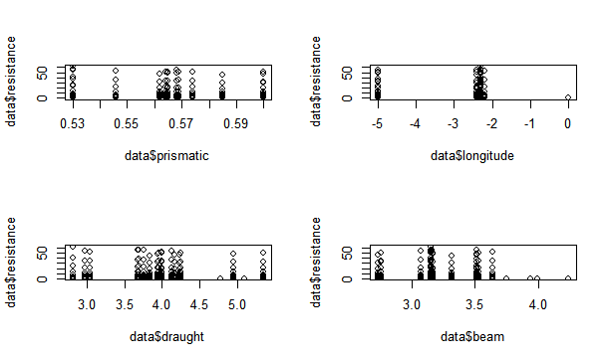Scatterplot Analysis and Discussion:

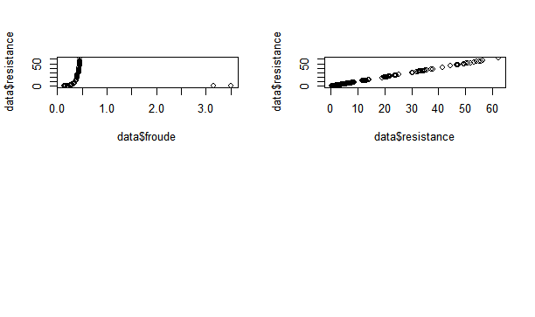

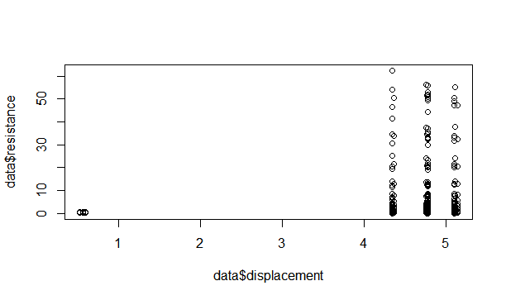

The graphs for prismatic, longitude, draught, displacement, and beam did not provide good scatter plots. Froude created a J shaped curve and resistance created a linear graph.

Model #1:

fit.disp <- lm(resistance~displacement,data=data)

fit.disp2 <- lm(resistance~displacement+I(displacement^2),data=data)

AIC(fit.disp,fit.disp2)

df AIC

fit.disp 3 2483.452

fit.disp2 4 2484.777

fit.froude <- lm(resistance~froude,data=data)

fit.froude2 <- lm(resistance~froude+I(froude^2),data=data)

AIC(fit.froude,fit.froude2)

df AIC

fit.froude 3 2492.869

fit.froude2 4 2343.461

fit.pris <- lm(resistance~prismatic,data=data)

fit.pris2 <- lm(resistance~prismatic+I(prismatic^2),data=data)

AIC(fit.pris,fit.pris2)

df AIC

fit.pris 3 2082.80

fit.pris2 4 2084.77

fit.beam <- lm(resistance~beam,data=data)

fit.beam2 <- lm(resistance~beam+I(beam^2),data=data)

AIC(fit.beam,fit.beam2)

df AIC

fit.beam 3 2492.88

fit.beam2 4 2490.21

The lowest AIC is the linear model in prismatic.

summary(fit.pris):

Call:

lm(formula = resistance ~ prismatic, data = data)

Residuals:

Min 1Q Median 3Q Max

-10.897 -9.440 -7.217 2.590 51.473

Coefficients:

Estimate Std. Error t value Pr(>|t|)

(Intercept) 21.11 23.23 0.909 0.364

prismatic -19.18 41.16 -0.466 0.642

Residual standard error: 14.96 on 250 degrees of freedom

Multiple R-squared: 0.0008678, Adjusted R-squared: -0.003129

F-statistic: 0.2171 on 1 and 250 DF, p-value: 0.6416

summary(fit.pris2):

Call:

lm(formula = resistance ~ prismatic + I(prismatic^2), data = data)

Residuals:

Min 1Q Median 3Q Max

-11.066 -9.453 -7.171 2.591 51.304

Coefficients:

Estimate Std. Error t value Pr(>|t|)

(Intercept) 111.9 531.0 0.211 0.833

prismatic -342.0 1887.0 -0.181 0.856

I(prismatic^2) 286.5 1674.4 0.171 0.864

Residual standard error: 14.99 on 249 degrees of freedom

Multiple R-squared: 0.0009853, Adjusted R-squared: -0.007039

F-statistic: 0.1228 on 2 and 249 DF, p-value: 0.8845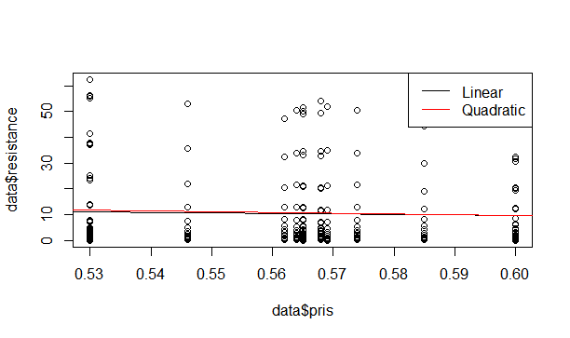

The fitted model is: resistance = 21.11 – 19.48prismatic.

*R*2 is 0.0008678 and it has an AIC of 2082.821.

Model #2:

Trying other variables:

Call:

lm(formula = resistance ~ prismatic + I(prismatic^2) + displacement +

I(displacement^2) + froude + I(froude^2) + beam + I(beam^2) +

longitude + draught, data = data)

Residuals:

Min 1Q Median 3Q Max

-7.0117 -4.0359 0.3109 3.0490 17.5846

Coefficients:

Estimate Std. Error t value Pr(>|t|)

(Intercept) 170.48581 189.52530 0.900 0.369

prismatic -362.75059 578.32363 -0.627 0.531

I(prismatic^2) 299.22365 505.81450 0.592 0.555

displacement -12.25749 42.47059 -0.289 0.773

I(displacement^2) 1.02446 4.11641 0.249 0.804

froude -375.84765 16.97197 -22.145 <2e-16 \*\*\*

I(froude^2) 861.55678 29.16573 29.540 <2e-16 \*\*\*

beam 3.12880 29.98396 0.104 0.917

I(beam^2) -0.13853 4.06138 -0.034 0.973

longitude -0.09003 0.27498 -0.327 0.744

draught 0.86643 3.40874 0.254 0.800

---

Signif. codes: 0 ‘\*\*\*’ 0.001 ‘\*\*’ 0.01 ‘\*’ 0.05 ‘.’ 0.1 ‘ ’ 1

Residual standard error: 4.173 on 241 degrees of freedom

Multiple R-squared: 0.9251, Adjusted R-squared: 0.922

F-statistic: 297.6 on 10 and 241 DF, p-value: < 2.2e-16

AIC(m2.1)

[1] 1447.972

After removing some variables from the formula:

Call:

lm(formula = resistance ~ prismatic + I(prismatic^2) + froude +

I(froude^2) + beam + I(beam^2) + longitude, data = data)

Residuals:

Min 1Q Median 3Q Max

-6.7842 -4.0620 0.4997 2.9510 17.9008

Coefficients:

Estimate Std. Error t value Pr(>|t|)

(Intercept) 142.04312 156.06983 0.910 0.364

prismatic -335.92274 526.27488 -0.638 0.524

I(prismatic^2) 280.55461 466.73539 0.601 0.548

froude -375.84765 16.87380 -22.274 <2e-16 \*\*\*

I(froude^2) 861.55678 28.99702 29.712 <2e-16 \*\*\*

beam -2.18894 23.64554 -0.093 0.926

I(beam^2) 0.31902 3.71157 0.086 0.932

longitude -0.04488 0.24756 -0.181 0.856

---

Signif. codes: 0 ‘\*\*\*’ 0.001 ‘\*\*’ 0.01 ‘\*’ 0.05 ‘.’ 0.1 ‘ ’ 1

Residual standard error: 4.149 on 244 degrees of freedom

(56 observations deleted due to missingness)

Multiple R-squared: 0.925, Adjusted R-squared: 0.9229

F-statistic: 430.1 on 7 and 244 DF, p-value: < 2.2e-16

> AIC(m2.1)

[1] 1442.166

The AIC became even lower. *R*2 is 0.925 and the AIC is 1442.166

Model Comparison:

Model #1 had an *R*2 of 0.0008678 and AIC of 2082.821. Model #2 had an *R*2 of 0.925 and an AIC of 1442.166. Model #2 had more variability for the yacht data and it has greater predictive power based on AIC.