**Car Rental System**

Nour Yasser 6604

Nour Mohamed 6392

Mohamed Bahaa 6586

Mohamed Nouh 6355

**ERD**

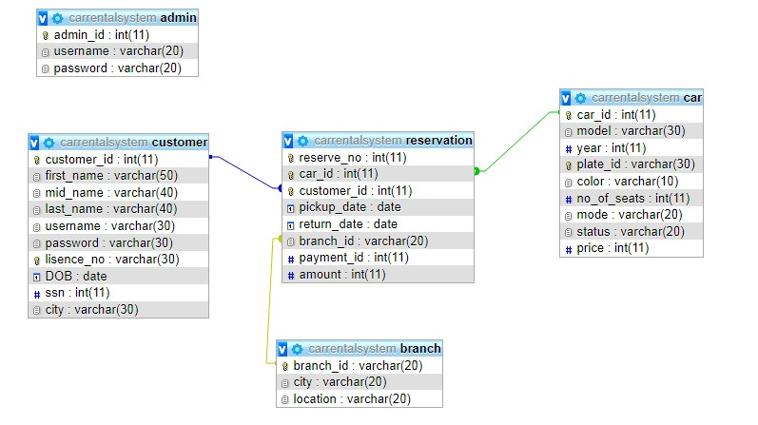

**DDL:**

CREATE DATABASE CarRentalSystem;

USE CarRentalSystem;

CREATE TABLE customer (customer_id int not null AUTO_INCREMENT ,

first_name varchar(50),

mid_name varchar(40),

last_name varchar(40),

username varchar(30),

password varchar(30),

lisence_no varchar(30) UNIQUE,

DOB date,

ssn int,

city varchar(30),

PRIMARY KEY(customer_id)

);

CREATE TABLE car (car_id INT not null AUTO_INCREMENT,

model varchar(30),

year INT,

plate_id varchar(30) UNIQUE,

color varchar(10),

no_of_seats INT,

mode varchar(20),

status varchar(20),

PRIMARY KEY(car_id)

);

CREATE TABLE reservation (reserve_no INT not null AUTO_INCREMENT UNIQUE,

car_id INT,

customer_id INT,

pickup_date date,

return_date date,

branch_id INT,

Amount double,

PRIMARY KEY (car_id, customer_id)

);

CREATE TABLE admin (admin_id INT not null AUTO_INCREMENT ,

username varchar(20),

password varchar(20),

PRIMARY KEY(admin_id)

);

CREATE TABLE branch(branch_id INT not null AUTO_INCREMENT,

city varchar(20),

location CHARACTER,

PRIMARY KEY (branch_id)

);

ALTER TABLE reservation ADD FOREIGN KEY (car_id) REFERENCES car(car_id);

ALTER TABLE reservation ADD FOREIGN KEY (customer_id) REFERENCES customer(customer_id);

ALTER TABLE reservation ADD FOREIGN KEY (branch_id) REFERENCES branch(branch_id);

**Features**

* **System Admin**
  + Register new cars to the system and adding its specifications
  + Apply advanced search for any car information, customer information, or reservations.
  + Generate reports for states of cars on a specific day, reservations on a specific period, reservations of a specific customer.
* **System User (Customer)**
  + Create account on the system to make reservations
  + Search for cars using any car specification
  + Make car reservations based on the customer’s requirements
  + Availability of online payment.

**Screens**

Login

Customer or admin uses his or her username or password to login to the system.

Registration

A new customer creates a new account by adding his or her personal information.

Search (Customer)

Customer can search for cars based on his or her preferences such as number of seats, car’s color, model, and mode (manual or automatic).

Reservation

Customer can reserve an available car based on his or her requirements specified. A customer chooses the pickup, return dates and pickup location.

Transition Screen

This screen allows the customer to decide whether to logout or proceed to pay the reservation amount.

Payment

Process the payment transaction where the customer chooses the payment method whether Visa or cash.

**ADMIN**

Register New Car

Admin can add a new car by specifying all car information including year, model, number of seats, plate id and color.

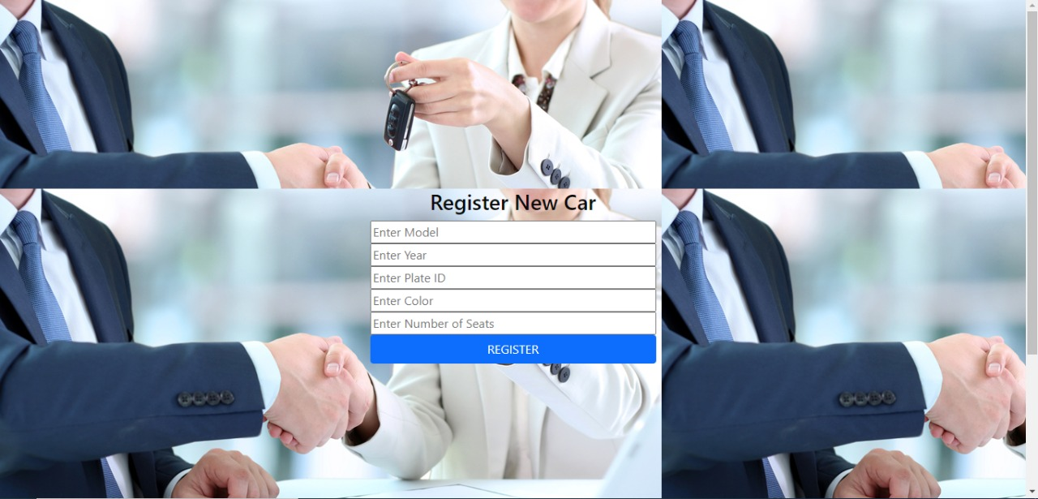

Search (Admin)

Admin can search by all car information including model, color, year and plate id. Admin can search for reservations on a specific period and car states on a specific day. Also search for customer information and reservations.

