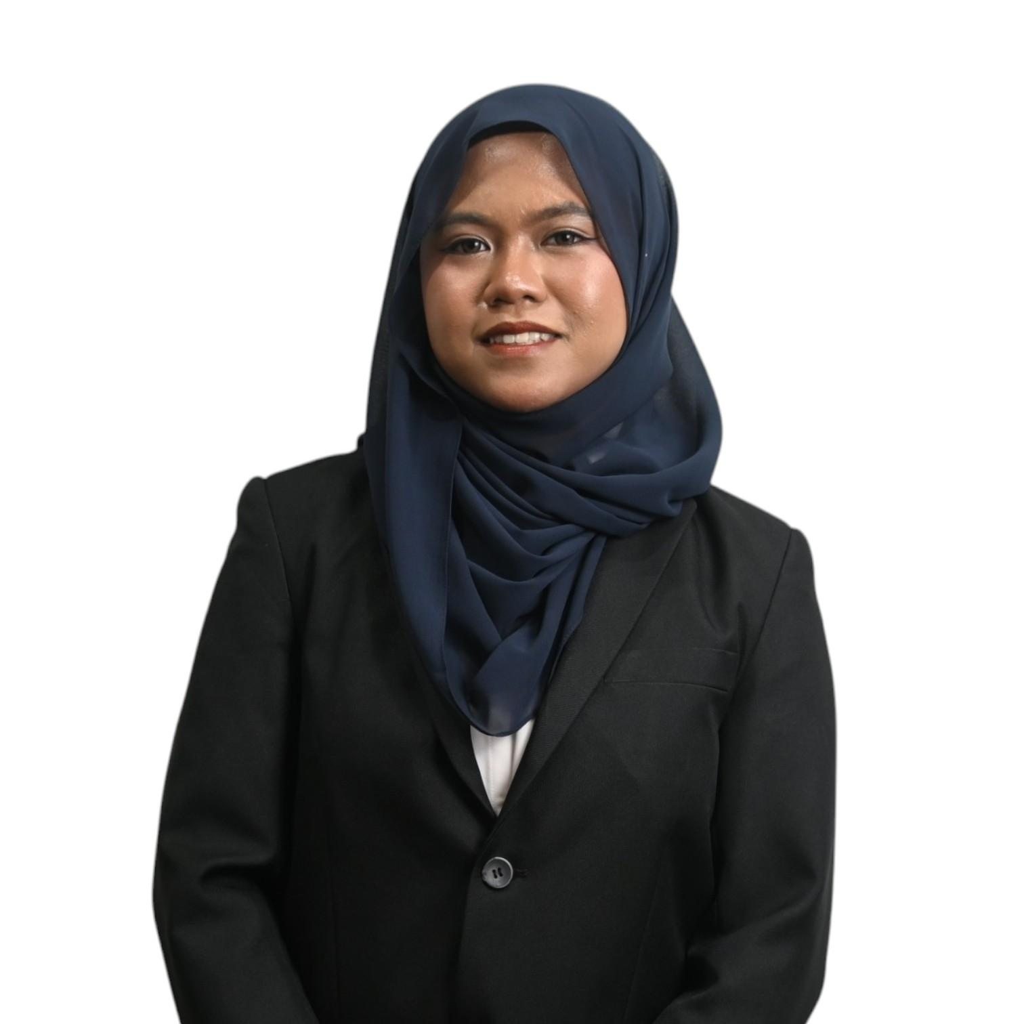

NOURYN ERYSSA
BINTI NOORHAZRIN
Phone: +6018-986 7977 | Email: nourynhazrin@gmail.com
Address: Puchong, Selangor | LinkedIn: linkedin.com/in/nouryneryssa

Professional Summary
Undergraduate student pursuing a Bachelor of Actuarial Science (Honours) at Universiti Teknologi MARA (UiTM). Highly organized with strong analytical and problem-solving skills. Adaptable, eager to learn, and committed to delivering innovative solutions in business, finance, and risk management.

Education
- Bachelor of Actuarial Science (Honours)
MARA University of Technology (UiTM)
Sep 2025 – Present
CGPA: 3.87 | Dean's List
- Foundation in Social Sciences (Business Major)
University of Malaya (UM)
Jul 2024 – Jul 2025
CGPA: 4.00 | MUET: Band 4.5
- Pre-Diploma in Business Administration
International Islamic College (IIC)
Mar 2024 – Jun 2024
- Sijil Pelajaran Malaysia (SPM)
Kolej Islam Sultan Alam Shah | 2022 – 2023
Results: 5A+ 4A 2A-

Academic Achievements
- Received Dean’s List during 1st semester of Bachelor's Degree at UiTM.
- Top CGPA of 4.00 during Foundation studies at UM, showcasing academic excellence.
- Served as ‘Guru Muda’ for Additional Mathematics, Economics and Principles of Management.
- Awarded Principal’s Award for outstanding performance in SPM Trial with 9As.

Extracurricular Achievements
- Silver Award in Pre-University Matriculation Innovation Competition 2025 for innovative solutions.
- Bronze Award in International Invention, Innovation and Design Competition 2023 for creative project design.
- Silver Award in Queen’s Commonwealth Essay Competition 2022 for exceptional writing skills.
- 3rd place in Digital Ninja Programme 2022 under MDEC for entrepreneurship and innovation skills.
- Digital Advance in Digital Competency Score 2021.
- Honorable Mentions in Kangaroo Maths and Beaver Computational Thinking 2022 competitions for analytical skills.

Data Analytics & Business Intelligence Projects
- XXX: XXX.

Innovation Projects
- Keyreyn: Conceptualized an innovative biometric payment system utilizing iris recognition technology and planned integration with ESP32-CAM to enhance transaction security, user authentication, and contactless payment efficiency.
- Project ARI (Aqua Rejuvenation Impact): Designed an IoT-enabled environmental solution combining an Arduino and ESP32-CAM-powered autonomous waste-collecting boat, a stationary water filtration system, and a monitoring application to combat plastic pollution and improve water quality in waterways.
- Nature’s Canvas: Developed an Arduino-based seed paper production machine by modifying a paper shredder to automate the recycling process, transforming paper waste into biodegradable seed paper that promotes sustainability and environmental awareness.
- MushPack: Created a waterproof, biodegradable packaging material from mushroom waste and used tea bags, providing an eco-friendly alternative to conventional plastic packaging while supporting waste reduction and sustainable resource utilization.

Professional Experience
- Sales & Promotion Roles | Apr-Jun 2024
Guardian Roadshow (SUI Eyelashes), Watsons Roadshow (JMELLA & Dirty Works), Watsons Campus Roadshow (T3 Pimple Solutions)
Sold over RM200 worth of products per day, increased brand visibility, and assisted customers across diverse age groups.
- Event Crew & Brand Ambassador | Jun-Dec 2024
MYC Fresh Faces (Hiruscar Roadshow), Mini E-Sports Con (Tencent PUBG/HOK), Petronas Appreciation Dinner, Ford Experience Hub
Supported event operations over 100 to 1000 participants including celebrities and ministers while ensuring smooth execution.

Leadership & Committee Experience
- Secretary | Entrepreneur Club FSKM (UiTM) | 2026–2027
- Internal Relations & Mobility Exco | Actuarial Science Club (UiTM) | 2026–2027
- Deputy Secretary | Supreme Council for Academic & Intellectual Development (JKP ADIN) | 2024–2025
- Secretary | TVPSS, Kolej Islam Sultan Alam Shah | 2023–2024
- Deputy Secretary | Academic Bureau, Student Council, Kolej Islam Sultan Alam Shah | 2023–2024

Project & Event Management Experience
- Director | Actuarial Case Excellence Competition (ACEC) | Nov 2026
- Multimedia Crew | Global Actuarial Mobility Programme (GAMP) | Sept 2026
- Secretary | Karnival Adat Warisan Negeri @ Bizventure FSKM | Sept 2026
- Secretary | InspirePreneur Talk @ Bizventure FSKM | Sept 2026
- Housekeeping Crew | Wheels On Road (WOR) | July 2026
- Programme & Protocol Crew | Decoding Risk | June 2026
- Secretary | Eats Expo: Senandung Budaya dan Rasa | June 2026
- Secretary | Community Project (Islamic Economics Research & Innovation Fund) | Apr - June 2026
- Multimedia Crew | Bengkel UTAMA FSKM UiTM | Apr 2026
- Programme & Protocol Crew | Bengkel Professional SOA : Financial Mathematics | Apr 2026
- Multimedia Crew | IFoA Seminar | Jan 2026
- Secretary | RISKFEST Carnival | Oct 2025
- Secretary | Malam Emas Asasi | March 2025
- Multimedia Crew | Debat Piala Pengetua Kolej | Feb 2025
- Technical Crew | MSAT Talk & Inspiring Session | Nov 2024

Volunteering Experience (Long-Term)
- Leader Marketing & Communications Officer | Projek Lindung (Bina Malaysia) | August - Oct 2026
- Production Manager Assistant | Nuvista Media Sdn Bhd (RASMA) | July – Sept 2026
- Storyteller | EcoCupid (RASMA) | July - Sept 2026
- Strategic Financial Outreach Associate | Small Changes MY | Jan - Dec 2026
- Workshop Coordinator | Impian Kencana | Feb - Apr 2026
- Volunteer Teacher | Teach For Malaysia | Jan - Feb 2026

Event-Based Volunteering
- Volunteer | 2nd National Championship for Sport Diving | Sport Diving Association Malaysia (SDAM) | June 2026
- Facilitator | Projek Kalsom | The Kalsom Movement (TKM) | May 2026
- Facilitator | Kelas Tuisyen Matematik Genius Infinity | ASClub (UiTM) | Apr - June 2026
- Volunteer | Program Sentuhan Kasih PPUMCare X CelcomDigi | Yayasan Sukarelawan Siswa (YSS) | March 2026
- Volunteer | MySaveFood@BazaarRamadhan | MBSAxBriged Sukarelawan UiTM | March 2026
- Volunteer | Tuai Kasih Project | Small Changes MYxBuku Jalanan Chow Kit | Jan 2026
- Volunteer | Green O’ Go Bin | Muslim Volunteer Malaysia | Nov 2025

Selected Programmes & International Exposure
- Delegate | Global Actuarial Mobility Programme (GAMP) | UiTM x Institut Teknologi Bandung (ITB) | Sept 2026
Selected as a UiTM delegate for an international actuarial mobility programme featuring academic sessions, actuarial research seminars, and collaborative activities with ITB’s actuarial community.
- Trainee | KADA Malaysia Track 2026–2027 (AI-Enabled Full Stack Development Bootcamp) | Garranto Academy x AKCF x NIPA Korea x MDEC x UiTM | July - Sept 2026
Selected for a fully sponsored ASEAN-Korea digital talent development programme covering AI-enabled full-stack development, frontend, backend, databases, and application development.
- Participant | Malaysian Youth SDG Summit 2026 | MySDG Academy | July 2026
Selected from 600+ applicants to participate in a national youth summit on the United Nations Sustainable Development Goals, engaging in discussions on sustainability, leadership, and community impact.
- Participant | ASEAN Data Science Explorers Enablement Session 2026 | ASEAN Youth Organization (AYO) x ASEAN Foundation x SAP | July 2026
Selected for a scholarship-based SAP Analytics Cloud (SAC) training programme focused on data analytics, critical thinking, problem-solving, and data storytelling.

Skills
- Languages: Bahasa Melayu (Native), English (Advanced), Arabic (Intermediate), Mandarin (Basic)
- Data Analytics & Business Intelligence: Data Analysis, Statistical Analysis, Data Visualisation, Dashboard Design, Business Intelligence, Data Storytelling
- Programming Languages: Python, R, SQL, JavaScript, TypeScript, C++, HTML5, CSS3, MAPLE
- Web & Full-Stack Development: React, Node.js, RESTful API Development, Front-End Development, Back-End Development, Full-Stack Development, Responsive Web Development
- Databases & Cloud: Database Design, Supabase, PostgreSQL, Cloud Computing, Cloud Deployment, Amazon Web Services (AWS) (Basic), Google Cloud Platform (GCP) (Basic), Microsoft Azure (Basic)
- Development Tools: Git, GitHub, API Integration, Authentication & Authorization, Version Control
- Artificial Intelligence: Prompt Engineering, AI-Assisted Development, Workflow Automation, Generative AI, Large Language Models (LLMs)
- Risk & Finance: Statistical Modelling, Predictive Modelling, Financial Mathematics, Risk Management, Financial Risk Analysis, Asset-Liability Management (ALM), Insurance Fundamentals, IFRS 17
- Accounting Software: AutoCount Cloud

Professional Certifications
- Probability (P) Exam | Society of Actuaries (SOA) | Expected 2027
- FIMM Combined Examination (FCE) | Federation of Investment Managers Malaysia (FIMM) | Expected 2027
- Takaful Basic Examination (Part A, B & C) | Malaysian Takaful Association (MTA) | Oct 2026
- SAS Certified Statistical Business Analyst Using SAS 9: Regression and Modeling | Statistical Analysis System (SAS) | Sept 2026
- AI+ Security Level 1 | AI CERTs® | July 2026

Digital Credentials & Knowledge Badges
- EY-Microsoft AI Skills Passport | EY x Microsoft
- AWS Cloud Essentials Knowledge Badge | Amazon Web Services (AWS)
- SAS SQL Essentials | Statistical Analysis System (SAS)
- Foundations of Risk and Asset Liability Management Knowledge Badge | Statistical Analysis System (SAS)
- Foundations of Insurance and the IFRS 17 Standard | Statistical Analysis System (SAS)

Professional Training & Development
- Data Analytics & BI: Microsoft Excel, Power Query, Power BI (Dashboard Development, DAX, Data Visualisation)
- Financial & Risk Analysis: SAS Risk Management, Insurance Fundamentals, IFRS 17, Financial Modelling, AutoCount Cloud
- Programming & Cloud: Python, SAS Viya Workbench, Git & GitHub, AWS, Microsoft Azure, Google Cloud
- Artificial Intelligence: Agentic AI for Data Science, AI Productivity Tools (NotebookLM, Prompt Engineering)
- Professional Development: Break Into Finance, Youth Speak Forum

