Q1(20 Marks) Open the spreadsheet application and open the file called **first.xlsx** from your candidate desktop drive

**-Make some formatting changes to the above data, to make it a bit more pleasing on the eye**

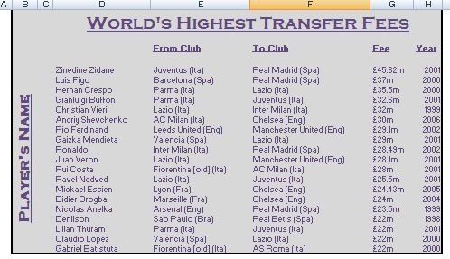

**When finished , save the file fist1.xlsx**

Q2(15 Marks) Open the spreadsheet **second.xlsx** from your candidate desktop drive

Using data validation, ensure that a drop-down list is available for country selection.

Create a range called Country on the Info worksheet which will provide the list.

, Apply the necessary protection to ensure this.

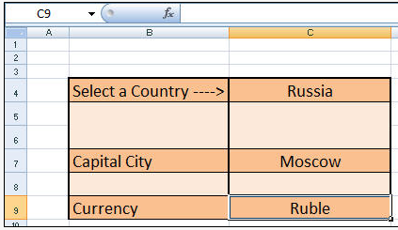

**When finished , save the file second1.xlsx**

Q3) (25 Marks) - Create a new spreadsheet and add the following labels and data

|  |  |  |  |  |  |  |  |
| --- | --- | --- | --- | --- | --- | --- | --- |
| Name | Mark1 | Mark2 | Mark3 | Total | average | Maximum  Mark | Minimum  Mark |
| Ali Mohd | 10 | 20 | 30 |  |  |  |  |
| Ahmad Younes | 20 | 13 | 41 |  |  |  |  |
| Noor Murad | 15 | 20 | 10 |  |  |  |  |

-Total = use Excel function to calculate ( mark1,mark2 and mark3) for each student

-Average = use Excel function to find the average Marks for each student

- Maximum Mark = use Excel function to find the Maximum Mark for each student

- Minimum Mark = use Excel function to find the Minimum Mark for each student

Q4) (15 Marks) Start a new spreadsheet in this workbook. Create the following labels:

Enter the Labels

In Cell A1 type: Present Value

In Cell A2 type: Interest

In Cell A3 type: Months

In Cell A4 type: Payment

In Cell B1=$20,000

Cell B2=4%

Cell B3=48

-Select Cell B4 and use the Function Wizard (fX) to calculate the Payment using the PMT function. Remember, the Rate (Cell B2) is divided by 12 to get a monthly payment

Q5) (25 Marks) -Open a new blank spreadsheet.

In cell A1 and type the word “April.” Tab across to B1 and type “May.” Use the Autofill to enter the

Labels from June through October.

- Add the following values to your spreadsheet:

A2=3.3

B2=4.7

C2=1.6

D2=.75

E2=.7

F2=6.5

G2=3.1

- Select the range from A1 through G2, Create a graph (chart). Select the Cylinder Chart type and remove the legend. Place the chart on the same spreadsheet .

- Select the columns and double click to change the fill to red. Select the column for May and

change the fill to yellow.

- Select the wall and change the fill to the Water droplets texture.

- Double click the text on the axis and format the type to be 14 pt.

- Rename the spreadsheet to be Unrwa