

**IR AUDIO TRANSMITTER AND RECIEVER**

NOUSHAD AHMED (2K19/CO/266)

**ACKNOWLEDGEMENT**

We have taken efforts in this project. However, it would not have been possible without the kind support and help of our Teacher. We would like to extend my sincere thanks to him.

We are highly indebted to (**DR. ANUKUL PANDEY**) for their guidance and constant supervision as well as for providing necessary information regarding the project & also for their support in completing the project.

We would like to express my gratitude towards my parents & our sir DR. ANUKUL PANDEY for their kind co-operation and encouragement which help me in completion of this project.

We would like to express our special gratitude and thanks to our college(DTU) for giving me such attention and time.

Our thanks and appreciations also go to our colleague in developing the project and people who have willingly helped us out with their abilities.

**CONTENT**

**1. INTODUCTION**

**2. ABSTRACT**

**3. OBJECTIVE**

**4. BLOCK DIAGRAM**

**5. CIRCUIT DIAGRAM**

**6. COMPONENT REQUIRED**

**7. COMPONENT DESCRIPTION**

**8. METHODOLOGY**

**9. WORKING**

**10. RESULTS**

**11. CONCLUSION**

**12. APPLICATION**

**13. FUTURE EXPANSION**

**14. CONTRIBUTIONS**

**15. REFERENCE**

**INTRODUCTION**

In this project, we will explain  how to design a Simple IR Audio transmitter and reciever circuit, which is used to transmit audio signals wirelessly. This IR audio transmitter and reciever is able transmit audio signals for short distances. The audio signal which is to be transmitted is applied at the base of the transistor . An 8 speaker or head phone is connected at the receiver section to listen to the transmitted signal.

**ABSTRACT**

The main principle in this project is IR communication, infrared rays are used only for line of sight communication over low range. Wireless communication allows information to be transmitted between two devices without using wires and cable. The data is being transmitted and received using electromagnetic radiation. The audio signal which is to be transmitted is applied at the base of the transistor in transmitter section. Speaker or head phone is connected at the receiver section to listen to the transmitted signal. Wireless Infrared (IR) communications system is meant to use free-space propagation of light waves as a transmission medium in near infrared band. In this paper, voice communication system is simulated and implemented by proteus software using IR as a source that is established an audio communication (link to transmit and receive voices and music via infrared light). The outcome of this proposed work is to design and implementation an optical wireless system to transmit voice over a certain distance in laboratory. This system has many advantages such as is a common, inexpensive, and the transmitter or receiver can be showed to another location with least distraction.

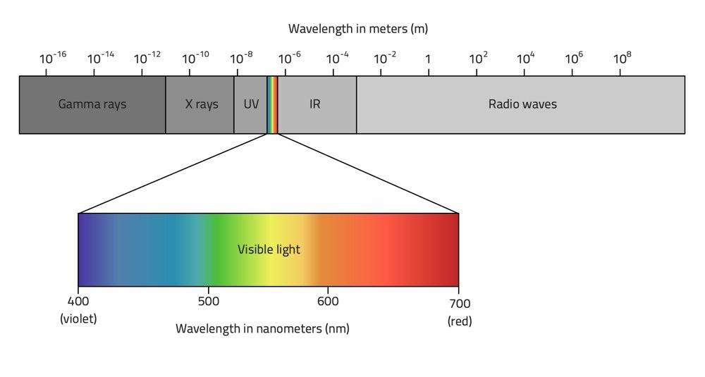

Electromagnetic spectrum

**OBJECTIVE**

**A simple project, which demonstrate the principle of infrared (IR) communication using IR transmitter and receiver. Some sound signal is transmitted to the device from one end and the same sound signal is received at the other end.**

Infrared (IR) communication is a very common wireless communication technology. IR communication is an easy to use and inexpensive wireless communication. IR Communication generally comprises of IR Transmitter and Receiver.

**BLOCK DIAGRAM**

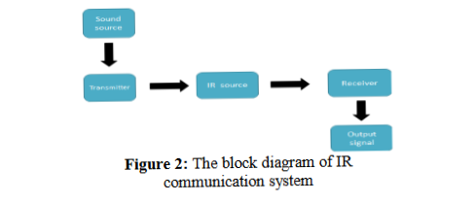

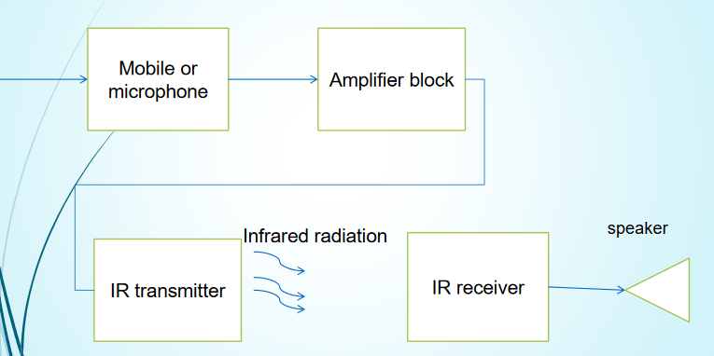

Block Diagram

**COMPONENTS REQUIRED**

1. RESISTOR R1, R2, R4 (1K OHM), R3 10K
2. Battery B1 B2 (9V)
3. Capacitor C1 (1u)
4. NPN BJT Q1, Q2, Q3 (BC548)
5. OPTO-COUPLER U1 (PC817), a small chip that transfers signals between two isolated circuits using light.
6. 8ohm SPEAKER LS1

**COMPONENTS DESCRIPTION**

**OPTO COUPLER**

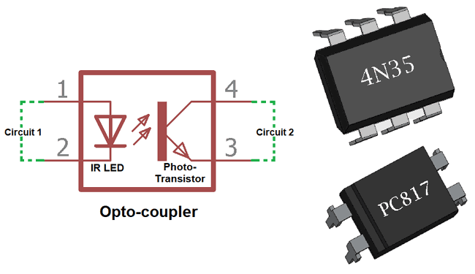

A small chip that transfers signals between two isolated circuits using light.

**Opto-coupler** is an electronic component that transfers electrical signals between two isolated circuits using light. **Optocoupler also called Opto-isolator, photo coupler or optical isolator.**

An opto-isolator contains a source (emitter) of light, almost always a near infrared, Light emitting diode(LED), that converts electrical input signal into light, a closed optical channel (also called dielectrical channel), and a photosensor, which detects incoming light and either generates electric energy directly,

Opto-isolators prevent high voltages from affecting the system receiving the signal. Commercially available opto-isolators withstand input-to-output voltages up to 10 KV.

A common type of opto-isolator consists of an LED and a phototransistor in the same opaque package.

### ****Photo-Transistor Optocoupler****

### Photo-Transistor Optocoupler

Current from the source signal passes through the input LED which emits an infra-red light whose intensity is proportional to the electrical signal.

This emitted light falls upon the base of the photo-transistor, causing it to switch-ON and conduct in a similar way to a normal bipolar transistor. Thus it helps to transfer the electric signals between two isolated components.

In the upper image the internal construction is shown inside a Photo-transistor Optocoupler. The Transistor type can be anything whether PNP or NPN.

**Npn transistor (BC548)**

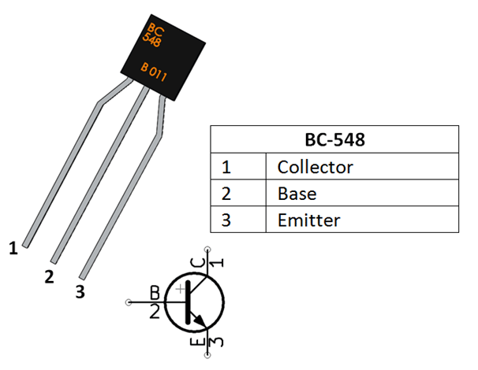

The transistor acts as an amplifier by raising the strength of a weak signal. The DC bias voltage applied to the emitter base junction, makes it remain in forward biased condition. This forward bias is maintained regardless of the polarity of the signal.

**Transistor Q1 is used to drive the IR diode. The input audio signal modulates the infrared signals from the IR diode and the transmitted infrared signals are received by the phototransistor.**

A pair of transistor(Q2,Q3) is used as Darlington pair to amplify the signals at the receiver end.

A Darlington Transistor configuration, also known as a “Darlington pair” , consist of two NPN or PNP transistors connected together so that the emitter current of the first transistor Q2 becomes the base current of the second transistor Q3. Further the base current is amplified and the amplified signal is received by the circuit.

**CAPACITOR**

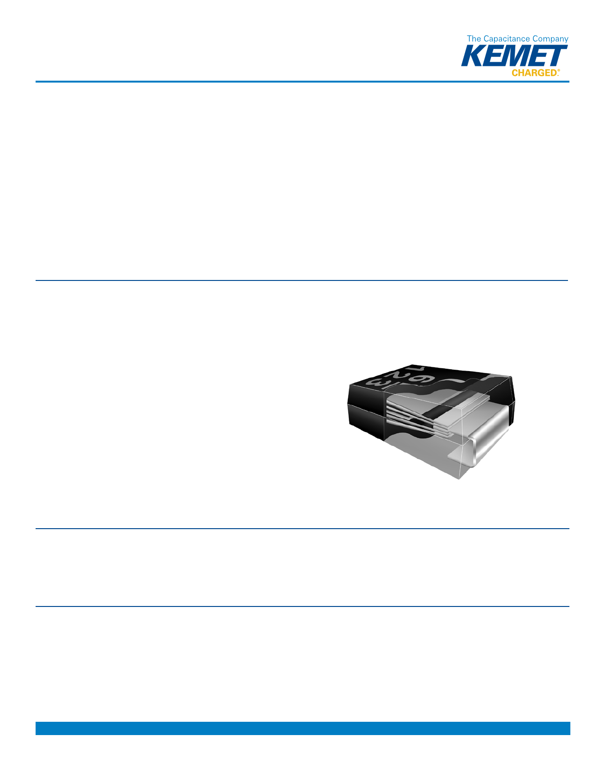

The capacitor is used to filter out a certain frequency otherwise series of frequencies from an electronic circuit . Generally, a capacitor filters out the signals which have a low frequency. The frequency value of these signals is near to 0Hz, these are also known as DC signals. So this capacitor is used to filter unwanted frequencies.

In this project , **capacitor C1 and resistor R3 form a filter used to reduce interference from stray infrared signals and filter the unwanted frequencies.**

The working of this capacitor mainly depends on the capacitive reactance principle. It is nothing but how the impedance of a capacitor alters with a signal frequency that is flowing through it. A nonreactive component like a resistor offers similar resistance to a signal apart from the frequency of the signal. This means 1Hz & 100KHZ signals flow throughout a resistor with equal resistance.

But, a capacitor is different because its impedance or resistance will change based on the signal frequency which is flowing through. These are reactive devices that offer high resistance to low-frequency signals and low-resistance to high-frequency signals using the formula like XC= 1/2πfc. A capacitor gives dissimilar impedance values for dissimilar frequency signal. In a circuit, it can operate as a resistor.

**Speaker (8 ohm)**

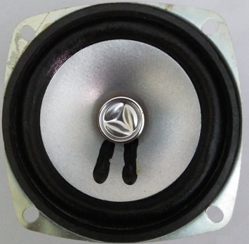 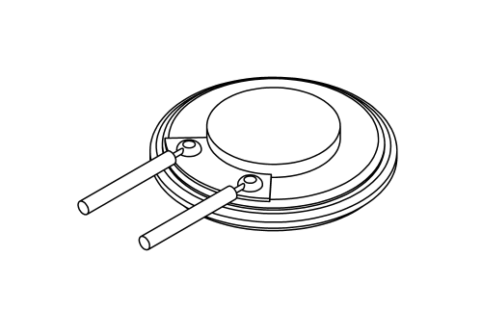

8 ohm speaker 8 OHM SPEAKER PINOUT

The purpose of speakeris to produce audio output that can be heard by the listeners. Speakers are the transducers that used to convert the electromagnetic waves into sound waves. It receives audio input from computer or audio receivers. The input fed to speaker is in analog or digital form. Analog speakers simply amplify electromagnetic waves into sound waves while digital first convert the signal into analog and then amplify it.

Sound produced by the speaker is defined by frequency and amplitude, where frequency determines how high or low the pitch of the sound is. Amplitude or loudness of the speaker is defines by the change in the air pressure created by the speaker’s sound waves.

We all know that, speakers have few different parameters like impedance, power handling, size, frequency response. Here, impedance tells you that how much current will flow through a speaker at a certain voltage. Like this speaker has 8 ohms of impedance and comes with a power handling capacity of 1W.

**METHODOLOGY**

The main principle in this circuit is IR communication. Infrared (IR) is used only for line – of – sight communications over low range. In electromagnetic spectrum Infrared rays are rays are having the wavelengths longer than the wavelengths of visible light. These Infrared rays are not visible to the human eye, but we can view these IR rays through the digital camera.

A typical IR communication system includes infrared source such as Infrared lasers or LEDs with specific wavelengths. The transmission mediums used for IR communication is vacuum, atmosphere and optical fibers. Finally in IR communication, to detect the IR rays, we will use photo diodes or photo transistors.

The output signal from this detectors is very small and might not be able to drive the speakers. Hence, we will use a simple amplifier to amplify the signal. This amplified signal can be able to drive the speakers.

**CIRCUIT DIAGRAM**

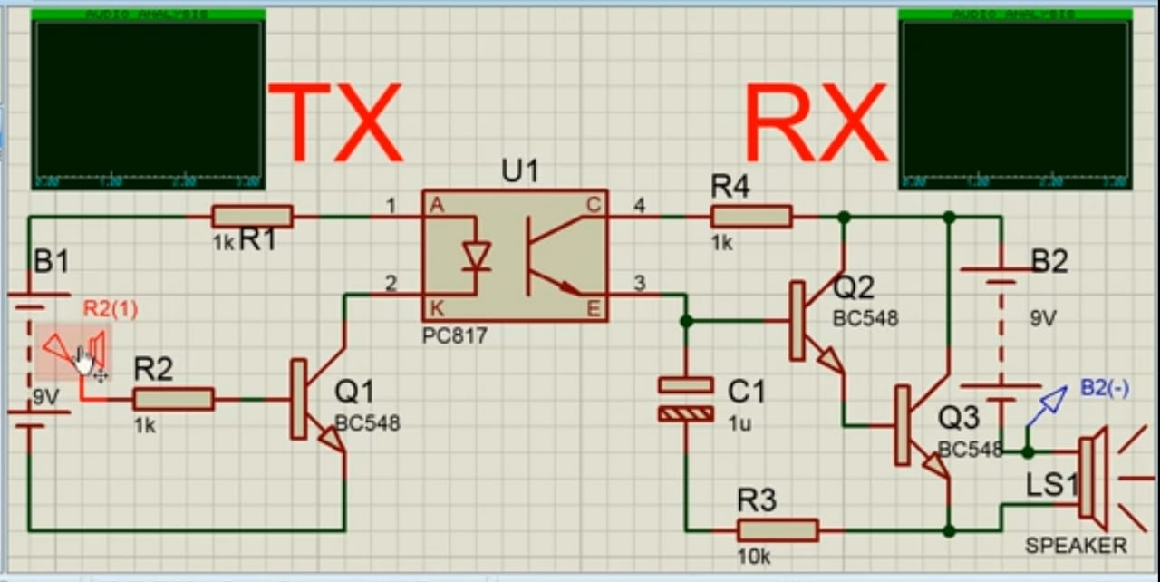

**WORKING**

**An IR audio transmitter and receiver circuit which can transmit audio signals up to small distances. The audio signal which is to be transmitted is applied at the base of a transistor in transmitter section and an 8 ohm speaker is connected at the receiver section to listen to the transmitted audio signal. The circuit uses a PC 817 opto-coupler, a small chip that transfers signals between two isolated circuits using light. A basic opto-coupler uses an LED and a phototransistor. The brighter the LED, the more current is allowed to pass through the phototransistor. The main principle in this circuit is IR communication which is only used for Line-of-Sight (LoS) communications over low range.**

**Transistor Q1 is used to drive the IR diode. The input audio signal modulates the infrared signals from the IR diode and the transmitted infrared signals are received by the phototransistor. Transistors Q2 and Q3 form a Darlington circuit which amplifies the output signal of phototransistor. The output signal from Darlington circuit is able to drive the speaker. Finally, capacitor C1 and resistor R3 form a filter used to reduce interference from stray infrared signals. Finally we get the sound output at the speaker.**

**RESULTS**

The supplying voltage from battery for each IR transmitter and receiver is (9V). Transmitter utilizes light as a data common carrier. To produce a series of audio signal encoding the transmitter via modulation frequency. Then the signal light will be received by the receiver, the modulated and enforced signals can be sent by amplifier where the music can be heard.

The main result of this proposed work is to design and implementation an optical wireless system to transmit voice over a certain distance in laboratory with many advantages such as is a common, inexpensive

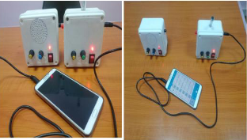

The circuit working of IR-communication system

**CONCLUSION**

This project is focusing on transmitting audio signal (mobile or radio) from the transmitter ending to the receiver ending using the infrared light radiation equipment ,this design is called the optical wireless audio system, The designing in this project devoted on the development of the conventional infrared radiation communicating by increasing the transmission distance and the effective signal coverage region, likewise this system has unique advantages such as minimal effort with low cost, high speed communication and almost no limitations of bandwidth range. The lowest cost of this design in our country is better to use for general conversation with neighbours where confidentiality is a prime issue.

**APPLICATION**

The project can be used for short range communication such as :

1. The project can be successfully used in conference room.
2. It can be used in political assembly.
3. It could also be used in classrooms.
4. It could be used in general conversation between two neighbouring houses.
5. It could be used in seminar halls.

**Future expansion**

1. The distance between IR transmitter and receiver can be increased.
2. This could be made to control multiple device at a time.
3. Data transfer rate can be increased by more than 4MBPS.
4. It could be made to carry it more easily.

**CONTRIBUTIONS**

We worked days and days together to work on this project. We usually research by our own on this topic and used to discuss it on the meet at the end of the day. We tried to find the best possible outcome with low cost by researching of our own and then by discussion , we decide what to select in the project. We both did the simulation of the project by our own on proteus 8. we used to ask questions to each other while explaining. So this project is hard work of both of its member along with the guidance of our teacher.

**REFERENCE**

[1]"Computer system with wireless audio signal transmitter module", *The Journal of the Acoustical Society of America*, vol. 121, no. 3, p. 1274, 2007. Available: 10.1121/1.2720002.

[2] "Computer system with wireless audio signal transmitter module", *The Journal of the Acoustical Society of America*, vol. 121, no. 3, p. 1274, 2007. Available: 10.1121/1.2720002.

[3] "Computer system with wireless audio signal transmitter module", *The Journal of the Acoustical Society of America*, vol. 121, no. 3, p. 1274, 2007. Available: 10.1121/1.2720002

[4]"IR based Wireless Audio Transmitter and Receiver Circuit", *Circuit Digest*, 2020. [Online]. Available: https://circuitdigest.com/electronic-circuits/ir-based-wireless-audio-transmitter-and-receiver-circuit-diagram. [Accessed: 03- Nov- 2020].

[5] Pooja Shree G, "IR AUDIO TRANSMITTER AND RECEIVER", *Slideshare.net*, 2020. [Online]. Available: https://www.slideshare.net/PoojashreeG/ir-audio-transmitter-and-receiver. [Accessed: 03- Nov- 2020].