NOUSHAD AHMED (2K19/CO/266)

**EXPERIMENT-6**

**AIM:**

To implement preemptive priority scheduling algorithm.

**CODE:**

#include<iostream>

#include<algorithm>

using namespace std;

struct node{

char pname;

int btime;

int atime;

int priority;

int restime=0;

int ctime=0;

int wtime=0;

}a[1000],b[1000],c[1000];

void insert(int n){

int i;

for(i=0;i<n;i++){

cin>>a[i].pname;

cin>>a[i].priority;

cin>>a[i].atime;

cin>>a[i].btime;

a[i].wtime=-a[i].atime+1;

}

}

bool btimeSort(node a,node b){

return a.btime < b.btime;

}

bool atimeSort(node a,node b){

return a.atime < b.atime;

}

bool prioritySort(node a,node b){

return a.priority < b.priority;

}

int k=0,f=0,r=0;

void disp(int nop,int qt){

int n=nop,q;

sort(a,a+n,atimeSort);

int ttime=0,i;

int j,tArray[n];

int alltime=0;

bool moveLast=false;

for(i=0;i<n;i++){

alltime+=a[i].btime;

}

alltime+=a[0].atime;

for(i=0;ttime<=alltime;){

j=i;

while(a[j].atime<=ttime&&j!=n){

b[r]=a[j];

j++;

r++;

}

if(r==f){

c[k].pname='i';

c[k].btime=a[j].atime-ttime;

c[k].atime=ttime;

ttime+=c[k].btime;

k++;

continue;

}

i=j;

if(moveLast==true){

sort(b+f,b+r,prioritySort);

// b[r]=b[f];

// f++;

// r++;

}

j=f;

if(b[j].btime>qt){

c[k]=b[j];

c[k].btime=qt;

k++;

b[j].btime=b[j].btime-qt;

ttime+=qt;

moveLast=true;

for(q=0;q<n;q++){

if(b[j].pname!=a[q].pname){

a[q].wtime+=qt;

}

}

}

else{

c[k]=b[j];

k++;

f++;

ttime+=b[j].btime;

moveLast=false;

for(q=0;q<n;q++){

if(b[j].pname!=a[q].pname){

a[q].wtime+=b[j].btime;

}

}

}

if(f==r&&i>=n)

break;

}

tArray[i]=ttime;

ttime+=a[i].btime;

for(i=0;i<k-1;i++){

if(c[i].pname==c[i+1].pname){

c[i].btime+=c[i+1].btime;

for(j=i+1;j<k-1;j++)

c[j]=c[j+1];

k--;

i--;

}

}

int rtime=0;

for(j=0;j<n;j++){

rtime=0;

for(i=0;i<k;i++){

if(c[i].pname==a[j].pname){

a[j].restime=rtime;

break;

}

rtime+=c[i].btime;

}

}

float averageWaitingTime=0;

float averageResponseTime=0;

float averageTAT=0;

cout<<"\nGantt Chart\n";

rtime=0;

for (i=0; i<k; i++){

if(i!=k)

cout<<"| "<<'P'<< c[i].pname << " ";

rtime+=c[i].btime;

for(j=0;j<n;j++){

if(a[j].pname==c[i].pname)

a[j].ctime=rtime;

}

}

cout<<"\n";

rtime=0;

for (i=0; i<k+1; i++){

cout << rtime << "\t";

tArray[i]=rtime;

rtime+=c[i].btime;

}

cout<<"\n";

cout<<"\n";

cout<<"P.Name Priority AT\tBT\tCT\tTAT\tWT\tRT\n";

for (i=0; i<nop&&a[i].pname!='i'; i++){

if(a[i].pname=='\0')

break;

cout <<'P'<< a[i].pname << "\t";

cout << a[i].priority << "\t";

cout << a[i].atime << "\t";

cout << a[i].btime << "\t";

cout << a[i].ctime << "\t";

cout << a[i].wtime+a[i].ctime-rtime+a[i].btime << "\t";

averageTAT+=a[i].wtime+a[i].ctime-rtime+a[i].btime;

cout << a[i].wtime+a[i].ctime-rtime << "\t";

averageWaitingTime+=a[i].wtime+a[i].ctime-rtime;

cout << a[i].restime-a[i].atime << "\t";

averageResponseTime+=a[i].restime-a[i].atime;

cout <<"\n";

}

cout<<"Average Response time: "<<(float)averageResponseTime/(float)n<<endl;

cout<<"Average Waiting time: "<<(float)averageWaitingTime/(float)n<<endl;

cout<<"Average TA time: "<<(float)averageTAT/(float)n<<endl;

}

int main(){

int nop,choice,i,qt;

cout<<"Enter number of processes\n";

cin>>nop;

cout<<"Enter process, priority, AT, BT\n";

insert(nop);

disp(nop,1);

return 0;

}

**OUTPUT SCREENSHOT:**

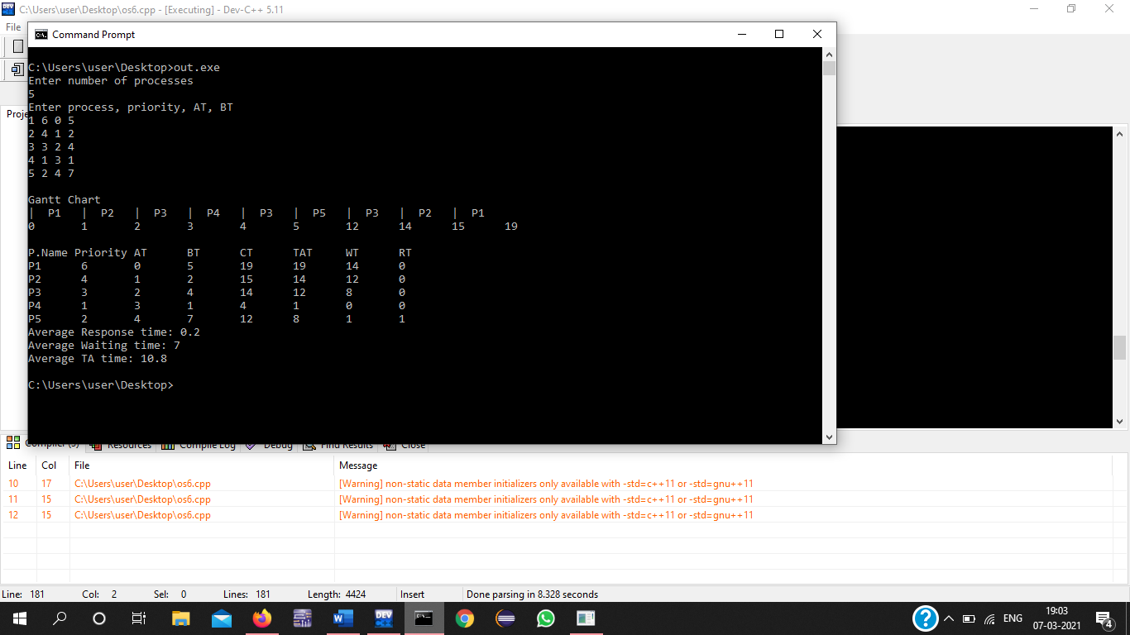

**LEARNING:**

CPU scheduling treats with the issues of deciding which of the processes in the ready queue needs to be allocated to the CPU. There are several different CPU scheduling algorithms used nowadays within an operating system.

Priority scheduling is a preemptive algorithm and one of the most common scheduling algorithms in batch systems. Each process is assigned first arrival time (less arrival time process first) if two processes have the same arrival time, then compare to priorities (highest process first). Also, if two processes have the same priority then compare to process number (less process number first). This process is repeated while all process gets executed.