**DBMS PROJECT REVIEW**



**ATTENDANCE MANAGEMENT SYSTEM**

**SUBMITTED BY:**

1. **NOUSHAD AHMED(2K19/CO/266)**
2. **NEERAJ GUPTA(2K19/CO/243)**

**SUBMITTED TO:**

**INDU SINGH**

## ABSTRACT

Student attendance management system deal with the maintenance of the student’s attendance details. It is generates the attendance of the student on basis of presence in class. It is maintaining daily basis of attendance, the staff will be provide with the separate username and password to make student attendance.

The staff handling the particular subject to responsible to make the attendance for all students. Only if the student presents the particular date, the attendance will be calculated. The student attendance report based on monthly and consolidate will be generated.

**INTRODUCTION**

Attendance Management System is software developed for daily student attendance in schools, colleges and institutes**.** It facilitates to access the attendance information of a particular student in a particular class. The information is sorted by the operators, which will be provided by the teacher for a particular class. This system will also help in evaluating attendance eligibility criteria of a student.

The purpose of developing attendance management system is to computerized the tradition way of taking attendance. Another purpose for developing this software is to generate the report automatically at the end of the session or in the between of the session.

Attendance Management System basically has two main modules for proper functioning:-

First module is admin which has right for creating space for new batch. Any entry of new faculty, Updating in subject if necessary, and sending notice.

Second module is handled by the user which can be a faulty or an operator. User has a right of making daily attendance, generating report.

**DESCRIPTION**

Our system has two types of accessing modes:-

**1.Administrator**

**2.User**

* Teacher
* Student

**Administrator**

Administrator have rights to manage student details, add a new student, provide register number for all students, assign each student a course etc., Administrator can update his profile, and also can give help to the teachers and students.

**User:** There are two users:-

**Student**: -Student do the login and see profile, Attendance Details etc.

**Teacher**:-Add student, view the student details and take attendance student.

**User Characteristics:-**

This software gives access to two kinds of users.

**1. Administrator:**

The administrators have features access to add, delete and modify information stored in the database.

**Authorized User**: Teaching staffs have access to view the data stored in the database and can update the student’s attendance in the form of formatted reports.

Student has access to view the data stored in the database.

**USE CASE DIAGRAM:**

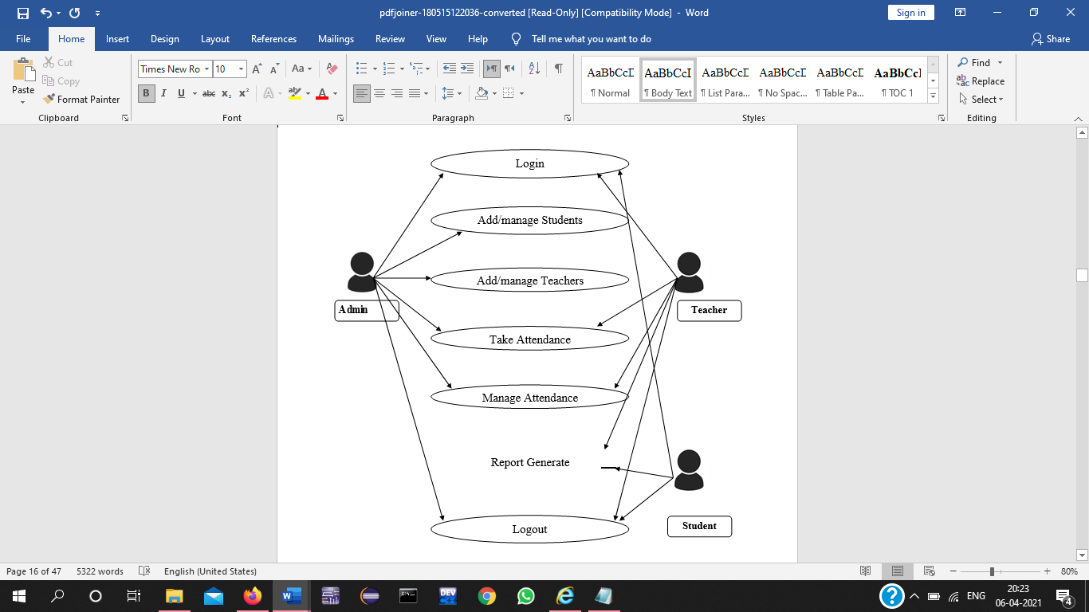

**ER DIAGRAM:**

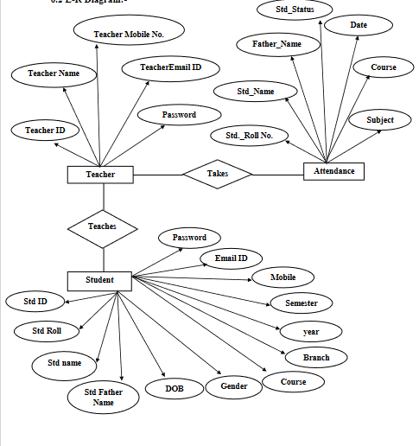

**DATABASE TABLE:**

**LOGIN TABLE:**

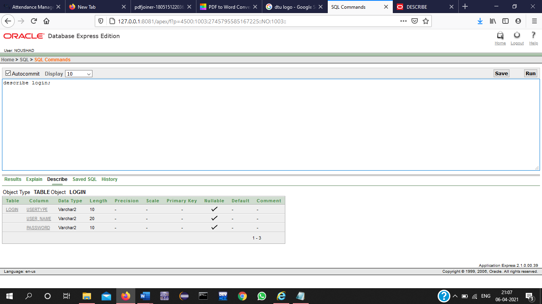

**TEACHER TABLE:**

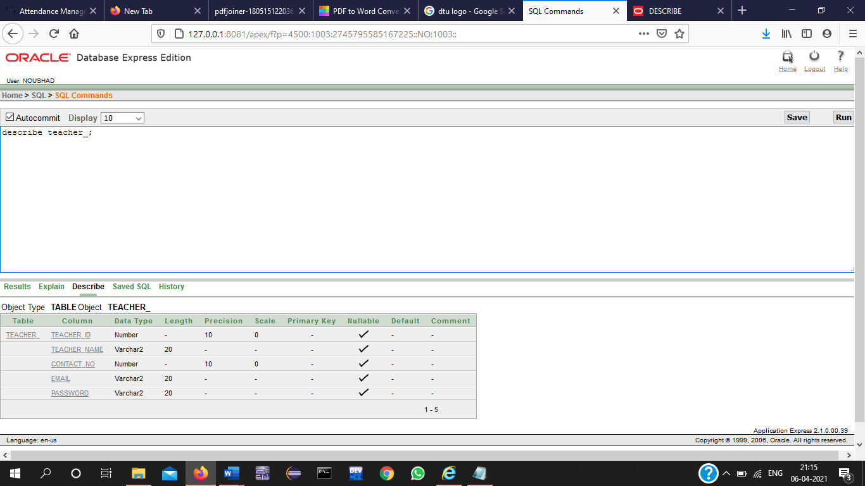

**TABLE STUDENT:**

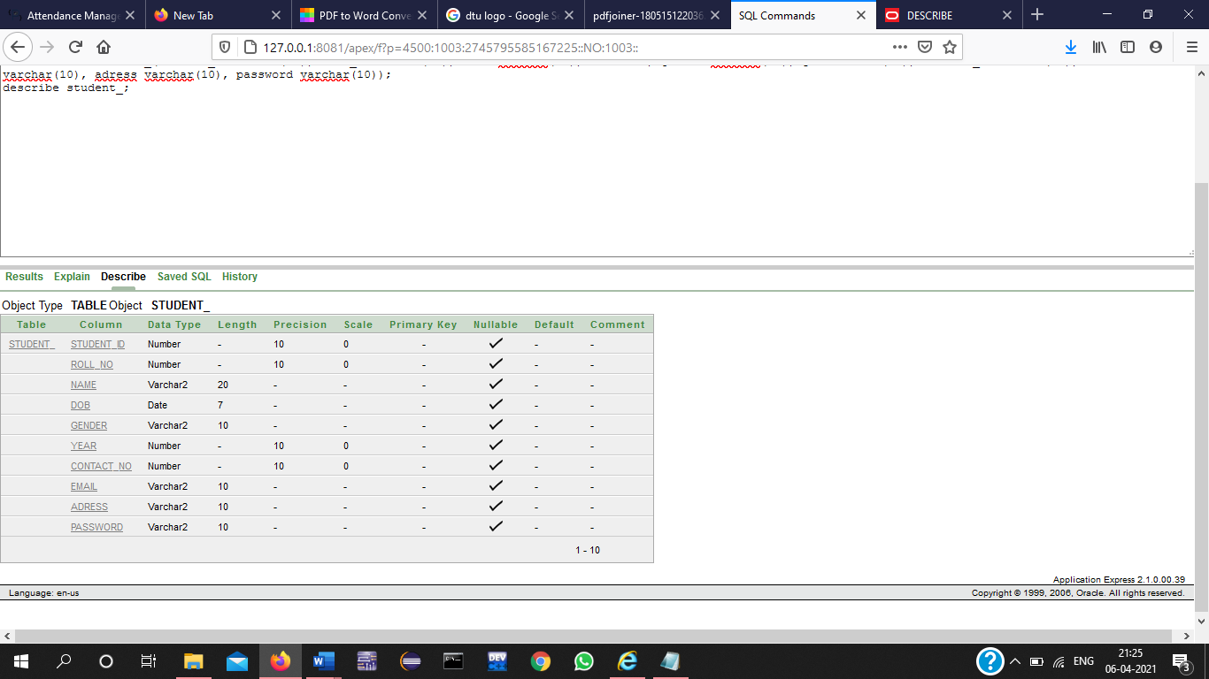

**ATTENDANCE TABLE:**

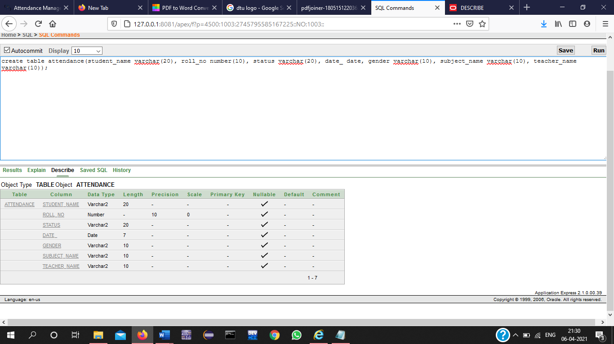

**COURSE TABLE:**

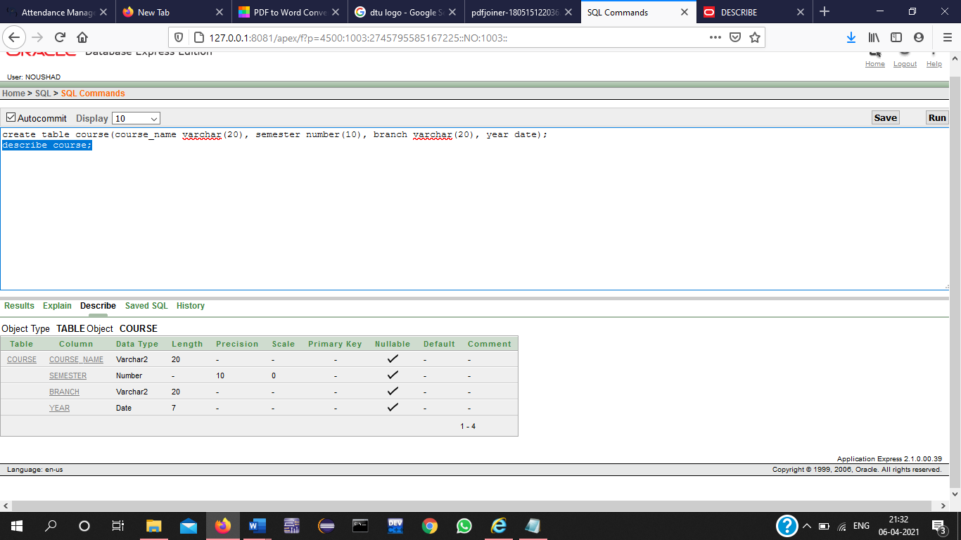

**CONCLUSION**

The system is operated at a high level of efficiency and all the teachers and user associated with the system understands its advantage. The system solves the problem. It was intended to solve as requirement specification.

The project has a very vast scope in future. The project can be implemented on intranet in future. Project can be updated in near future as and when requirement for the same arises, as it is very flexible in terms of expansion. With the proposed software of database Space Manager ready and fully functional the client is now able to manage and hence run the entire work in a much better, accurate and error free manner.