**DIGITAL ELECTRONICS PROJECT REVIEW**



**ANTI-COLLISION SYSTEM**

**SUBMITTED BY-**

**1.NOUSHAD AHMED(2K19/CO/266)**

**2. NEERAJ GUPTA(2K19/CO/243)**

**Guided by: Lavi Tanwar Mam**

**ABSTRACT**

Our motive behind this project is to analyze present day condition of Indian automobile industry and its standard and by keeping the current information in mind introduce a concept vehicle that can not only enhance the present standard of safety and comfort in Indian automobiles but also tackle the nightmare of pollution and shortage of fuel as well .

The Anti–Collision system is a detection device meant to be incorporated into vehicles for the purpose of safety. As opposed to the anti–collision devices present in the market today, this system is not designed to control the vehicle. Instead, it serves as an alert in the face of imminent collision.

The device is made up of an infrared transmitter and receiver. The device works by sending out streams of infrared radiation and alerts when any obstacle is present within specific range or safe distance, to take the necessary precaution to avert a collision. The device would still alert once by an alarm even though it is not recieving infrared beams from the oncoming vehicle. This is due to reflection of its own infrared beams.

**INTRODUCTION**

Due to the accident cases reported daily on the major roads in all parts of the developed and developing countries, more attention is needed for research in the designing an efficient car driving aiding system.

It is expected that if such a device is designed and incorporated into our cars as a road safety device, it will reduce the incidence of accidents on our roads and various premises, with subsequent reduction in loss of life and property.

The Infrared Anti-Collision Device are expected to be made of relatively inexpensive components for easy purchase and incorporation. This research aims at the design of a prototype showing how this could function. The main objective is to find a way to implement a minimum spacing for cars in traffic in an affordable way, alongside to achieve safety for passengers of a moving car. The anti-collision device, when wired into the circuitry of a vehicle would help in the reduction of road mishaps.

**OBJECTIVE**

The main objective is to find a way to implement a minimum spacing for cars in traffic in an affordable way, alongside to achieve safety for passengers of a moving car.

**ANTI-COLLISION SYSTEM**

The Anti–Collision device is a detection device meant to be incorporated into cars for the purpose of safety. This system is designed to serves as an alert in the face of imminent collision. The device is intended to find a way to implement a minimum spacing for cars in traffic in an affordable way. It would also achieve safety for the passengers of a moving car.

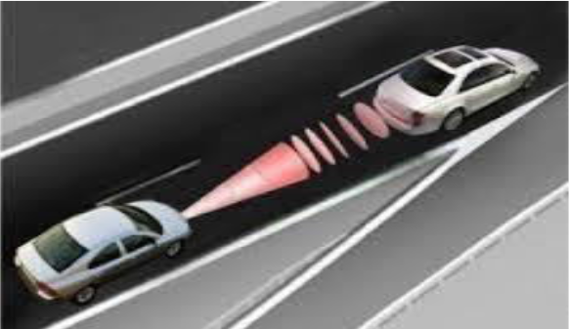

The device works by sending out streams of infrared radiation and when these rays are seen by the other equipped vehicle, both are meant to take the necessary precaution to avert a collision. The device would still sound an alarm even though it is not receiving infrared beams from the oncoming vehicle.

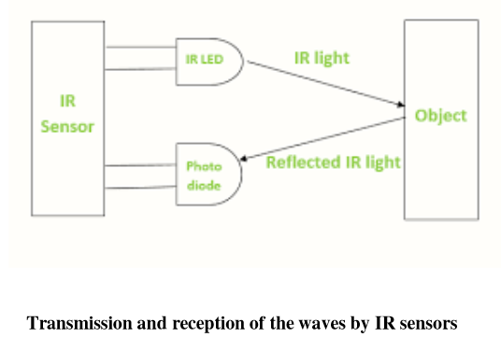

This is due to reflection of its own infrared beams. At the end of the design and testing process, overall system was implemented with a constructed work, tested working and perfectly functional.

**BLOCK DIAGRAM**

A typical system for detecting infrared radiation is given in the following block diagram :



**IMPLEMENTATION**

We are using hardware to implement this project. The various components required to implement this is listed below:

**COMPONENTS REQUIRED**

Hence below is the list of components used in our project :

1.Transistor as A Switch And As an Amplifier

2.IR Detection System

3.Ultra Sonic Distance Sensor

4.Shocking Circuit and Alarm Alert system

5.Main and Secondary power supply

6.Piezocrystal Circuit For Automatic Call Alert

**CONCLUSION**

The hybrid car concept designed and developed by us is a state of the art concept and behind this our endeavour is to project a fully indigenous hybrid car concept in Indian car market so that the entire India in general and economic and rural community in India in particular can be benefited.

This concept is a single lined solutions of so many existing socio economic problems like pollution, energy shortage and parking shortage. The concepts which are presented in this car like wind energy device, solar energy device, active suspension device and folding car concept are made this car concept unique and also sate of the art in particular.