**DÈLHI TÈCHNOLOGICÀL UNIVÈRSITY**



**DIGITÀL ÈLÈCTRONICS PRÀCTICAL**

**NOUSHAD AHMED(2K19/CO/266)**

**EXPERIMENT-6**

**AIM:**

Verify Binary to Gray and Gray to Binary conversion using NAND gates only

**Theory**

**Introduction**

Binary Numbers is default way to store numbers, but in many applications binary numbers are difficult to use and a variation of binary numbers is needed. This is where Gray codes are very useful.  
  
Gray code has property that two successive numbers differ in only one bit because of this property gray code does the cycling through various states with minimal effort and used in K-maps, error correction, communication etc.  
  
In computer science many a times we need to convert binary code to gray code and vice versa. This conversion can be done by applying following rules :

**1) Binary to Gray conversion :**

1. The Most Significant Bit (MSB) of the gray code is always equal to the MSB of the given binary code.
2. Other bits of the output gray code can be obtained by Ex-ORing binary code bit at that index and previous index.  
     
   There are four inputs and four outputs. The input variable are defined as B3, B2, B1, B0 and the output variables are defined as G3, G2, G1, G0. From the truth table, combinational circuit is designed. The logical expressions are defined as :

**B3 = G3**

**B2 ⊕ B3 = G2**

**B1 ⊕ B2 = G1**

**B0 ⊕ B1 = G0**

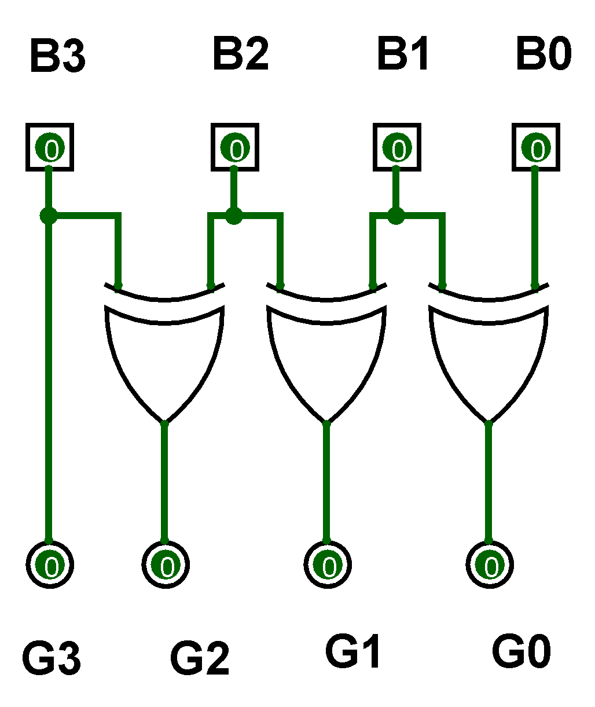

**Figure-1: Binary to Gray Code Converter Circuit**  
  
**Figure-2: Binary to Gray Code Converter Truth Table**

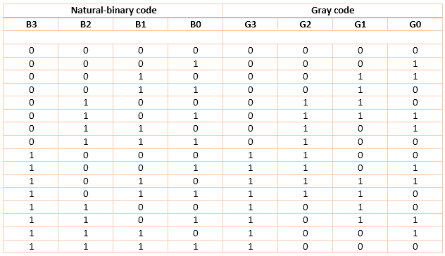

**2) Gray to binary conversion :**

1.The Most Significant Bit (MSB) of the binary code is always equal to the MSB of the given binary number.

2.Other bits of the output binary code can be obtained by checking gray code bit at that index. If current gray code bit is 0, then copy previous binary code bit, else copy invert of previous binary code bit.  
  
There are four inputs and four outputs. The input variable are defined as G3, G2, G1, G0 and the output variables are defined as B3, B2, B1, B0. From the truth table, combinational circuit is designed.The logical expressions are defined as :

**G0 ⊕ G1 ⊕ G2 ⊕ G3 = B0**

**G1 ⊕ G2 ⊕ G3 = B1**

**G2 ⊕ G3 = B2**

**G3 = B3**

**Figure-3: Gray to Binary Code Converter Circuit**

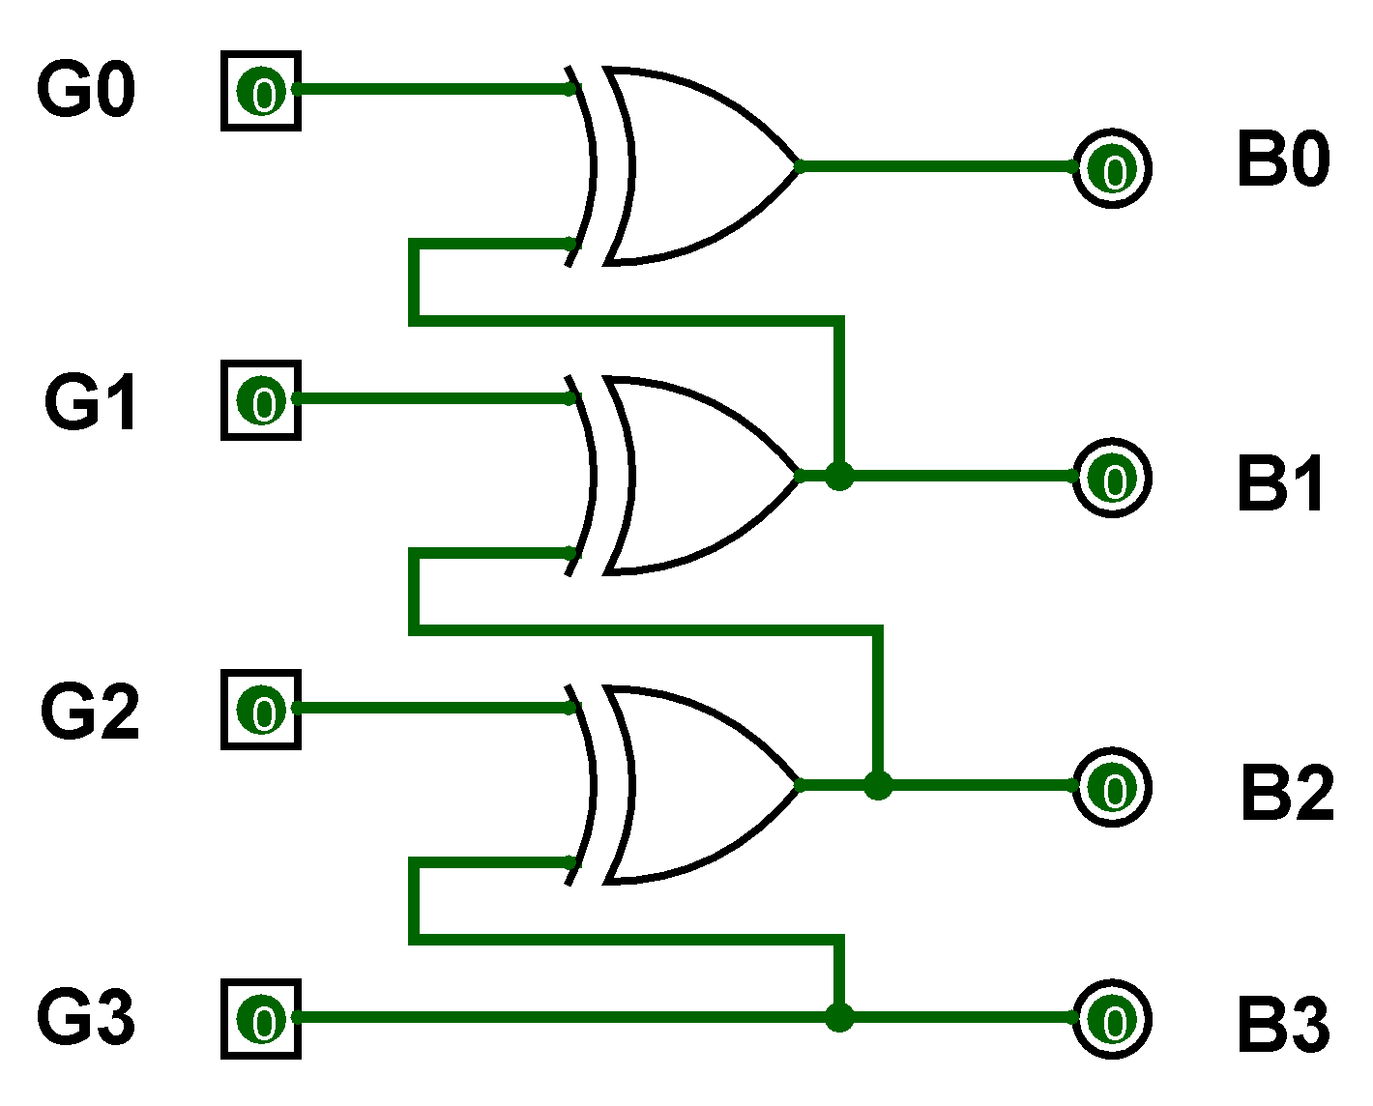

**Figure-4: Gray to Binary Code Converter Truth Table**

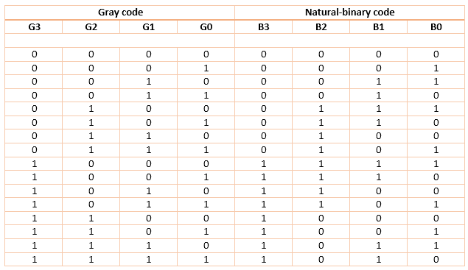

**Procedure**

* **Gray to Binary Conversion**

1. Step-1) Connect battery to supply 5V to the circuit.
2. Step-2) Press Switches for different inputs.  
   The switch in ON state is  and the switch in OFF state is



3. Step-3) The corresponding combination of input and output LEDs lit up for different combination of inputs.

The input gray code LEDs are G3,G2,G1 and G0 and the output binary code LEDs B3,B2,B1 and B0 glow accordingly.  
The input LED in OFF state is  and in ON state is  .  
The output LED in OFF state is  and in ON state is  .  
Step-4) Click "Add" to add the values to the Truth Table.  
  
Step-5) Click "Print" to get the print out of the Truth Table.

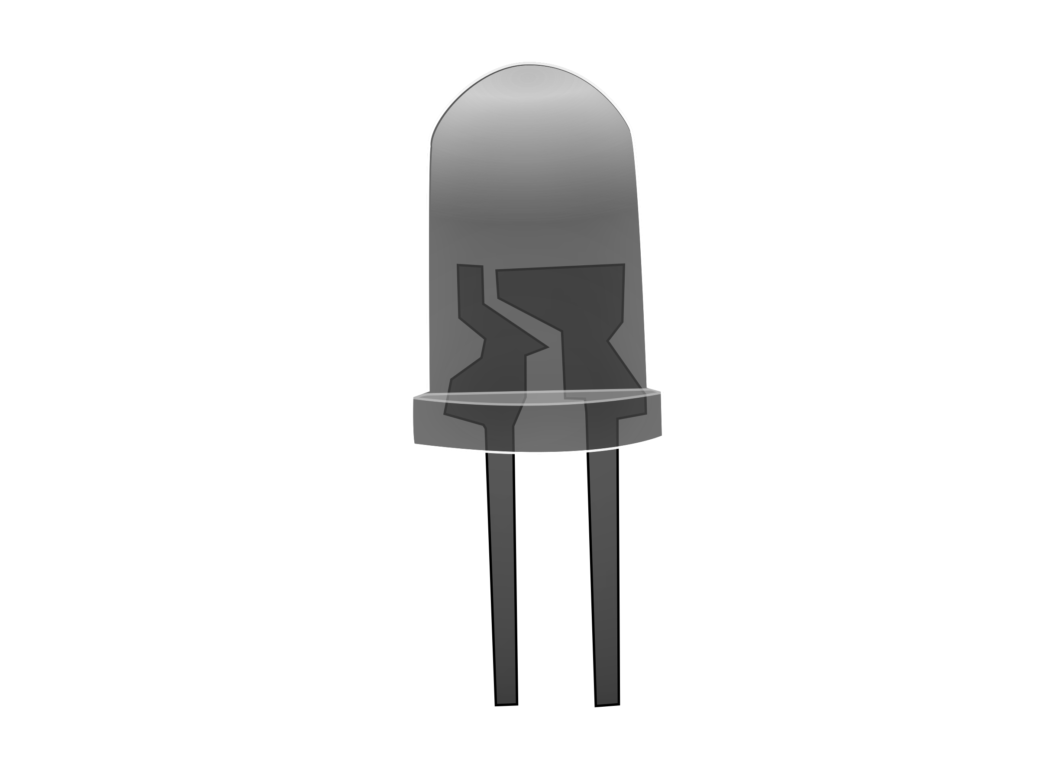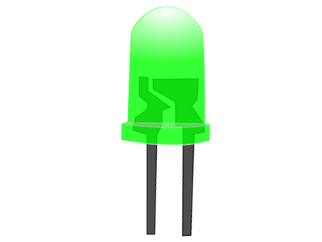

* **Binary to Gray Code Conversion**

1. Step-1) Connect battery to supply 5V to the circuit.
2. Step-2) Press Switches for different inputs.  
   The switch in ON state is  and the switch in OFF state is



1. Step-3) The corresponding combination of input and output LEDs lit up for different combination of inputs.

The input binary code LEDs are B3,B2,B1 and B0 and the output gray code LEDs G3,G2,G1 and G0 glow accordingly.  
The input LED in OFF state is  and in ON state is  .  
The output LED in OFF state is  and in ON state is  .  
Step-4) Click "Add" to add the values to the Truth Table.  
  
Step-5) Click "Print" to get the print out of the Truth Table.



**CIRCUIT DIAGRAM:**

**1.Binary to Gray conversion :**



**2.Gray to Binary conversion :**

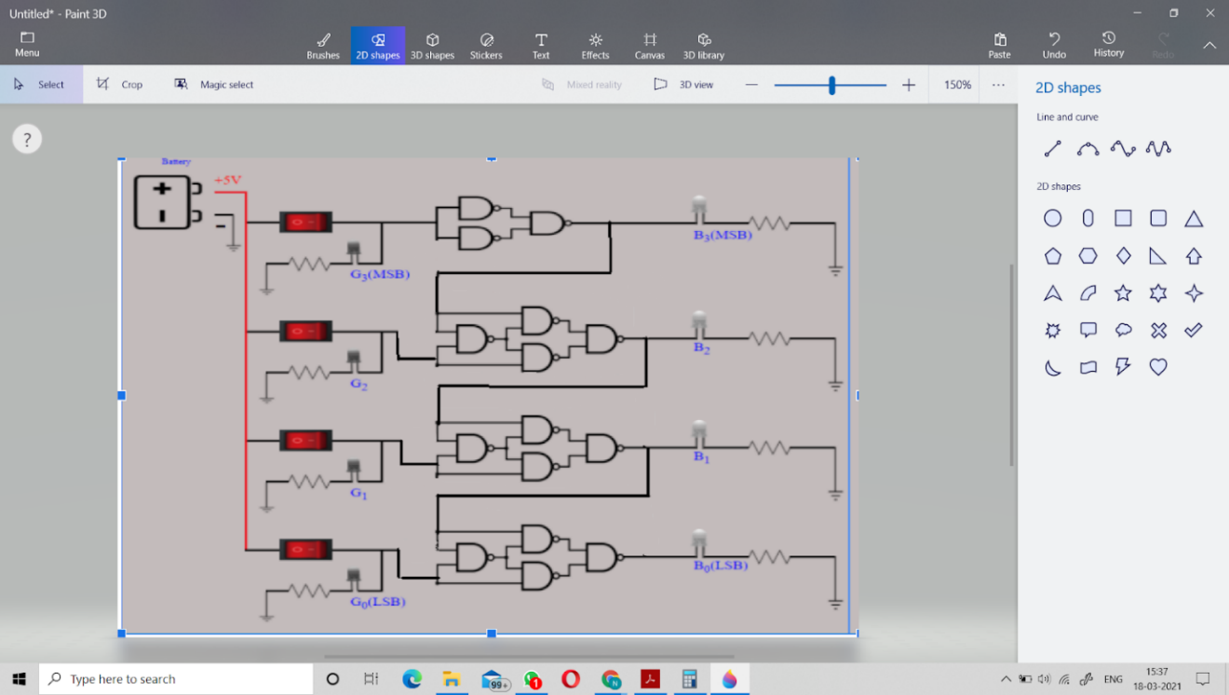

**OBSERVATION:**

**1.Binary to Gray conversion :**

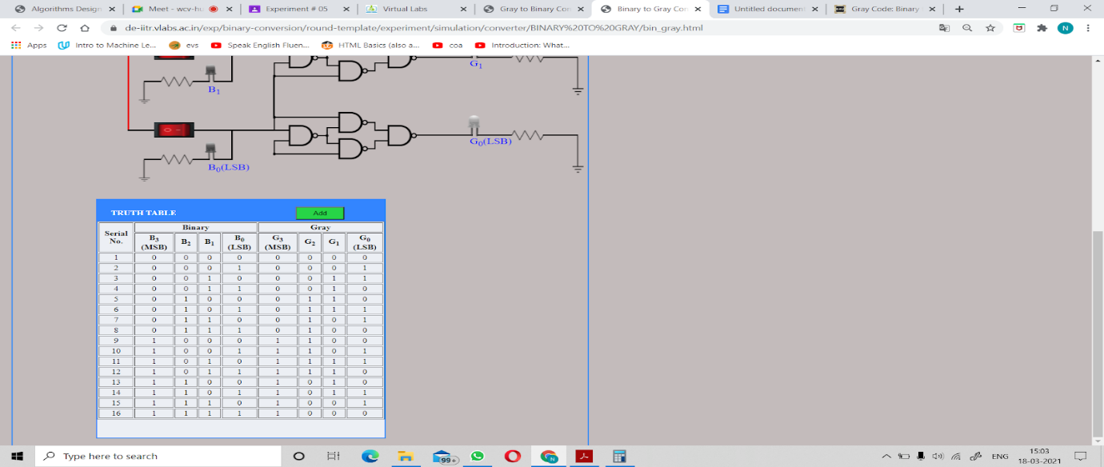

**2.Gray to Binary conversion :**

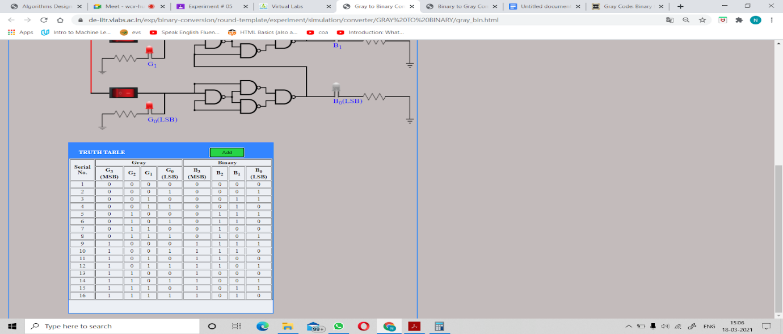

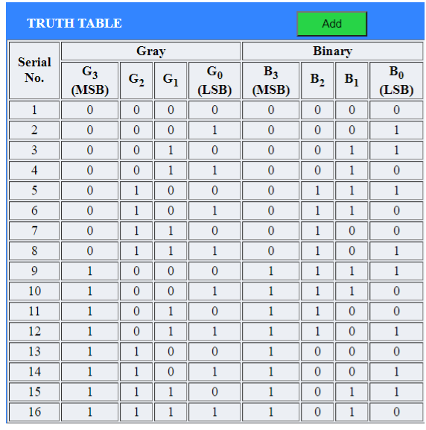

**RESULT:**

**The logic and truth table of all the gates have been verified using diode transistor logic and transistor transistor logic in simulator.**