**DÈLHI TÈCHNOLOGICÀL UNIVÈRSITY**



**DIGITÀL ÈLÈCTRONICS PRÀCTICAL**

**NOUSHAD AHMED(2K19/CO/266)**

**EXPERIMENT-7**

**AIM:**

To analyse the truth table of 1-bit comparator by using NOT, AND and NOR logic gate ICs and 2-bit comparator by using 1-input NOT, 3-input AND, 2-input AND, 3-input OR and 2-input Ex-NOR logic gate ICs and to understand the working of 1-bit comparator and 2- bit comparator with the help of LEDs display.

**THEORY:**

### Introduction

A magnitude digital comparator is a combinational circuit that compares two digital or binary numbers in order to find out whether one binary number is equal, less than or greater than the other binary number. We logically design a circuit for which we will have two inputs one for A and other for B and have three output terminals, one for A > B condition, one for A = B condition and one for A < B condition.

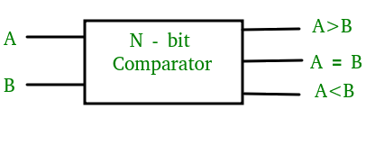

**Figure-1: Block Diagram of Comparator**

### 1) 1-Bit Magnitude Comparator :

A comparator used to compare two bits is called a single bit comparator. It consists of two inputs each for two single bit numbers and three outputs to generate less than, equal to and greater than between two binary numbers. The truth table for a 1-bit comparator is given below :

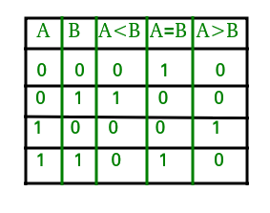  
**Figure-2: Truth Table of 1-Bit Comparator**

From the above truth table logical expressions for each output can be expressed as follows:  
A > B : AB'  
A < B : A'B  
A = B : A'B' + AB  
  
By using these Boolean expressions, we can implement a logic circuit for this comparator as given below :

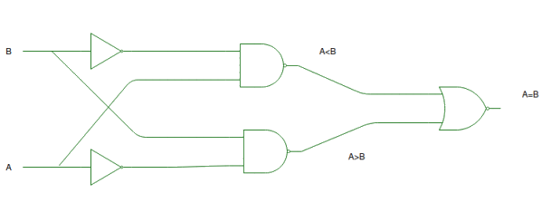  
**Figure-3: Logic Circuit of 1-Bit Comparator**

### 2) 2-Bit Magnitude Comparator :

A comparator used to compare two binary numbers each of two bits is called a 2-bit magnitude comparator. It consists of four inputs and three outputs to generate less than, equal to and greater than between two binary numbers.

The truth table for a 2-bit comparator is given below:

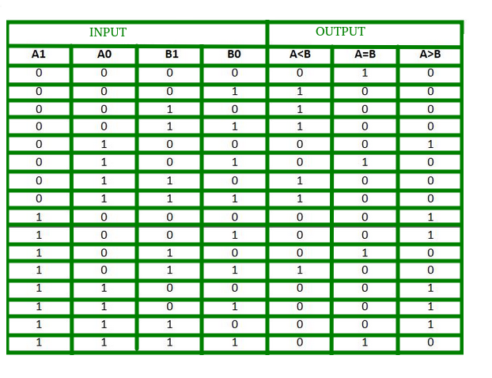  
**Figure-4: Truth Table of 2-Bit Comparator**

From the above truth table logical expressions for each output can be expressed as follows:  
A > B : A1B1’ + A0B1’B0’ + A1A0B0’  
A = B : A1’A0’B1’B0’ + A1’A0B1’B0 + A1A0B1B0 + A1A0’B1B0’  
           : A1’B1’ (A0’B0’ + A0B0) + A1B1 (A0B0 + A0’B0’)  
           : (A0B0 + A0’B0’) (A1B1 + A1’B1’)  
           : (A0 Ex-Nor B0) (A1 Ex-Nor B1)  
A < B : A1’B1 + A0’B1B0 + A1’A0’B0  
  
By using these Boolean expressions, we can implement a logic circuit for this comparator as given below :

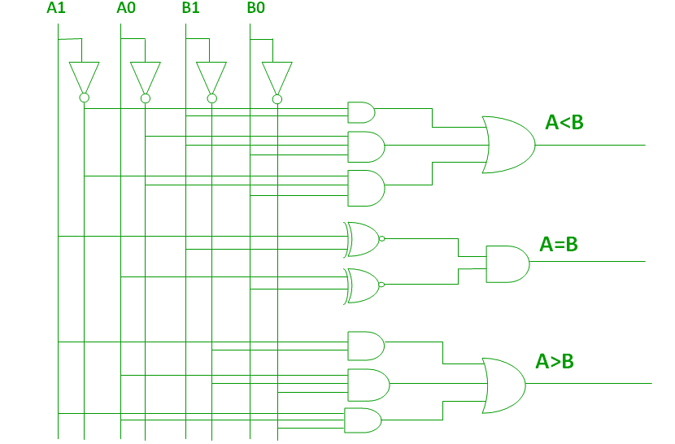  
**Figure-5: Logic Circuit of 2-Bit Comparator**

### Applications of Comparators :

1. Comparators are used in central processing units (CPUs) and microcontrollers (MCUs).
2. These are used in control applications in which the binary numbers representing physical variables such as temperature, position, etc. are compared with a reference value.
3. Comparators are also used as process controllers and for Servo motor control.
4. Used in password verification and biometric applications.

**PROCEDURE:**

### 1- Bit Comparator

#### Simulator 1:

Step-1) Switch ON the power supply button to supply 5V to the circuit.  
Step-2) Press Switch 1 for input A and Switch 2 for input B.  
The switch in ON state is and the switch in OFF state is   
Step-3) i)When the input A is greater than the input B,LED 1 lits up.   
ii)When the input A is lesser than the input B,LED 2 lits up.   
iii)When the input A is equal to the input B,LED 3 lits up.   
  
The LED in OFF state is and the LED in ON state is .  
Step-4) Click on "Add" Button to add data to the Truth Table.  
Step-5) Repeat Steps 2 to 4 for another set of data.  
Step-6) Click "Print" to get the print out of the Truth Table.

##### Simulator 2:

Step-1) Enter the Boolean input "A" and "B".  
Step-2) Enter the Boolean output for your corresponding inputs.  
Step-3) Click on "Check" Button to verify your output.  
Step-4) Click "Print" if you want to get print out of Truth Table.

### 2- Bit Comparator

#### Simulator 1:

Step-1) Switch ON the power supply button to supply 5V to the circuit.  
Step-2) Press Switch 1 for input A1,Switch 2 for input A0,Switch 3 for input B1and Switch 4 for input B0.  
The switch in ON state is and the switch in OFF state is   
Step-3) i)When the input A1A0 is greater than the input B1B0,LED 1 lits up.   
ii)When the input A1A0 is lesser than the input B1B0,LED 2 lits up.   
iii)When the input XA1A0 is equal to the input B1B0,LED 3 lits up.   
  
The LED in OFF state is and the LED in ON state is .  
Step-4) Click on "Add" Button to add data to the Truth Table.  
Step-5) Repeat Steps 2 to 4 for another set of data.  
Step-6) Click "Print" to get the print out of the Truth Table.

#### Simulator 2:

Step-1) Enter the two bit Boolean input "A" and "B".  
Step-2) Inputs should be written such that for 'A'="A1A0" and for 'B'="B1B0"   
Step-3) Enter the Boolean output for your corresponding inputs.  
Step-4) Click on "Check" Button to verify your output.  
Step-5) Click "Print" if you want to get print out of Truth Table.

**OBSERVATION:**

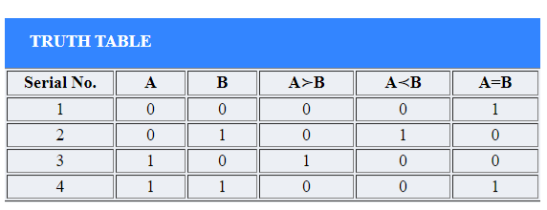

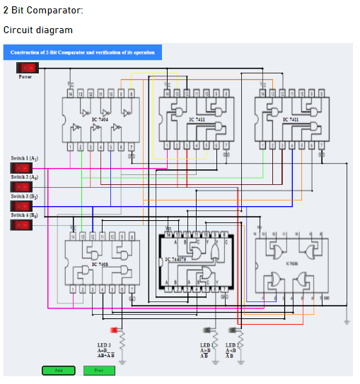

**OBSERVATION**

