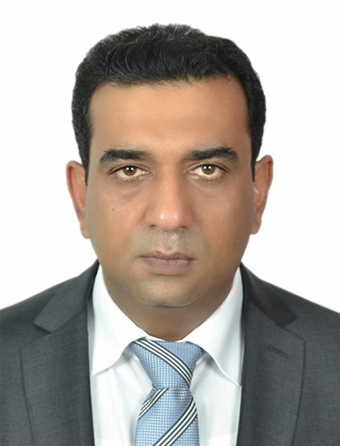
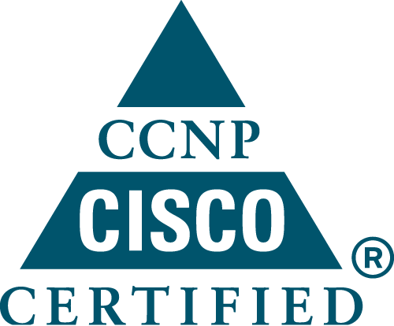
Amir Noor
P.O.Box 105846, Abu Dhabi.

Mobile: +97150-5680763
Email: amirnoor@hotmail.com
Pressure
Objective | To get absorbed in the field of Information Technology to explore and exploit my strengths that I have achieved through vast experience and professionalism acquired in Multinational Organizations.
Career Summary | 15 years of work experience in the field of IT for installation, configuration, troubleshooting and administration of Systems, Data Centre Cisco Routers/switches, security and network management. Managing LAN as well as remote sites in different cities. maintained routing protocols, Microsoft Dynamic Great Plains 8.0, 10, 11  Windows NT 4.0/2000/2003,2008 Proxy2.0/ISA 2006, Exchange 5.5/2000 2007 servers  Data Center Migration & Vast experience of infrastructure development/maintenance  Site to site connectivity via VPN, Barracuda anti-Spam & Web filter Firewalls
Skills & Known Technologies | Designing and implementing VMware,ESXI, vSphare 5 & 5.5, EMC VNX, VMAX, ExtremeIO, DDS, Avamar, Nutanix, SCOM, LANDesk 9.5, SM9, IBM rational manager clear case suite, HP Blades 460C and B480C series, CISCO UCS 200 M3, HP blade onboard administration, HP virtual connect for inter blade and SAN,  connectivity Disaster Recovery Strategies through VERITAS Backup Exec,  SAN/NAS Storage, Tape Library, IBM & HP Blade Centers, Clustering Microsoft Windows NT4.0/2000/2003/2008 Domain Controllers, MS Hyper V Core 2008, SCVVM Server  Active Directory Restore Process, Schema Master, Forest and Child Domain,  Microsoft Windows 2000/2003/2008, 2012,standard, enterprise and Infrastructure Servers (DNS,DHCP.. etc)  Microsoft Exchange Server 5.5/2000/2003/2007 Hub Cass Servers  Microsoft SMS & SUS Server, Microsoft ISA Server 2006  Microsoft SQL Server 2000/2005 (MS Dynamics Great Plains Version 8.0, 10, 11 Navision)  File and Print Server ,Security Quest 9, Barracuda Anti-Spam & Web Filter Devices  CITRIX Meta frame XP Server, VDI Client  Microsoft Project and Visio, CISCO CUCM 7.2, CISCO Unity Server  CISCO Phones 7941, 7942, 7962, 7965, Cisco Routers 1804, 2800,2900 3600,  Cisco Switches 2900, 3500, 3850, 4500, 6500  Frame Relay, ATM, Leased circuits, MPLS layer 2 switching
Employment History | 30th July 2014 till date  ITS (International Turnkey Systems PJSC  Stationed to Abu Dhabi Islamic Bank  Position: Senior Service Engineer  Responsible for tear 2 support to bank staff & various departments under ADIB IT umbrella  Including, day to day physical and virtual server installation (VMware vSphare 5 & 5.5).  Responsible to convert physical server to virtual server through VMware converter  Monthly basis documentation of current and newly created server, applying predefined IT security policies on QA, Development, Production & DMZ servers (physical and virtual)  Actively participating on pre and post go live activities of different QA, development servers to production and DMZ environment, patch deployment of preapproved patches through IBM rational manager clear case suite, granting users NTFC security access for their files and folders on file server through security quest 9  Fulfillment of users created tasks, incidents and service desk queries through HP service manager 9.5  Users issue software issues resolving through LANDesk 9.5 for remote connectivity, supporting local and international branch issues  Member of ongoing CITRIX VDI implementation team for moving from physical to 2000 VDI client by 2nd quarter of year 2015  Member of data center migration team for moving all current datacenter servers to newly install datacenter in pacific control center (Jabel Ali).  Sept 2008 - July 2014  Viola Communication, Abu Dhabi, U.A.E  (Viola Communication is subsidiary of Al Qudra & Royal Group)  Position: IT Manager  Responsible for designing, installation, configuration & troubleshooting.  Data Centre, Microsoft hyper V Core, San Storage IBM DS4700, 32 TB  Tape Library IBM LTO 4 TS3200, IBM Blade Center H 21 Series, HP DL 380 G6, G7, G8 Series, Windows Clustering, Backup Exec VERITAS 10  Managing Exchange Server 2007,Hub Case,ISA 2006 Server, SMTP Relay Agent, Barracuda  anti-span & web filtering devices, MAC OS & hardware support  Successfully implemented windows clustering with SAN storage & backup devices  Along with disaster recovery plan  Coordinated with ERP consultants for migrating Microsoft dynamics great plain version 8.0 to  version 11.0, CISCO CM 7.2, Unity 7.0, CISCO IP Phones 7941G, 7942G, 7965, 7962, 7935  Managing Cisco Routers ASA 5510 firewall, Barracuda Anti-Spam Firewall  McAfee Antivirus Server Total Protection, 3COM IP Telephony system  July 2003 – Sept 2008  Al Ain Mineral Water Bottling Factory, Al Ain, U.A.E  (Al Ain Mineral Water Bottling Factory is Part of AGTHIA Group, a government organization which owns 4 Branches in U.A.E)  Position: IT Analyst  Responsible for designing, installation, configuration & troubleshooting of hardware/software/ network in Factory & at 4 sites  Successfully upgraded Windows NT 4.0 to Windows 2003 Enterprise Server  Microsoft Windows NT4.0/2000/2003 Domain Controllers  Managing Exchange Server 2000, ISA Servers, SMTP Relay Agent  Providing end user support and troubleshooting to resolve day-to-day system problems  .Responsible for evaluation & scheduling of the staff’s training requirements to meet the latest developments in IT.  Coordinating with ERP consultants for implementing & troubleshooting ERP including Maximo & Great Plains.  Administering & maintaining Microsoft Great Plain databases for users including remote Users accessibility for 4 remote sites, Resolving day to day Great Plains users issues  Planning and implementing backup/restore strategy VARITAS backup software along with disaster recovery and open file system options.  Planning and budgeting the requirements and allocating the resources for current and future projects.  Managing Cisco Routers 2611, 3600, 2800, 7200 Cisco Switches 3500, 1900, 2900, 6500 Frame Relay, Lease circuits, Worked on CISCO Call Manager Express 3.0  Installation & configuration of CITRIX Meta Frame XP Version 4.0.  Alcatel OMNI PCX PABX system with PRI DID line  Oct 1999 – Mar 2003  Wide Computer Systems Dubai, U.A.E  (Wide Computer Systems is well growing company in software development as well as System, network Support)  Position: System Support Engineer  Responsibilities:  Hardware & network support for different clients Installation, Configuration and maintenance of following items,  Installation and Configuration of Windows 2000 Servers  Exchange Server 5.5, MS Proxy 2.0 Servers, Wingate Proxy and Clients  Cisco Routers 2503, Cisco & 3Com Switches  Wireless Networking  IMB HP, Compaq & DELL Servers  Point of Sale Terminals & Software  Cabling, connectivity & Patch Panel  Project Design, documentation and cost estimation  Sep.’97 – Sep.’99  Paragon Network Technology, Karachi, Pakistan.  (Paragon is a well known IT company and Cisco Resellers)  Position: System Support Executive  Responsibilities:  Managing Microsoft Windows NT 4.0 Network,  Cabling and connectivity & administration and troubleshooting of network.  Installation of operating system and software.  Teaching advance computer courses like M.C.S.E, Internet, and Hardware etc.  Assembling, Servicing and troubleshooting of PCs.  Installation & Configuration of entry level Servers.
Education | Master of Computer Science (MCS)  Bachelor of Computer Science (BCS)
Certifications/ Trainings | - Cisco Certified Internetwork Expert Theory (C.C.I.E)  - Cisco Certified Network Associate (C.C.N.A)  - Cisco Certified Network Professional (C.C.N.P)  - Microsoft Certified Systems Engineer (M.C.S.E)  - Certified SE for EMC Products  - Attended training for BSCI from Fast Lane, Dubai  - Attended training for BCMSN from Fast Lane, Dubai  - Attended training for CIT from Fast Lane, Dubai  Additional Microsoft Exams:  - Upgraded Exam for Windows 2000 (Accelerated Exam)  - Installation of Microsoft SQL Server  - FRX Report Writing  - Microsoft Great Plains Advance Security  Attended training at Microsoft, Dubai for the following courses:  - Windows 2000 Advance Server  - Microsoft Exchange Server 2000 & 2010  - Microsoft Small Business Server
Personal Details | Nationality : Pakistani  Age : 39 yrs.  Marital Status : Married
Driving License | UAE driving license
Accreditation’s | Certificate of Excellence from Grace Institute of Technology on Organizing Seminars and events

