P1.
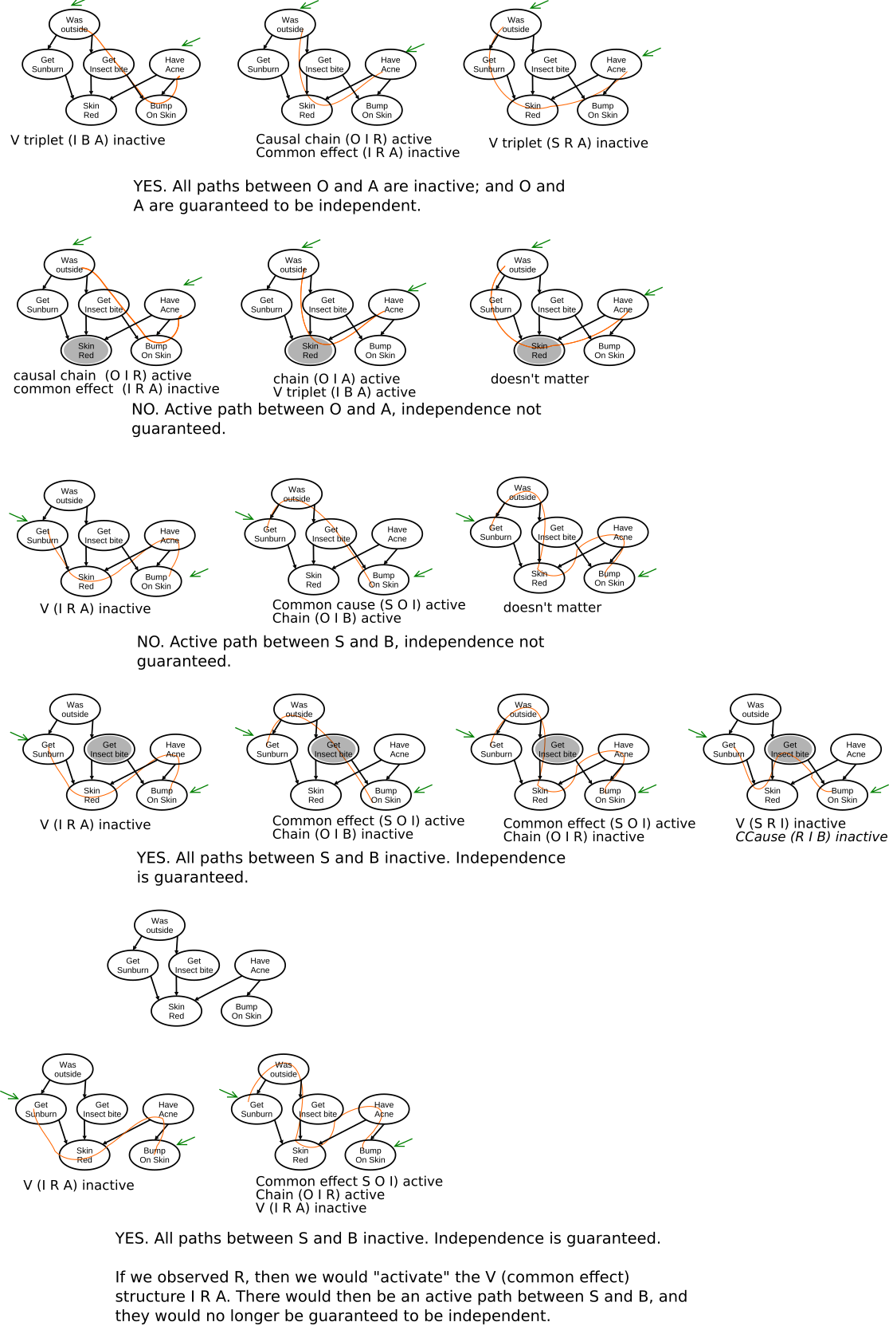
Problem 1 Intuitions.
1. YES, Yes, having acne is independent of going outside. Whether we go outside or not doesn't affect whether we get acne (at least according to this model).
Also, having acne doesn't affect whether we go outside or not (according to this model).

2. NO, If we know whether or not we we have acne, does also knowing whether our skin is red or not impact our estimate of of whether we were outside? If we know we have red skin, and knowing we had acne would "explain away" some of our certainty about being outside or not. Thus, having observed R, O and A are no longer independent.

3. NO, Not independent. The likelihood of us getting sunburned impacts our estimate of being outside, which in turn impacts our estimate of getting an insect bite and potentially having a bump on our skin.

4. YES, Given that we got an insect bite, do we care about whether we have a bump or not, in order to estimate if we are sunburned or not? No! (thus YES, they are independent).

6.

Part 2.1
Update step: see code.
On measurement, multiply Gaussian.
On motion, convolve.

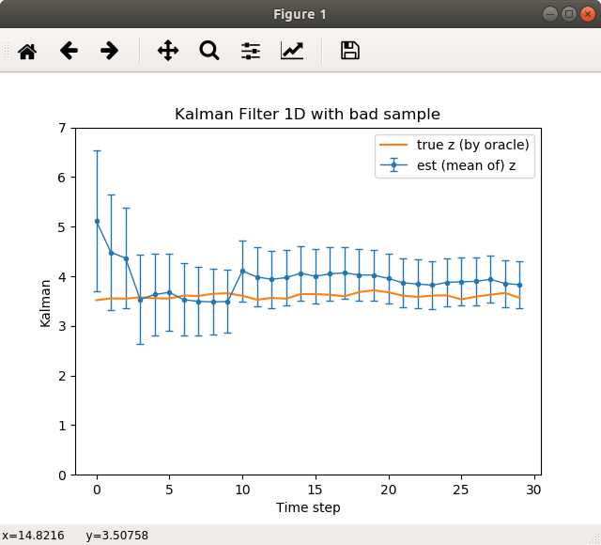
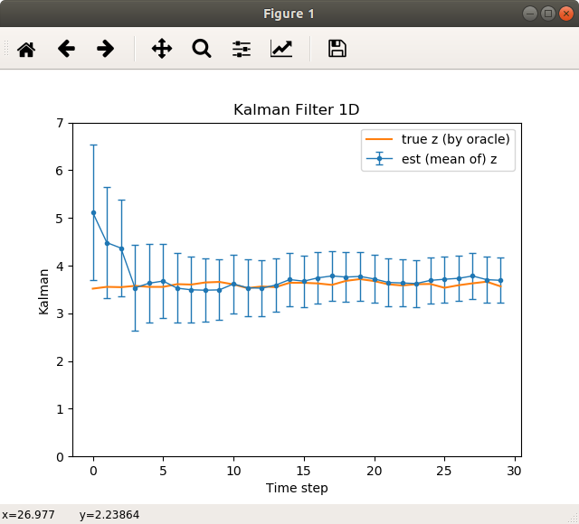

Part
Part 3. b.
Yes, Kalman filter catches up to true hidden object.

3. c. Kalman filter mean jumps up but not all the way up to outlier. The standard deviation of our estimate does not actually increase! Continues to monotonically decrease. It starts moving toward the true but after the outlier, it never quite recovers within our window of 30 time samples.

Part 3. d.
# Since we think our hidden variable cannot move too far, and we think our measurements are not that
# far off. Thus, when we get a measurement of 3.56 and then a measurement of 10.2, and our
# measurement has settled around 3.5 with only a small variance (0.1), we cannot update our estimate
# of the hidden variable to 10. Instead, we can assume our prior estimate of z is at most (that
# small measurment variance) off, and then the most z can move is on the order of epsilon, and thus
# we update our estimate to be 4.1. Furthermore, since we are fairly certain in our estimates (as
# limited by our initial measurement variance tempered by the mostly consistent samples we've had so
# far), our z estimate will only shift so far on each time step (with a reasonable measurement).
# Thus, at the end of time, our mean still has not recovered to be close to the true z.
Part 3.
1.
states = each grid, 1 to 9
actions: going north east south or west
reward( given original state, and action): our expectation of points given our action
If falls off, -1
If lands on 5, -100
If lands on 9, +10.
transition model: likelihood that our policy action will succeed as intended.
2.
Work

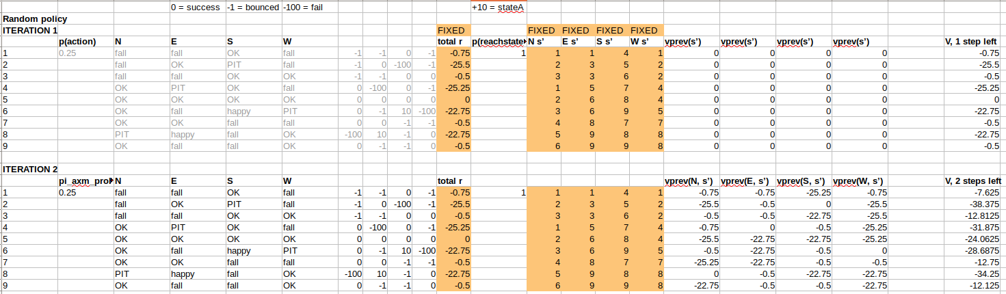
Answer
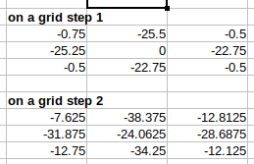

Work
Ans

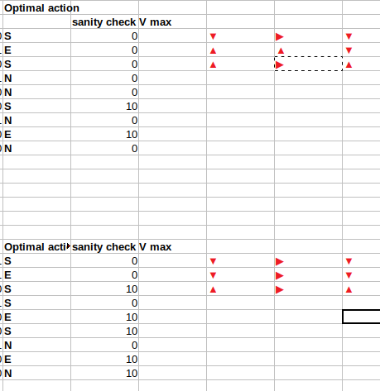

Part 3 4.
t=1

did not get to t=2

it only changes the transition probabilities, p(s’| s,a ), which also mean that we must sum over the three possible states.
the policy is no longer optimal.
Part 4.
Worked with:
Eric
Philip
Will

Materials from:
CS188 Berkeley
Udacity Intro to Robotics CS373

Hours:
20-30??

name:
nao ouyang

