Four buzzing terms in the IT industry today:

Data Science, Artificial Intelligence, Machine Learning, Deep Learning

What are these terms means, what is the difference between them.

Is there a difference between them or they are synonyms of each other.

Here is an attempt to visualize the distinction between them:

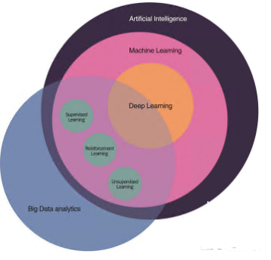

As you can see on the above image of Four concentric circles, DL is a subset of ML, which is also a subset of AI.

Intresting?

So, AI is the all-encompassing concept that initially erupted, then followed by ML that thrived later, and lastly DL that is promising to escalate the advances of AI to another level.

**What is artificial intelligence?**

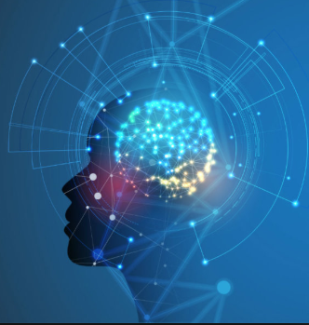

As the name suggests, artificial intelligence can be loosely interpreted to mean incorporating human intelligence to machines.

Whenever a machine completes tasks based on a set of stipulated rules that solve problems (algorithms), such an “intelligent” behavior is what is called artificial intelligence.

For example, such machines can move and manipulate objects, recognize whether someone has raised the hands, or solve other problems.

### ****What is machine learning?****

### 

The intention of ML is to enable machines to learn by themselves using the provided data and make accurate predictions.

ML is a subset of artificial intelligence; in fact, it’s simply a technique for realizing AI.

For example, here is a table that identifies the type of fruit based on its characteristics:

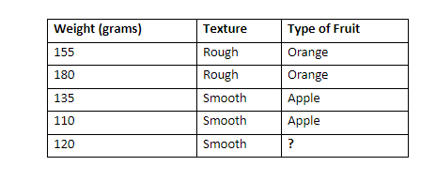

As you can see on the table above, the fruits are differentiated based on their weight and texture.

However, the last row gives only the weight and texture, without the type of fruit.

And, a machine learning algorithm can be developed to try to identify whether the fruit is an orange or an apple.

After the algorithm is fed with the training data, it will learn the differing characteristics between an orange and an apple.

Therefore, if provided with data of weight and texture, it can predict accurately the type of fruit with those characteristics.

### ****What is deep learning?****

### 

### Deep learning excels at identifying patterns in unstructured data, which most people know as media such as images, sound, video and text.

### DL algorithms are roughly inspired by the information processing patterns found in the human brain.

Just like we use our brains to identify patterns and classify various types of information, deep learning algorithms can be taught to accomplish the same tasks for machines.

**Examples**: Self Driving Cars

**What is Data Science:**

Data science is a field about scientific methods, processes and systems to extract knowledge to extract knowledge and insights from data in various forms either structured or unstructured.

