How to move ahead?

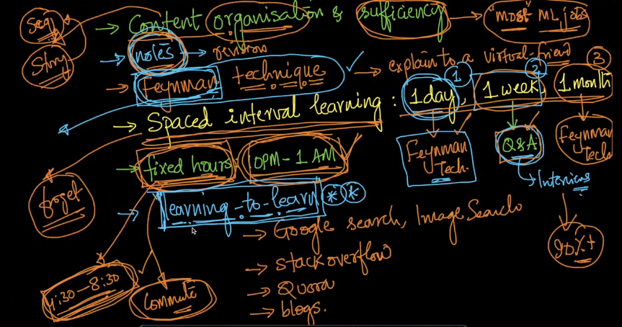

**2.3 Keywords and Identifiers**

**Keywords:**

Keywords are reserved words in python

Keywords cannot be used as variable names, functions or any other identifiers

Keywords are case sensitive

import keyword

print (keyword.kwlist)

print ('\nTotal number of keywords', len(keyword.kwlist))

**Identifiers:**

Identifiers can be a combination of (a-z) (A-Z) (0-9) and a underscore

Identifier cannot start with a number 1variable

**2.4 Comments, Indentations and Statements**

Comment: #

Multiline Comment= “”” “””

Multiline Statement:

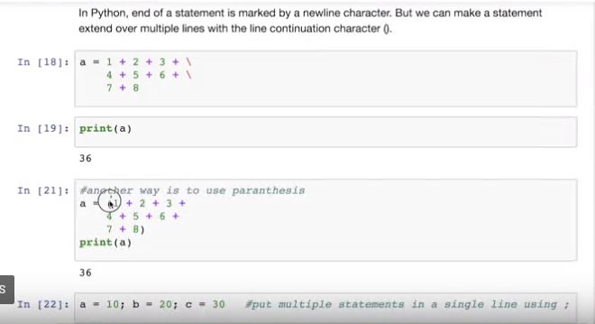

**2.5 Variable Assignment and data types**

A,b,c=1,2,”Prudhvi”

A=b=c=”Divya”

**Storage Location:**

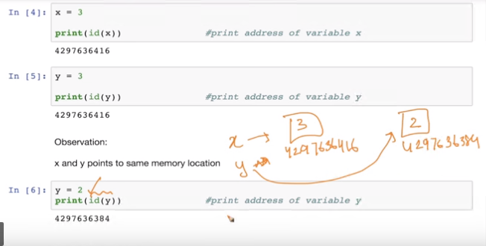

**Data Types:**

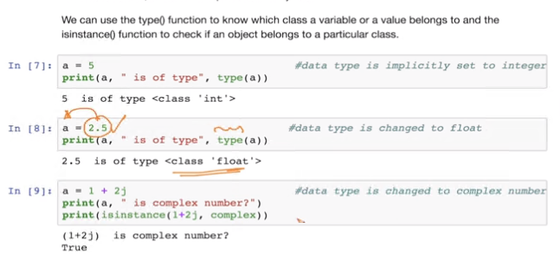

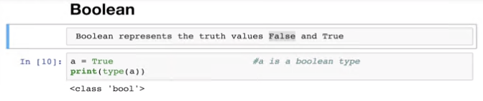

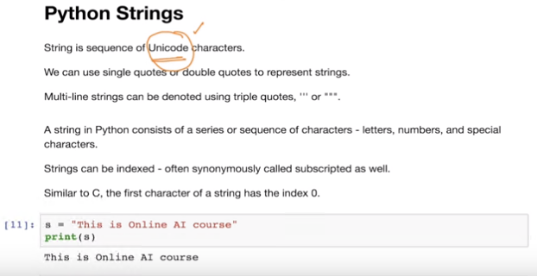

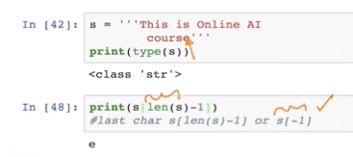

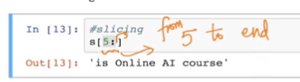

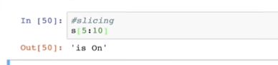

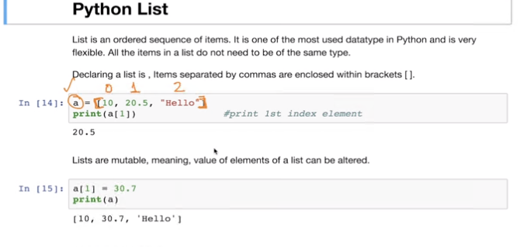

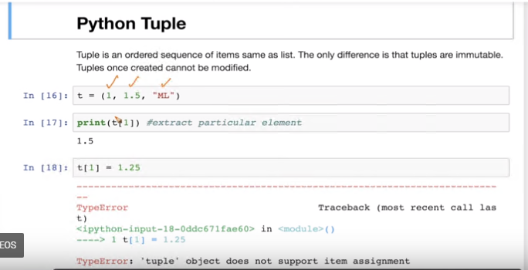

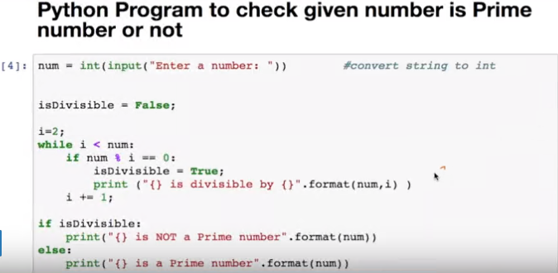

**2.10 Control … For Loop**

