**How to take the videos for analyzing biomechanics?**

-- **Video quality setting**:

-- Minimum quality requirement for analysis accuracy:

1. 640 x 480 | 30 FPS Camera

-- Preferred camera requirement:

1. 1920x1080 | 60 FPS Camera

-- Maximum camera setting:

4K, 120/240 FPS

**Most of the time 2K | 60 FPS is totally enough for model accuracy.**

**If you don’t know how to set the video quality, check the links below:**

**Samsung:** [**https://www.youtube.com/watch?app=desktop&v=wyLqbyP1dlE**](https://www.youtube.com/watch?app=desktop&v=wyLqbyP1dlE)

[**https://www.samsung.com/latin_en/support/mobile-devices/how-to-record-edit-and-share-videos-in-8k-with-your-galaxy-device/**](https://www.samsung.com/latin_en/support/mobile-devices/how-to-record-edit-and-share-videos-in-8k-with-your-galaxy-device/)

**iPhone:**

[**https://www.pcmag.com/how-to/lights-camera-action-how-to-shoot-video-on-iphone-like-a-pro**](https://www.pcmag.com/how-to/lights-camera-action-how-to-shoot-video-on-iphone-like-a-pro)

**Google Pixel:** [**https://www.zdnet.com/article/how-to-enable-10-bit-color-for-improved-video-quality-on-a-pixel-7-pro/**](https://www.zdnet.com/article/how-to-enable-10-bit-color-for-improved-video-quality-on-a-pixel-7-pro/)

--- **Camera position setting**:

When you take the video, please set the camera at this position as shown below:

**Acceleration/Block start camera position setting:**

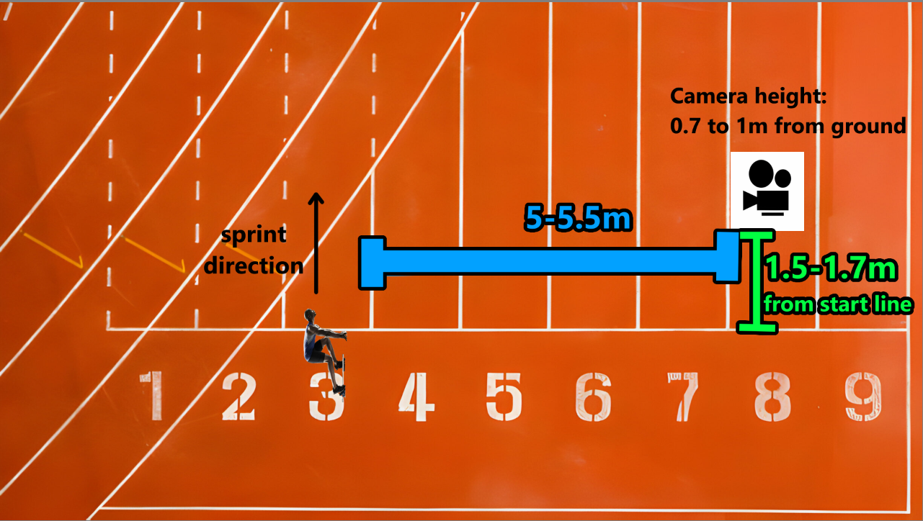

Example: your sprint starts on lane 3 on the outdoor track, set the camera 5 to 5.5m away on the **right-side angle**. 1.5 to 1.7m from start line. The camera height should be around 0.7 to 1m high from the ground. Accelerate at least 6 steps for analysis.

**You can take the video from both left-side or right-side angle**

**Max velocity camera position setting:**

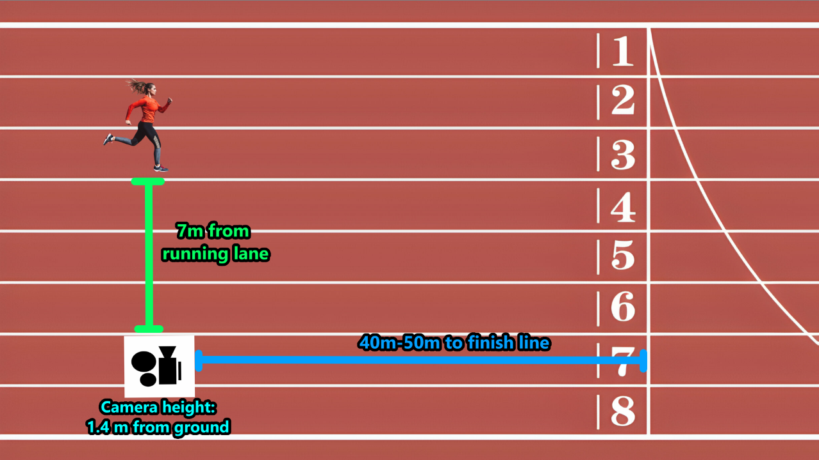

**Example:** sprinters running on lane 3, the camera is set at 7 meters from running lane. If you’re sprinting from 100m start line, sprint at least **50m to 70m** to pass the camera. Camera is set around 60 meter’s distances.

The video footage should contain **at least 3 strides** of your max velocity phase.

**You can take the video from both left-side or right-side angle, just make sure the distance of camera is correct.**

**Important Note:**

1. **Please send those videos through email (donktr17@gmail.com), since Instagram will downgrade the video quality.**
2. You can use any camera (iPhone, Samsung, professional camera…). To get the maximum accuracy and quality, the distance mentioned above may differ from person to person. Just make sure when you take the acceleration video, the video should contain **at least 5 pushes** from blocks, and max velocity it should contain **at least 3 strides** when athletes pass the camera.
3. If you have a partner to take the video for you, just let them stand at the correct position and hold the camera **as stable as they can. Don’t move the camera when you sprint (don’t let the camera track the athlete).** Just stand there like a Tripod. Make sure the camera **is paralleled with** the track lane. Don’t zoom in or zoom out. The camera angle should be horizontal (don’t look up or look down). See the pinned video on Nova Instagram account.