

How to Update Laser Stuff On GitHub

- On the Laser Cutter PC Navigate To
- Update on GitHub: In the file explorer, navigate to NovaLabsLaserCutterMaterialsLibrary\LaserCut\

- Do a Right Mouse -> GIT GUI HERE. Git GUI should come up: 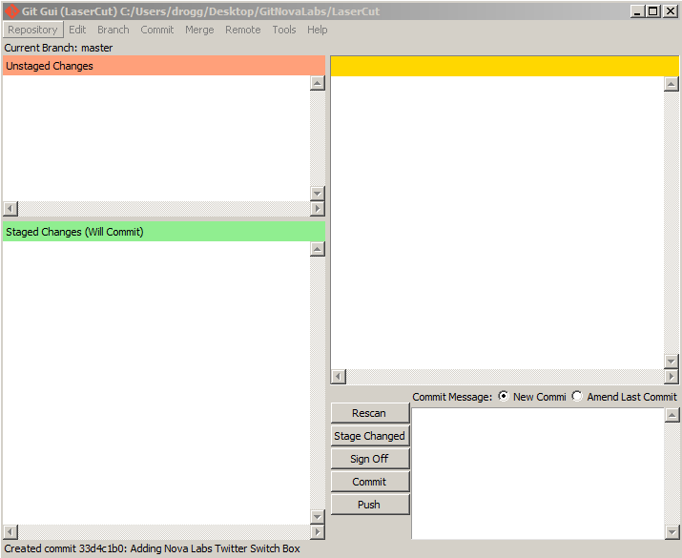
- Click Rescan
- Click State Changed
- Enter comment like “Added Material foobar to Materials Library - <your name>
- Click Commit
- Click Push. If Push dialog comes up, click Push again

