

How to Contribute Projects and Materials Settings
Figured Out the Right Settings ?
PLEASE SHARE !
(This is a hacker space, after all)

- Review what colors you used for what modes. The following convention is suggested but not mandatory:
RED (255,0.0) : Vector Cut all the way through
GREEN (0,255,0) : Vector Engrave
BLUE (0,0,255) : Raster Engrave

- On the Laser Cutter PC Navigate To
NovaLabsLaserCutterMaterialsLibrary\LaserCut\HurricaneCharley100w\Materials\
(there should be a shortcut on the desktop)

- Create a new directory. Call it something like “Delrin6mm” or “MDF12MM”, etc.
- Copy just the .ecp and .ini files from your working job into this directory
- Rename them both to the same as the directory (Delrin6mm[.ecp,.ini])
- Open them in LaserCut.
- Delete your job from the work area
- Replace with simple,small graphics or text for each color . Export .dxf graphic from an existing material entry:
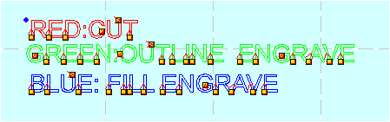

- If your job uses a different convention. Document appropriately.
- Edit the README.txt file Make the following entries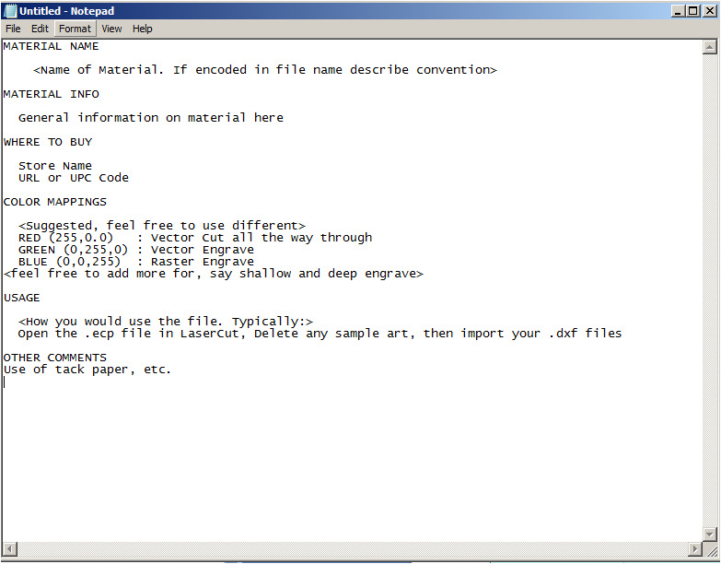
- Follow the Instructions in HowToUpdateLaserStuffOnGitHub

