A MINOR PROJECT REPORT ON
MILITARY LOGISTICS ANOMALY DETECTION USING MACHINE LEARNING
(Simulated Data - Academic Demonstration Only)
Machine Learning Laboratory
Bachelor of Technology / Engineering - Information Technology
Submitted by:
Name: [To be filled by student]
Enrolment / Roll No.: [To be filled by student]
Semester / Year: Third Year
Submitted to:
Guide / Faculty: [To be filled by student]
Department of Information Technology
Institute: [To be filled by student]
Academic Session: 2026-27

1. Abstract
Supply chains record large numbers of shipments, and a few of them behave very differently from the rest: they arrive far too late, travel unusually long routes, carry unexpected quantities, or show a mismatch between expected and recorded inventory. This project builds a small machine learning model that flags such unusual shipment records automatically. Because no genuine military logistics data is available for academic work, the project uses a simulated dataset of 800 shipment records created with a fixed random seed, in which 40 records were deliberately made unusual.
The model is an Isolation Forest, an unsupervised anomaly detection algorithm from Scikit-learn. Eight numerical features were scaled and given to the model with an assumed contamination of 0.05. The model flagged 40 of 800 shipments (5.0%). Three graphs, a full results file and a risk report file were produced. An optional comparison with the simulated tags showed that 33 of the 40 injected records were flagged, including all 10 abnormal-distance and all 10 extreme-delay records, but only 6 of 10 inventory-mismatch and 7 of 10 unusual-quantity records. These figures describe behaviour on simulated data only and are not real-world performance measures. Flagged records are statistical outliers, not confirmed sabotage, threats or security breaches.
Keywords: anomaly detection, Isolation Forest, unsupervised learning, logistics, Scikit-learn, simulated data.

2. Introduction
Logistics is the process of planning, moving and storing goods so that the right quantity reaches the right place at the right time. In any large supply chain, most shipments follow familiar patterns. Reviewing every record by hand is slow, so organisations look for ways to automatically highlight the small number of records that deserve a closer look.
Machine learning can help with this task. Instead of writing fixed rules for every possible problem, an anomaly detection model learns what typical records look like and marks those that differ strongly. This project applies that idea to a simulated military-style logistics setting, covering delivery delay, route distance, shipment quantity and inventory discrepancy.
Scope note: this is a standalone academic model. It uses only simulated data and makes no claim of detecting real threats. A flagged shipment simply means that its numbers are unusual compared with the other shipments in the dataset.

3. Aim and Objectives
Aim: To build and demonstrate an unsupervised machine learning model that identifies unusual shipment records in a simulated logistics dataset.
Objectives:
- Generate a documented, reproducible simulated dataset of about 800 shipments.
- Check and prepare the data (missing values, duplicates, feature selection, scaling).
- Train an Isolation Forest model and obtain a prediction and anomaly score for every shipment.
- Visualise the scores and the flagged records using Matplotlib.
- Export complete results and a separate risk report of flagged records.
- Discuss honestly the limits of evaluating an unsupervised model on simulated data.

4. Software and Hardware Requirements
Item | Details
Programming language | Python 3.9 or later
Libraries (versions used) | pandas 3.0.5, NumPy 2.5.3, Matplotlib 3.11.2, scikit-learn 1.9.1
Environment | Jupyter Notebook, Google Colab, or plain Python scripts
Operating system | Windows, Linux or macOS
Hardware | Any basic laptop (about 4 GB RAM); no GPU needed

5. Theory

5.1 Anomaly Detection
An anomaly (or outlier) is a data point that differs markedly from the majority of the data. Anomaly detection is the task of finding such points. It can be supervised, when labelled examples of anomalies exist, or unsupervised, when no labels are available. In logistics, labelled examples of confirmed problems are rare, so unsupervised methods are a natural choice (Chandola, Banerjee and Kumar, 2009).

5.2 Isolation Forest
Isolation Forest (Liu, Ting and Zhou, 2008) is based on a simple idea: unusual points are easier to separate from the rest than typical points. The algorithm builds many random decision trees. Each tree repeatedly picks a random feature and a random split value, cutting the data into smaller groups until a point is alone. A point in a crowded region needs many cuts to be isolated, while a point far from the crowd needs only a few. The average number of cuts over all trees (the path length) decides how anomalous a record is: short path means more anomalous.
Isolation Forest suits this project because it is unsupervised, works with numerical features, is fast on small datasets, needs little tuning, and does not require labels. Scaling is not strictly required for tree-based splits, but it was applied here as a good habit and to keep all features on a comparable footing.

5.3 Dataset Features
Feature | Meaning
shipment_id | Unique identifier (not used for training)
category | Rations, Fuel, Medical Supplies, Spare Parts, Ammunition (kept for reporting; not used as a model feature)
shipment_quantity | Number of units shipped
route_distance_km | Route distance in kilometres
expected_delivery_days | Planned delivery time
actual_delivery_days | Observed delivery time
delivery_delay_days | Actual minus expected delivery time
expected_inventory | Inventory the system expects at the destination
recorded_inventory | Inventory actually recorded
inventory_discrepancy | Recorded minus expected inventory

All records are simulated. Normal records use random values within typical ranges (for example, distance 100-900 km and small inventory counting errors). About 5% of records (40 of 800) were then modified to show one of four unusual behaviours: extreme delay, inventory mismatch, unusual quantity, or abnormal route distance. These simulated tags are stored in a separate file (simulated_labels.csv) and were never given to the model.

5.4 Data Preprocessing
Preprocessing prepares the data so the model receives clean numbers. The steps used were: loading the CSV with Pandas; checking missing values and duplicates; converting values to numeric type and filling any missing or invalid values with the column median (no such values were found in this dataset); selecting eight numerical features while keeping the shipment ID and category out of the model; and standardising features with StandardScaler so each has mean 0 and standard deviation 1.

5.5 Anomaly Scores
In Scikit-learn, predict() returns +1 for normal records and -1 for anomalies. The decision_function() method returns a score for each record: the lower the score, the more abnormal the record, and negative scores correspond to records flagged as anomalies. The contamination parameter (0.05 here) tells the model to treat roughly the lowest 5% of scores as anomalies. It is an assumed share chosen for demonstration, not a guaranteed real-world anomaly rate, so exactly 5% of records will always be flagged regardless of how many are truly unusual.

5.6 Evaluation Limitations
Accuracy, precision, recall and F1-score need trusted labels, which real logistics data usually lacks. Therefore this report does not claim any performance metric. For demonstration only, the generator's simulated tags were compared with the predictions after training. Such a comparison is limited because the tags describe only the unusual patterns that we chose to create, the data is far cleaner than real data, and results on simulated data cannot be assumed to transfer to real operations.

5.7 Anomaly versus Confirmed Threat
An anomaly is a statistical statement: this record looks different from the others. A threat is a real-world conclusion that needs investigation. A late shipment may be caused by weather, a road closure or a data-entry error. Flagged records should therefore be treated only as items for human review.

6. Methodology
Step 1: Generate the simulated dataset (generate_dataset.py) with random seed 42.
Step 2: Load shipment_data.csv and check missing values and duplicates.
Step 3: Select eight numerical features and separate ID and category columns.
Step 4: Scale features with StandardScaler.
Step 5: Train IsolationForest (200 trees, contamination 0.05, random_state 42).
Step 6: Predict labels and compute anomaly scores for every shipment.
Step 7: Save shipment_anomaly_results.csv and logistics_risk_report.csv.
Step 8: Create three PNG visualisations and print a summary.
Step 9: Optionally compare predictions with the simulated tags and discuss limits.

7. Implementation: Code and Outputs
The complete code is in generate_dataset.py and train_model.py. Key parts are shown below with the actual outputs from running them.

7.1 Dataset Generation
rng = np.random.default_rng(42)
route_distance_km = rng.uniform(100, 900, size=800)
expected_delivery_days = route_distance_km / 350 + rng.uniform(1, 2, size=800)
actual_delivery_days = np.maximum(
expected_delivery_days + rng.normal(0.2, 0.5, size=800), 0.5)
recorded_inventory = expected_inventory + rng.normal(0, 2.0, size=800)
# ... then 40 records are made unusual (delay, mismatch, quantity, distance)
Output:
Simulated dataset created (NOT real military data).
Records: 800
Injected unusual records: 40
Saved: shipment_data.csv, simulated_labels.csv
Table 1: First five records of the simulated dataset.
ID | Category | Qty | Dist (km) | Exp. days | Act. days | Delay | Exp. inv. | Rec. inv. | Discr.
SHP0001 | Rations | 207 | 690.9 | 3.89 | 4.41 | 0.52 | 368 | 369 | 1
SHP0002 | Spare Parts | 103 | 353.7 | 2.15 | 2.66 | 0.51 | 268 | 268 | 0
SHP0003 | Spare Parts | 148 | 812.0 | 4.00 | 4.18 | 0.18 | 344 | 345 | 1
SHP0004 | Medical Supplies | 280 | 575.1 | 3.46 | 3.76 | 0.30 | 421 | 420 | -1
SHP0005 | Medical Supplies | 235 | 200.8 | 1.81 | 1.42 | -0.39 | 338 | 337 | -1

7.2 Loading and Quality Checks
df = pd.read_csv("shipment_data.csv")
print(df.isnull().sum())
print("Duplicate rows:", df.duplicated().sum())
Output: all columns showed 0 missing values, 0 duplicate rows and 0 duplicate shipment IDs. Common error: FileNotFoundError means generate_dataset.py has not been run, or the script is being run from a different folder.

7.3 Feature Selection and Scaling
feature_columns = ["shipment_quantity", "route_distance_km",
"expected_delivery_days", "actual_delivery_days", "delivery_delay_days",
"expected_inventory", "recorded_inventory", "inventory_discrepancy"]
X = df[feature_columns]
X_scaled = StandardScaler().fit_transform(X)

7.4 Model Training and Prediction
model = IsolationForest(n_estimators=200, contamination=0.05,
random_state=42)
model.fit(X_scaled)
raw_prediction = model.predict(X_scaled) # +1 normal, -1 anomaly
df["prediction"] = np.where(raw_prediction == -1, "Anomaly", "Normal")
df["anomaly_score"] = model.decision_function(X_scaled).round(4)

7.5 Summary Output
Total shipments analyzed: 800
Flagged anomalies: 40 (5.0%)

Files created:
- shipment_anomaly_results.csv
- logistics_risk_report.csv
- visualizations/01_anomaly_score_distribution.png
- visualizations/02_delay_vs_distance.png
- visualizations/03_inventory_discrepancy_vs_quantity.png

8. Results and Discussion
The model analysed 800 shipments and flagged 40 (5.0%). The proportion equals the contamination setting by design. The score of every flagged record is negative (highest flagged score -0.0015) and every normal record has a positive score (lowest 0.0001), which is consistent with the Scikit-learn convention. Anomaly scores across all records ranged from -0.1992 to 0.1524.
Table 2: Average values of normal and flagged groups (from the results file).
Feature (mean) | Normal (760) | Flagged (40)
Shipment quantity | 337.71 | 718.02
Route distance (km) | 502.44 | 1017.36
Delivery delay (days) | 0.23 | 1.71
Inventory discrepancy | 0.06 | -0.38

Table 3: Ten most unusual flagged records (lowest scores).
Shipment ID | Category | Qty | Dist (km) | Delay (days) | Discr. | Score
SHP0523 | Rations | 2123 | 104.4 | -0.34 | 0 | -0.1992
SHP0519 | Medical Supplies | 162 | 2789.7 | -0.28 | 0 | -0.1902
SHP0375 | Ammunition | 103 | 2790.1 | 0.07 | 0 | -0.1869
SHP0117 | Rations | 526 | 2525.7 | -0.34 | 4 | -0.1727
SHP0285 | Medical Supplies | 100 | 2613.5 | 0.39 | -1 | -0.1708
SHP0460 | Rations | 2145 | 897.3 | -0.49 | 2 | -0.1685
SHP0533 | Rations | 455 | 2524.1 | 0.49 | 3 | -0.1671
SHP0243 | Rations | 2216 | 624.4 | 0.43 | -2 | -0.1633
SHP0219 | Medical Supplies | 60 | 2050.4 | 0.08 | -4 | -0.1617
SHP0334 | Ammunition | 405 | 682.3 | 8.98 | -3 | -0.1493

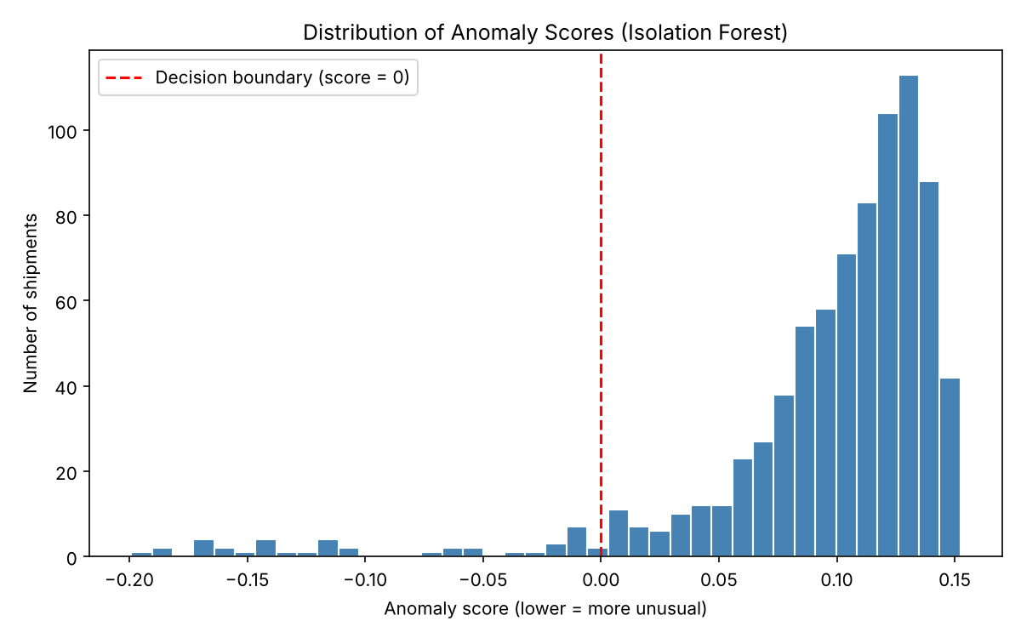
Figure 1: Distribution of anomaly scores. Records left of the red line (score below 0) are flagged.
Figure 1 shows that most shipments have positive scores, with a small tail of negative scores, which are the flagged records.
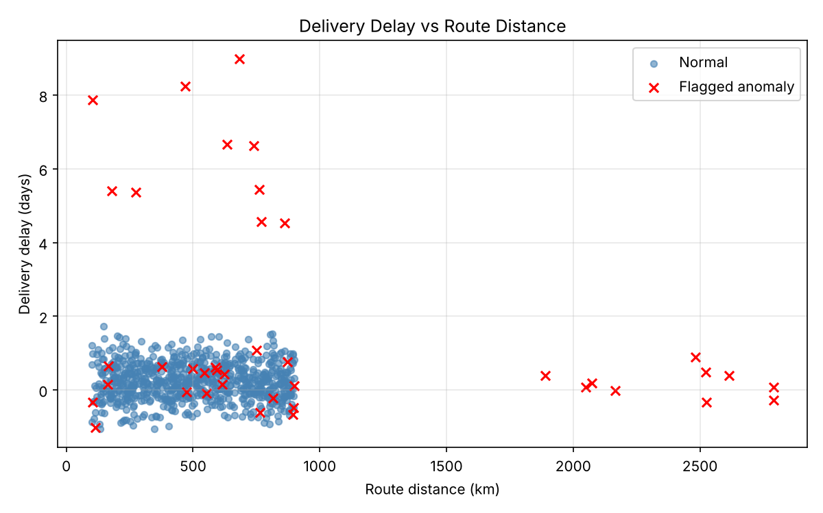
Figure 2: Delivery delay versus route distance, flagged records highlighted.
In Figure 2, flagged records fall into two clear groups: shipments with very large delays (4.5 to 9 days) and shipments with route distances far above the usual range of about 100-900 km. Several flagged points sit inside the normal cloud; these were flagged because of other features, such as quantity.
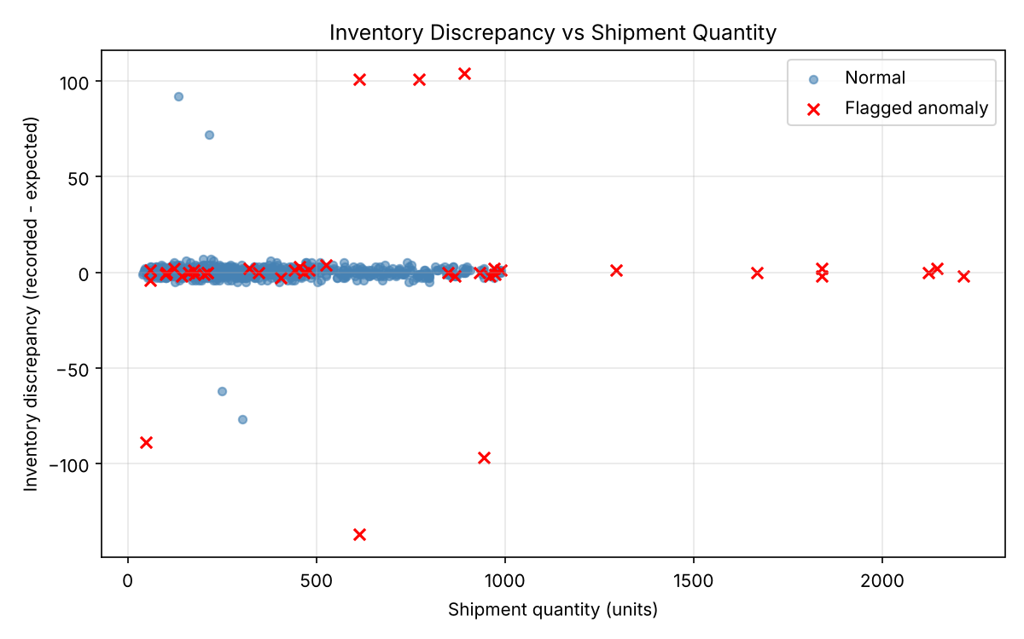
Figure 3: Inventory discrepancy versus shipment quantity, flagged records highlighted.
Figure 3 shows flagged records with large positive or negative discrepancies and with very large quantities. It also shows four unflagged records with discrepancies of roughly 60 to 90 units in either direction, which the model treated as normal.

8.1 Optional Comparison with Simulated Tags
After training, the generator's hidden tags were compared with the predictions. The tags were never used for training. Table 4 shows the actual counts.
Injected type | Flagged by model
Abnormal distance | 10 of 10
Extreme delay | 10 of 10
Unusual quantity | 7 of 10
Inventory mismatch | 6 of 10
Total injected records flagged | 33 of 40
Flagged but not injected | 7
Injected but not flagged | 7
Table 4: Comparison with simulated tags (demonstration only, not a real-world metric).
The model found distance and delay anomalies reliably, because those values are far outside the normal range. It was weaker on inventory mismatches. One likely reason is that the two inventory columns are highly correlated with each other and with quantity, and the mismatch is visible mainly in one derived feature among eight, so the isolation signal is diluted. The seven flagged-but-not-injected records are ordinary records that happened to have a low score, which is expected when exactly 5% of records are forced to be flagged. This is an interpretation of the results and was not separately tested.

9. Limitations
- The dataset is simulated and much simpler than real logistics data; results may not transfer to real operations.
- Contamination was assumed to be 0.05, so the model always flags about 5% of records.
- No genuine labels exist, so no real accuracy, precision or recall can be reported.
- Only one random seed and one parameter setting were tested; no tuning study was performed.
- Highly related features (such as the two inventory columns) can weaken detection of some anomaly types.
- A flagged record is only a statistical outlier and gives no reason for why it is unusual.
- Category was not used as a model feature.

10. Conclusion
This project built a simple, reproducible Isolation Forest model that flagged 40 of 800 simulated shipments as unusual and exported the results, a risk report and three graphs. The model separated records with extreme delay or abnormal distance very clearly in the simulated data, and was less consistent for inventory mismatches and unusual quantities. Since the data is simulated and unlabelled in practice, the results demonstrate the method only. Flagged shipments are candidates for human review, not evidence of sabotage or threats.

11. Future Scope
- Test the model on real or public supply-chain datasets with proper permission.
- Add engineered features such as inventory discrepancy as a percentage of quantity, or category-wise comparison.
- Try different contamination values and compare with other simple methods such as Local Outlier Factor.
- Add one-hot encoded shipment category and study its effect.
- Explain individual flagged records to help reviewers see which feature caused the flag.
- Build a simple review dashboard if a larger application is later required.

12. References
[1] Liu, F. T., Ting, K. M. and Zhou, Z.-H. (2008). Isolation Forest. Proceedings of the 2008 Eighth IEEE International Conference on Data Mining (ICDM), pp. 413-422.
[2] Chandola, V., Banerjee, A. and Kumar, V. (2009). Anomaly detection: A survey. ACM Computing Surveys, 41(3), Article 15.
[3] Pedregosa, F. et al. (2011). Scikit-learn: Machine learning in Python. Journal of Machine Learning Research, 12, 2825-2830.
[4] Scikit-learn documentation: IsolationForest. https://scikit-learn.org/stable/modules/generated/sklearn.ensemble.IsolationForest.html

