**22) Create wireframes illustrating how localization features can be integrated into a mobile app, ensuring a user-friendly design in Figma.**

**Aim:**Wireframes illustrating how localization features can be integrated into a mobile app using Figma

**Procedure: -**

1. Open Figma
2. Create a new file
3. Select the Frames
4. Design Visual Elements
5. Make it Interactive
6. Add icons on the Frame
7. Incorporate Multimedia
8. Storyboard Animation
9. Review and edit the Prototype
10. Save and Share

**Design:**

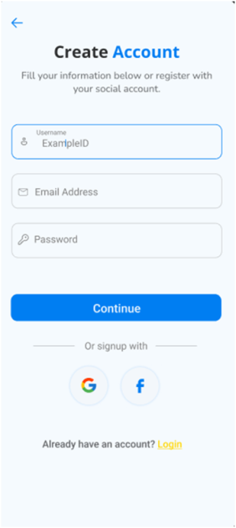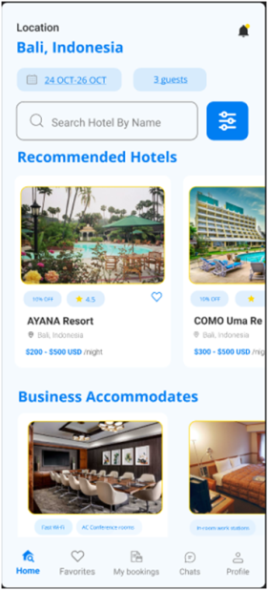

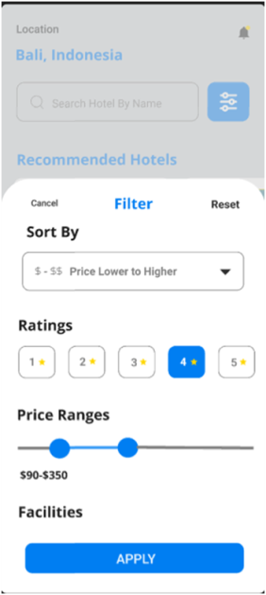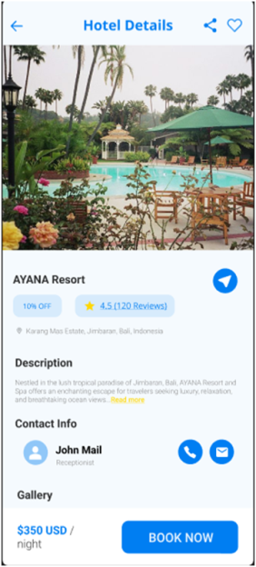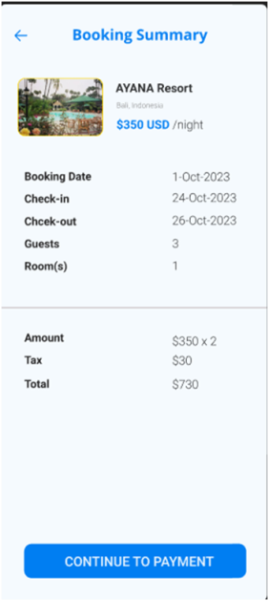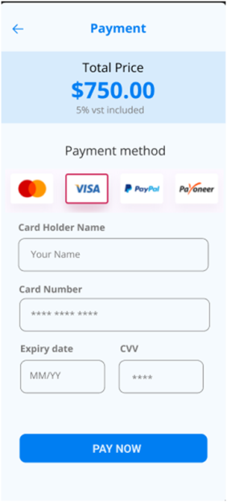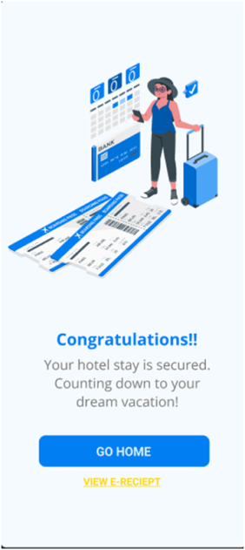

**Prototype: -**

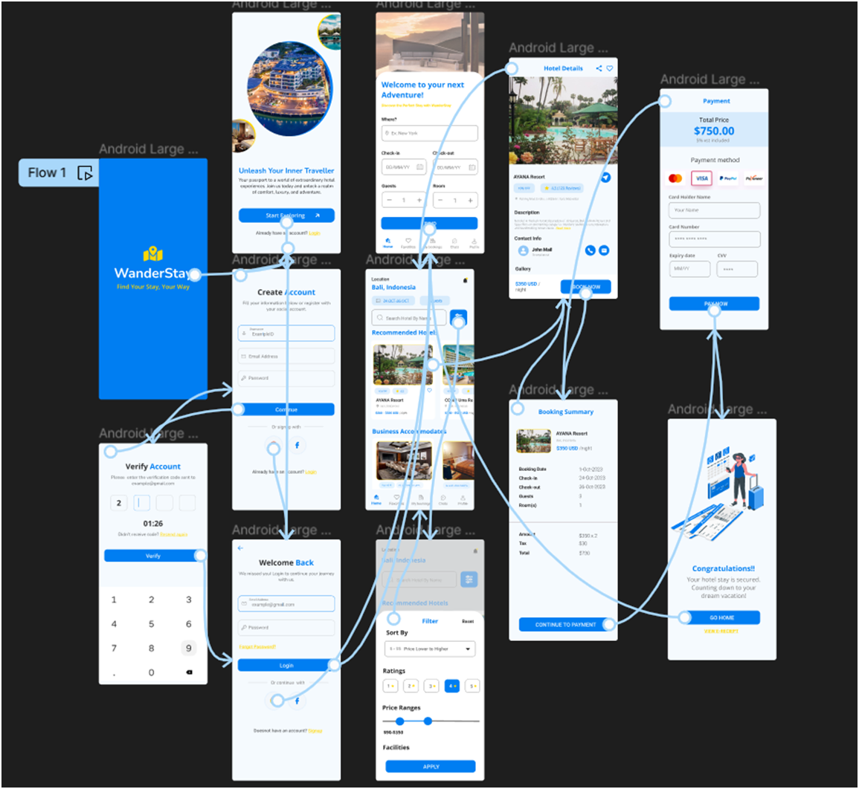

**Result: -**

Hence the localization features can be integrated into a mobile app is created and executed successfully