Devin Jira Member Flow Guide
  - Practical steps for React and Spring Boot
Version 1.0 | 5 October 2026 | Separate from the VS Code Copilot guide
Use one focused Devin Agent session to deliver a Jira story or bug across your two repositories. Follow the flow below, use the matching prompts, and verify the result. The main path uses existing company access and does not depend on creating hooks, integrations or organization settings.
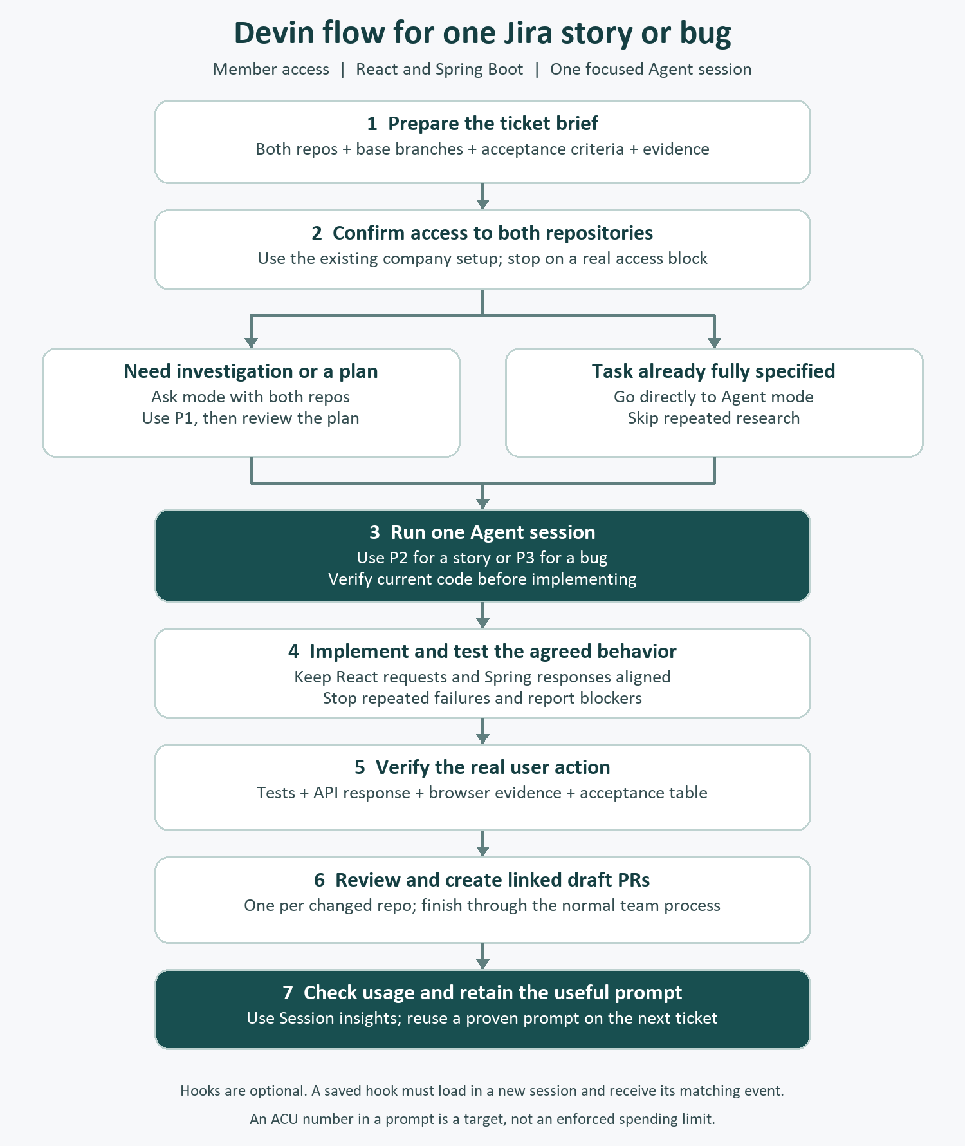

1 Start with the access you already have

Step 1 Open the correct organization
1. Sign in to your company Devin web app and select the organization that owns the project. This guide targets the web Ask and Agent experience; local CLI commands are identified separately.
2. Confirm that you can open Ask and create an Agent session. Member is not a complete permission description: Use Ask Devin, Use Devin Sessions and permissions to manage shared settings are separate capabilities. [1]

Step 2 Check both repositories before coding
3. In the new-task composer, open the repository selector and choose the React and Spring repositories. If either is absent, keep the task in planning and ask the repository/environment owner to make it available. Selecting a name cannot grant missing Git access. [2]
4. Use the existing company development environment. In the implementation prompt, require Devin to confirm both checkout paths and branch/commit references before editing. Local VS Code files and uncommitted changes are not automatically present in Devin Cloud.

Step 3 Choose how to provide the Jira story
What is available | Action
You can read Jira; no Devin integration | Copy the title, description, acceptance criteria, relevant comments and evidence into P0. Include the Jira link as a reference.
Devin can already read the ticket link | Provide the link and ask Devin to restate the acceptance criteria. If it cannot retrieve them, paste the task content.
Your team already triggers Devin from Jira | Use that existing route once. Continue in its linked session; do not also launch a duplicate session from the web app.

Native Jira setup requires organization permissions. The manual task-brief path works without configuring that integration. For a Rovo-based Jira integration, each new @mention comment can start a new session; continue through the existing agent panel or session link. [3]

Use these defaults
For a small, precisely scoped fix, select Lite if offered. For a normal story spanning React and Spring, begin with the company-approved Normal/default agent. Use more capable modes only for a demonstrated need. Options depend on company settings. [2]
Ready to continue: both repository names and intended base branches are known; you have the story text and access to the existing development setup. Hooks are not a prerequisite.

2 Prepare the prompt once

Step 4 Fill the task brief
Open Devin_Jira_Prompt_Pack.txt and fill P0. Replace brackets with facts. Leave unknown implementation details as UNKNOWN so Devin can inspect them.
Jira key and link: [KEY-123 and URL]
Task type: [story / bug]
Goal: [one user-visible outcome]
React repo and base branch: [owner/repo, branch]
Spring repo and base branch: [owner/repo, branch]
Related branch/PR/commit to continue, if any: [exact refs or none]
Acceptance criteria:
AC1: [successful user action and expected result]
AC2: [validation or error case and expected result]
AC3: [compatibility, accessibility or other requirement]
Scope: [screen/route/service, if known]
Out of scope: [unrelated behavior]
API contract source and revision: [path/link + version, or UNKNOWN]
Existing examples/design: [relevant file paths or attached design]
Test/start instructions: [repo documentation paths, or UNKNOWN]
Required services: [existing development environment, or UNKNOWN]
Delivery: [reviewable changes first / draft PRs]
If something is UNKNOWN, inspect existing files before asking me.
Do not invent business behavior. Ask only questions that block correctness.

Step 5 Decide whether Ask is useful
If you need code discovery or clarification, use Ask with both repositories selected and send P1 plus the completed brief. If the change and verification steps are already clear, go directly to the Agent prompt on page 5. Ask is intended for research and planning; an Agent session performs implementation and command execution. [2, 4]
For bug reports, provide actual steps, the observed result and the expected result. “Fix Jira KEY-123” alone leaves too many decisions unresolved when the ticket cannot be read or lacks detail.

Do not omit these five facts
The user action; both repositories and base branches; observable acceptance criteria; the API behavior or its source; the required test or reproduction evidence. A design attachment or one relevant example file can remove more ambiguity than a long generic instruction.

3 Use Ask to produce a bounded plan

Step 6 Send the planning prompt
In Ask, select both repositories in the composer. Starting from one repository’s DeepWiki page scopes the initial question to that repository, so confirm the scope before asking about the full stack. [2]
Use the task brief below to plan one Jira story across the selected
React and Spring Boot repositories. Research only; do not start an
Agent session or claim to have run application tests.
Locate the existing UI, API client, route/controller, DTO/service
and relevant tests. Compare both sides against the API contract.
Return: relevant paths with evidence, API mismatches, blocking
questions, a short ordered plan and the existing verification
commands. Say which branch/revision the evidence represents;
if the index cannot establish it, mark that UNVERIFIED.
Limit the plan to about 500 words. Avoid broad architecture review.
Prepare a concise handoff prompt once the requirements are clear.

[Paste the completed P0 task brief here.]

Step 7 Review the answer
1. Confirm that the answer cites real files from both repositories. Check that it identifies the React request and the matching Spring route/DTO or clearly says a side is not affected.
2. Resolve only the questions that change the required behavior. Ask Devin to propose the smallest option when you are unsure. Have the project owner resolve domain decisions that the ticket and code do not establish.
3. Check the contract: endpoint/method, request fields, required or nullable values, response/error shape and pagination where relevant. Confirm what must stay compatible.
4. Read the planned verification. It should test the changed behavior and the actual API interaction, not merely say “run tests.”

Step 8 Move the accepted plan to Agent
Use the Ask handoff: construct the Devin prompt, inspect the generated task, then select Send to Devin. Alternatively, create one Agent session and paste the accepted plan with P2. Confirm both repos in the target session. [2, 4]
Before sending: remove stale assumptions and unrelated research from the handoff. Ask’s indexed evidence may differ from the current checkout, so P2 explicitly requires a fresh branch/file check.
Efficiency check: do not ask Agent to repeat the entire exploration. Carry forward the short plan, exact paths, acceptance criteria and unresolved facts. Do not assume Ask is free or that its billing matches every company contract.

4 Run the story implementation session

Step 9 Paste P2 with your brief and accepted plan
This prompt authorizes the specified implementation. It avoids an extra approval round when the requirements are already clear. Choose the Delivery value deliberately: start with reviewable changes first.
Complete this one Jira story in ONE Devin session across both
repositories. Do not launch managed/child sessions or competing
implementations. Coordinate both sides against one agreed contract.

1. Verify access to both repos, actual checkout paths, intended
base branches/HEADs and any existing work. Read applicable repo
instructions and existing setup/test docs. Treat the Ask plan
as guidance; check it against the current files before editing.
If access, required services or a blocking requirement is missing,
report the exact blocker and stop that dependent work.
2. Give a brief plan tied to AC1/AC2/AC3, then implement without
waiting for another confirmation if the brief is unambiguous.
Ask before changing agreed business behavior or expanding scope.
3. Use a feature branch in each changed repo. Reuse existing React
components/hooks/API clients and Spring DTO/validation/error
patterns. Keep edits small. Preserve unrelated work. Do not add
libraries, perform broad refactors or change deployment settings
unless the task requires it and the scope has been agreed.
4. Keep endpoint, request/response types, nullability, validation,
error codes and pagination consistent. If the contract changes,
update its authoritative source and explain compatibility/order.
5. Add or update meaningful tests. First run focused checks, then
the required repo checks from the documented working directories.
Use non-watch commands. Inspect failures before retrying. After
two attempts with the same cause and no new evidence, stop and
report the cause, attempted fix and next action. Do not relax tests.
6. Start the relevant development services and verify the actual
React-to-Spring action and its error case in the browser when
available. Inspect the API response. Capture concise evidence.
Mark unavailable checks NOT RUN; never substitute a claim of PASS.
7. Recheck the latest relevant diffs and contract in both repos.
Return an AC-by-AC PASS/FAIL/BLOCKED/NOT RUN table, commands and
results, branches/commits, files changed and remaining work.
Follow the Delivery field. Do not merge, deploy or change Jira
status. Draft a short Jira update for me to review.

Efficiency: follow the relevant code paths; skip generated files
and dependency trees. Do not rerun unchanged passing checks.
Do independent reads/checks concurrently only when supported and
safe within this session; concurrent work is not an ACU guarantee.
Do not promise an ACU cap from this prompt or invent usage figures.

[Paste the completed P0 brief and accepted plan here.]
During execution: use the Progress tab to inspect commands, changes and browser activity. If the task drifts, stop/redirect the main session with P4; a side chat is read-only and does not redirect its work. [5]

5 Use the bug prompt or correct a wrong turn

Step 9 alternative Fix a reproducible bug
Use P3 instead of P2 when the ticket is a defect. Include the failing request and a short relevant log excerpt when available.
Fix one reproducible bug in the selected React/Spring repositories
using one session. Do not start additional sessions.

Jira key/link: [key and URL]
React repo/base: [repo and branch]
Spring repo/base: [repo and branch]
Steps to reproduce: [numbered user actions]
Actual result: [observed symptom and relevant error]
Expected result: [precise behavior]
Environment: [dev/test environment, affected version]
Evidence: [small log excerpt, request/response, screenshot if useful]
Recent relevant change: [commit/PR, or UNKNOWN]
Out of scope: [unrelated changes]
Delivery: reviewable changes first; no push or PR until requested.

Verify the checkouts and repo instructions. Reproduce the failure
and follow the request from React to Spring. Identify the root cause
with file evidence. If reproduction is blocked, report it instead
of making speculative broad changes. Implement the smallest fix,
add a regression test for the failure, and run required checks.
Verify the corrected browser/API behavior and an adjacent error
case. Keep existing contract behavior unless the ticket changes it.
After two failed attempts with the same cause and no new evidence,
stop and report the blocker. Return cause, fix, changed files,
test commands/results, unrun work and a proposed Jira update.

Step 10 Intervene when the same failure repeats
Stop the current line of investigation after the active safe step.
Keep all existing work. Do not start a new session or wider refactor.
The required outcome is: [exact acceptance criterion].
The useful evidence is: [file / error / observed behavior].
Your current assumption to correct is: [specific correction].
Summarize the blocker and propose the smallest next action.
Do not repeat the same failed command without a changed input or
new diagnostic reason. Wait for my answer if the next step needs
missing access, a business decision or an expanded scope.
Expected result: a concrete cause or blocker, a small next action and preserved work. If a missing service or permission causes the failure, resolve that prerequisite instead of paying for repeated speculative code changes.

6 Verify and finish the Jira work

Step 11 Inspect the latest result
If P2 or P3 already produced current verification evidence, review it. Send P5 only for gaps, changed requirements or changes that invalidate earlier results.
Verify the current changes for [Jira key] against the agreed
acceptance criteria in BOTH repositories. Reconfirm branch, HEAD
and relevant working-tree differences before using earlier results.
Compare UI request/types and backend DTO/validation/errors against
the same contract revision. Run missing or invalidated checks;
reuse still-current passing evidence with its commit/snapshot.
Verify the actual successful user action and required failure case.
Return a table: criterion | result | exact evidence | remaining work.
Use PASS, FAIL, BLOCKED or NOT RUN. Include working directories,
commands, exit results and browser/API evidence where available.
Distinguish existing environment failures from this change.
Do not claim completion, push or open PRs while required checks are
unresolved. Give me one next action for any blocker.
1. Open the session’s Browser or Computer tab and check the actual acceptance action when practical. Inspect the API request/response and verify that the intended backend was used. Record unavailable integration as NOT RUN. [5]
2. Open each repository diff. Confirm that every change supports the ticket. Have an appropriate reviewer check business behavior and unfamiliar implementation details before release.

Step 12 Publish only after review
For [Jira key], publish only the reviewed task changes on the
agreed feature branches and open a draft PR in each changed repo
against [React base] and [Spring base]. Follow repo PR templates.
Cross-link the PRs and Jira ticket. Include the acceptance results,
commands, integration evidence and any compatibility/deployment
order. Do not merge, deploy, or change Jira status.
If permissions or required checks block publication, preserve the
work and report the exact blocker instead of trying another identity.
Return both PR links and a Jira update for me to paste.
3. Review the returned PRs, required CI results and linked integration evidence. If a reviewer requests changes, continue the existing session with P7 from the prompt pack.
4. Paste the drafted Jira update yourself, or explicitly request that update if an authorized integration is available. Move Jira to Done only when your team’s definition of done is satisfied; PR creation alone may not meet it.
Finish with: one acceptance table, real test evidence, a linked PR for each changed repository, remaining limitations and the next review/release action. Do not treat a confident summary as test evidence.

7 Diagnose a hook that saved but never ran

Step H1 Check the saved location and the session time
If the Hooks page shows only Save, save the definition and test it through a new session and its matching event. A separate Run button is not needed for this procedure. Saving alone does not execute the hook.
1. Open the saved hook and note its scope, event, matcher, command and save time. On the web, use Customize > Hooks and check the Personal/Organization/Enterprise scope shown. [6]
2. Start a genuinely new Agent session after the save. Resuming an old session is not this test. Current Devin customizations are loaded at session start; existing sessions retain their loaded configuration. [6]

Step H2 Separate the three possible failures
Failure | Evidence to look for | Next action
Not loaded | Wrong scope, old session, missing effective configuration, indexing/policy notice | Correct the scope/source or use a new session. Inspect the notice; do not assume Member access is the cause.
Loaded but not triggered | The expected lifecycle event or tool call did not occur | Choose a harmless operation that actually produces the configured event. A chat response alone may not call the matching tool.
Triggered but failed | Nonzero exit, command not found, bad path, missing runtime or no expected output | Read the execution error and fix that specific dependency/path. Saving configuration is not an execution test.

Step H3 Use the correct product surface
Use Ask for code questions and planning, and an Agent session for the command-hook smoke test. Do not paste a hook name as a task and expect that to invoke a lifecycle hook. Hooks execute on matching events. The standalone CLI has its own /hooks diagnostic command; that is not a documented web Ask command. [2, 7]
For CLI project files, .devin/hooks.v1.json contains the hook object directly; hooks inside config.json use a hooks property. Tool matchers are regular expressions on actual tool names. For non-tool events, use an empty matcher or omit it. [7, 8]

Step H4 Collect a minimal diagnosis
Fill P8 in the prompt pack with the actual location, event and timings. Keep the original hook unchanged while diagnosing. A reply that says “I will follow the hook” does not prove it loaded or ran. Do not use a repeatedly blocking Stop hook to force progress; it can create a loop. [8]

8 Prove hook execution with a harmless marker
Use this optional test only if personal hooks are available and your session is a Linux cloud environment. It writes a marker to a temporary file and does not change application code. If your organization restricts hooks, use the normal prompts instead.

Step H5 Add a temporary personal probe
1. In Customize > Hooks, select Personal and create a separate temporary hook. Keep the original hook. Configure PostToolUse, leave the matcher empty, and use a command hook. Use the command below in the editor’s command field. [6, 7, 8]
printf 'DEVIN_HOOK_PROBE_20261005\n' >> /tmp/devin-hook-probe.log
For a local Linux CLI test instead, merge this event into a copy of .devin/hooks.v1.json; do not replace existing hooks. This is the CLI standalone file shape, not a claim about every web editor’s outer JSON structure.
{
"PostToolUse": [
{
"matcher": "",
"hooks": [
{
"type": "command",
"command": "printf 'DEVIN_HOOK_PROBE_20261005\\n' >> /tmp/devin-hook-probe.log"
}
]
}
]
}

Step H6 Save and test once in a fresh Agent session
This is a short hook smoke test, not a coding task. In this fresh
Agent session, run the harmless shell command pwd once. Then read
/tmp/devin-hook-probe.log if it exists and report whether it contains
DEVIN_HOOK_PROBE_20261005, including the tool/event evidence if
available. Check that its modification time is from this fresh
session; an old marker is not proof. Do not create or write that file;
only the configured hook should write it. Do not modify source
files, create PRs or start other sessions. If missing, report it
as missing and stop. Do not repair the hook during this test.
2. Inspect the actual tool output or read the marker file in the session environment. Do not manually execute the hook command during this test; that would invalidate the evidence of automatic execution.
3. Require a marker written during this fresh session; an older file is not proof. Compare the original hook with the working probe. If missing or stale, inspect loading and errors using page 8; do not keep starting paid sessions to guess.
4. Remove the temporary hook from your Personal configuration after the check. Use a new session for ordinary work so it loads the updated configuration. Removing the probe does not require deleting your original hook.
Limit: a successful probe proves that this hook/event worked in that session. It does not prove that a different hook ran, or that your application tests passed. Cloud hooks are documented as best effort. [6]

9 Reuse prompts with member access

Step 13 Start with the option that works now
Option | How to use it | Access needed
Saved prompt text | Keep the supplied prompt pack; paste P2 or P3 with the ticket facts. | Existing Agent/session access.
Existing playbook | Select an available playbook or its !macro; confirm the attached playbook chip before sending. | Access to that playbook and session.
Personal rule | Customize > Rules > Personal > New rule. Use P12 as short standing guidance if permitted. | Your personal scope, subject to policy.
Team playbook | Settings > Playbooks > Organization > Create playbook; use P11 and a unique !macro such as !fullstack-jira. | Manage Playbooks permission.
Repository skill | Use a normal PR for .agents/skills/<name>/SKILL.md and invoke it using the available skill picker. | Repository contribution and review rights.

Personal customization and shared organization settings have different access rules. If a control is unavailable, use the plain prompt path; do not make obtaining administrator access a prerequisite. [1, 6, 9, 10, 16]

Step 14 Prove reuse before relying on it
1. For a playbook, confirm its visible attachment before starting. An unregistered !name typed into a message is not evidence that a playbook was attached. [10]
2. For a new personal rule or changed reusable configuration, open a fresh session. Ask Devin to identify the instruction and explain the planned behavior before a small task. Review actual behavior too; acknowledgement alone is insufficient.
3. Save stable commands and conventions in existing repository instructions. Devin supports AGENTS.md; keep it short and merge with existing guidance. Store task-specific requirements in the ticket/brief. [11]

Use hooks only for a concrete event
Use prompts/playbooks for “complete this story with tests.” Use a hook only when you need an event-triggered command with observable output. Do not move a long story prompt into a hook simply to make it persistent. Do not run the entire React and Java test suites after every tool call.

10 Reduce avoidable ACU consumption

Step 15 Apply these controls to each ticket
When | Action
Before launch | One ticket or coherent vertical slice; both repo refs; acceptance criteria; relevant examples and test instructions.
Choosing the mode | Use the least costly available agent that reliably handles the task. Start small fixes with Lite; use Normal/default for ordinary full-stack stories. [2]
Planning | Use Ask when it resolves uncertainty. Skip repeated discovery when the ticket already gives a complete plan.
Execution | Use one Agent session by default. Do not race multiple implementations for an ordinary story. Concurrency shortens elapsed time in some cases; it does not imply lower total usage.
Repeated failure | After two attempts with the same cause and no new evidence, stop and identify the prerequisite or decision. This is a workflow rule, not a built-in limit.
Testing | Run focused checks during editing, then the required gates. Re-run passing checks only when changed inputs invalidate them.
Follow-up | Continue related review feedback in the same session. Start a fresh session for a new unrelated ticket; carry only the short reusable facts.

ACUs are not simply prompt tokens or a fixed number of minutes. Devin meters work such as planning, reading, execution and browser actions, with some infrastructure usage. Shorter prompts alone do not ensure lower ACUs. While waiting there can still be small VM usage; sleeping sessions consume no usage. [12]

Step 16 Measure the completed work
1. After completion, open the session top-bar menu (...) > Session insights. Read the ACU usage and, when useful, select Generate Analysis to identify repeated errors or wasted investigation. [13]
2. Record ticket type, session links, acceptance result, displayed usage and manual rework. Compare similar accepted tasks over several runs. Include all related sessions; do not count only the successful final attempt.
3. If your role has it, open Settings > Personal > My analytics. If absent, that page needs View Personal Analytics; use available session data or ask for a usage summary. Do not guess missing ACU figures. [14]
Budget limit: writing “use at most 5 ACUs” in a prompt is not an enforced cap. Use existing product-enforced limits where available; enterprise usage-policy changes belong to the authorized owner. No fixed percentage saving is promised. [15]

11 Use Copilot and Devin without duplicate work

Choose one active implementer for each ticket
Task situation | Practical choice
You are editing locally and want quick interaction | Use the existing VS Code Fullstack agent with both local repositories.
A bounded story can run in the prepared cloud environment | Use one Devin Agent session with both repositories and the task brief.
The story is unclear | Use one planning path, then transfer the accepted plan. Avoid paying both tools to repeat the same discovery.
You switch tools partway through | Pause the first implementer, share the exact approved branches/commits or patch through the normal process, and use P10.

Step 17 Transfer state explicitly
Continue one task; do not restart completed work.
Jira key/link: [key and URL]
Previous tool/session: [Copilot or Devin plus link if accessible]
React repo + branch + pushed commit: [values]
Spring repo + branch + pushed commit: [values]
PR links: [links or none]
Working tree in previous tool: [clean / uncommitted work not shared]
Agreed API contract + revision: [source and revision]
Completed acceptance criteria: [IDs and evidence]
Latest test evidence + commit: [commands/results]
Remaining work: [specific criterion or review comment]
Known blockers: [facts]

Verify you can access these exact refs before editing. A local
uncommitted change in the other tool is not available automatically.
Confirm the intended continuation branch; do not make duplicate
PRs or rewrite finished work. Recheck evidence invalidated by new
changes. The previous tool is paused and will not edit this task.

Confirm the Copilot coverage
You can define multiple Copilot custom agents. The supplied Fullstack pack gives you one visible coordinator and two read-only repository helpers. The coordinator performs the implementation and verification. For a Jira ticket, attach the ticket content or an available authorized integration; an agent definition alone does not connect Jira.
The Copilot workflow covers setup, scoping, coordinated edits, tests, integration checks and separate PRs. Company-specific build commands, domain rules and release criteria must come from the actual repositories and team. Neither tool can guarantee every story is correct on the first attempt. Judge completion by acceptance evidence and review.

12 Pilot checklist and official references

Run one small ticket before team rollout
- Both repositories are accessible and their base branches are confirmed.
- The ticket has concrete acceptance criteria and the API behavior is agreed.
- One Agent session implements the task; additional sessions are not started accidentally.
- Tests and the real frontend-to-backend action have evidence or an explicit blocker.
- Each changed repository has a reviewed contribution and both reference the same ticket.
- The hook test, if used, shows real execution; the temporary probe is removed.
- Actual usage and manual rework are recorded; one useful prompt improvement is retained.

Official references checked on 5 October 2026
[1] Member capabilities and custom roles
[2] Ask and Agent controls and agent selection
[3] Jira integration and trigger behavior
[4] Ask planning and handoff
[5] Progress browser shell and side chats
[6] Personal scopes hooks and new-session loading
[7] Hook configuration and CLI diagnostics
[8] Hook events matchers and execution behavior
[9] Creating reusable playbooks
[10] Attaching and using playbooks
[11] Repository instructions for Devin
[12] How usage is metered
[13] Session Insights and usage evidence
[14] Personal analytics permissions
[15] Enterprise usage policies
[16] Repository skills
The companion prompt pack contains P0 through P13, including a worked example. Company menus and available features can vary with deployment and role; use the stated fallback when a control is absent.

