VS Code Fullstack Copilot Steps
  - One visible agent for React and Spring Boot
Version 2.0 | 4 October 2026 | Windows steps | Copilot Business or Enterprise
Follow this guide to use Fullstack in one chat with both local repositories. The supplied files configure two hidden helpers for concurrent inspection and one coordinator for changes. Use this setup in place of the earlier separate-agent workflow. No organization admin changes are part of these steps.
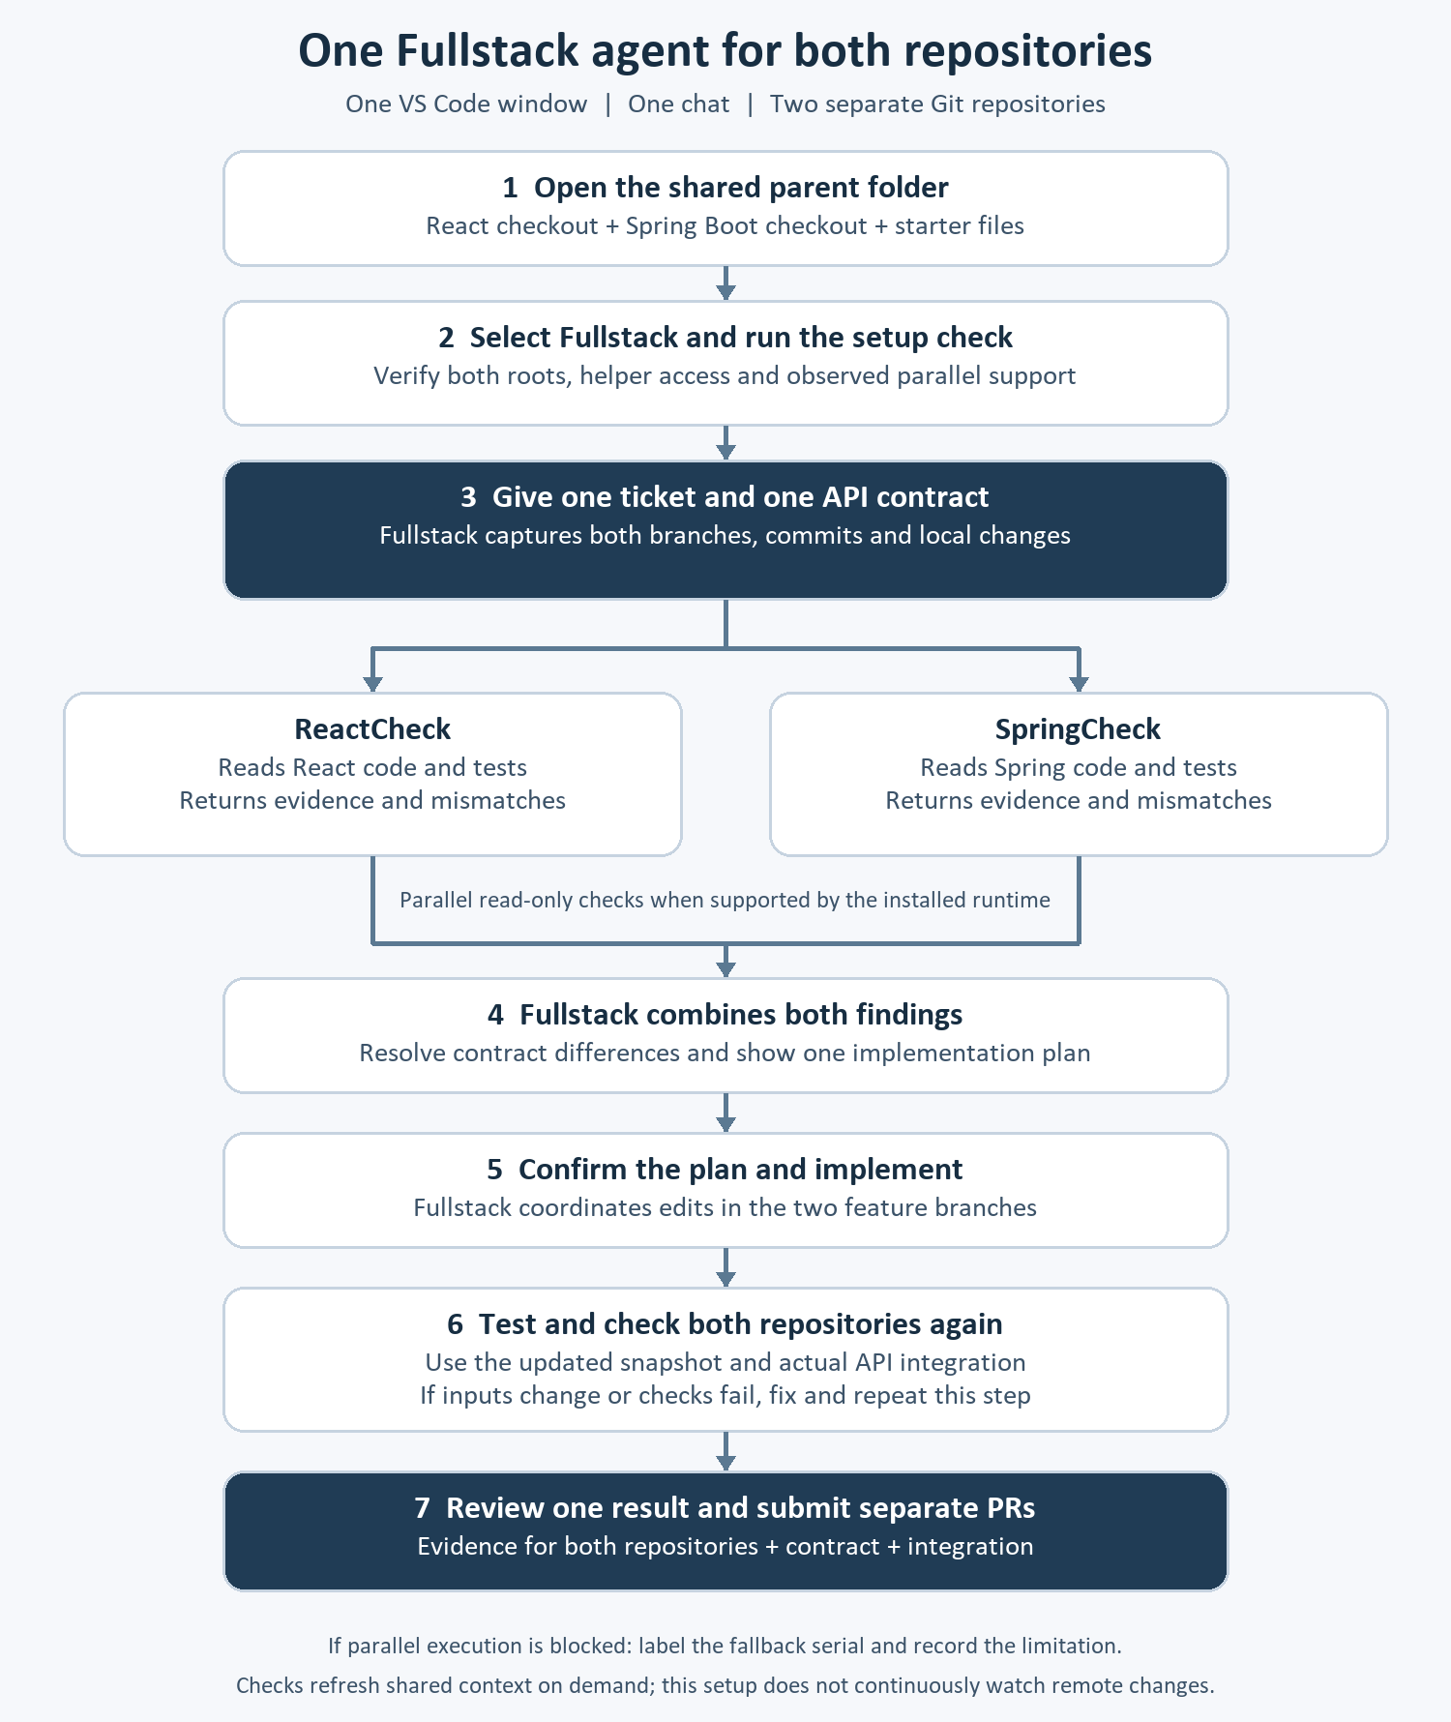

1 Prepare one workspace for both repositories

Step 1 Open Copilot with your company account
1. Open your company-approved VS Code. Select the Copilot status icon and sign in with the account that has your company seat. If already signed in, confirm that account in the Accounts menu. [1]
2. Open Chat from the Copilot menu. Send “Reply with Ready only.” Continue when it replies. If access or installation is blocked, use the relevant row on page 8; do not change organization settings.

Step 2 Put both checkouts under one narrow parent folder
3. If the two repositories already share a suitable parent, use it. Otherwise create a folder in Windows File Explorer, for example Documents > CompanyWork > customer-app.
4. For each company repository, press Ctrl+Shift+P, run Git: Clone, enter its existing repository URL and choose customer-app as the destination parent. Keep the generated repository names. Decline opening each clone separately, then use File > Open Folder to open customer-app. [2]
A fresh clone contains remote commits; it does not contain uncommitted work or unpublished commits from an older checkout. If your task is in an older checkout, use that existing layout or ask your project owner to help preserve the work before continuing.

Step 3 Confirm what the Explorer shows
customer-app/ <- open this folder in VS Code
web-client/ <- actual React repository name
.git/
package.json <- may be inside an app subfolder
customer-service/ <- actual Spring repository name
.git/
pom.xml <- or build.gradle / build.gradle.kts
5. Check that both child folders contain the expected project files. Keep each repository’s existing .git folder. Do not select Initialize Repository for the parent.
Complete when: one Explorer window shows both checkouts. Opening only the frontend folder does not give this setup its intended workspace context.

2 Install and select the Fullstack agent

Step 4 Copy the supplied configuration
1. In File Explorer, right-click Fullstack_Copilot_Starter_Pack.zip and select Extract All. Open the extracted folder. Copy .github and coordination into customer-app. If matching files exist, compare and merge them; preserve existing company instructions.
customer-app/
.github/
copilot-instructions.md
agents/
fullstack.agent.md
reactcheck.agent.md
springcheck.agent.md
coordination/
workspace-map.md
current-task.md
report-template.md
web-client/ <- remains a separate repository
customer-service/ <- remains a separate repository
2. In VS Code, open coordination/workspace-map.md. Set React repository root to web-client and Spring repository root to customer-service, replacing these examples with your actual names. Save with Ctrl+S. Fullstack will inspect the other fields later.

Step 5 Select the agent and its available tools
3. Open the normal editor Chat view. If a Session Target picker is shown, select Local for this guide. Open the agent dropdown and select Fullstack. Workspace agent files belong in .github/agents. [3]
4. Select Configure Tools in Chat. Check that read/search, edit, terminal execution and Run Subagent are available. The subagent tool may be shown as agent/runSubagent. Keep the normal company approval behavior. [4]
5. If Fullstack is absent, press Ctrl+Shift+P and run Developer: Reload Window. Reopen Chat. If still absent, check the location above, then run Chat: Open Customizations and inspect Agents or use Chat diagnostics. [3]
Complete when: Fullstack is selectable. ReactCheck and SpringCheck are deliberately hidden from the agent picker; Fullstack invokes them. [3] If your version only exposes Copilot as the target, use its Configure Chat > Tools controls and require the next smoke test to pass before relying on delegation. [4]

3 Prove that both repository checks work

Step 6 Run this read only smoke test
Select Fullstack and paste the text below. This test does not authorize application changes.
Read coordination/workspace-map.md. Do not change files.
Verify both repository roots. Give ReactCheck and SpringCheck
the same snapshot ID SMOKE-1 and contract revision not-applicable.
Ask each to locate its manifest and one real source file.
Request both checks concurrently. Return helper name, root,
exact file paths and observed execution mode.
If delegation or overlap is unavailable, say so plainly.
Do not claim parallel execution unless it is observable.
1. Expand the helper/tool entries in the chat response. Confirm that one names ReactCheck and the other SpringCheck, and that their evidence comes from the correct repositories.
2. Check the displayed execution details for overlap where available. Two finished reports alone do not prove simultaneous execution. If overlap cannot be observed, record parallel support as UNVERIFIED and keep the setup pilot open.
3. If a helper is unavailable, correct its exact name or tool selection and retry once. If the client or policy blocks it, record the block using page 8. Serial checking can still combine both repositories, but does not meet the parallel requirement.

Step 7 Let Fullstack fill the project map
Inspect both repositories and their existing instructions.
Populate only coordination/workspace-map.md with discovered
app/module paths, documented runtime versions, existing commands
for setup, non-watch tests, lint/typecheck/build and local startup,
their working directories, and the authoritative API contract.
Leave unsupported facts UNSET and list the questions.
Do not edit application files or install dependencies.
Read the proposed map. Ask the project owner only for facts the files do not establish, such as the team base branch, local service setup or contract owner. Have Fullstack record those answers.
Complete when: both roots and app/module paths are correct; helper reports use the same snapshot; parallel support has an observed result; commands and required local services are identified. The pack uses self-contained helper requests because Local subagents do not inherit the main chat history. [5]

4 Prepare a small ticket and one shared contract

Step 8 Establish the working baseline
1. Ask Fullstack to follow the existing setup instructions in the map, prepare the local dependencies if needed, and run the required baseline checks from each correct directory. Review any normal tool approval prompts.
2. If a command fails before your change, record it as a baseline failure. Fix missing runtimes, private-package access or services through the existing project setup; do not ask the agent to rewrite code to hide an environment problem.

Step 9 Paste one bounded request
Task ID: TICKET-123
Goal: [one feature or bug to complete]
Expected user behavior: [what should happen]
Acceptance criteria:
- [specific successful outcome]
- [validation or error outcome]
Scope: [screen/component and API if known]
Do not change: [unrelated behavior]

Check both repositories in parallel with ReactCheck and
SpringCheck. Use the same current snapshot and API contract.
Compare their findings, identify mismatches, and return one
implementation plan with files and verification commands.
Do not edit any files yet. Ask only questions that block the plan.
3. Review the combined plan. Confirm the request/response fields, required values, error behavior and acceptance criteria in plain language. A guessed API contract must not become an accepted decision silently.
4. If no formal contract exists, ask Fullstack to draft the task’s agreed API behavior in coordination/current-task.md and review it before implementation. If an OpenAPI contract already exists, use that source and its revision; avoid maintaining a competing copy.

Step 10 Prepare feature branches
Check the current branch and local changes in both repositories.
Use feature branches [React branch] and [Spring branch] from
the confirmed team base branches in the map. Create them if
needed and safe. Preserve existing work; report conflicts.
Show both roots, branch names and starting commits.
Do not implement until the branches are ready.
Complete when: the behavior is agreed, one plan covers both sides, and the intended feature branch is identified in each repository. Work on one ticket per chat.

5 Implement and verify the complete user action

Step 11 Ask Fullstack to implement the agreed plan
Implement the agreed plan for TICKET-123 in both repositories.
Record the accepted contract and plan in current-task.md.
Coordinate the edits yourself; use helpers for read-only checks.
Reuse existing React and Spring patterns. Add or update tests
for the changed behavior. Run the required checks from the map.
Preserve unrelated files and do not commit or push yet.
1. Review any tool approval showing the command and its working directory. Confirm it targets the intended repository/module. Let Fullstack finish the scoped work and collect real command results.

Step 12 Recheck against the new shared snapshot
Capture the current state of both repositories and the contract.
Recheck both with ReactCheck and SpringCheck in parallel using
that same updated snapshot. Compare route, request, response,
validation and error behavior. Recheck any changed inputs.
Run the available integration check and return one report using
coordination/report-template.md. Mark unrun work NOT RUN.
Fix failures caused by this task and repeat the affected checks.

Step 13 Check the real frontend to backend interaction
2. Have Fullstack start the backend and frontend using the existing local profiles and commands in the map, plus required development services. Open the frontend URL it reports.
3. Perform the ticket’s successful action. Open browser Developer Tools > Network, repeat the action and select the API request. Confirm its URL, method, status and response match the agreed contract and intended backend.
4. Repeat the agreed validation/error case and any relevant empty/loading case. Ask Fullstack for exact clicks and expected results if you need them. Report the actual result; the agent should record it as a manual check with the environment.
5. If local integration cannot run, record the blocker and the remaining action. Passing React and Java unit tests does not prove the application works across the API.
Complete when: the final report contains results for React, Spring, the API agreement and integration. Any FAIL, BLOCKED or required NOT RUN item still needs action. If code or branches change afterward, ask Fullstack to refresh the relevant checks.

6 Review and submit the two repository changes

Step 14 Review each diff
1. Open Source Control with Ctrl+Shift+G. Select the intended repository before a Git action. Click each changed file to compare the previous and new content. Ask Fullstack to explain unfamiliar changes against an acceptance criterion. [2]
2. If a nested repository is not listed, use File > New Window, then File > Open Folder for that repository just for Git review. Keep the original parent window and Fullstack chat for the combined task. Repeat for the other repository if needed.
3. For any unexpected change, ask Fullstack to explain or remove only its unrelated edit. Do not discard a whole file containing your existing work. Re-run affected checks after a correction.

Step 15 Commit and publish per repository
4. Stage only reviewed task files with the + action beside each file. Enter the ticket-based commit message and select Commit. Repeat in the other repository if it changed.
5. Select Publish Branch if the feature branch has no upstream, or use More Actions > Push if it already has one. Check the repository and branch first. Publish Branch uploads to the existing remote; do not create a new hosted repository for this task. [2]
6. If access is missing or the push is rejected, keep the local work and use the team’s existing contribution process. Record the exact error; do not force-push as a shortcut.

Step 16 Create linked pull requests
7. On your company GitHub repository page, open Pull requests > New pull request. Choose the team base and your feature branch, inspect the comparison, then create the PR. Repeat for each changed repository. [6]
8. Put the same ticket in both PRs and link each PR to the other. Include the agreed API change, actual test results, any incomplete integration check and the compatibility or deployment order when needed.
9. Return to the Fullstack chat and provide both PR links. Ask it to record the final references and remaining review actions in current-task.md. Continue with the organization’s existing review and release process.
Complete when: each changed repository has its own reviewed contribution and both reference the same ticket and API behavior. The two repositories remain separate; their commits and releases are not atomic.

Step 17 Start the next ticket
Ask Fullstack to save the concise current task under coordination/history/TICKET-123.md and reset current-task.md. Start a new chat with Fullstack for the next ticket. The workspace map stays reusable; the old task is only loaded when relevant.

7 Resolve blocks and share the setup
If you see this | Do this
Copilot does not respond | Confirm the company account and assigned access. Send the exact sign-in or policy error to the existing support channel.
Fullstack is missing | Check parent/.github/agents/fullstack.agent.md, reload the window, and inspect Chat customizations/diagnostics.
Only one repository is visible | Open the narrow parent containing both checkouts. Correct both roots in workspace-map.md and rerun SMOKE-1.
Helpers run serially or do not run | Check the session target, Run Subagent availability and exact helper names. Record serial or unverified; request company support only if the feature is unavailable.
Tests fail before code changes | Use the existing setup guide to restore dependencies, runtime or services. Keep the baseline failure separate from this ticket.
Results disagree or become stale | Refresh both HEADs, relevant local changes and contract revision. Send a new shared snapshot to both helpers and reconcile again.
The chat grows large or repeats work | Finish the ticket, retain the short task record, and start a new chat. Reference exact paths and the failing output; avoid pasting whole repositories.

Keep the work focused
Use one clear ticket, a few relevant example files and bounded helper reports. Use the current company-approved model. Read the Copilot status dashboard to monitor allowance use. Parallel delegation can add model usage; measure time to an accepted change and actual usage rather than assuming a token saving. [1, 5]

Share the configuration with colleagues
Share this guide and the versioned ZIP through the normal team channel. Each colleague copies it into their own parent workspace, fills the map and repeats the smoke test. The parent configuration is outside the two repositories, so ordinary frontend/backend commits do not distribute it. Keep one team-owned version of the templates.

Official references checked on 4 October 2026
[1] VS Code Copilot setup
[2] VS Code repositories and remotes
[3] VS Code custom agents
[4] VS Code tools and tool selection
[5] VS Code subagent execution and context
[6] GitHub pull request creation
Validation status: the supplied file structure, agent names, tool lists and links have been checked. Company repository discovery, actual helper concurrency and application tests must be verified in your environment using steps 6 to 13.

