HAITIAN AND DOMINICAN ASSISTANCE CORPORATION
“Helping people; help themselves” EIN number 26-3807169 a USA 501c3 and Dominican Republic NGO
HADAC501c3@gmail.com 829.649.4555 ritzenchuck@gmail.com

HADAC
Second Quarter Report-July 2010
Highlights of this quarter:

-David Snodgrass DDS, Nashville, donates dental equipment
-Jessie Veil, DDS, Minnesota, and daughter visit to help clinic
-Crusades for Christ 40’ container arrives in Puerto Plata
-Bob Biscan, Pres. Biscan Construction, Nashville, helps complete zip line
-www.withinyour power. ca, a Canadian Group donates $4,000.00 for food distribution
-Clinic hires new MD and DDS
-Gerry Pinsonneault, DDS and wife Sandy, Canada, retired, supervise dental clinic
-Jud Phillips make second trip to DR to add graphics to our buildings
-Zip line of 4,400’; 7 stations, completed
-Monkey Jungle nears completion
-Ft. Liberte’ free zone project gets first industrial commitment for factory
-Cabarete mayor visits Monkey Jungle for “taxes”; Puerto Plata mayor intervenes
-New medicines arrive
-Little Jimmy off to Santiago for surgery
-New agreement for CT, MRI, X-ray and blood tests with Caberete Emergency Center
-Haitian and Dominican Assistance Corporation receives NGO status from Dominican Republic

The last three months only seem like a blur. The amount of construction progress at Monkey Jungle has been astonishing. The Leon Laroche Medical Clinic and Snodgrass Dental Suite have been open for 2.5 months and have treated almost 1000 Haitians and Dominicans. The Leon-Laroche Medical Clinic is named after our great Haitian friends, Bernie Leon and Maurice Laroche. Bernie died suddenly of a heat attach after visiting our home in Nashville to celebrate his 50th birthday. Maurice is very much alive and well. Bernie’s ashes were buried near the Clinic this week.
We hope to open the zip line and jungle in September and with hard work, have an estimated 6,000 tourist visits per year. This should provide almost 80% of the funding to sustain the medical/dental clinic. Details on our other major events are as follows:
David Snodgrass, DDS donates dental equipment
David Snodgrass DDS, a pediatric dentist from Nashville, Tennessee made his fourth visit to Monkey Jungle on his way to Danita’s Children, an orphanage in Quanamenthe, Haiti, that is his passion. David was on his way to install a state of the art, dental suite for the orphanage. He announced he had an extra dental chair and a full drill instrument set for us if we could get it to Monkey Jungle. We did and got it set up just before Jessie Veil, DDS (orthodontics) and his daughter arrived from Minnesota, to provide specialty care for many Dominicans and Haitians. Standard Dominican and Haitian dentistry is to pull teeth with cavities since fillings are not available. We now have the opportunity to fill teeth and provide sealants and fluoride treatment. This is a significant upgrade in the standard of care previously unavailable to the poor. The Snodgrass Dental Suite in the Leon Laroche Medical Clinic is up and running.
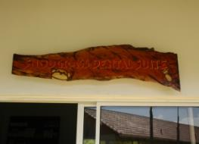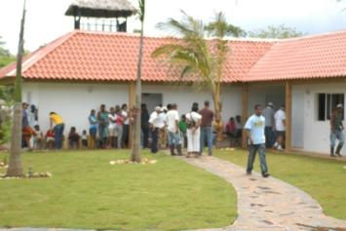
Snodgrass Dental Suite in Leon Laroche Medical Clinic

Jessie Veil, DDS, Minnesota, and daughter visit to help clinic
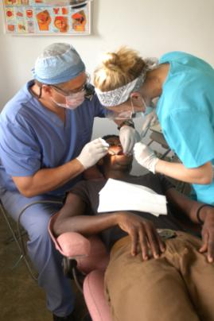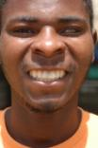
Dr. Jessie Veil (Minnesota) and his talented daughter, assistant are the first to use new dental equipment provided by David Snodgrass, DDS (Tennessee). Below is one of Jessie’s new smiles.

During all of this I learned that dental drills require suction and compressed air to work and not surprisingly, this equipment can cost $6,000 to $7,000 USD and require specialized installation. Jessie was to arrive in three days and necessity is the mother of invention. We purchased a shop vac and small air compressor, added a reverse osmosis and charcoal water filter for the drills and were up and running 12 hours before Jessie arrived.

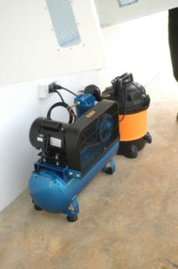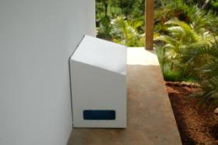
Shop vac, compressor and waterproof cover installed before Jessie arrived are still running strong.

Crusades for Christ, Brother Joe Mobely, London, Ky
Several months ago we were contacted by Brother Joe, head of Crusades for Christ, located in London, Ky. He informed us that freight was backing up in Porte Au Prince, Haiti, and supplies were not getting to the poor. “Quality inspections” by Haitian customs are now the easy way to take what is desired from shipments to the poor. Brother Joe, as he is referred to, offered to send up to twenty seven, 40’ containers of medical equipment, cloths, food and supplies to us if we could get it distributed and not stolen for black market sales. Haiti has become a lawless, everyone for themselves, black market region where corrupt police stop us each time we are there and ask for or demand supplies or “coffee money”. They even shake down the poor who buy meager supplies in Quanamenthe on “open border” days. A six foot cop blocking the main road to Cap Haitian, with automatic weapon and pistol, driving a UN truck was our latest encounter this month. We avoided conflict, but neither party left happy.
We negotiated a transaction, whereby the container would be shipped to the Mayor and city of Sosua and had letters of agreement signed that there would be no duties, taxes or charges for the shipment. Brother Joe and his staff shipped the container during the worst flood in Tennessee and Kentucky’s history and after many delays arrived in Puerto Plata. In short, elections were taking place and the Mayor, long favored, lost the election. Needless to say agreements were not honored and we were on our own. To make a long expensive, frustrating story short, we were able to pick up the contents of the container, less some used cloths and store it at Monkey Jungle this week.

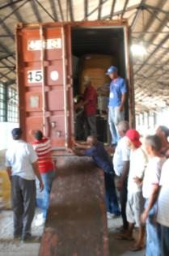
Breaking the customs seal, inspection and unloading supplies, for the third time into the blue truck and our white Dodge with Haitian license plates.
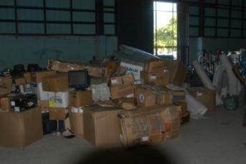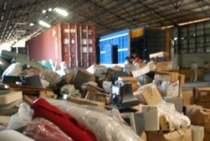
While the Mayor of Sosua lost the election, his assistant Clarisa ran for and won the election in a neighboring town. She “volunteered” to assist our efforts to free the container. Below right she discusses amounts of “duties” to be paid with customs official.

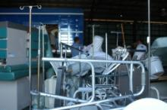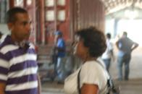

The man in the middle is the gate agent, who allows trucks to leave after inspection. He heard we had sewing machines and demanded one as our fee to leave. After 1.5 hours of delay and threats of reinspection and my spouting of newly leaned Spanish expletives, we settled on a cigarette and cold water. He didn’t want his picture taken and is giving me the universal salute of “friendship”.
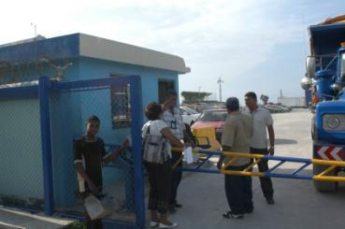
Delsa, area supervisor for distribution 25 miles to the East

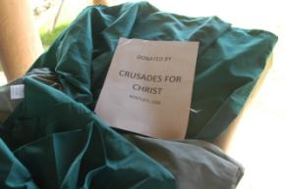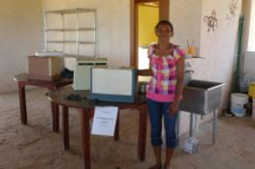
Crusades for Christ’s donations will change many 100’s of people’s life on the North coast of the Dominican Republic and Haiti. We sincerely thank them for their trust and support and have learned that distribution to needy families is quite a challenge and time consuming process. Four non-political, religious regional heads of small cities have been selected to distribute and document placement of the goods and equipment. It will be a while to get it done properly. More on this subject next quarter as supplies are distributed.

Robert S Biscan Construction Company of Brentwood, Tennessee has built 100’s of millions of dollars of commercial construction projects throughout Tennessee. Bob is a dear friend and volunteered to come over and assist in pushing our zip line project along. Bob is also a structural engineer and great motivator. He spent 7 hot days with our folks adding comments, suggestions and insight on how to make the project better, safer and stronger. He will return the last week of July to review and finalize our systems. Thanks Bob. See you soon.
Monkey Jungle adds new staff to Leon Laroche Medical Clinic
Karen Conquergood, the Monkey Jungle Medical Center administrator, hired new staff in March to upgrade medical and dental services every Saturday. Dr. Vanelsa de la Tour, a Haitian trained in Santo Domingo, is our staff physician. Dr. Clarydania Bonilla Cid is our staff dentist. She is a beautiful new graduate of the Santo Domingo Dental School. Both are paid employees. Dora our medical coordinator has been with us from the beginning and triages physician patients.
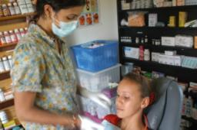
Monkey Jungle Medical Clinic operates Saturdays 10 am until 3:00pm. Between 8 and 12 volunteers show up each weekend to make things run smoothly. We treat an average of 40 dental patients and 60 medical patients each Saturday.
Both Haiti and the Dominican Republic critically need dental care, however, we learned firsthand, earlier this year, that dental hygiene and tooth decay are greater in DR than Haiti. Having some extra income, easy access to soft drinks, candy and lack of attention to brushing teeth (most rural children have never seen a tooth brush) have exacerbated the problem. To combat this problem we needed constant, well trained, experience staff to supervise and trained newly hired dentists. We are very fortunate to have added two important volunteers to Monkey Jungle Dental Clinic. They are Gerry Pinsonneault, DDS and his wife Sandy. Gerry and Sandy are retired Canadians who worked together practicing dentistry in Canada before retiring to the DR. Lucky for me they are also neighbors. Both give up several days a week to organize, train and buy new equipment for the Snodgrass Dental Suite. Thanks Gerry and Sandy.

Canadian group donates $4,000 for food distribution
Approximately three Saturdays ago two young people arrived at Monkey Jungle to volunteer their help. They are Tony Lewis, a professional photographer and Cheral MacLellan, a registered nurse. Cheral jumped right in and began triaging patients, moving along groups and determining care needed. Tony took some great shots. After a long day all staff parted and Cheral and Tony showed up the next day, clean up time. Cheral announce that they have an organization called WITHIN YOUR POWER in Edmonton, Canada and would like to donate $4,000 for food. Since we now distribute rice, bean, tomato paste, vegetable oil and tuna to the needy during clinic, I jumped at their offer. They explained that this was a restricted gift and funds could only be used for the sickest, poorest, near death, preferably HIV/AIDS patients, in the neediest communities. In my naivety, I thought –that’s easy. I thought buy the best food for the cheapest price and get it out. We accepted the gift and have learned the real problem is distribution. We learned the best price for rice was in Santiago at Price Smart, a USA clone membership store. I first flew in our Cessna 206 to Santiago and our big dodge truck arrived and was loaded with rice, beans, oil etc. We spent about $1,200 of the $4,000 on the food (we paid for airplane and fuel for the dodge). Looking at our costs we decided to buy the food locally and add the dollars we spend on fuel to the Canadian contribution. We also learned the following:
- Very sick people need weekly deliveries to their home
- Polling small communities for their sickest 10 people gives us leads
- Each family must be interviewed and sick people observed
- Teams of 2 people each must deliver the food at exactly the same time of the day each week.
- Only committed volunteers are able to be assigned this task and photo documentation is required.
We have used extra volunteers on Saturdays to re-bag 50lb bags of rice, beans, oil etc into one week supplies for the patients. We now have 18 people we deliver to each week aging from age 10 to 70. All are HIV/AIDS positive and in the terminal stage. To date we have spent less than 40% of your gift. Thank you both; Tony and Cheral. Please be patient with us. We will get it done.
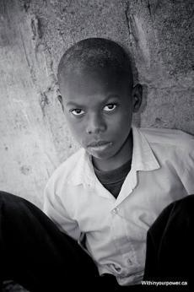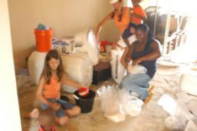
Volunteers repackage food at Monkey Jungle for distribution to preselected families
www.withinyour power.ca
Photo credit: Tony Lewis
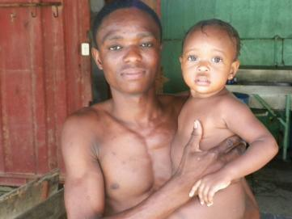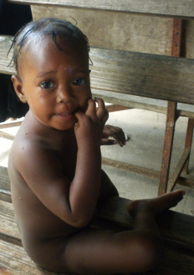
A family Candy found and committed to assist.

Jud Phillips adds graphics to Monkey Jungle
Jud Phillips is a good friend from Nashville, my flight instructor and a superb graphic artist. Jud revisited Monkey Jungle in June to upgrade our image. Jud is responsible for the Monkey Jungle logo we use on T-shirts and expanded our décor by painting our main facility with amazing monkey graphics. Thanks again Jud. We have had many accolades on your work.
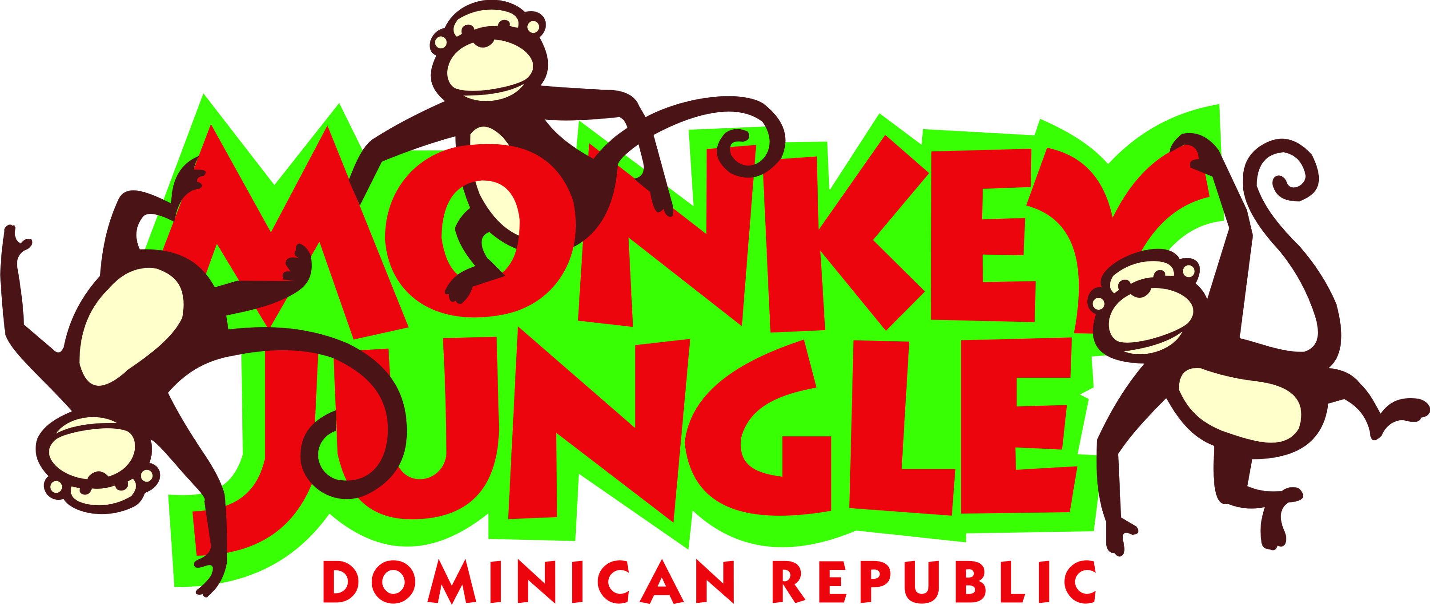
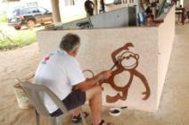

Zip Line nears completion; Monkey Jungle adds 100’ foot waterfall and 40,000 gallon swimming pool
It is our hope that the Monkey Jungle and Zip Line attractions will help provide revenue to support the Leon Laroche Medical Center. Nearing completion; we have installed a 4,400 foot zip line with seven stations, a 50’ fan descender into a large cave and have the only Dominican zip line with a full safety line (a 4,400’ additional line 6” above the primary line). We used USA made ½” galvanized steel cable with engineered poles and bases from England. Derek Watson joined us a month ago to oversee zip line activities and complete the project. Derek is from North Carolina and served a tour in Iraq, before joining us. He has become an invaluable asset in his short tenure here. Engineers from Canada (Steve Kostamo), USA (thanks Bob) and Puerto Plata, DR assisted in and supervised the construction. We hope to obtain the coveted ACCT certification on the facility. It would be the only one certified as such in the DR.

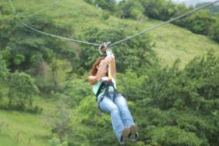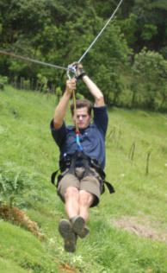
Candy and Derek Watson test the zip line
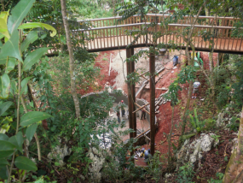
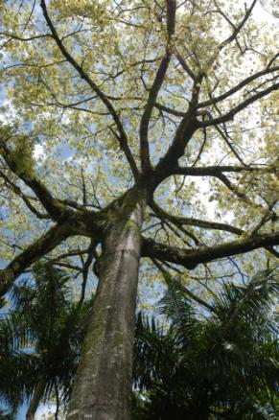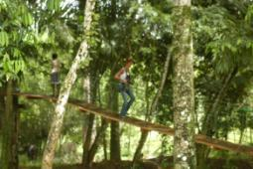
Over 200’ tall Seba tree at zip line landing #7 and Candy completes the course on suspension bridge at landing #7
Monkey Jungle is nearly complete with the exception of the final landscaping, suspension bridge and the swimming pool plumbing. The 40,000 gallon pool and waterfall will provide a refreshing hideaway for visitors and its 20 monkeys. By Christmas we expect to add about 6 newborn monkeys conceived and delivered in the park.

Fort Liberte’, Haiti “Free Zone” project moves ahead with first industrial commitment from US group
Mike Wnek of Florida needed twenty acres in a port area on the north coast of Haiti where materials could be shipped and assembled by Haitians for Haitians. Maurice Laroche, our dear friend in Cap Haitian, offered his land and Mike got the ball rolling without outside help from any government agency. Just a great example of people helping people while governmental agencies stand by and watch, meet and wring their hands.
I quote a portion of the memorandum of understanding and outline of the transaction:

“All product supplied to other non-profits will be done at cost. Gramatica SIPS to employ 90+% Haitian employees. United Aid Foundation (UAF) will contract with Haitian Landholder and SIPS will contract with UAF.

National Football League Players Association will provide 2 million dollars to fund construction of housing for Haitian Earthquake victims with funds paid direct to UAF. Wnek will seek aid from other Professional Sports organizations, celebrities and organizations like Rotary Club.

SIP factory to be built and operated by Gramatica SIPS International owned by Martin Gramatica, Bill Gramatica and Santiago Gramatica will build all initial product as not for profit ultimately into a for profit business through other providing materials for higher end rebuild. All product supplied to other non-profits will be done at cost. Gramatica SIPS to employ 90% Haitian employees. SIPs will also export to other Caribbean countries like Jamaica. This is geared to be a long term employment opportunity for Haitians.
Palm Harbor Homes, a publicly traded US corporation (PHHM NASDAQ) to provide architectural drawings, product approvals (at no fee), and organize site construction and finish of SIP Panel construction in various Haitian neighborhoods starting with Simonette, Haiti. PHH will be reimbursed at cost for any employee expenses and equipment for field construction. PHH may build employee housing and initial prototypes as well as model center product for SIP factory display at cost plus 10%. All PHH efforts will be managed by Mike Wnek who has been with Palm Harbor Homes since its inception year 1978…”
Mike Wnek is a dedicated humanitarian who has focused his aid efforts on Haiti for many years. His efforts were witnessed by me during the aftermath of the earthquake in January when we were able to spend a few days together at my home in Sosua after his many flights for aid to Haiti. NOTE: This transaction is pending and not completed. Knowing Mike and Maurice as I do, I believe it will be completed this year. We are proud to help facilitate this transaction. Good luck guys.

Cabarete Mayor pays Monkey Jungle a visit
Two weekends ago the Sindico (mayor) of Cabarette revisited Monkey Jungle and informed us he desired to collect our “taxes” on the property improvements. I was not there at the time but Pedro our farm manager, met with him and his armed “tax collector”. It was surely a scene from an old gangster movie. The mayor informed Pedro that he had annexed our property 9 years ago and needed to be paid the annual property taxes by August 15th. Pedro deferred to me and the mayor left. Three days later I met the Sindico on the road to the farm and he again explained his request. I informed the Sindico that by Presidential decree two years ago, our farm was in Sosua not Cabarete. He was unimpressed. I offered him a copy of the law since he had visited us last year and extracted $700 USD for “permits for our cistern”. The permit was never issued, but the Sindico felt he had his foot in the door. Two years ago the Sindico established a law to allow him personally to collect all taxes in Cabarete and spend them as he saw fit on the community. His shiny new 4 wheel drive vehicle was an example of his newly created wealth. I suppose he did help the community, he bought the truck in Cabarete.
In short we exchange a few Spanish words and he promised me a nocturnal visit and assured me that we would see each other again. I thanked him and explained I liked his new name “el Gordo Sindico” and looked forward to our next meeting. Our farm neighbor is the father figure for the Sindico of Puerto Plata and as cities go, Puerto Plata is 20 times the size of Cabarete. Hence; it is more politically powerful. He made a call and el Gordo has calmed down. Puerto Plata police officers patrolled our farm for 2 days. I am sure the story will continue until this much hated, corrupt politician is replaced.

Little Jimmy of to Santiago for surgery
Two months ago a distressed young Haitian woman showed up at Saturday clinic with her child. Jimmy is one year old and had “tumor like” growths on his face. She said he had them since birth and they had gotten larger. Unaware of the diagnosis, our doctor sent Jimmy to the Cabarete Medical Hospital for CT and blood work. Three weeks later Jimmy and his mother were back and it was determined Jimmy needed surgery in Santiago to remove the growths that were rapidly growing and threatening his breathing. We arranged for his surgery. Surprisingly enough, Karen our Medical Center administrator saw Jimmy and his mother with a Haitian doctor at the hospital again and had and American couple observing Jimmy. The doctor seemed embarrassed by the accidental meeting. In short, we discovered the doctor was requesting money for Jimmy’s surgery that we had already paid for. Our good friend Roberto, head of the hospital and a neurosurgeon, was informed of the doctor’s indiscretion. He is no longer practicing medicine in this area and Jimmy is off to Santiago for the first stage of many operations.

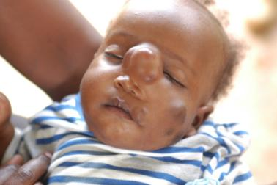
Little Jimmy’s growths have increase 3 fold since his first visit to the clinic.
Jimmy is also missing his right foot.

New agreement with Cabarette Medical Clinic

The Leon Laroche medical clinic has entered into a new agreement with Cabarette Medical Clinic to provide us with lab and diagnostic services at a reduced rate. The rate is approximately one half the costs that walk-in patients pay. This will reduce our expenditures on X-ray, CTs and blood work by about $500 US per week.

HADAC receives NGO status from DR government

After 12 months of legal work, many dollars and too many lawyers, HADAC received its approval as a Dominican NGO. The designation means it is a recognized Non Governmental Organization (private charitable organization) in the Dominican Republic. We now can receive shipments of supplies and gifts without paying duties and taxes.
Please visit our website at www.hadac.org

Some more pictures of activities at Monkey Jungle:


Clinic Saturday, July 10th; new patient waiting room at 7:00 am for our clinic which starts at 10:00 am. 48 people arrived by 9:00 am. Clinic is from 10-3:00 pm

New waiting room built last week.
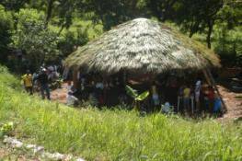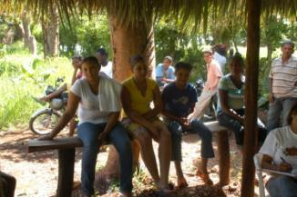

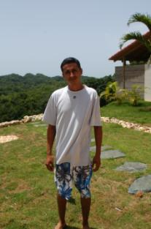
Pedro Louis Alvarenga is the farm manager. Pedro is from El Salvador and was brought to the DR to head up our operation. Without Pedro the project would not be as far along as it is. He works tirelessly to coordinate all construction and manage up to 40 employees. Thank you Pedro.

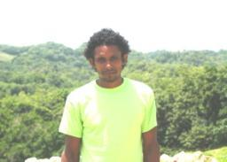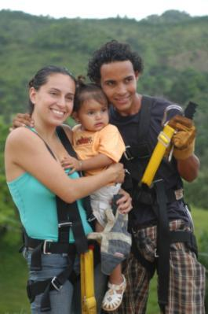
Odaley is in charge of 70 head of cattle and security for Monkey Jungle.
Dauri is chief monkey trainer pictured at right with his family after some zip line fun.

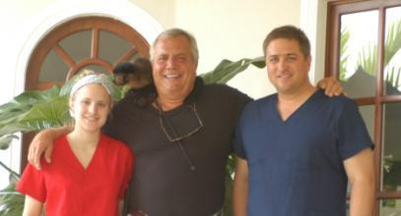
Jessie Veil and his daughter stayed in our home in Sosua during their visit.
Coco on my right shoulder is in love

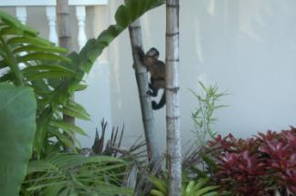

Please consider the following needs:
A few thoughts the staff and volunteers at Monkey Jungle would like you to consider:
1.) 20% of our patients are HIV/AIDS positive
2.) 10% are Hepatitis A, B or C positive
3.) All families live on less than $3,000 USD/ year
4.) We dispense up to 1000 doses of amoxicillin or cipro every day the clinic is open
5.) We fill teeth with composites whenever possible rather than pull a tooth. Our dental team is so good they can handle 6 patients per hour.
6.) Fluoride treatment and sealants are used in all children when available and time permits.
7.) Most families do not own 1 toothbrush, let alone toothpaste. We give every child both at each visit.
8.) Shoes are very expensive here and we pass out flip flops and tennis shoes to all children that have none.
9.) All patients receive a BP, pulse, temp and diabetes screen before they see a doctor. Ten percent are hypertensive.
10.) All dental equipment is sterilized in a Clorox solution inside a pressure cooker for 14 minutes after use. We need an autoclave.
11.) Shortage of dental hand tools slow us down. Consider donating your surplus.
12.) We can test patients at the clinic for pregnancy, HIV/AIDS, Hep A and B and diabetes. We support 4 other clinics.
13.) All doctor, dental visits including medicines prescribed are free. No one else providing these services does this gratis.
14.) Our optometrist checks eyes and dispenses free sun and reading glasses. Saturday

-Ask your Dentist for any surplus handle tools
-Ask your doctor for any surplus or samples of cholesterol meds
-Send us large bottles of fish oil
-New tennis shoes or flip flops
-New or used reading and sun glasses
-CONSIDER VOLUNTEERING FOR A WEEK IN THE CLINIC OR TEACHING ENGLISH to 4-12 year olds
-Look at the Blessings International website and see if you can help us buy medicines. The site requires a password (peace, joy) and doctors signature to buy.
One of us is in Florida once a month. You can ship any items to the following:
Chuck Ritzen, Sky Harbor East Condos # 11f
2100 South Ocean Blvd
Ft Lauderdale, Fl 33316
Your help is greatly appreciated. All cash donations go through PayPal on our website or are sent to Dale Royse, Senior Vice President, Red Mountain Bank, 157 Franklin Rd, Brentwood, Tn. 37027 615.372.1750 droyse@redmountainbank.com

HADAC is a USA 501c3 corporation; Tax Number 26-3807169 and registered NGO in the Dominican Republic
Thank you for your time in reviewing our progress.
Chuck and Candy Ritzen from Sosua, Dominican Republic and various areas of Haiti. ritzenchuck@gmail.com and ritzencandy@gmail.com
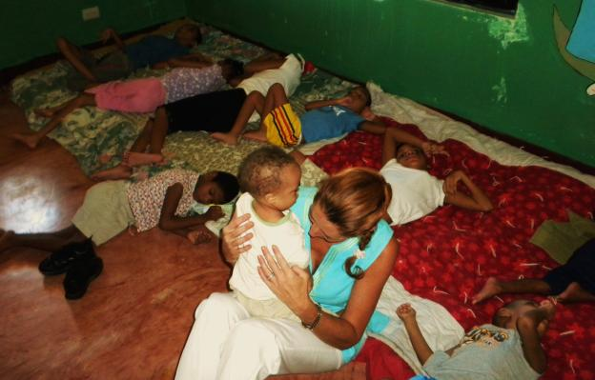
Candy was in an orphanage for female children with cerebral palsy. The care and accommodations were very good with plenty of food and staff. No assistance was needed, but visits and hugs were required. Please consider visiting and helping with hugs. These children are desperate for attention.

TCOYC Maurice

