Gamma-gamma correlations

Abstract
Linear momentum conservation in successive gamma ray emission from a nucleus dictates an angular correlation between photons. Correlation measurements thus hold information regarding the nature of the interaction leading to the emission. In this experiment, such measurements will be used to define and identify interactions in unstable ${Na}^{22}$ and ${Co}^{60}$ atoms, originating from annihilation, electrical forces and parity effects.

- Introduction
Unstable atomic nuclei emit radiation spontaneously in order to reduce energy to the minimum and achieve equilibrium. We distinguish several different types of radiation emitted by ${Na}^{22}$ and ${Co}^{60}$ atoms in our experimental setup:
- $γ$ radiation – electromagnetic radiation emitted as an excited electron returns to its ground steady-state in form of a single photon which has exactly the energy of the difference between the two electron energy levels.
- $β^{+}$ radiation – an unstable nucleus emits a positron and a neutrino as a proton transforms into a neutron.
- $β^{-}$ radiation – an unstable nucleus emits an electron and an anti-neutrino as a neutron transforms into a proton.
As an elementary particle collides with its anti-particle, it can undergo the process of annihilation – in which the two particles vanish while releasing two photons. Energy and linear momentum conservation dictate the photons’ energy and angular correlation, assuming both particles have slowed down before collision so that their total linear momentum is effectively zero.
In the first part of the experiment, ${Na}^{22}$ atoms decay to excited ${Ne}^{22}$ atoms by $β^{+}$ radiation with a half-life time of $t_{1/2}=2.6 years$. The emitted positrons undergo annihilations with electrons in the surrounding material, resulting in the emission of two photons of $0.511 MeV$ each. The excited ${Ne}^{22}$ atoms later emit photons of $1.27 MeV$ as electrons move to the ground state.
In the second part of the experiment, ${Co}^{60}$ atoms decay to excited ${Ni}^{60}$ atoms by $β^{-}$ radiation with a half-life time of $t_{1/2}=5.2 years$. These atoms in turn emit two successive photons, corresponding to two successive electronic energy level drops, of $1.33 MeV \& 1.17 MeV$. The expected photon energy count distributions for both materials are shown in figure 1.
Another important effect for the experiment is the Compton scattering – a scattering of a photon on an electron, in which energy is partially transferred to the electron so that the scattered photon reduces in frequency. As will be further explained, most emitted photons in the experiment in fact scatter on electrons in the detectors rather then vanishing and transferring all their energy to an electron through the photoelectric effect.

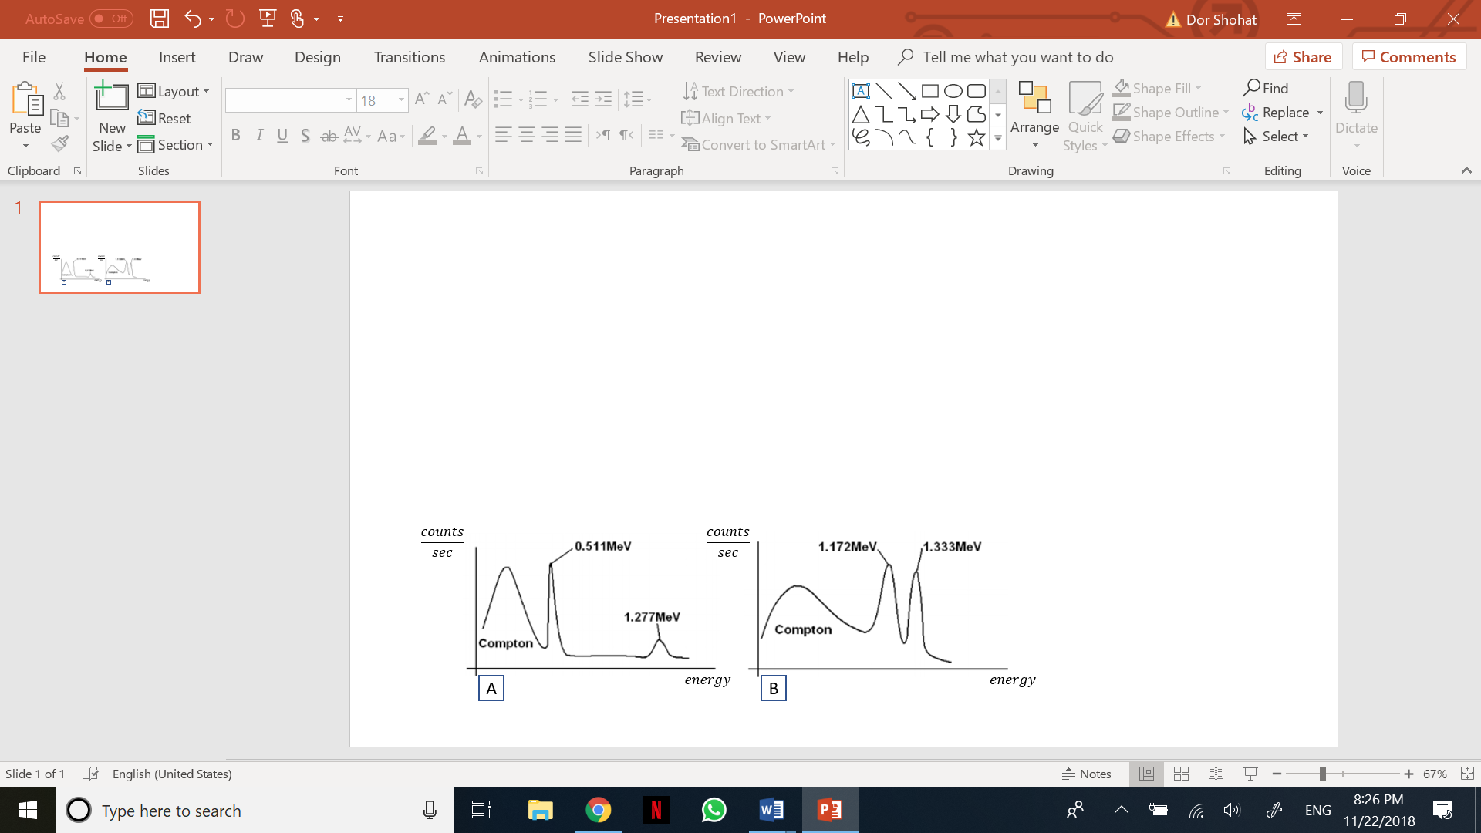
Figure 1 photon energy count distributions for ${Na}^{22}$ (A) and ${Co}^{60}$ (B)

- Theoretical derivation
The angular correlation between photons is generally governed by laws of momentum end energy conservation. For the case of two photons created through the annihilation of an electron and a positron, the correlation is simply:
- $W_{1}\left(θ\right)=δ(θ-π)$
As the total linear momentum of zero is conserved. The unnormalized angular correlation between successive photons emitted from a ${Ni}^{60}$ atom is defined by the probability distribution function:

- $W_{2}\left(θ\right)=1+a∙\cos^{2}θ+b∙\cos^{4}θ$

With $a=\frac{1}{8} ;b=\frac{1}{24}$ . Accounting for the detector’s nonnegligible size we get:

- $F\left(θ\right)=\int_{θ-2ϵ}^{θ+2ϵ}{W\left(θ^{'}\right)dθ^{'}}$
$=\left(aϵ+2ϵ+\frac{3b}{4ϵ}\right)+(\operatorname{asin}\left(ϵ\right)\cos\left(ϵ\right)+\frac{b}{2}\sin\left(2ϵ\right))\cos{(2θ)}+(\frac{b}{16}\sin\left(4ϵ\right))\cos{(4θ)}$

While neglecting the detector’s dimension in the $φ$ axis, and $ϵ$ being the angle between the edge and center of the detector in the $X-Y$ plane. Every measurement will account for a range of angles as shown in figure 2.
The normalization factor for the discrete sum for angles varying from $\frac{π}{2}$ to $π$ will thus be:
- $C=\sum_{n=0}^{9}{F\left(\frac{π}{2}+\frac{nπ}{18}\right)}$
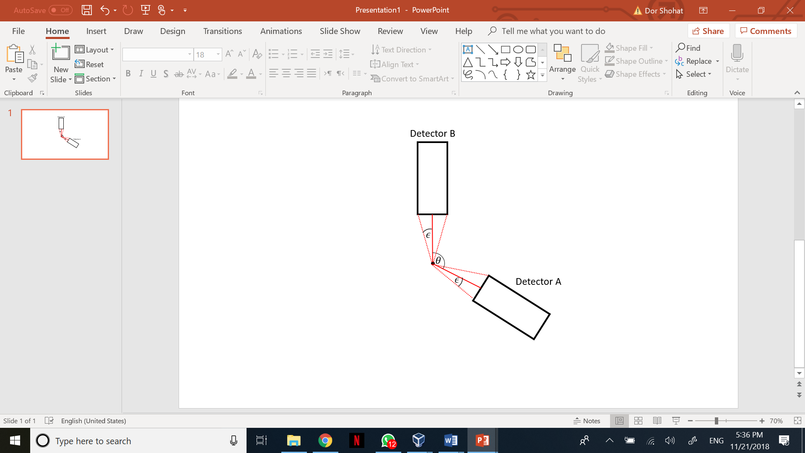
Figure 2 Angle calculation for integrating counts over a non-singular detector

Assuming the time between two emissions is small enough, angular momentum is conserved and the angular momentum which the photon gets equals to the difference in the system’s angular momentum before and after.
Gamma radiation can be categorized according to the type of the electrical and magnetic multipoles. The electrical and magnetic multipolarities are defined define by their evenness: For even bursts electrical multipoles and for odd bursts magnetic ones, during the radiation process the nuclei evenness can vary from an electrical multipole to a magnetic one and vice versa. Furthermore, both multipolarities differ in their polarization plane, by defining the parallel and perpendicular electrical field planes as $E_{∥},E_{⊥}$. To calculate $\frac{E_{⊥}}{E_{∥}}$ by using the ratio between the number coincidences on the parallel plane and the number on the perpendicular plane $\frac{N_{∥}}{N_{⊥}}$ the following equation taken from the article(1) is used
$$5) \frac{N_{∥}}{N_{⊥}}=\frac{p+R}{pR+1}$$
Where $p≡\frac{E_{∥}}{E_{⊥}}$ and $R≡\frac{dσ_{ϕ={90}^{∘}} }{dσ_{ϕ=0^{∘}}}$ , $dσ$ is the cross section for a scattering of a photon of energy $k_{0}$ through an angle $θ$, and is given by the Klien-Nishina equation
$$dσ=\frac{r_{0}}{2}dΩ\left[\frac{k}{k_{0}}+\frac{k_{0}}{k}-2\sin^{2}{θ\cos^{2}{ ϕ}}\right]$$
When $k≡k_{0}[1+\frac{k_{0}}{mc^{2}(1-\cos{θ } }]$, is the energy of the photon after scattering $ϕ$ is the angle between the direction of polarization of the incident photon and the scattering plane, $r_{0}$ is the classical radius of the electron and $dΩ$ the element of the solid angle.

- System configuration
The experimental setup consists of three inorganic scintillators that act as particle detectors, with the source fixed between them as seen in figure 3. Inorganic scintillators have the advantage of high photon absorption efficiency and energy resolution, due to a large amount of energy bands. Detectors B and C are polarization sensitive, while detector A is polarization insensitive. Detector B is fixed, while detector A is rotatable in $θ$ axis from $\frac{π}{2}$ to $\frac{3π}{2}$. Detector C can only be placed in $φ=0$or $φ=\frac{π}{2}$.

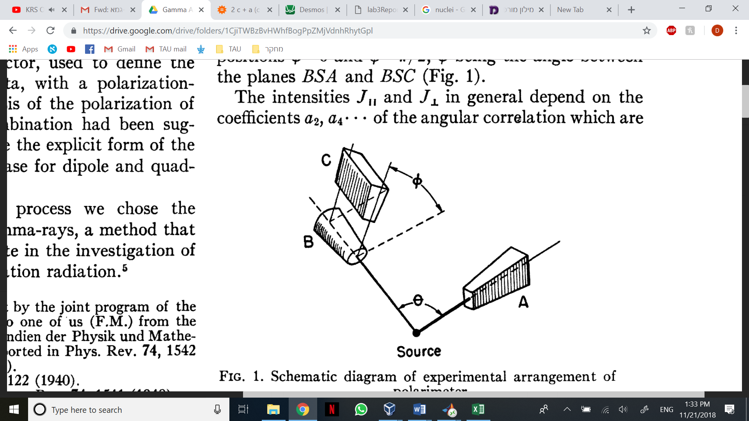
Figure 3 Detector placement and configuration
As a single photon hits a detector, it interacts with an electron and can either transfer all of its energy through to photoelectric effect or undergo a Compton scattering and transfer only a part of its energy – while decreasing in frequency.
Energetic electrons enter a PMT (photo multiplier tube), where they are accelerated in a vacuum tube containing dynodes. Dynodes are electrodes which upon collision with a single electron release more electrons – in rate corresponding to the colliding electron’s energy. Thus, when arriving to the anode at the end of the tube, the many released electrons produce an electric analog signal that matches to the original energy of the single electron.
The signal enters an analog amplifier before entering the SCA unit (single channel analyzer), where it is converted to a digital square pulse that is more easily handled by the later processing of signal through logical gates and computers. The SCA also allows delaying an entering signal or controlling the allowed range of signal voltages – corresponding to an allowed range of energies of photons originally hitting the detector.
Onwards, the signals from all three detectors are passed to a multichannel analyzer, allowing further examination of data when connected to a computer (measurements of counts vs. energy) or an oscilloscope (measurements of signal voltage vs. time). The signals from the SCA units are also passed to a coincidence unit – where they enter a dynamic set of logical .AND. & .OR. connected to a counter, allowing count of signals coming from any subset of counters simultaneously. A timer set next to the coincidence unit allows manual measurements of count per time unit.

- Experimental results
Firstly, with ${Na}^{22}$ as a source, the trivial angular correlation between photons created by annihilation was used to calibrate the experimental system, as the different detectors have different inherent delays and simultaneous counting is needed. As described in figure 1, the energy distribution has several peaks – thus the peak correlating to the annihilation photons – $0.511 MeV$ – had to be singled out to achieve successful correlation. Through the SCA unit the allowed energy window was manipulated so that only the desired range remained.
After establishing the energy ranges for all detectors, the delay was optimized between every two detectors. Firstly, while keeping detector A constant, detector B’s delay was shifted as coinciding counts were measured for both detectors. As expected, plotting this result produces a square signal, with width representing the relative delay window. Contrary to the knobs controlling the energy windows that showed to have a different relative influence on different detectors, the delay showed to be synchronized and scaled evenly for all SCA units. To show that, detector B was kept constant as detector A’s delay was shifted. The resulting delay window has the same width, as seen in figure 4. Using this graph, the delay$B-A$was concluded to be $B-A=1.5$ for the remainder of the experiment.
Next, the same measurement was conducted between detectors B and C and produced figure 5. Using this graph, the delay$C-B$was concluded to be $C-B=2$ for the remainder of the experiment, assuring that detectors A and C are also well timed.
Connecting the multichannel analyzer to the oscilloscope allows quantification of the otherwise arbitrary delay dial. However, the inner delays of each signal from the detectors are not constant, and the oscilloscope reading can only give an estimate to the dial’s scale. Turning the dial 50 notches changed the delay in approximately 50 ns as see n in figure 6, thus the dial scale would be approximately 1 ns per notch, determining the scale for the delay graphs.
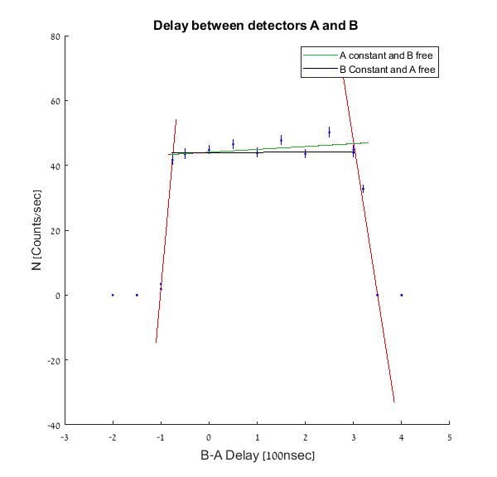
Figure 4 Delay graph between detectors A and B
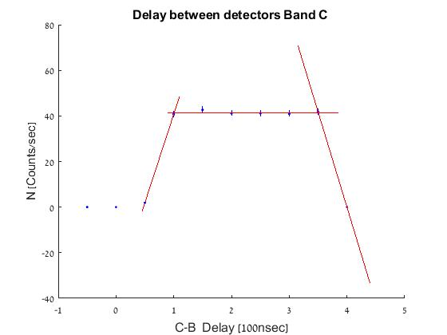
Figure 5 Delay graph between detectors B and C
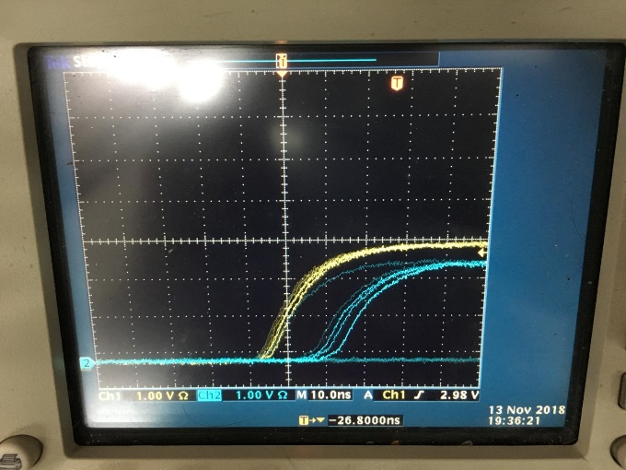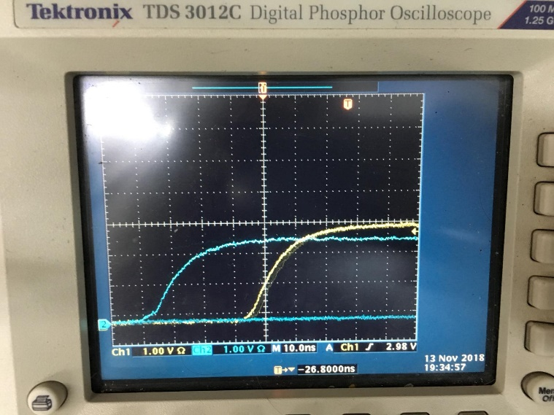
Figure 6 Oscilloscope readings 50 delay notches apart, showing an approximate scale of 1ns per notch
After having determined the fixed delays between the detectors and the energy window, counts per second were measured over a range of angles between the detectors. The errors for the measurement number of counts assuming a Poisson distribution were measured as $ΔN=\sqrt{N}$ and for the angle using the equal distribution method were $Δθ=\frac{1}{\sqrt{12}} Rad$ .
As equation (1) states, a trivial delta function at 180 degrees was expected. Realistically, since the detectors aren’t singular but have a non-negligible size data was fitted to:
$$f= a_{1}e^{-\frac{{\left(x-a_{2}\right)}^{2}}{2a_{3}^{2}} }$$
While $a_{1}$ is the normalization factor, $a_{2}$ is the angle fix and $a_{3}$ is the standard deviation of a gaussian, with the following results:
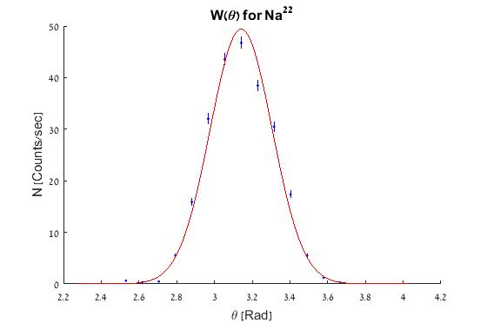
Figure 7 Measurements for $Na^{22}$
$a_{1}=49.38 ± 0.80$ $\frac{Δa_{1}}{a_{1}}=1.6\%$
$a_{2}=3.1418 ± 0.0024 [Rad]$ $\frac{Δa_{2}}{a_{2}}=0.00076\%$
$a_{3}=0.1642 ± 0.0016 [Rad]$ $\frac{Δa_{3}}{a_{3}}=0.97\%$

$χ_{red}^{2}=8.4$
$p-probability=4.3∙{10}^{-15}$

In the case of two singular detectors, a gaussian fit with a distribution width of zero is expected, though since that is not the case the gaussian error is attributed to the detectors’ finite large size. Moving forward to the ${Co}^{60}$ measurements, the gaussian error was taken as the angle measurement error for the original function fit – as it intuitively describes the deviation from the theoretical fit caused by the size of the detectors. For this case appropriate energy windows were found containing only the two peaks of $1.33 MeV \& 1.17 MeV$ as shown in figure 1.
After measuring the number of counts per angle, two fits were made: The first, fitting to the original singular detector correlation function using the gaussian error, and the second, fitting with only the resolution error to the integrated equation (3) that includes the detectors’ size inherently. The data was fitted to:
$$f_{original}=a_{1}+a_{2}\cos^{2}{(x+a_{4})+}a_{3}\cos^{4}{(x+a_{4})}$$
$$f_{integral}=a_{1}+a_{2}\cos{(2x+a_{4)}+}a_{3}\cos{(4x+a_{4})}$$
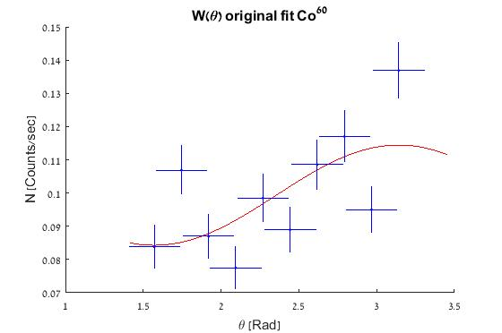
Showing that:
Figure 8 Original fit graph for $Co^{60}$
$a_{1} = 0.084 ± 0.015$ $N_{σ}=32.30$
$a_{2} = 0.014 ± 0.268$ $N_{σ}=0.22$
$a_{3} = 0.015 ± 0.84$ $N_{σ}=0.011$
$a_{4} = 0.00010 ± 0.046 [Rad]$
$chi_{red}^{2} = 4.7$
$p_{prob} = 8.61e-05$

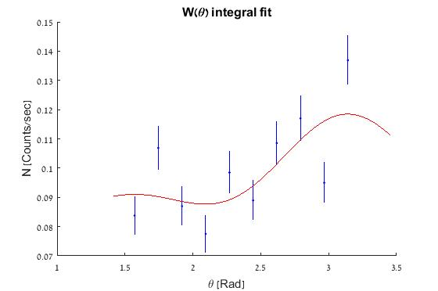
$a_{1} = 0.097 ± 0.016$ $N_{σ}=0.12$
Figure 9 Integral fit graph $Co^{60}$
$a_{2} = 0.013 ± 0.015$ $N_{σ}=0.52$
$a_{3} = 0.0068 ± 0.23$ $N_{σ}=0.028$
$a_{4} = 9.9e-06 ± 0.58 [Rad]$
$chi_{red}^{2} = 4.41$
$p_{prob} = 0.00018$

So far, the ${Co}^{60}$ results showed little compliance with theory. However, looking back at the experimental process, we realized that working with a limited energy window we were limiting our measurements substantially. Figure 10 shows the energy distribution for 5 seconds of random ${Co}^{60}$ emissions, as read by a single detector. Assuming the only decay process here is the beta decay of cobalt to nickel – in fact all the detected photons originate in this case by the successive nickel electron energy drops. In other words, all the photons that undergo Compton scattering should be included in the count. Thus, to improve precision, the same measurements were taken with the energy windows open to the maximum. From the energy spectrum data, approximately 80% of the counts were from Compton scattered photons. Only 20% of the counts were measured around the two singular peaks, and so previous measurements “lost” many data points.
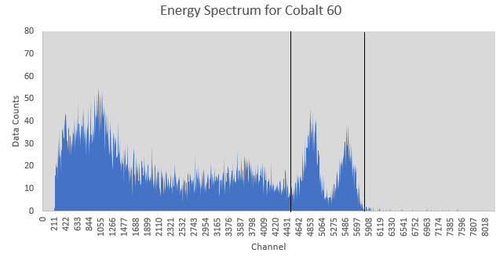
Figure 10 Energy Spectrum as shown in computer

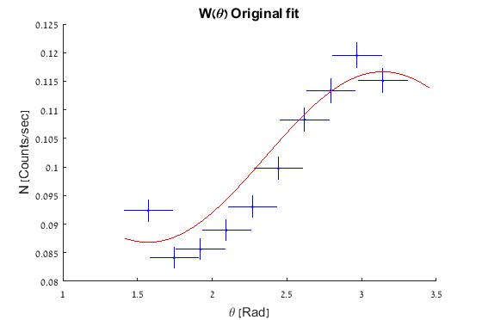
Conducting the same measurements with the windows fully open, produced two additional fits:
Figure 11 Original fit graph for $Co^{60}$ full window
$a_{1} = 0.0868 ± 0.0016$ $N_{σ}=300$
$a_{2} = 0.014 ± 0.088$ $N_{σ}=0.67$
$a_{3} = 0.015 ± 0.31$ $N_{σ}=0.030$
$a_{4} = 0.00010 ± 0.034 [Rad]$
$chi_{red}^{2} = 2.98$
$p_{prob} = 0.0065$

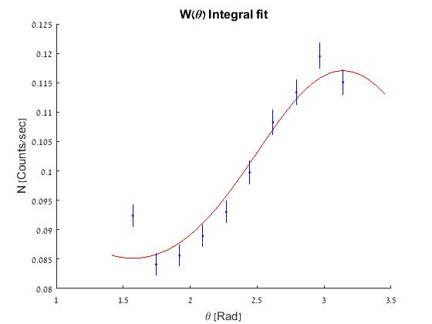
Figure 12 Integral fit graph for $Co^{60}$ full window

$a_{1} = 0.0997 ± 0.0028$ $N_{σ}=0.075$
$a_{2} = 0.016 ± 0.0035$ $N_{σ}=2.9$
$a_{3} = 0.0013 ± 0.079$ $N_{σ}=0.012$
$a_{4} = 9.9e-06 ± 0.15 \left[Rad\right]$
$chi_{red}^{2} = 3.98$
$p_{prob} = 0.00055$

Showing better compatibility with theory and expectations, and a clear trend.
Finally, the triple coincidence between the gamma rays was measured to the following results:
$$θ$$  Angle between A and B | $$ϕ$$  Angle between C and AB plane | Counts per sec
$${180}^{∘}$$ | $$0^{∘}$$ | $$0.545±0.017$$
$${180}^{∘}$$ | $${90}^{∘}$$ | $$0.677±0.019$$
$${90}^{∘}$$ | $$0^{∘}$$ | $$0.460±0.016$$
$$9^{∘}0$$ | $${90}^{∘}$$ | $$0.651+0.018$$
Table 1 Data for triple coincidence counts.
From the results above, we conclude the following ratios Using equation (5):
For $θ={180}^{∘}$ $\frac{N_{∥}}{N_{⊥}}=0.806±0.034$
For $θ={90}^{∘}$ $\frac{N_{∥}}{N_{⊥}}=\frac{ε_{⊥}}{ε_{∥}}=0.706±0.031$

- Conclusions
Under the system’s physical limitations, our results generally show good compatibility with theory and expectations:
The delay between detectors was symmetric as expected and was quantified to be around 1ns per notch. The total delay windows were in expected timescale of ~100ns, as the estimated timescale for the detectors’ reaction times for count measurements.
For the ${Na}^{22}$, although the correlation function is far for the theoretical delta function, a good compliance is seen when remembering the detectors’ size. The gaussian is well centered around $θ=π$. We do not expect a delta function and use this measurement as system calibration, and to estimate the deviance of the system from theory. The gaussian error is the indication to the correction needed to the formula, and points in the correction direction – including the many angles covered by the detector. In this case, the gaussian is merely a simple approximation for the correlation function from which it is easy to extract a standard deviation. The real function would have a complicated angular dependency, as the partial overlap between the detectors’ solid angles and the source.
For the ${Co}^{60}$, previous understandings from the ${Na}^{22}$ measurements helped shape the desired function – integrating over the original angular correlation function instead of using large errors. At first though, both fits (the original and the integrated) seem similar. $Chi_{red}^{2}$ values are similar, so are the parameter fits and the visual agreeance with the fit. However, a closer look reveals a different picture: The two fits have another crucial difference – the relative errors of the input data. Reaching the same statistical assurance for cases with different relative errors is meaningful to the quality of each fit. Thus, generally we would strive to fit data with the lowest errors possible. We should not force problematic data into the theory using large errors, but rather adapt the theory to take the physical system limitations (i.e. the detectors’ size in this case) so it would fit the measured data more accurately. We see the integrated correlation function over the detector as a first order approximation – as deriving the integral over a solid angle would be quite hard analytically. Adding next order approximations and taking in mind detector dimensions on $φ$ axis would help and drive accuracy even higher. The integrated function fits also produce values for the free parameter $a_{1}$ that are substantially more accurate. Using the full energy windows also proved as valuable to improve fit accuracy. It seemed as if with the limited window many of the coincidence counts were missed – providing a false picture of the system. Opening the window also bumped up the number of counts and correspondingly lowered their relative errors. This allows conducting the experiment faster and more efficiently, as every measurement could last half the time but get twice the counts. The visual difference between the two sets of graphs almost speaks for itself.
Finally, the measurement of the triple coincidence bursts do not agree with the theory as shown in the article (4) not even within an error margin. A possible reason for that is the fact that the asymmetry factor was not considered accurately for the configuration of our experiment and could be taken differently with further consideration of the spared of the detectors just as we tried for the double coincidence. The fact that from the result for $ϕ={90}^{∘}$ ratio received is smaller than one meaning the parity of the nucleus has not changed did indicate that at least part of these measurements did fit the theory.

- Bibliography
  - F. Metzger and M. Deutsch, Physical review 78.5 (1950): 552.
  - E. L. Brady, and M. Deutsch, Physical review 78.5 (1950): 558.‬ ‬‬‬‬‬‬
  - F. Metzger and M. Deutsch, Physical review 78.5 (1950): 551.
  - F. Metzger and M. Deutsch, Physical review 78.5 (1950): 555.

- Appendix
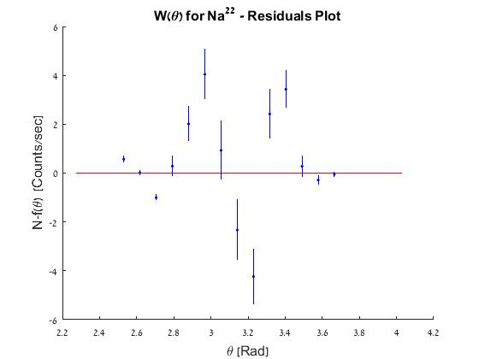
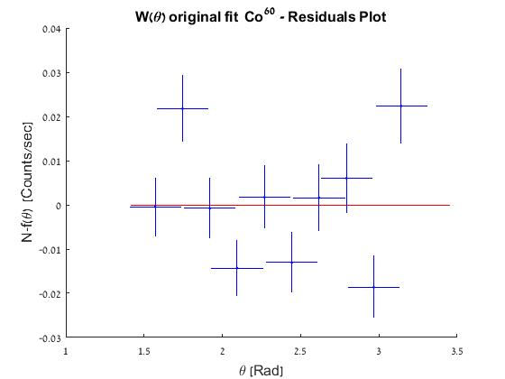
Figure 13 Residuals plot for $Na^{22}$
Figure 14 Original fit residuals for $Co^{60}$

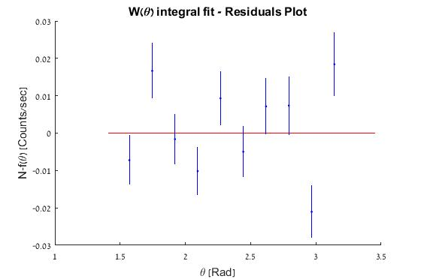
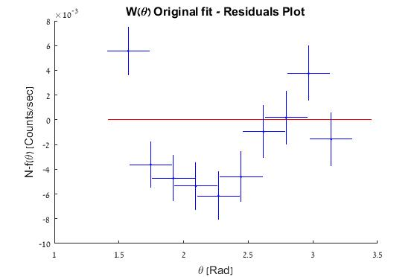
Figure 15 Integral fit residuals for $Co^{60}$
Figure 16 Original fit graph residuals for $Co^{60}$ full window
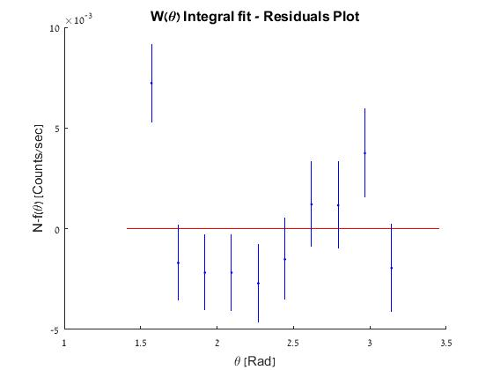
Figure 17 Integral fit graph residuals for $Co^{60}$ full window

