Apparatus
The experimental apparatus is consisted of two radioactive sources, Na²² and Co⁶⁰, and three photon detectors (inorganic scintillation counters). Each detector is connected to an amplifier, which is then connected to a Single Channel Analyzer (SCA). The SCA’s functions on the inserted signal are digitization, delay addition, and height filtering according to a specified range. The digitized output of all three SCAs is directed to a configurable coincidence unit (CU), which supports logical operations between its inputs. For every time the output of the CU is logical true, it results in an increase by one of a resettable display counter located next to it. In addition, the amplifier and SCA corresponding to detector B are connected to a Multi-Channel Analyzer (MCA). The MCA is then connected to a private computer running ___insert program name___, allowing a live view of the detector’s photon count as a histogram (with bins corresponding to signal height ranges).
Detector B

Amplifier
gain
SCA

Detector C

Amplifier
gain
SCA

Detector A

Amplifier
gain
SCA

Coincidence unit

MCA

Computer

The detectors are spatially configurable according to figure __insert figure number__ where, in radians, $ϕ∈\{0,\frac{π}{2},π\}$ and $θ∈[\frac{π}{2},\frac{3π}{2}]$.
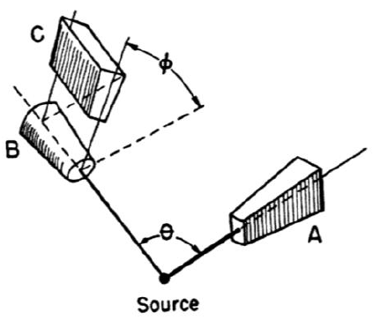
Experimental Process
First of all, we shall note for the rest of the paper that every time it is mentioned that a count measurement was performed, it is to be understood that the timespan of the measurement was also measured, and the discussed magnitude is the amount of counts per time unit.
The timespan measurements were performed using a stopwatch, which ideally should have been started and stopped at the same time as the coincidence counter. In actuality it cannot be guaranteed that it was so, and errors in the time measurements were introduced. To make those negligible, we made no measurements spanning less than $20 s$.
Noise measurement
With no source present, a count measurement was performed for approximately two minutes to measure the background noise in the experiment. Under the assumption that the noise is the same for every spatial configuration, we did only one measurement for one specific location and orientation ($θ=180°$). We used detector A, which we have found to be the most sensitive detector out of the three, and received no counts at all for the measurement duration. Thus, we have concluded the noise in the experiment to be negligible.
Delay calibration
To count coincident gamma rays, it is necessary to compensate for the corresponding signals’ relative delay. As such, we first configured the CU to perform logical AND between the inputs belonging to detectors A and B. Afterwards, at the presence of an Na²² source, we measured the amount of counts for a range of different delay settings of the SCAs. From those measurements we produced a graph of counts as function of delay, with a shape resembling that of an isosceles trapezoid. From that, we picked the delay value of the perceived middle of the trapezoid base as the delay setting for the rest of the experiment. We then repeated the process with detectors B and C.
Na²² correlation
When an Na²² nuclei decays into the nuclei of an Ne²² a positron is emitted. Upon collision with its anti-particle, the electron, both particles are annihilated and cause the emission of two anti-parallel gamma rays. In other words, the angular correlation between the resulting gamma rays is:
$$W\left(Θ\right)=δ(Θ-π)$$
The purpose of this part of the experiment was to measure the angular correlation between the two resulting gamma rays.
With Co⁶⁰ as a source, we first set the CU to perform logical AND between the inputs belonging to detectors A and B. Then, we performed count measurements for at least 50 seconds for different $θ∈[150°,210°]$.
Co⁶⁰ correlation
Part of the decay cascade of Co⁶⁰ into Ni⁶⁰ includes two closely timed emissions of gamma rays. The difference in their emission time is much too small to be detected by the experiment’s apparatus and so they are also termed coincident. These rays also have an angular correlation function:
$$W\left(Θ\right)= ?$$
With Co⁶⁰ as a source, we first configured the CU to perform logical AND between the inputs belonging to detectors A and B. Then, we performed count measurements for at least 1 minute for different $θ∈[90°,180°]$.
Co⁶⁰ multipolarity
With Co⁶⁰ as a source, we first set the CU to perform logical AND between the inputs belonging to all three detectors. Then, we performed count measurements for at least 30 minutes for each configuration in $\{\left(ϕ=0°, θ=90°\right), \left(ϕ=0°, θ=180°\right), \left(ϕ=90°, θ=90°\right), \left(ϕ=90°, θ=180°\right)\}$.

Data analysis
Delay calibration

Na²² correlation
The best fit we have found to the data is a gaussian function:
$$f\left(θ\right)=ae^{{\left(\frac{θ-b}{c}\right)}^{2}}$$
With $a=9.65±0.39 cps$, $b=11.50±0.21 degrees$, $c=180.72±0.28 degrees$. The goodness of fit indicators are $χ_{red}^{2}=1.6$ and $p_{probability}=0.060$.
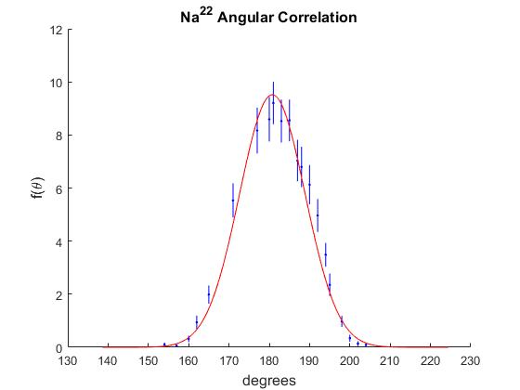

The fact that the data does not conform to a delta function could be attributed to the finite solid angle subtended by each of the detectors (as viewed from the source). Figure __insert figure number__ shows why the number of counts is not 0 for $θ≠180°$, and why it declines as $\left|θ-180°\right|$ increases.
A
B
A
B
A
B
A
B

The reason why the MCA is connected not only to the amplifier but to the SCA as well, is that the SCA output encodes the information regarding range filtering of the signal. Without it, the processing performed later would not be able to make use of the range limits specified for the SCA.
That is, the difference in arrival times of the signals to the logical operation implementation, which may be caused (but not limited to) by the positioning of the detectors, wires used and the internal structure of the electronic devices.
We have also tried to fit a Lorentzian function, as is shown in appendix __insert appendix letter__.

