Lomb-Scargle Periodogram
Dealing with uniformly sampled data is very common in scientific research. An evenly sampled periodic signal $g$can be superimposed by a sum of sinusoidal components and its Fourier Transform $F\{g\}$ is a sum of Delta functions. Each Delta function is marking a frequency in one of the sinusoidal components. Thus, if we compute the power spectrum of the signal, ${\left|F\left\{g\right\}\right|}^{2}$, we can easily deduce the period of a pulsating star oscillations.
Unfortunately, astronomical data is not always uniformly sampled. Observational astronomy can be challenging and different constraints may appear: weather conditions, seasonal changes, telescope errors and etc. To deal with the unevenly sampled data and still get a power spectrum, a technique called Lomb-Scargle Periodogram can be used. Scargle developed a more general form of a periodogram which a. reduces to the evenly sampled form if the signal were to be evenly sampled, b. is analytic, c. insensitive to data shift in time. Not only these, but the “new” periodgram simplifies the data analysis since it is mathematically equivalent to the periodgram obtained by using the least squares method when fitting a single sinusoidal component to the data.
In the current experiment a use of the plomb matlab function was used in order to achieve the Lomb-Scargle periodogram. The plomb matlab function directly calculates the periodogram without using the least squares approach. The result can be seen in figure(_).
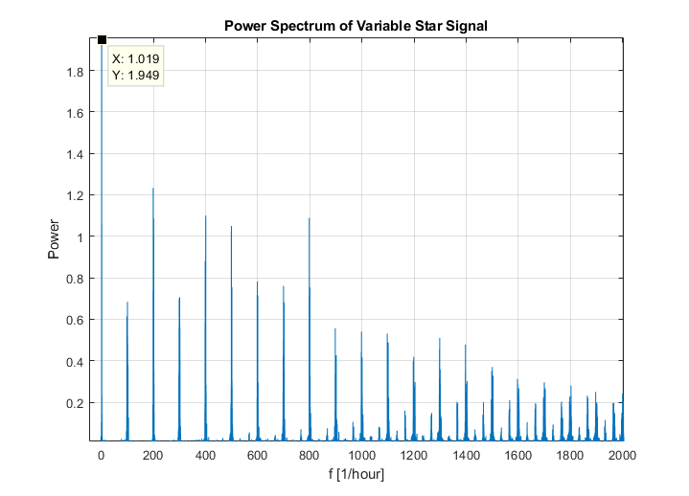
Figure 1 Power spectrum of variable star BL Cam
Least Squares Fit
As mention above, the Lomb-Scargle periodogram is equivalent to fitting single-term sinusoidal function to the data. By extending this approach a more sophisticated model was used:
$$y_{model}=θ_{0}+\sum_{n=1}^{N}{\left[θ_{2n-1}\sin\left(2πnft\right)+θ_{2n}\cos\left(2πnft\right)\right]}$$
Where $f$ is the frequency found in the “Lomb-Scargle Periodogram” section above, and $θ_{0}, …, θ_{N}$ are the model hypothesis values. We took N to be 4 since adding more terms to the model did not improve minimal $χ^{2}$ value. For sanity purposes, we validated the power spectrum of $y_{model}$ and it looked exactly like the one calculated using plomb.

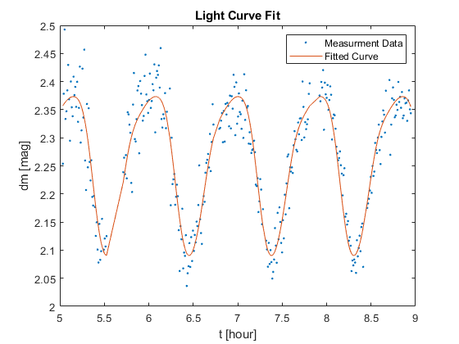
Figure 2 Light Curve Model least squares fit
The following results were obtained:
$$θ_{0}$$ | $$θ_{1}$$ | $$θ_{2}$$ | $$θ_{3}$$ | $$θ_{4}$$ | $$θ_{5}$$ | $$θ_{6}$$ | $$θ_{7}$$ | $$θ_{8}$$ | $$χ_{red}^{2}$$
$2.3$ (0.025%) | $$3.9e-3$$  (0.01%) | $$-0.14$$  (0.001%) | $$1.7e-2$$  (0.0024%) | $$-2.8e-2$$  (0.0024%) | $$1.9e-3$$  (0.017%) | $$1.7e-3$$  (0.01%) | $$-6.4e-4$$  (0.26%) | $$2.0e-3$$  (0.0001%) | 3.3  (2.3%)
Table 1: Results from least squares fit. Errors in parentheses.
The $χ_{red}^{2}$ value is larger then expected. Adding more sinusoidal terms does not improve it as much, meaning there is probably and underestimation of errors. The residual plot doesn’t show any trend which support the last claim. The unaccounted errors may come from different weather and air conditions when observing comparison and target stars at different times. Which more reasons we have for errors?
The error in $χ_{red}^{2}$ was calculated by taking the STD of $χ_{red}^{2}$ distribution $\left(\sqrt{\frac{2}{DOF}}\right)$ . The error in frequency was determined by polynomial interpolation of the function $χ_{red}^{2}(f)$ where the $\vec{θ}$ from table 1 was taken. The $f$ values giving $χ_{red}^{2}±\sqrt{\frac{2}{DOF}}$ were used in order to obtain error in the frequency of the pulsating star. The resulting frequency and period values were found to be$f=1.080±0.001 \left[\frac{1}{hour}\right]$ and $P=0.9259±8.6e-4 \left[hour\right]$.

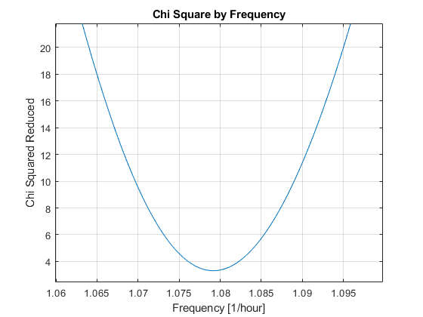
Figure 3 Chi Square Reduced by f

Appendix:
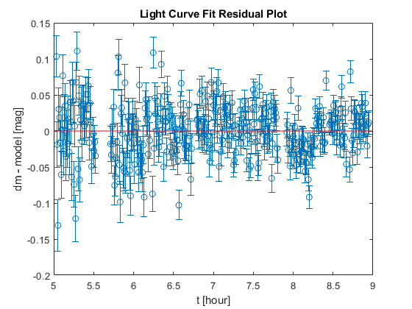
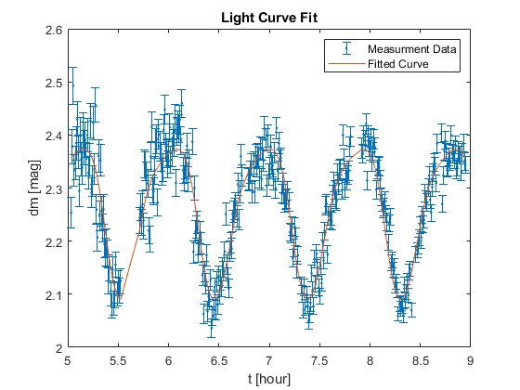

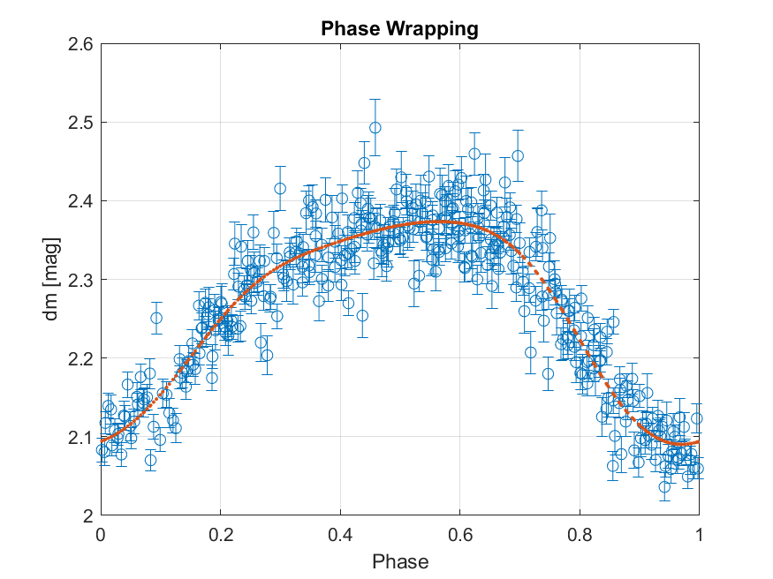

“Understanding Lomb Scargle Periodogram”
“Periodograms for Multiband Astronomical Time Series”, Jacob T. VanderPlas, Zeljko Ivezic
“Fast algorithm for spectral analysis of unevenly sampled data”, Press, W. H. & Rybicki, G. B. 1989 ApJ vol. 338, p. 277-280.

