Hyperbolic Functions in Algebra and Calculus
By Kevin Mirus, Madison Area Technical College

- Uses of the hyperbolic functions:
  - Engineering applications (catenary curves)
  - Finding certain antiderivatives.
  - Solving differential equations, such as
y′′(x) = y(x), which has solution y(x) = Asinh(x) + Bcosh(x)
vs. y′′(x) = -y(x), which has solution y(x) = Asin(x) + Bcos(x)

- Definition of the hyperbolic functions:

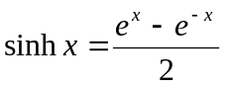 | 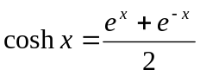
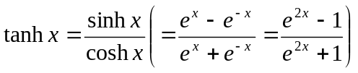 | 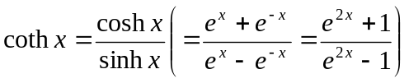
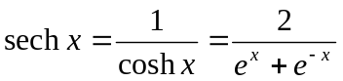 | 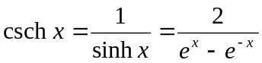

- Some identities involving hyperbolic functions:

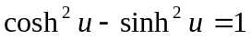  Note: if x = cosh u and y = sinh u, then  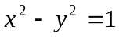is the equation of a hyperbola | 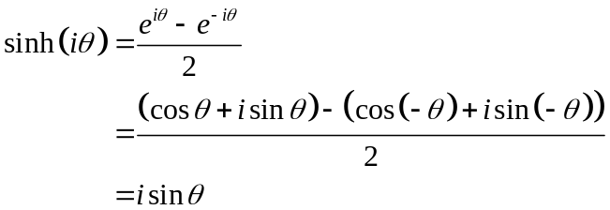
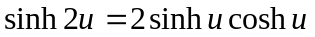 | 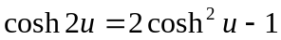
cosh (s + t) = cosh s cosh t + sinh s sinh t | sinh (s + t) = sinh s cosh t + cosh s sinh t

- Osbornes’s Rule: a trigonometry identity can be converted to an analogous identity for hyperbolic functions by expanding, exchanging trigonometric functions with their hyperbolic counterparts, and then flipping the sign of each term involving the product of two hyperbolic sines. For example, given the identity Osborne's rule gives the corresponding identity

Citation: Eric W. Weisstein. "Osborne's Rule." From MathWorld--A Wolfram Web Resource. http://mathworld.wolfram.com/OsbornesRule.html

- Graphs of the hyperbolic functions:

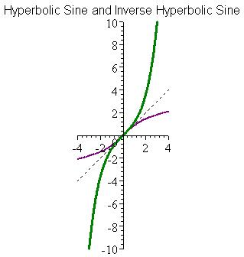 | 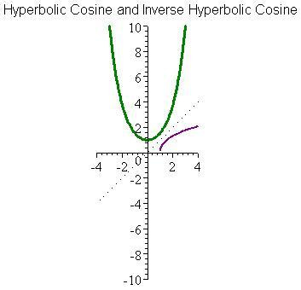
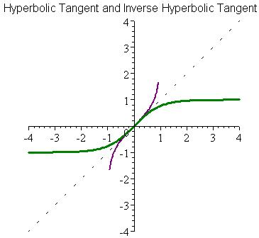 | 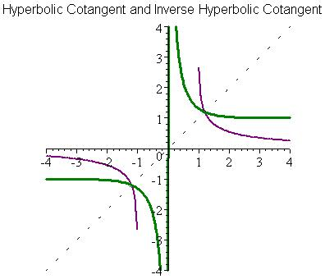
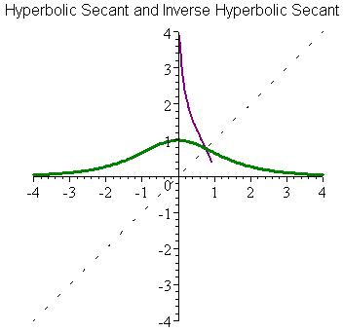 | 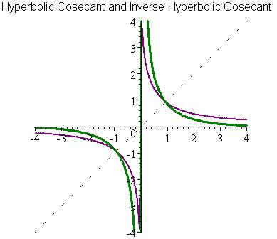

- Inverses of the hyperbolic functions and their formulae:
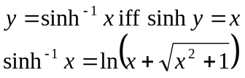 | 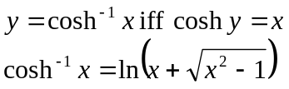
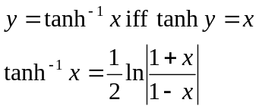 | 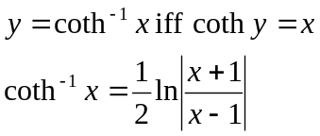  Also: 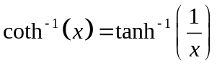
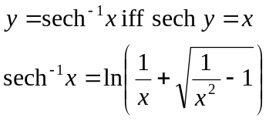  Also: 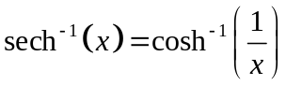 | 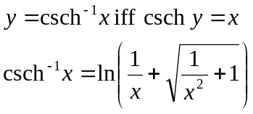  Also: 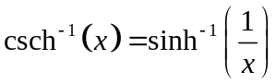

- Proof of the formula for the inverse hyperbolic sine:
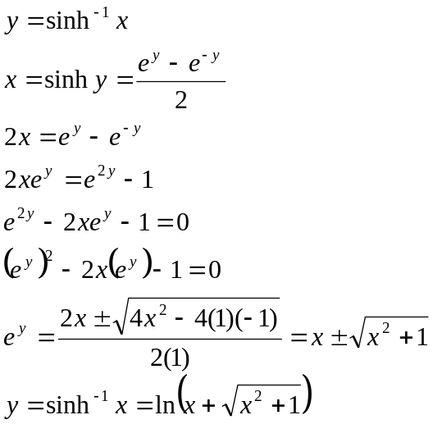

- Composition of hyperbolic functions and inverse hyperbolic functions:
(Sorry this is so incomplete right now)

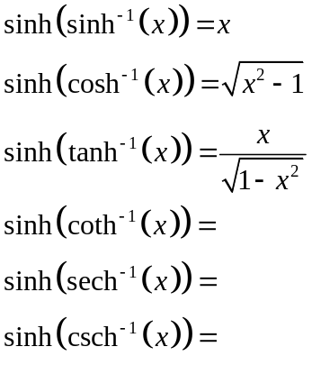 | 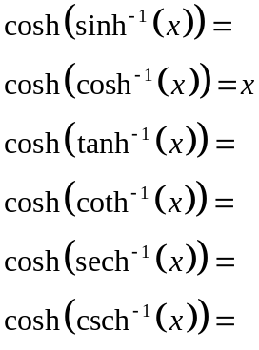 | 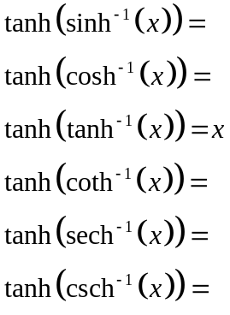
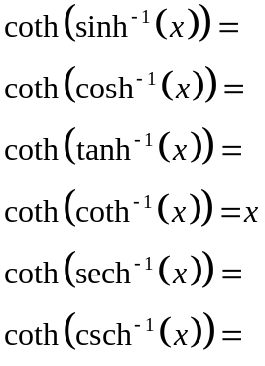 | 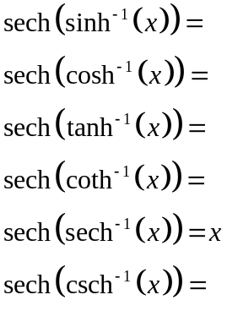 | 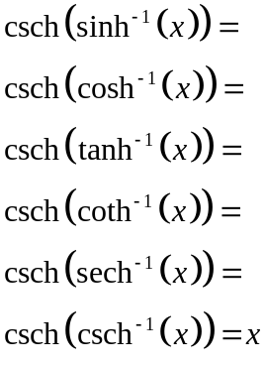

- Derivatives of the hyperbolic functions:
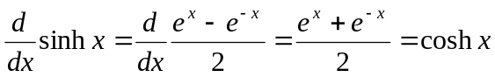 | 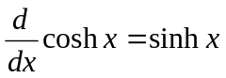
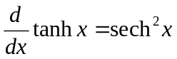 | 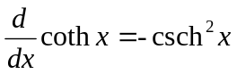
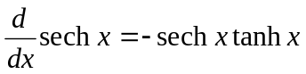 | 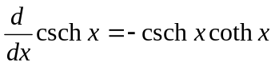

- Recall that the derivative formulas can be used to obtain integral formulas, like
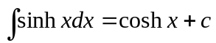

- Derivatives of the inverse hyperbolic functions:
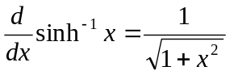 | 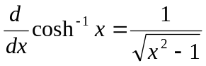
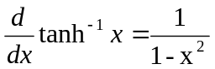 | 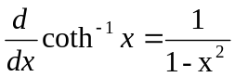
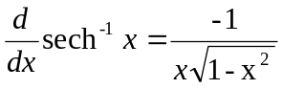 | 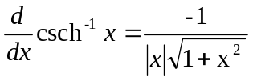

- Recall that the derivative formulas can be used to obtain integral formulas, like
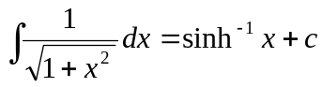

Also, you can prove using integration by substitution that
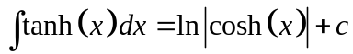, and that
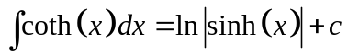

- Proof of the derivative of the inverse hyperbolic sine:
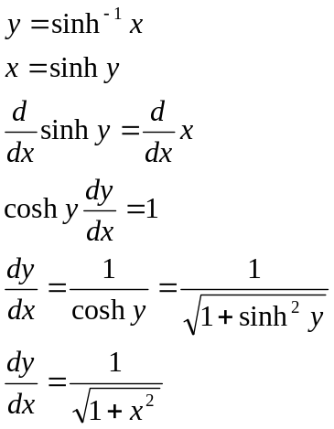 | 